Supplementary Information
Single Ru site dispersed Cu nanocluster dual sites enables outstanding photocatalytic CO₂ reduction
Lizhen Liu,^{1,2†} Jingcong Hu,^{3†} Yuan Sheng,⁴ Hossein Akhoundzadeh,² Wenguang Tu,⁵ Wei Jian Samuel Siow,^{2,6,7} Hongwei Huang,^{1*} Rong Xu^{2,8*}

¹Engineering Research Center of Ministry of Education for Geological Carbon Storage and Low Carbon Utilization of Resources, Beijing Key Laboratory of Materials Utilization of Nonmetallic Minerals and Solid Wastes, National Laboratory of Mineral Materials, School of Material Sciences and Technology, China University of Geosciences (Beijing), Beijing 100083, China
²School of Chemistry, Chemical Engineering and Biotechnology, Nanyang Technological University, Singapore 637459, Singapore
³Beijing Key Laboratory of Microstructure and Properties of Solids, Faculty of Materials and Manufacturing, Beijing University of Technology, Beijing 100124, China
⁴College of Chemical Engineering, Zhejiang University of Technology, Hangzhou 310014, China
⁵School of Science and Engineering, The Chinese University of Hong Kong (Shenzhen) Guangdong 518172, China
⁶Singapore Membrane Technology Centre, Nanyang Environment and Water Research Institute, Nanyang Technological University, Singapore 637141, Singapore
⁷Nanyang Environment and Water Research Institute, Interdisciplinary Graduate Programme, Nanyang Technological University, Singapore
⁸C4T CREATE, National Research Foundation, CREATE Tower 1 Create Way, Singapore 138602, Singapore
†These authors contributed equally to this work.
*Corresponding author: hhw@cugb.edu.cn (Hongwei Huang); rxu@ntu.edu.sg (Rong Xu)

Supplementary Text
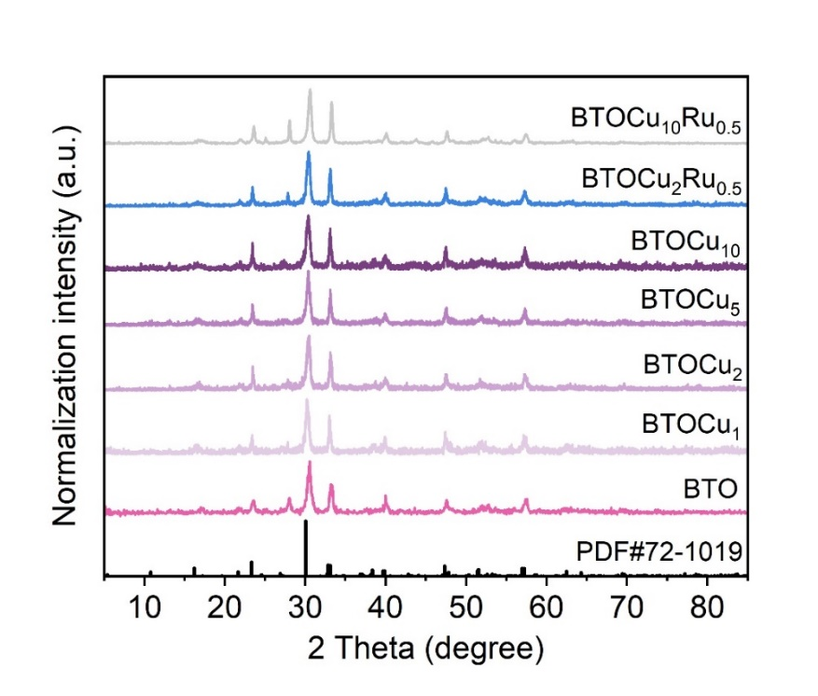
Fig. S1. XRD patterns of BTO, BTOCux (x = 1, 2, 5, 10) and BTOCuyRu_{0.5} (y = 2, 10).
The detailed information about the purity and crystallinity of the samples is obtained by XRD analysis. The diffraction peaks of BTO coincide with the standard peaks of Bi₄Ti₃O₁₂ (PDF#72-1019). The strong peaks indicate good crystallinity. In addition, no other phases can be found in the series of BTO samples, indicating that the introduction of Cu and Ru loading does not produce impurities or change the crystal structure.
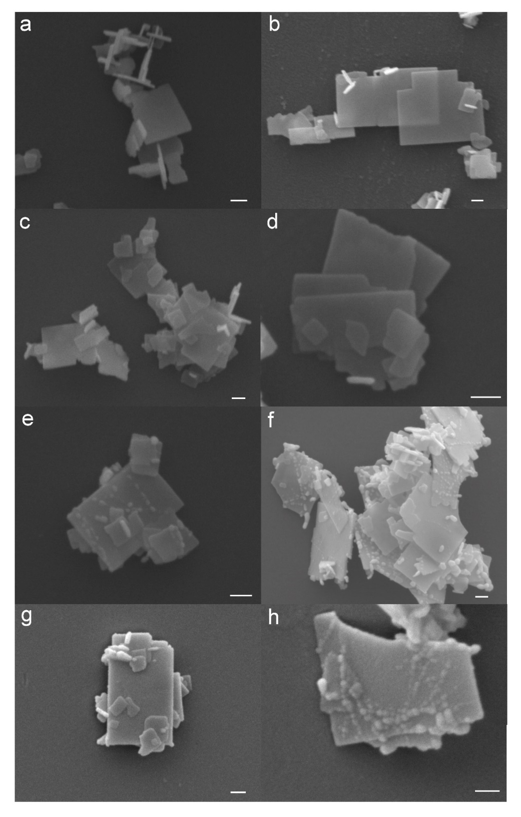
Fig. S2. SEM images of a BTO, b BTOT, c-f BTOCux (x = 1, 2, 5, and 10) and g-h BTOCuyRu_{0.5} (y = 2 and 10) (the scale bar is 100 nm).
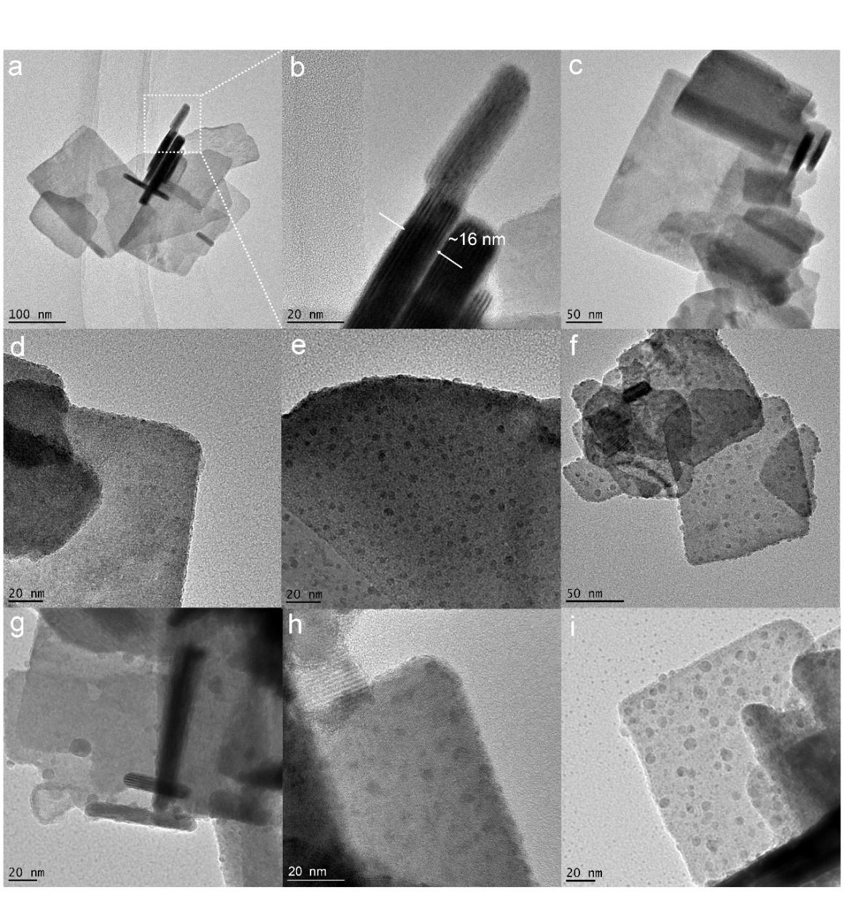
Fig. S3. TEM images of a BTO, b the enlarged area in a, c BTOT, d-g BTOCux (x = 1, 2, 5, 10) and h-i BTOCuyRu_{0.5} (y = 2, 10).
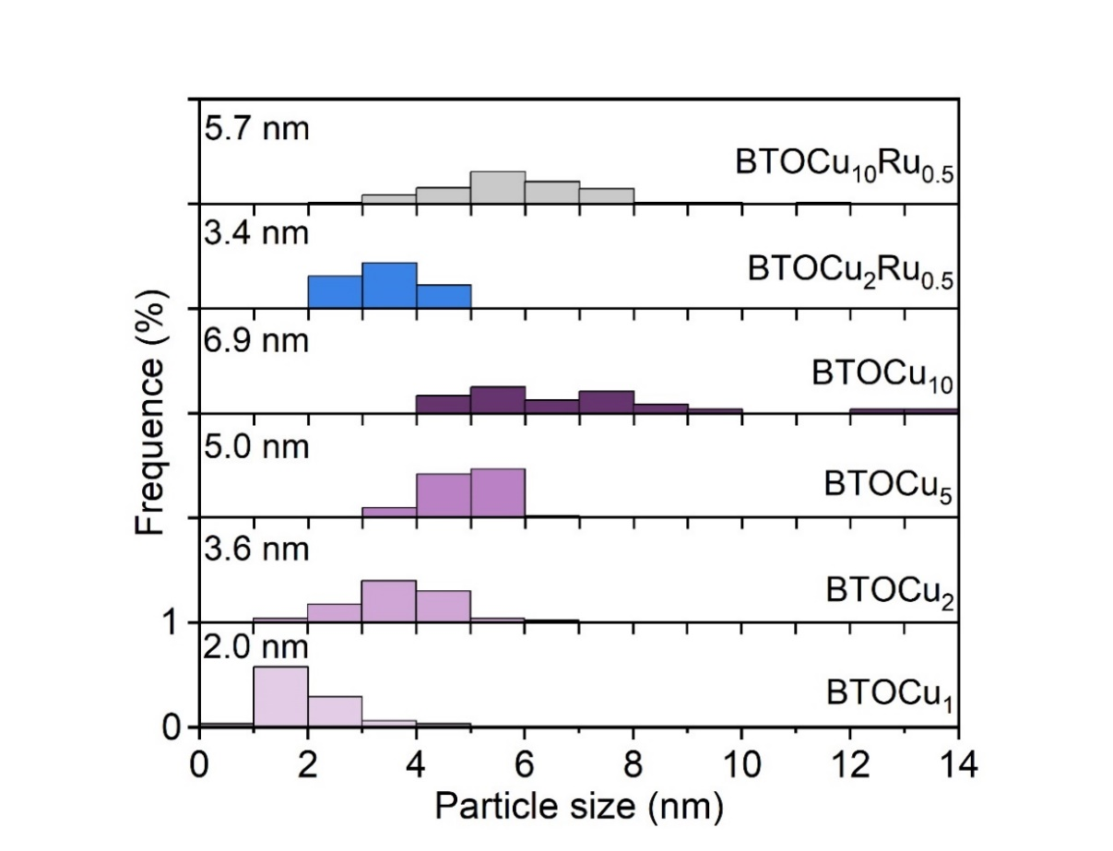
Fig. S4. Size distribution histograms of metal clusters obtained from TEM images (Fig. 3).
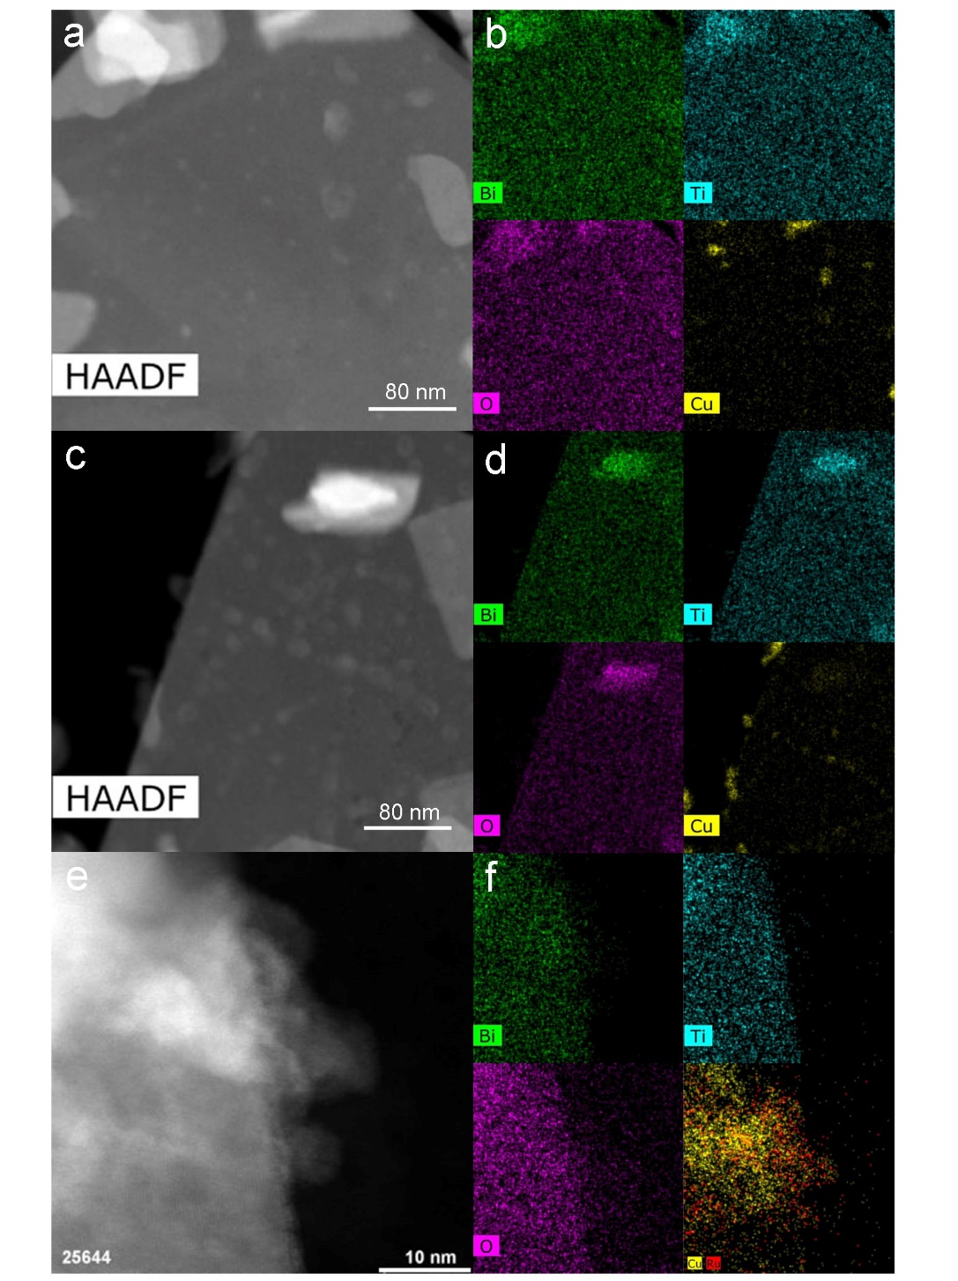
Fig. S5. HAADF-STEM images and corresponding elemental mapping of a-b BTOCu₂, c-d BTOCu₁₀ and e-f BTOCu₁₀Ru_{0.5}.

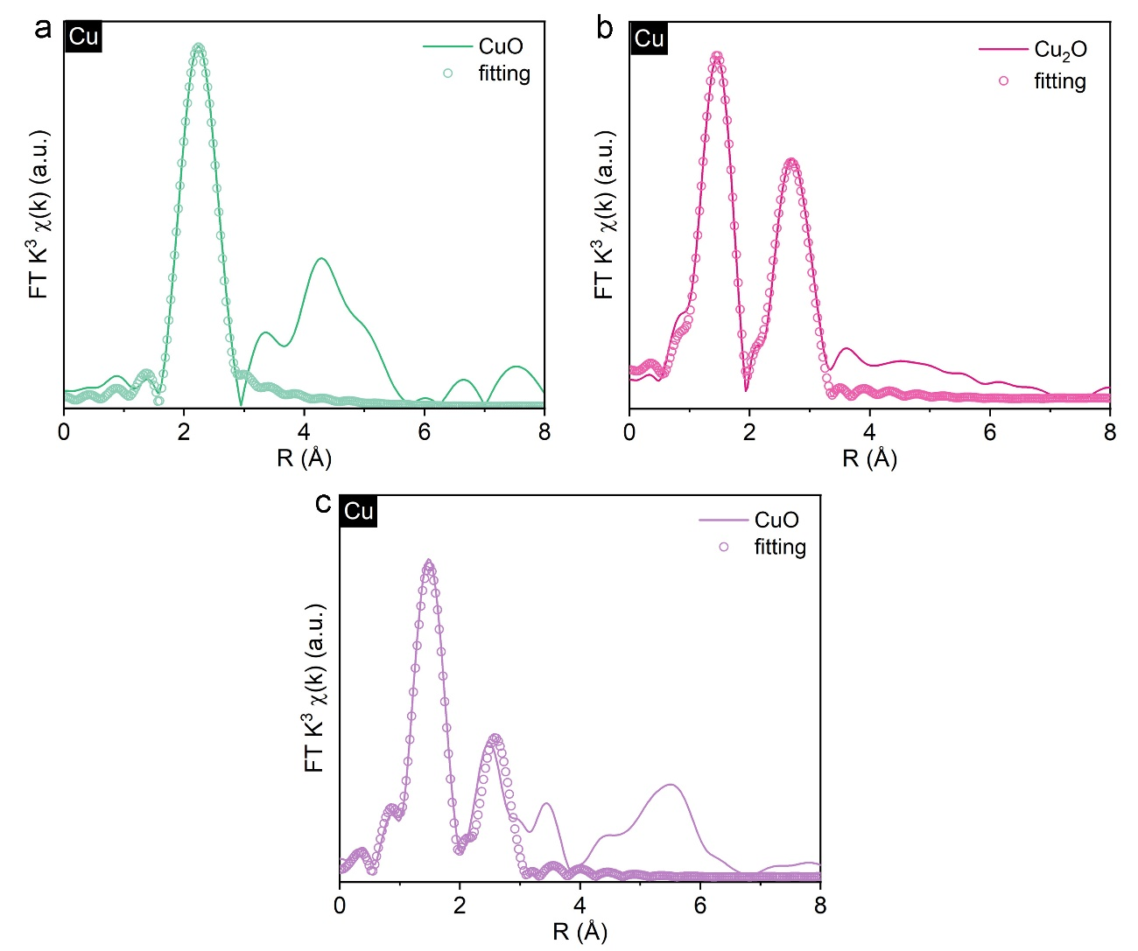
Fig. S6. Fitting results of FT spectrum of a Cu foil, b Cu₂O and c CuO at Cu K-edge.

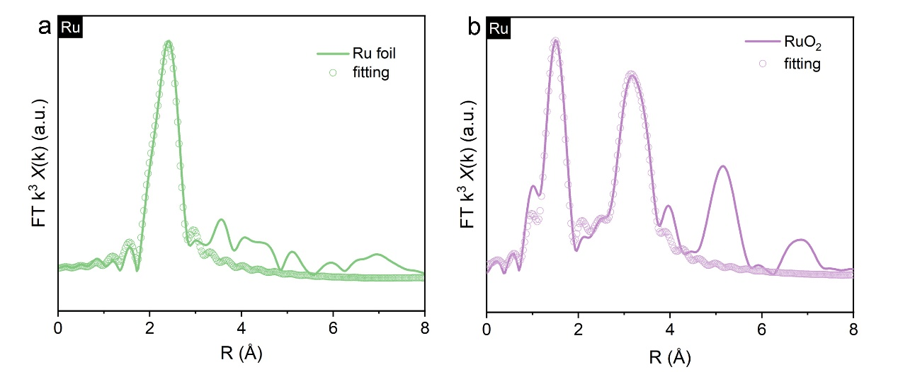
Fig. S7. Fitting results of FT spectrum of a Ru foil and b RuO₂ at Ru K-edge.

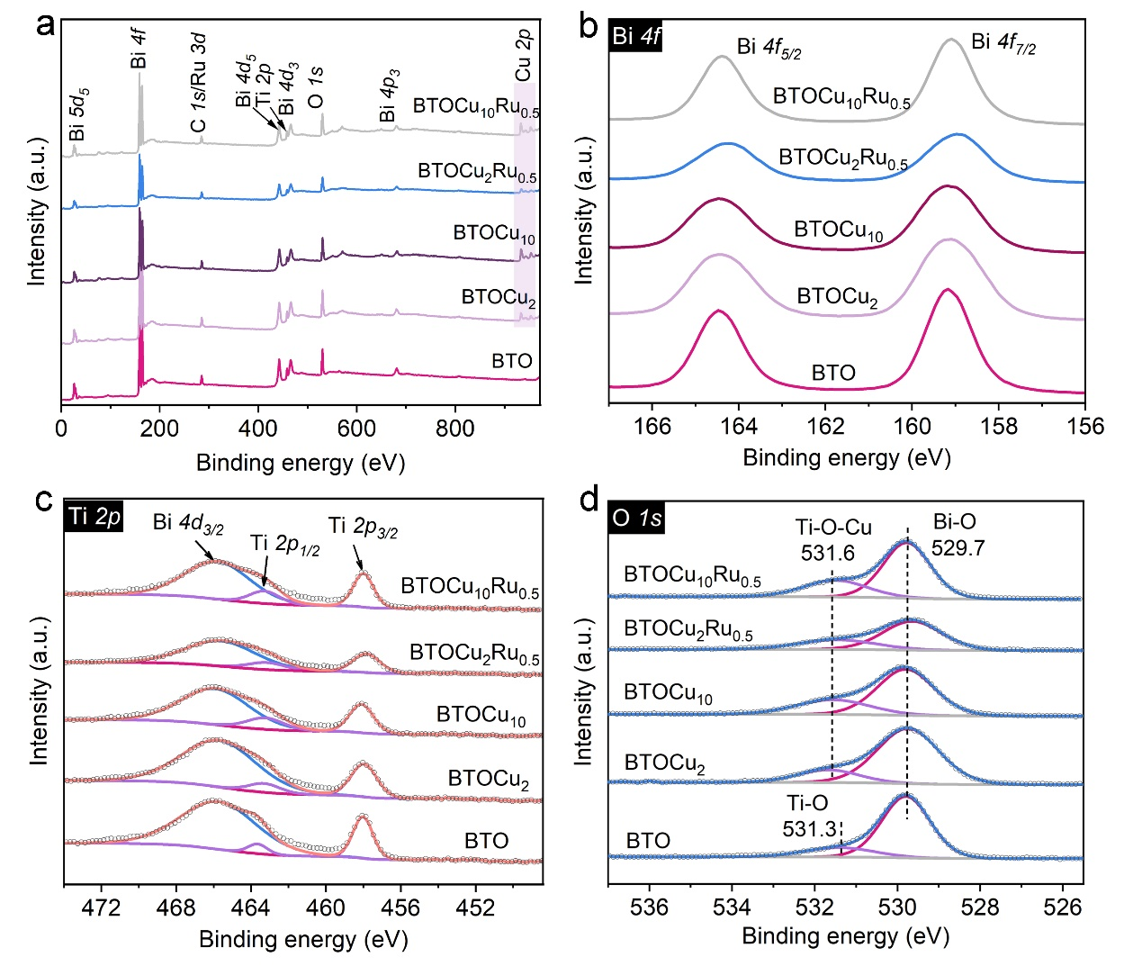
Fig. S8. XPS spectra: a survey, b Bi 4f, c Ti 2p and d O 1s of BTO, BTOCu₂, BTOCu₁₀, BTOCu₂Ru_{0.5} and BTOCu₁₀Ru_{0.5}.
XPS spectra of Bi 4f and Ti 2p of BTO, BTOCu₂, BTOCu₁₀, BTOCu₂Ru_{0.5} and BTOCu₁₀Ru_{0.5} show no obvious difference. O 1s of BTOCu₂, BTOCu₁₀, BTOCu₂Ru_{0.5} and BTOCu₁₀Ru_{0.5} differs from that of BTO, which indicates that Cu nanocluster successfully anchors on BTO surface and Cu atoms adjacent to the surface coordinate with surface O atoms. O 1s at 529.7 eV is associated with O in lattice Bi-O. O 1s of lattice Ti-O is up-shifted from 531.3 eV to 531.6 eV, which shows that Cu-O coordination influences the Ti-O coordination, confirming Cu atoms adjacent to the surface coordinate with surface O atoms.
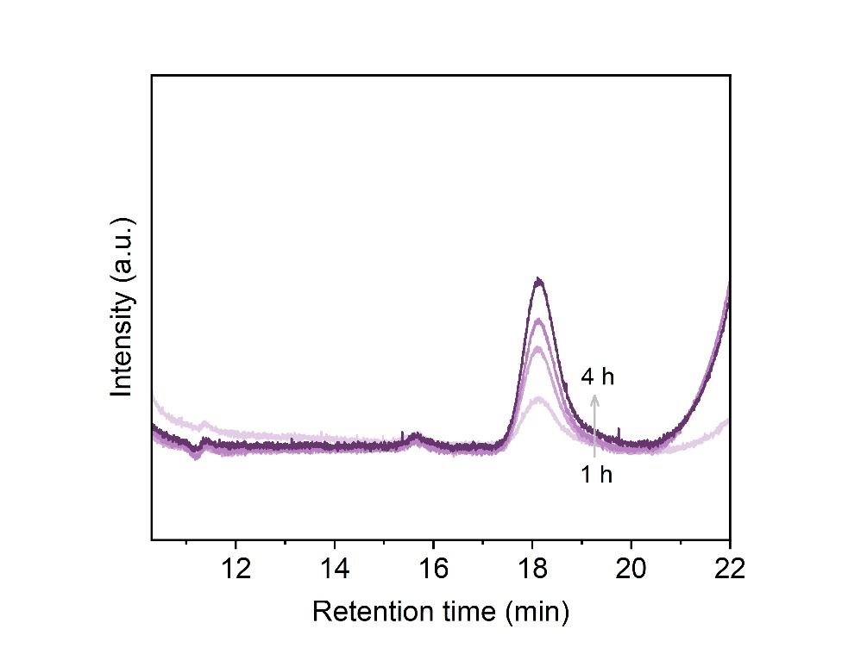
Fig. S9. GC curves during gas sample analysis over BTOCu₂Ru_{0.5}.

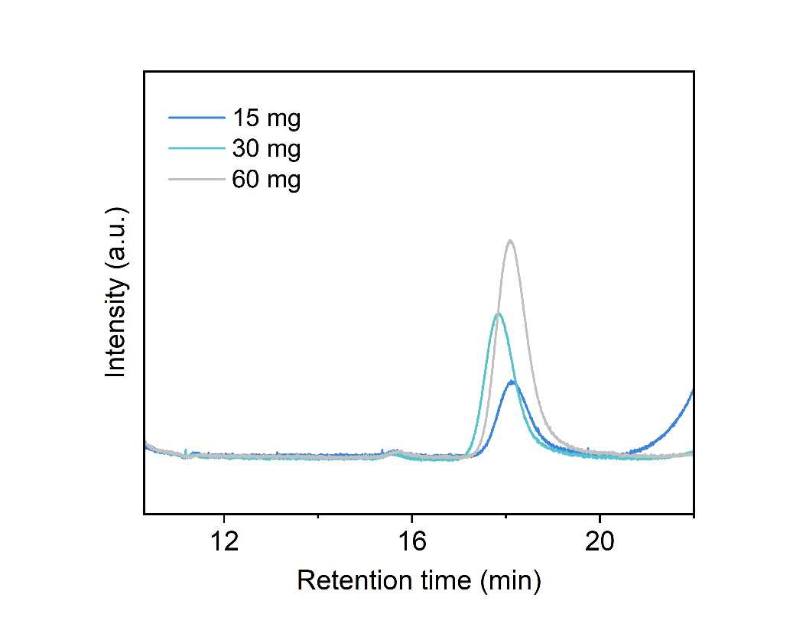
Fig. S10. GC curves during gas sample analysis over BTOCu₂Ru_{0.5}.

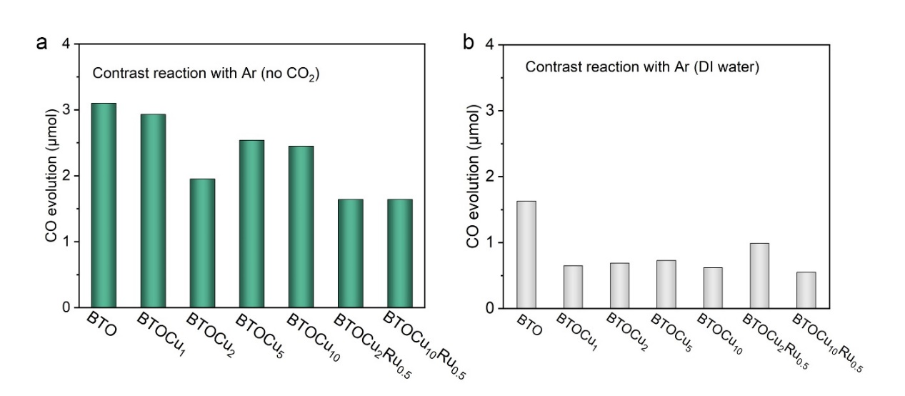
Fig. S11. Control experiments: CO production from CO₂ photoreduction over BTO, BTOCux (x = 1, 2, 5, 10) and BTOCuyRu_{0.5} (y = 2, 10) samples (15 mg) without a CO₂ (Ar atmosphere) and without b CO₂ and acetonitrile (Ar atmosphere and ultra-pure water as solvent).

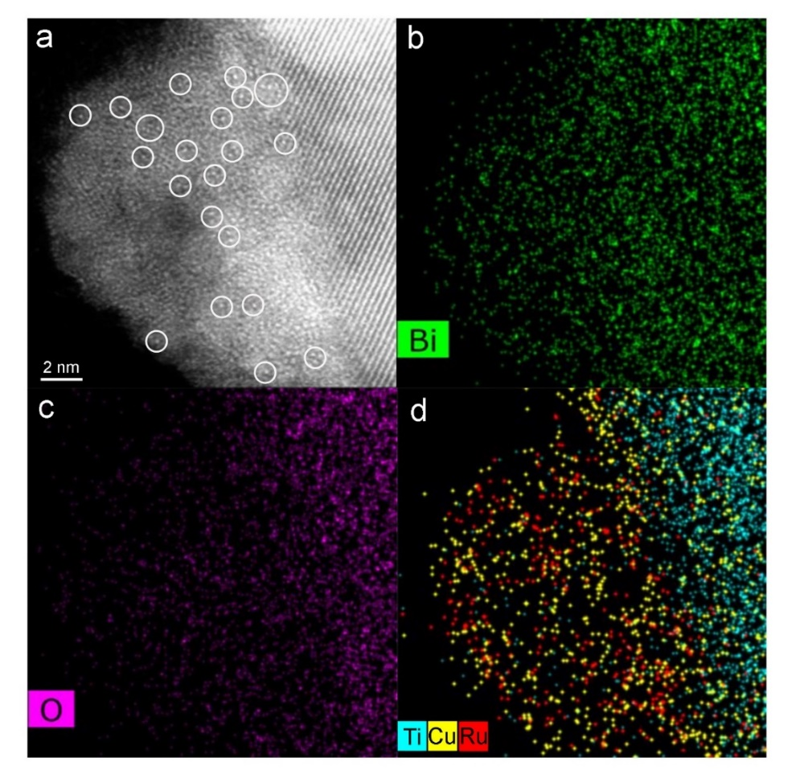
Fig. S12. a HAADF-STEM images and b-d corresponding element mapping of BTOCu₂Ru_{0.5} after 12 h of reaction time.

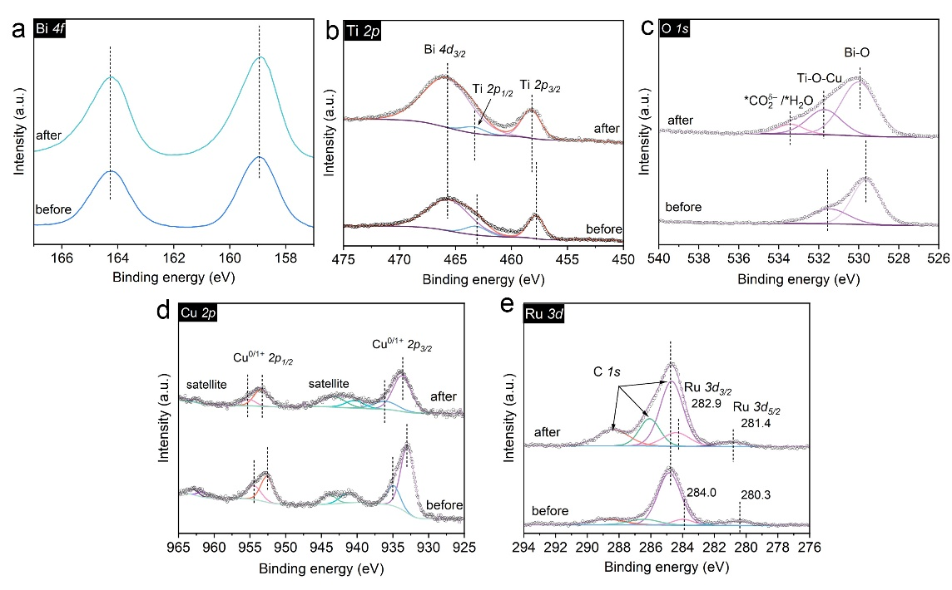
Fig. S13. XPS spectra: a Bi 4f, b Ti 2p, c O1s, d Cu 2p and e Ru 3d of BTOCu₂Ru_{0.5} before and after reaction.

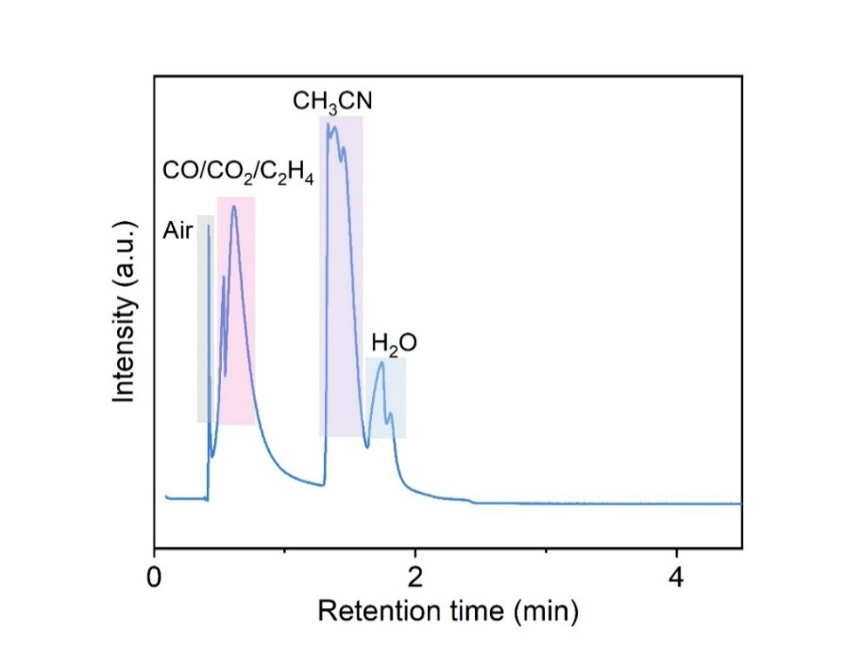
Fig. S14. GC-MS curves during gas sample analysis.

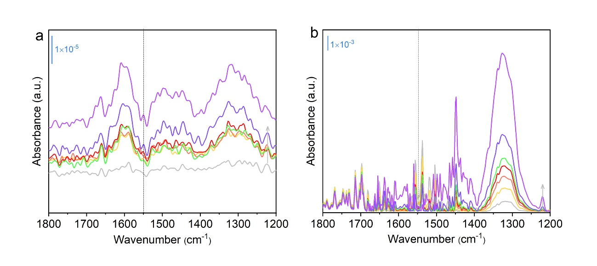
Fig. S15. In situ FTIR spectra for dark adsorption over a BTOCu₂Ru_{0.5} and b BTOCu₁₀ before illumination (data collected at 1, 2, 3, 4, 5, 10 and 20 min from bottom to top).

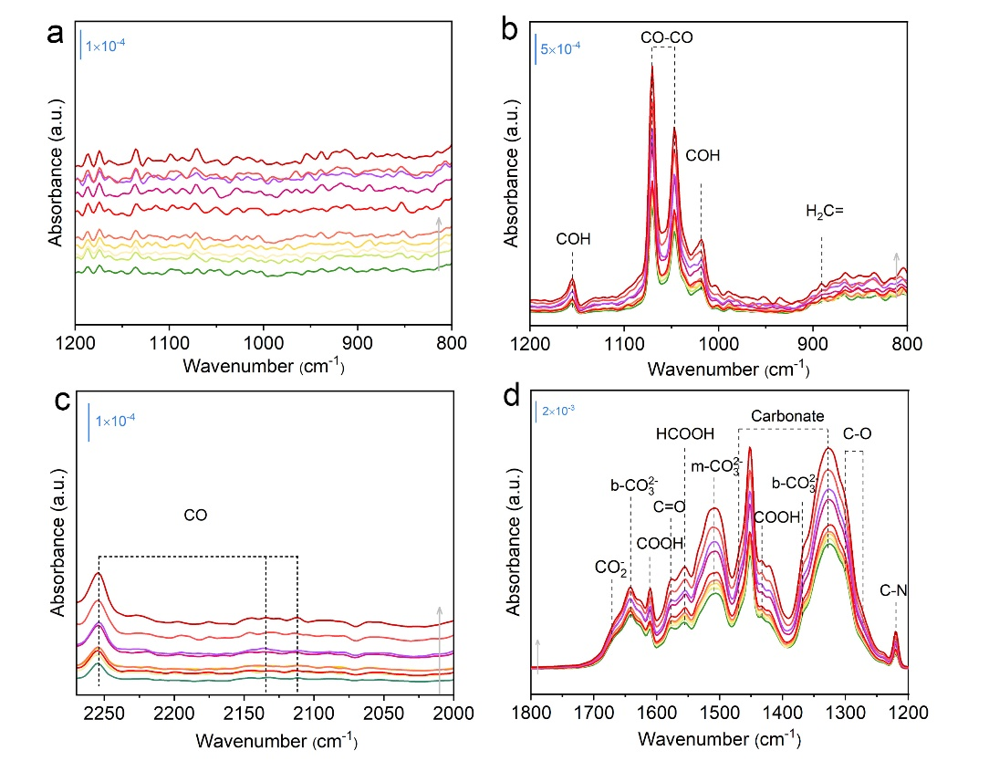
Fig. S16. In situ FTIR spectra for CO₂ photoreduction process under 300 W Xe lamp over a BTOCu₂Ru_{0.5} and b-d BTOCu₁₀ (data collected at 2, 4, 6, 8, 10, 20, 30, 40, 50 and 60 min from bottom to top).

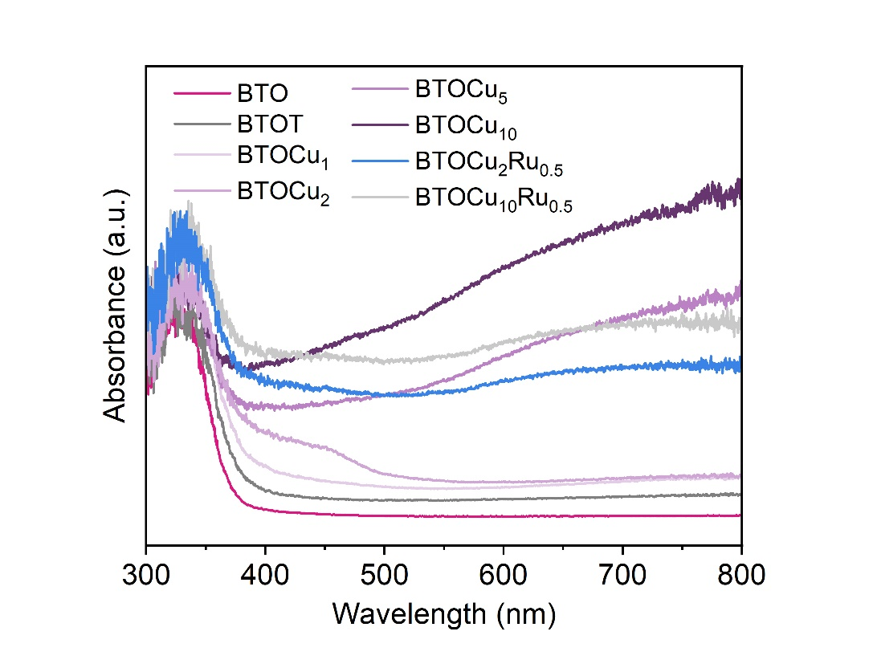
Fig. S17. DRS spectra of BTO, BTOT, BTOCux (x = 1, 2, 5, 10) and BTOCuyRu_{0.5} (y = 2, 10).

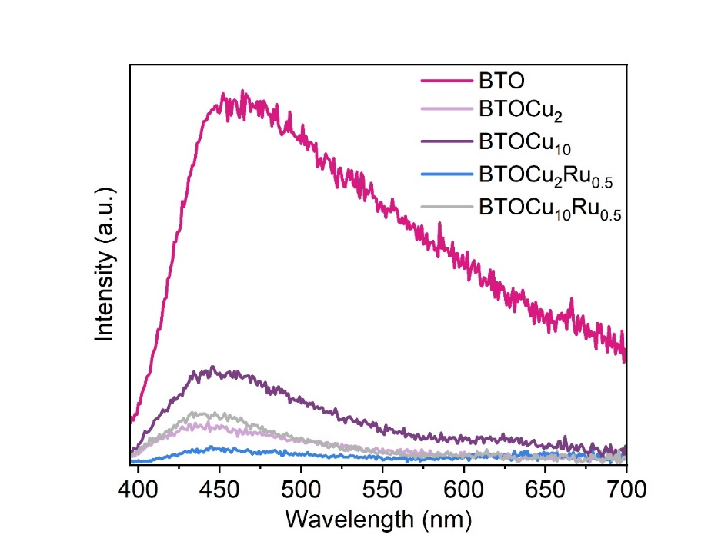
Fig. S18. PL spectra of BTO, BTOCu₂, BTOCu₁₀, BTOCu₂Ru_{0.5} and BTOCu₁₀Ru_{0.5}.

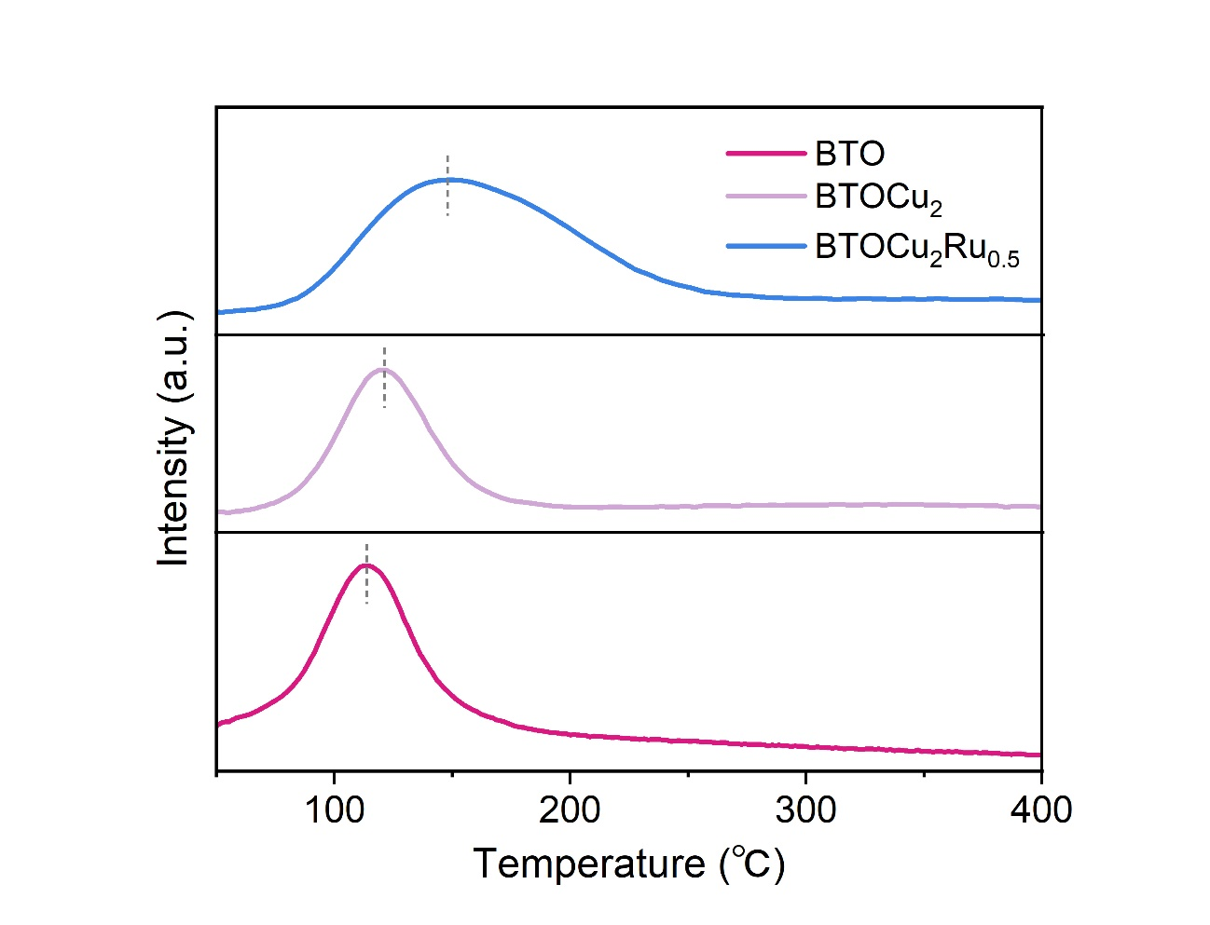
Fig. S19. CO₂ TPD curves of BTO, BTOCu₂ and BTOCu₂Ru_{0.5}.

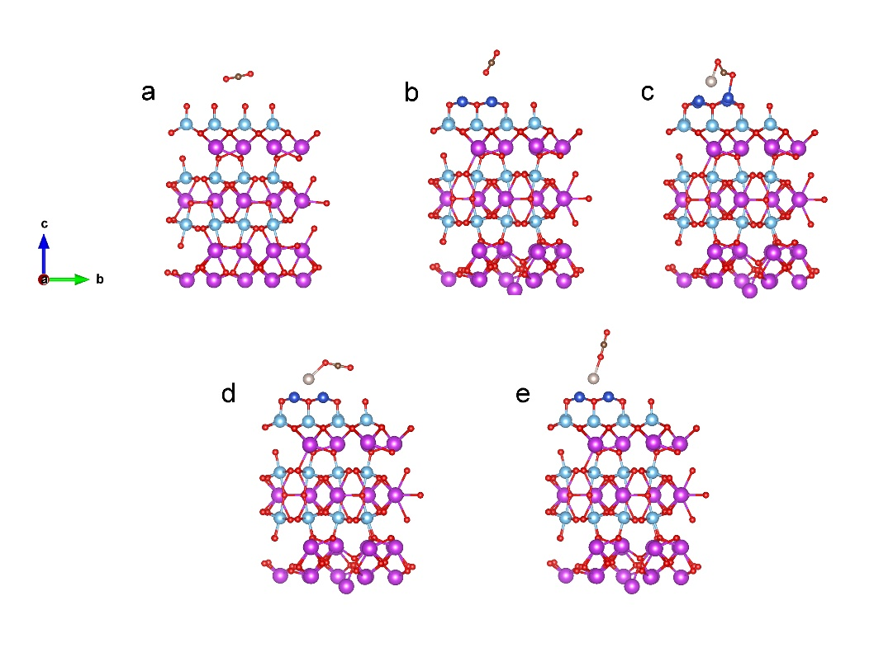
Fig. S20. Calculated structures of CO₂ adsorbed on a BTO, b BTOCu₂ and c site 1, d site 2, e site 3 of BTOCu₂Ru_{0.5}.

Table S1. EXAFS fitting parameters of the Cu K-edge.
Sample | Shell | CNª | R(Å)^{b} | σ²(Å²)^{c} | ΔE₀(eV)^{d} | R factor | S0²
Cu foil | Cu-Cu | 12 | 2.550±0.010 | 0.01022 | 5.86 | 0.0068 | 0.92
Cu₂O | Cu-O | 2 | 1.862±0.023 | 0.00415 | 7.07 | 0.0048 | 0.67
Cu₂O | Cu-Cu | 12 | 3.019± 0.016 | 0.03986 | 7.07 | 0.0048 | 0.67
CuO | Cu-O | 4 | 1.946± 0.006 | 0.00532 | -1.11 | 0.0152 | 0.79
CuO | Cu-Cu | 12 | 2.960±0.027 | 0.02571 | -1.11 | 0.0152 | 0.79
BTOCu₂Ru_{0.5} | Cu-O | 2.2 | 1.946± 0.107 | 0.00429 | 0.41 | 0.007 | 0.80
BTOCu₂Ru_{0.5} | Cu-Cu | 1.2 | 2.688± 0.069 | 0.01749 | 0.41 | 0.007 | 0.80
BTOCu₂Ru_{0.5} | Cu-Ru | 2 | 3.918±0.224 | 0.02043 | 0.41 | 0.007 | 0.80
ªCN, coordination number; ^{b}R, the distance to the neighboring atom; ^{c}σ², the Mean Square Relative Displacement (MSRD); ^{d}ΔE₀, inner potential correction; R factor indicates the goodness of the fit. Fitting range: 3.0 ≤ k (/Å) ≤ 10.0 and 1.0 ≤ R (Å) ≤ 3.0 (Cu foil); 3.0 ≤ k (/Å) ≤ 10.0 and 1.0 ≤ R (Å) ≤ 3.5 (Cu2O); 3.0 ≤ k (/Å) ≤ 10.0 and 1.0 ≤ R (Å) ≤ 3.0 (CuO); 3.0 ≤ k (/Å) ≤ 8.0 and 1.0 ≤ R (Å) ≤ 4.0 (BTOCu₂Ru0.5). A reasonable range of EXAFS fitting parameters: 0.700 < Ѕ₀² < 1.000; CN > 0; σ² > 0 Å²; |ΔE₀| < 15 eV; R factor < 0.02.

Table S2. EXAFS fitting parameters of the Ru K-edge.
Sample | Shell | CNª | R(Å)^{b} | σ²(Å²)^{c} | ΔE₀(eV)^{d} | R factor
Ru-foil | Ru-Ru | 12* | 2.674±0.004 | 0.0030±0.0007 | 3.0±0.9 | 0.0089
RuO₂ | Ru-O | 6.0±0.4 | 1.962±0.001 | 0.0017±0.0007 | 0.2±0.5 | 0.0082
RuO₂ | Ru-Ru | 10.4±0.9 | 3.141±0.001 | 0.0101±0.0001 | -1.2±0.6 | 0.0082
RuO₂ | Ru-Ru | 4.4±0.3 | 3.585±0.001 | 0.0004±0.0001 | 8.0±0.7 | 0.0082
BTOCu₂Ru_{0.5} | Ru-O | 5.2±0.2 | 2.014±0.001 | 0.0045±0.0006 | 0.7±0.3 | 0.0021
BTOCu₂Ru_{0.5} | Ru-Cu | 2.5±0.1 | 2.498±0.001 | 0.0089±0.0008 | 3.7±0.4 | 0.0021
BTOCu₂Ru_{0.5} | Ru-Ru | 3.1±0.3 | 2.713±0.001 | 0.0089±0.0008 | 3.7±0.4 | 0.0021
ªCN, coordination number; ^{b}R, the distance to the neighboring atom; ^{c}σ², the Mean Square Relative Displacement (MSRD); ^{d}ΔE₀, inner potential correction; R factor indicates the goodness of the fit. S0² was fixed to 0.728, according to the experimental EXAFS fit of Au foil by fixing CN as the known crystallographic value. * This value was fixed during EXAFS fitting, based on the known structure of Au. Fitting range: 3.0 ≤ k (/Å) ≤ 12.0 and 1.0 ≤ R (Å) ≤ 3.0 (Ru foil); 3.0 ≤ k (/Å) ≤ 12.0 and 1.0 ≤ R (Å) ≤ 3.8 (RuO2); 3.0 ≤ k (/Å) ≤12.0 and 1.0 ≤ R (Å) ≤ 3.0 (BTOCu₂Ru0.5). A reasonable range of EXAFS fitting parameters: 0.700 < Ѕ₀² < 1.000; CN > 0; σ² > 0 Å²; |ΔE₀| < 15 eV; R factor < 0.02.

Table S3. Comparison of the CO₂ photoreduction activity of BTOCu₂Ru_{0.5} with selected dual sites, Cu site and bismuth-based photocatalysts reported in the literature.
Photocatalysts | Light source |  | Reaction system |  | Production  (µmolg⁻¹h⁻¹) | Ref.
BTOCu₂Ru_{0.5} | A 300 W Xe lamp |  | Without photosensitizer and sacrificial reagent |  | CO: ~180.7 | This work
Cu-ZnTCPP/g-C₃N₄ hybrid | A 300 W Xe lamp (λ: 360-800 nm; 150 mW/cm²) |  | As above |  | CO: 92.0 | 1
C–TiO₂–Cu | A 300 W Xe lamp (λ = 320–780 nm) |  | As above |  | CO: 53.4 | 2
Cu₁N₃@PCN | Visible light |  | As above |  | CO: 49.8 | 3
Cu-substituted ZnIn₂S₄ | A 300 W Xe lamp with an AM 1.5G filter (112 mW/cm²) |  | As above |  | CO: 47.2 | 4
Cu nanoclusters modified TiO₂ with oxygen vacancies | A 300 W Xe lamp |  | As above |  | CO: 40.3 | 5
Cu_{1.95}S@CuS | A 300 W Xe lamp with an AM 1.5G filter |  | As above |  | CO: 28.6 | 6
CoRu-HCNp | A 300 W Xe lamp |  | As above |  | CO: 27.3 | 7
Bi₄O₅I₂–Fe30 | A 300 W Xe lamp |  | As above |  | CO: 23.77; CH₄: 4.98 | 8
TOC/Cu-MOF | A 300 W Xe lamp |  | As above |  | CO: 23.01 | 9
SrBi₄Ti₄O₁₅ | A 300 W Xe lamp |  | As above |  | CO: 19.8 | 10
Bi₂MoO₆ | A 300 W Xe lamp |  | As above |  | CO: 14.38 | 11
Cu/C₃N₄ | A 350 W Xe lamp |  | As above |  | CO: 9.89 | 12
Au/Co loaded CdS NPs |  | A 300 W Xe lamp with 400 nm filter |  | As above | CO: 9.16; CH₄: 1.1 | 13
SrBi₂Nb₂O₉ | A 300 W Xe lamp |  | As above |  | CH₄: 8.75 | 14
Cu-CCN | A 300 W Xe lamp |  | As above |  | CO: 3.086 | 15
Ru@Cu-HHTP | A Xe lamp (λ > 400 nm; 100 mW/cm²) |  | TEOA as the sacrificial reagent |  | CO: 130(5)000 | 16
Isolated square-planar Cu center in boron imidazolate nanocages | Visible light |  | [Ru(bpy)₃]Cl₂ as the photosensitizer; TEOA as the sacrificial reagent |  | CO: 3334 | 17
CoNi-COF-3 | A 300 W Xe lamp with a  420 nm cutoff filter |  | TEOA as the sacrificial agent; [Ru(bpy)₃]Cl₂·6H₂O as the photosensitizer |  | CO: 2567 | 18
Cu-cobalt carbonate hydroxide | A 300 W xenon lamp a 420 nm cutoff filter |  | TEOA as the sacrificial agent; Ru(bpy)₃²⁺(bpy=2,2’-bipyridine) as the photosensitizer |  | CO: 1627.58 | 19
P/Cu SAs@CN | A 300 W Xe lamp |  | TEOA as the sacrificial agent |  | C₂H₆: 616.6 | 20
PCN-224(Cu)/TiO₂ | A 300 W Xe lamp (λ > 300 nm) |  | Poly(3, 4-ethylenedioxythiophene)/poly(styrenesulfonate) (PEDO/TPSS) aqueous solution |  | CO: 37.21 | 21
InCu/PCN | A 300 W Xenon lamp) at 1 W/cm-2 light intensity |  | DMF as the sacrificial agent |  | Ethanol: 28.5 | 22
Cu₂O@Cu@UiO-66-NH₂ | A long-pass filter (λ ≥ 400 nm) |  | TEOA as the sacrificial reagent |  | CO: 20.9 | 23
PCN-RuCu | A 300 W Xe lamp |  | TEOA as the sacrificial agent |  | CO: 0.25; CH₄: 19.25 | 24
Sn-Cu/C₃N₄ | A 300 W Xe lamp with a 420 nm cut-off filter |  | TEA as the sacrificial agent |  | HCHO: 10.80 | 25
Cu purpurin chromophore | Light-emitting diode (λ > 400 nm) |  | DMF as solution; BIH as the sacrificial donor |  | CO: ~0.71 (0.1 mM catalysts) | 26

Supplementary References
- S. Xie, C. Deng, Q. Huang, C. Zhang, C. Chen, J. Zhao, H. Sheng, Facilitated photocatalytic CO₂ reduction in aerobic environment on a copper-porphyrin metal–organic framework. Angew. Chem. Int. Ed. 62, e202216717 (2013).
- Z. Tai, G. Sun, T. Wang, Z. Li, J. Tai, Netted C-doped TiO₂ mesoporous nanostructure decorated by Cu nanoparticles for photocatalytic CO₂ reduction. ACS Appl. Nano Mater. 5, 18070–18079 (2022).
- X. Sun, L. Sun, G. Li, Y. Tuo, C. Ye, J. Yang, J. Low, X. Yu, J. H. Bitter, Y. Lei, D. Wang, Y. Li, Phosphorus tailors the d-band center of copper atomic sites for efficient CO₂ Photoreduction under visible-light irradiation. Angew. Chem. Int. Ed. 62, e202207677 (2022).
- L. Xiao, C. Yuan, P. Chen, Y. Liu, J. Sheng, S. Zhang, F. Dong, Y. Sun, Cu–S bonds as an atomic-level transfer channel to achieve photocatalytic CO₂ reduction to CO on Cu-substituted ZnIn₂S₄. ACS Sustainable Chem. Eng. 10, 11902–11912 (2022).
- X. Bao, M. Zhang, Z. Wang, D. Dai, P. Wang, H. Cheng, Y. Liu, Z. Zheng, Y. Dai, B. Huang, Molten-salt assisted synthesis of Cu clusters modified TiO₂ with oxygen vacancies for efficient photocatalytic reduction of CO₂ to CO. Chem. Eng. J. 445, 136718 (2022).
- X. Shi, L. Wang, W. Dai, X. Dong, Y. Bai, L. Ye, CO₂ photoreduction catalyzed by Cu-deficient Cu_{1.95}S@CuS: enhanced performance via boosted directional interfacial charge transfer. ACS Catal. 13, 5264–5271 (2023).
- L. Cheng, X. Yue, L. Wang, D. Zhang, P. Zhang, J. Fan, Q. Xiang, Dual-single-atom tailoring with bifunctional integration for high-performance CO₂ photoreduction. Adv. Mater. 33, 2105135 (2021).
- X. Jin, Y. Xu, X. Zhou, C. Lv, Q. Huang, G. Chen, H. Xie, T. Ge, J. Cao, J. Zhan, L. Ye, Single-atom Fe triggers superb CO₂ photoreduction on a bismuth-rich catalyst. ACS Mater. Lett. 3, 364-371 (2021).
- Q. Wu, H. Ma, Y. Wang, J. Chen, J. Dai, X. Xu, X. Wu, Surface electron localization in Cu-MOF-bonded double-heterojunction Cu₂O induces highly efficient photocatalytic CO₂ reduction. ACS Appl. Mater. Interfaces 14, 54328–54337 (2022).
- S. Tu, Y. Zhang, A. H. Reshak, S. Auluck, L. Ye, X. Han, T. Ma, H. Huang, Ferroelectric polarization promoted bulk charge separation for highly efficient CO₂ photoreduction of SrBi₄Ti₄O₁₅. Nano Energy 56, 840-850 (2019).
- S. Li, L. Bai, N. Ji, S. Yu, S. Lin, N. Tian, H. Huang, Ferroelectric polarization and thin-layered structure synergistically promoting CO₂ photoreduction of Bi₂MoO₆. J. Mater. Chem. A 8, 9268-9277 (2020).
- G. Shi, L. Yang, Z. Liu, X. Chen, J. Zhou, Y. Yu, Photocatalytic reduction of CO₂ to CO over copper decorated g-C₃N₄ nanosheets with enhanced yield and selectivity. Appl. Surf. Sci. 427, 1165-1173 (2018).
- Y. Zhang, B. Johannessen, P. Zhang, J. Gong, J. Ran, S.-Z. Qiao, Reversed electron transfer in dual single atom catalyst for boosted photoreduction of CO₂. Adv. Mater. 35, 2306923 (2023).
- H. Yu, F. Chen, X. Li, H. Huang, Q. Zhang, S. Su, K. Wang, E. Mao, B. Mei, G. Mul, T. Ma, Y. Zhang, Synergy of ferroelectric polarization and oxygen vacancy to promote CO₂ photoreduction. Nat. Commun. 12, 4594 (2021).
- Y. Li, B. Li, D. Zhang, L. Cheng, Q. Xiang, Crystalline carbon nitride supported copper single atoms for photocatalytic CO₂ reduction with nearly 100% CO selectivity. ACS Nano 14, 10552–10561 (2020).
- N.-Y. Huang, H. He, S. Liu, H.-L. Zhu, Y.-J. Li, J. Xu, J.-R. Huang, X. Wang, P.-Q. Liao, X.-M. Chen, Electrostatic attraction-driven assembly of a metal–organic framework with a photosensitizer boosts photocatalytic CO₂ reduction to CO. J. Am. Chem. Soc. 143, 17424–17430 (2021).
- H.-X. Zhang, Q.-L. Hong, J. Li, F. Wang, X. Huang, S. Chen, W. Tu, D. Yu, R. Xu, T. Zhou, J. Zhang, Isolated square-planar copper center in boron imidazolate nanocages for photocatalytic reduction of CO₂ to CO. Angew. Chem. Int. Ed. 58, 11752 (2019).
- J. Wang, W. Zhu, F. Meng, G. Bai, Q. Zhang, X. Lan, Integrating dual-metal sites into covalent organic frameworks for enhanced photocatalytic CO₂ reduction. ACS Catal. 13, 4316−4329 (2023).
- H. Liu, Y. Chen, H. Li, G. Wan, Y. Feng, W. Wang, C. Xiao, G. Zhang, Y. Xie, Construction of asymmetrical dual Jahn–Teller sites for photocatalytic CO₂ reduction. Angew. Chem. Int. Ed. 62, e202304562 (2023).
- G. Wang, Z. Chen, T. Wang, D. Wang, J. Mao, P and Cu dual sites on graphitic carbon nitride for photocatalytic CO₂ reduction to hydrocarbon fuels with high C₂H₆ evolution. Angew. Chem. Int. Ed. 61, e202210789 (2022).
- L. Wang, P. Jin, J. Huang, H. She, Q. Wang, Integration of Copper(II)-porphyrin zirconium metal–organic framework and titanium dioxide to construct Z-scheme system for highly improved photocatalytic CO₂ reduction. ACS Sustainable Chem. Eng. 7, 15660–15670 (2019).
- H. Shi, H. Wang, Y. Zhou, J. Li, P. Zhai, X. Li, G. G. Gurzadyan, J. Hou, H. Yang, X. Guo, Atomically dispersed indium-copper dual-metal active sites promoting C-C coupling for CO₂ photoreduction to ethanol. Angew. Chem. Int. Ed. 61, e202208904 (2022).
- S.-Q. Wang, X.-Y. Zhang, X.-Y. Dao, X.-M. Cheng, W.-Y. Sun, Cu₂O@Cu@UiO-66-NH₂ ternary nanocubes for photocatalytic CO₂ reduction. ACS Appl. Nano Mater. 3, 10437–10445 (2020).
- L. Zeng, J.-W. Chen, L. Zhong, W. Zhen, Y. Y. Tay, S. Li, Y.-G. Wang, L. Huang, C. Xue, Synergistic effect of Ru-N₄ sites and Cu-N₃ sites in carbon nitride for highly selective photocatalytic reduction of CO₂ to methane. Appl. Catal., B 307, 121154 (2022).
- B. Kim, D. Kwon, J.-O. Baeg, M. Austeria P, G. H. Gu, J.-H. Lee, J. Jeong, W. Kim, W. Choi, Dual-atom-site Sn-Cu/C₃N₄ photocatalyst selectively produces formaldehyde from CO₂ reduction. Adv. Funct. Mater. 33, 2212453 (2023).
- H. Yuan, B. Cheng, J. Lei, L. Jiang, Z. Han, Promoting photocatalytic CO₂ reduction with a molecular copper purpurin chromophore. Nat. Commun. 12, 1835 (2021).

