PinMyMetal: A hybrid learning system to accurately model metal binding sites in macromolecules

Supplementary information
Supplementary Table 1. A benchmark dataset of CMM-validated non-redundant zinc binding sites for training PMM.
No. of ligands | CC | HH | CH | All sites | No. of structure | cutoff criteria of CMM
2 | 163 | 3644 | 541 | 4348 | 3936 | Qc>0.355, Qv>0.25, Qe>0.5
3 | 665 | 2748 | 1015 | 4428 | 4041 | Qc>0.5, Qv>0.5, Qe>0.5
4 | 6536 | 27 | 5640 | 12203 | 7376 | Qc>0.5, Qv>0.5, Qe>0.5

Supplementary Table 2. For the benchmark dataset, the statistics of the candidate zinc sites and verified zinc sites predicted by PMM.
No. of ligands | Candidate zinc sites |  |  |  |  | Verified zinc sites
No. of ligands | CC | HH | CH | All sites | Recall¹ | CC | HH | CH | All sites | Recall²
2 | 147  (94)* | 3046  (2933) | 434  (430) | 3627  (3457) | 83.4 %  (79.5%) | 134 | 2885 | 417 | 3436 | 94.7%
3 | 636  (430) | 2350  (2336) | 841  (763) | 3827  (3529) | 86.4 %  (79.7%) | 591 | 2344 | 826 | 3761 | 98.3%
4 | 5842  (5300) | 22  (20) | 5307  (5146) | 11171  (10466) | 91.5 %  (85.8%) | 5742 | 22 | 5268 | 11032 | 98.8%
*The values in parentheses are obtained when the predicted ligand is exactly the same as the actual ligand, which is the statistical result when IouR=1; "Recall¹" indicates the recall for PMM predicting candidate zinc sites on the CMM-validated dataset, and "Recall²" represents the recall for PMM predicting verified zinc sites on the dataset with previously identified candidate sites.

Supplementary Table 3. Zinc binding sites of unknown function predicted by PMM.
No. of ligands | Predicted sites |  |  |  | Other metal sites |  |  |  | Cryo-EM sites
No. of ligands | CC | HH | CH | All | CC | HH | CH | All | CC | HH | CH | All
2 | 1125 | 554 | 374 | 2035 | 176 | 252 | 17 | 445 | 282 | 39 | 104 | 425
3 | 186 | 463 | 364 | 1013 | 4 | 159 | 141 | 304 | 59 | 4 | 35 | 98
4 | 245 | 64 | 177 | 486 | 4 | 38 | 0 | 42 | 22 | 0 | 28 | 50
Predicted sites: All zinc sites predicted by PMM, including other metal sites and EM sites; Other metal sites: predicted zinc sites that contain another experimentally determined transition metal other than zinc; Cryo-EM sites: Predicted zinc sites are from structures determined by cryo-electron microscopy.
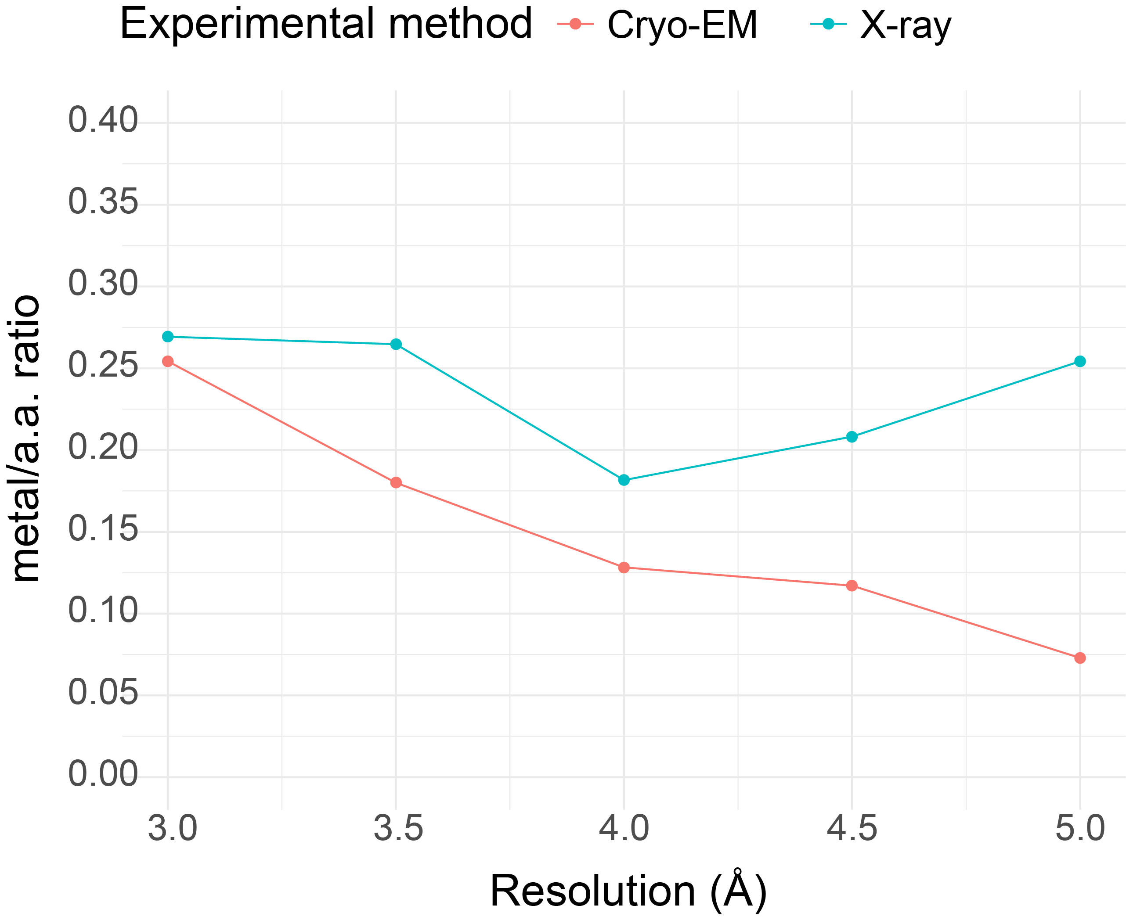
Supplementary Figure 1. Average number of transition metal ions per 100 amino acids in X-ray and Cryo-EM structures of different resolutions.

Supplementary Table 4. Statistics of prediction results of PMM, ZincBindDB, GRE4Zn, TEMSP, and CHED on the same dataset.
Method | No. of TP |  | No. of FN | No. of FP | Precision | Recall | Average Zinc-deviation (Å)
PMM | 129 | 7 |  | 3 | 0.977 | 0.949 | 0.248
GRE4Zn | 101 | 35 |  | 5 | 0.953 | 0.743 | 0.267
TEMSP | 117 | 19 |  | 5 | 0.959 | 0.860 | 0.380
ZincBindDB | 115 | 21 |  | 273 | 0.296 | 0.846 | -
CHED | 112 | 24 |  | 11 | 0.911 | 0.824 | -
TP (true positive): IoUR≥0.5; FP (false positive): IoUR<0.5; FN (false negative): Sites that were not labeled as zinc binding based on the original PDB data.
Supplementary Table 5. Comparison of PMM and Metal3D predictor.
Test set data in the Metal3D article (59 PDB entries）
Method | Exp_site | Deviation (Å) | TP | FP | FN | Precision | Recall
Metal3D | 189 | 0.52 | 78 | 47 | 111 | 0.624 | 0.412
PMM | 205 | 0.166 | 117 | 2 | 88 | 0.983 | 0.571
Prediction results of PMM on the identification of other transition metals dataset in Metal3D
Metal | Exp_site | Deviation (Å) | TP | FP | FN | Precision | Recall
Mn | 38 | 0.818 | 16 | 3 | 22 | 0.889 | 0.421
Fe2 | 33 | 0.468 | 27 | 3 | 6 | 0.900 | 0.818
Fe3 | 33 | 0.746 | 23 | 4 | 10 | 0.852 | 0.697
Co | 31 | 0.826 | 15 | 2 | 16 | 0.882 | 0.484
Ni | 30 | 0.355 | 26 | 4 | 4 | 0.867 | 0.867
Cu | 66 | 0.616 | 64 | 6 | 2 | 0.914 | 0.970
Zn | 61 | 0.257 | 50 | 4 | 11 | 0.926 | 0.820
Prediction results of PMM on CMM-validated dataset with Resolution < 2 Å
Metal | Exp_site | Deviation (Å) | TP | FP | FN | Precision | Recall
Mn | 2270 | 0.717 | 488 | 26 | 1782 | 0.949 | 0.215
Fe2 | 419 | 0.340 | 283 | 2 | 136 | 0.993 | 0.675
Fe3 | 874 | 0.457 | 475 | 12 | 399 | 0.975 | 0.543
Co | 633 | 0.512 | 234 | 21 | 399 | 0.918 | 0.370
Ni | 854 | 1.245 | 431 | 25 | 423 | 0.945 | 0.505
Cu | 1462 | 0.510 | 1241 | 22 | 221 | 0.983 | 0.849
Zn | 10148 | 0.333 | 8228 | 443 | 1920 | 0.949 | 0.811
Exp_site: Experimental metal site; Deviation (Å): Average deviation between predicted positions and experimental locations.
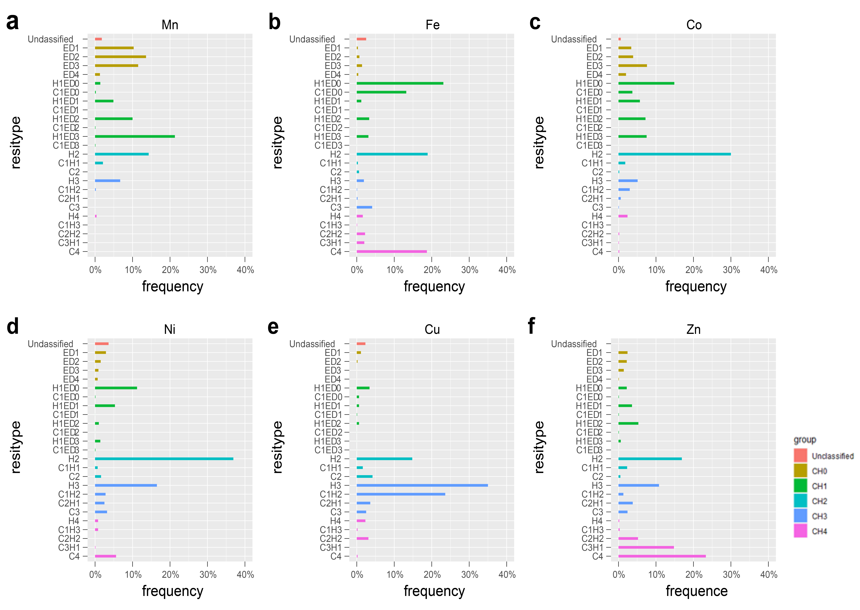
Supplementary Figure 2. Distribution of transition metal coordination motifs. CH0, CH1, CH2, CH3, and CH4 represent combinations of metal coordination sites where ligands contain 0, 1, 2, 3, 4 C and/or H ligands; "Unclassified" denotes other uncategorized ligand combinations.

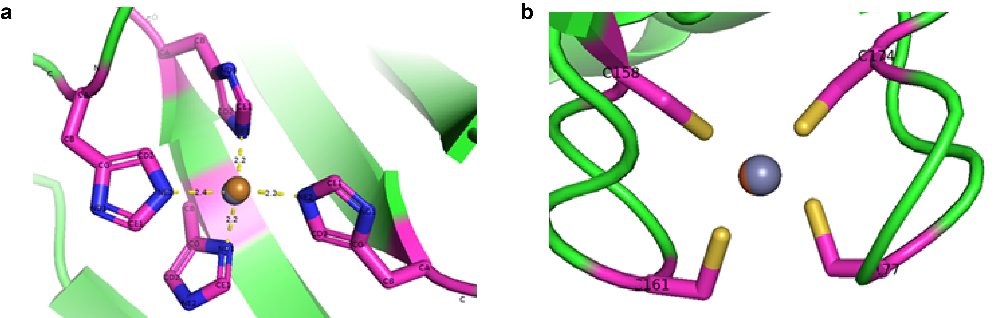
Supplementary Figure 3. Incorrectly assigned zinc ions. a, 3mnd, Cu assigned as Zn. b, 1jyb, Fe assigned as Zn.
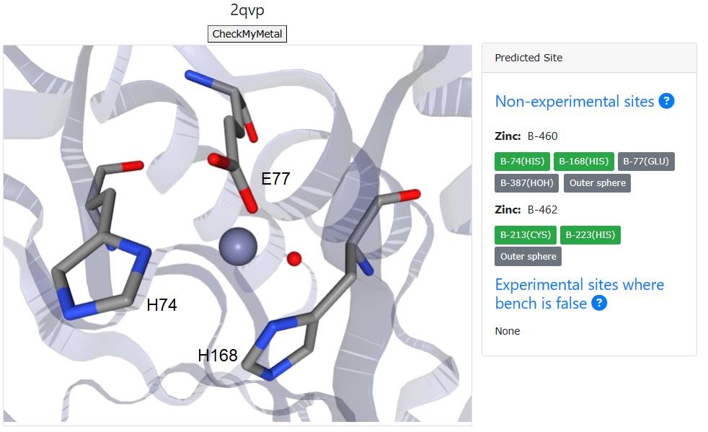
Supplementary Figure 4. PMM recognizes ligands other than CH at zinc binding sites. A screenshot of the predicted results for the B chain of 2qvp on the PMM web server. Non-experimental sites: Zinc binding sites with unknown functions predicted by PMM. Ligand coloring at zinc binding sites: Green represents C or H ligands, while gray represents ligands other than C and H.

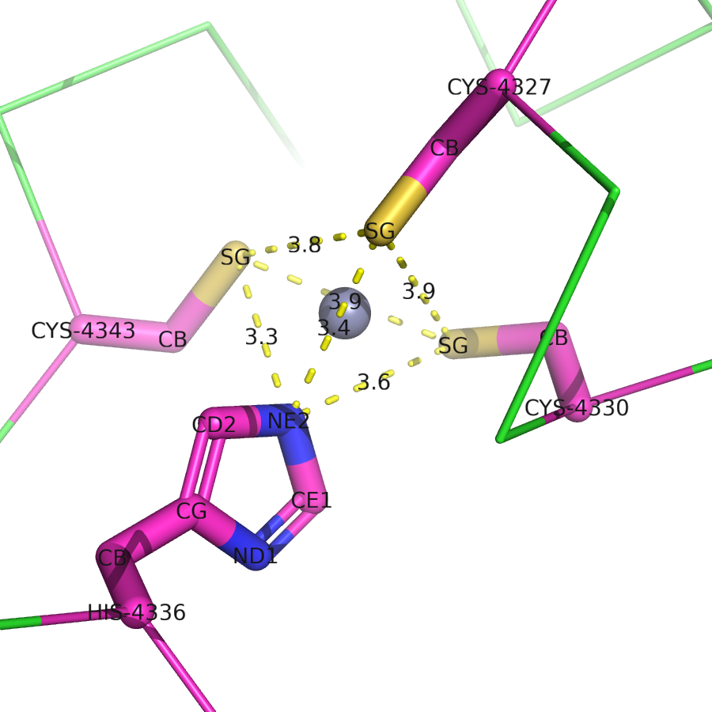
Supplementary Figure 5. Geometric characteristics of zinc binding sites. Using a zinc binding site from the structure of 6w4h as an example illustrates the structural features of the zinc binding site.
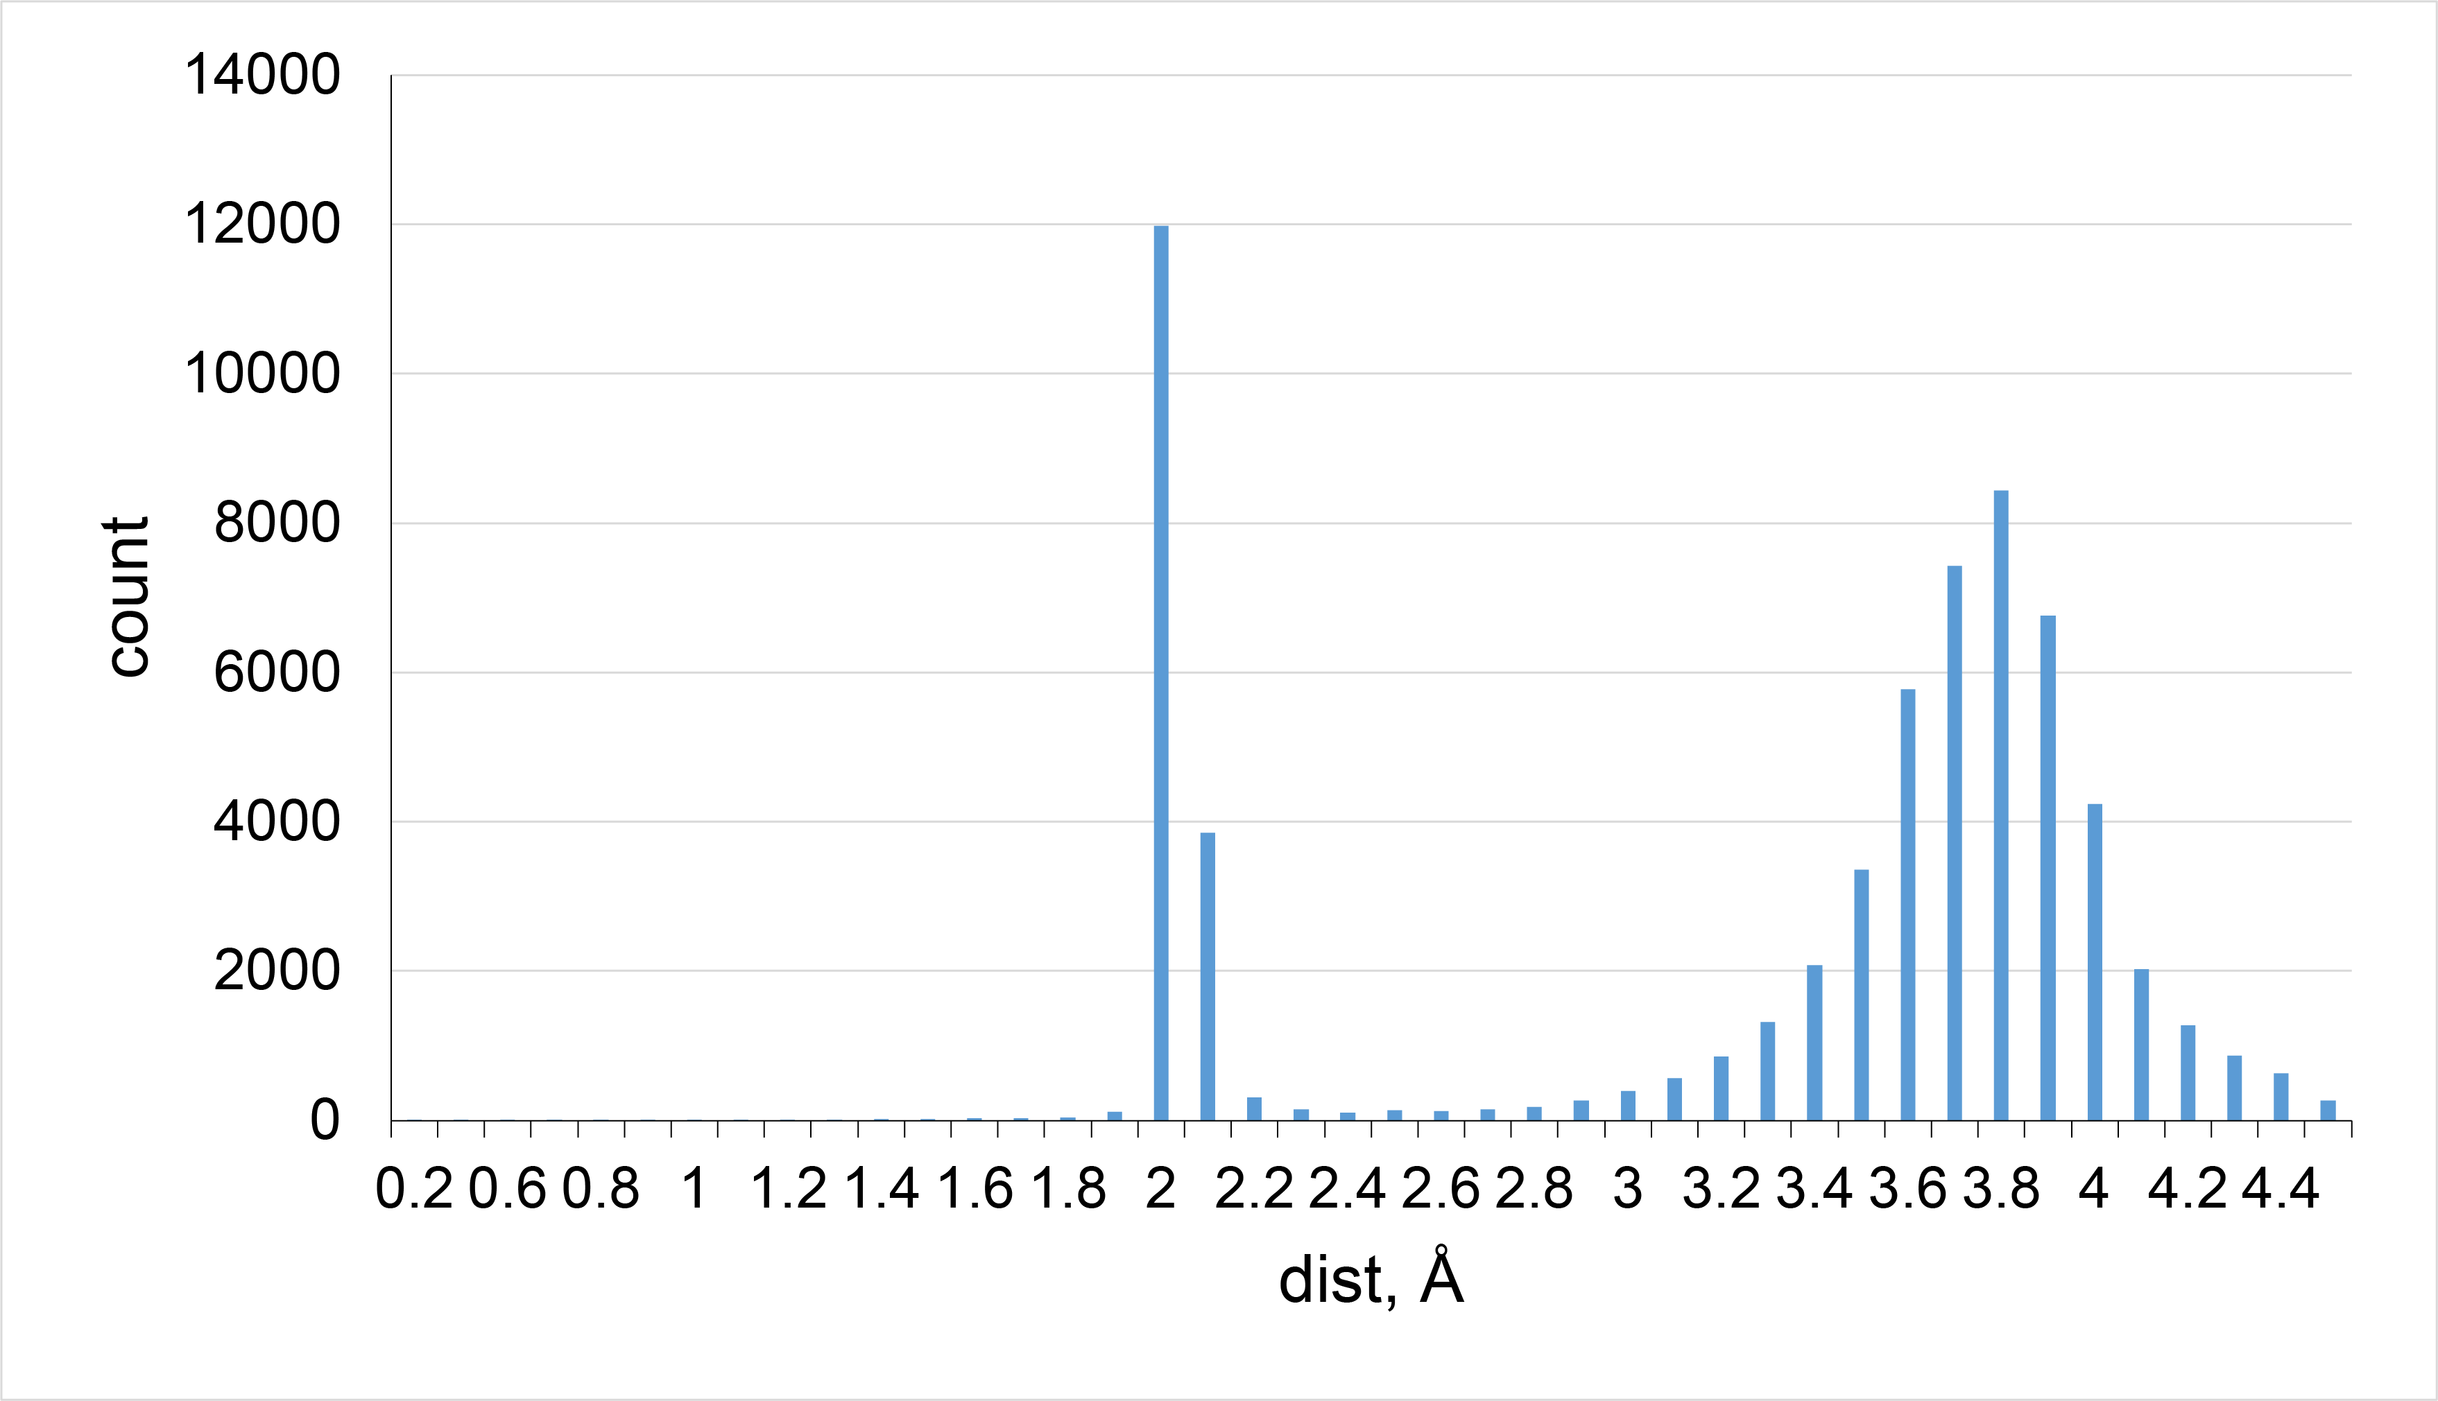
Supplementary Figure 6. Distance distribution between SG atoms in protein structure.
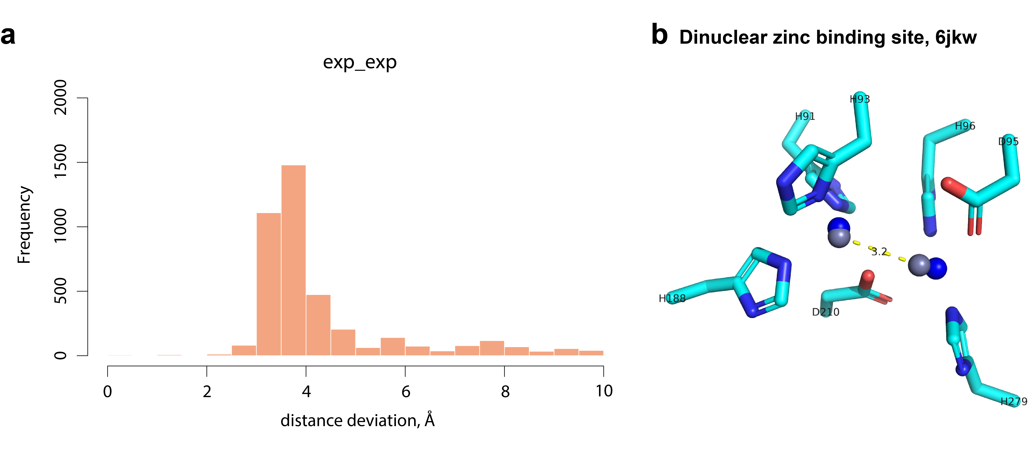Supplementary Figure 7. Distance distribution between experimental zinc binding sites. a, experimentally determined zinc ion distance distribution. b, PMM predicts the dinuclear zinc binding sites. The blue spheres represent predicted zinc sites, while the gray spheres depict zinc sites already present in the structure.
Supplementary Table 6. Most common coordination spheres in enzymes by class. The count represents approximately 80% of found spheres for each enzyme class. Note that these show only the protein ligands and may contain various external ligands, especially at low coordination numbers.
Function | Common coordination spheres (share-%)ª
Structural | C4(28.17%), C3H1(18.50%), C2H2(8.54%), H3E/D1(1.66%),
Oxidoreductase 1 | C4(20.31%), H3D1(19.19%), C3H1(11.41%), C2H1(8.88%), H2E/D1(6.76%), C1H2(3.94%), H3(3.84%), H1E/D2(4.46%), H1(2.53%), C2H1E/D1(2.40%), C1H1E/D1(3.05%), H2(1.63%), H1D1(1.31%), C2H2(1.19%), E2(1.12%)
Transferase2 | C4(43.77%), C3H1(32.22%), C2H2(4.96%), C3(4.06%), H1E/D2(1.92%), C1H1E/D1(1.85%), C2H1(1.40%), C2H1E/D1(1.15%)
Hydrolase3 | H2D1(10.60%), H2E1(10.58%),H1E/D2(10.28%), H2D2(9.93%), C4(8.76%), H3(8.12%), C3H1(5.82%), H3E/D1(5.22%), C2H2(3.56%), H2(3.01%), C2H1(2.85%), H1(2.59%), C1H1E/D1(2.49%), E1D2(2.09%), C3(1.68%), H1E/D1(3.07%), C1H2(1.35%), E/D1(2.63%), E1D1(1.34%)
Lyase4 | H3(67.49%), H2D1(5.07%), C2H1D1(4.47%), C2H1(3.79%), H3E/D1(3.53%), H2(2.88%), C4(1.69%), C3(1.55%), H2E/D1(1.51%)
Isomerase5 | H2E/D2(20.76%), H1E/D3(17.49%), D3(11.48%), C3H1(7.65%), H1E/D2(6.56%), H2E/D1(7.10%), H3E/D1(6.01%), H1(4.92%), H1E/D1(4.37%), C4(3.83%), H3(2.19%), E2D2(1.64%), E1D1(1.64%)
Ligase6 | C3H1(38.88%), C4(37.56%), C2H2(4.92%), H2E/D1(3.81%), C1H2(3.74%), C2E/D1(1.52%), C1H2E/D1(1.46%), C3(1.32%), H2(1.32%), H1E/D1(0.76%)
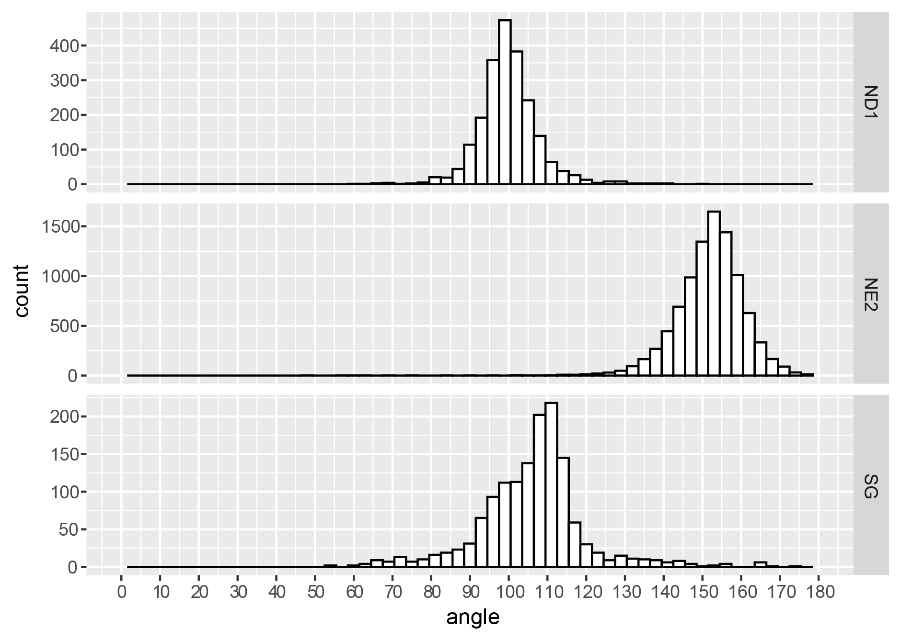
Supplementary Figure 8. Distribution of Zn_atom_Cβ angle. The distribution of angles between the zinc ion and atoms (ND1, NE2, or SG) as well as the Cβ atom of amino acids in the zinc binding site.
Supplementary Figure 9. Hydrophobicity contrast functions (a, c) and mean Δσ values (b, d) around zinc binding sites in proteins (within radius R=7Å). exp: experimentally identified zinc binding sites; pre_TP: ensemble model predicted positive zinc binding sites ; pre_FP: ensemble model predicted negative zinc binding sites. a, CH2, hydrophobicity contrast functions. b, CH2, mean Δσ values. c, CH3/4，hydrophobicity contrast functions. d, CH3/4, mean Δσ values.
Supplementary Table 7. Feature parameters for hybrid learning networks.
Parameter | Annotation | Number
AA_type | - The type of amino acid coordinated with zinc (CYS, HIS). | 1
Atom_type | - An atom in a ligand amino acid that interacts with zinc  (SG, NE2, ND1, CD2, CE1). | 2
Atom_dist | - The Euclidean distance between the atom of the ligand amino acid interacting with zinc. | 3
Cα_dist | - The distance between the Cα of the ligand amino acids. | 4
Cβ_dist | The distance between the Cβ of the ligand amino acids. | 5
Angle1 | The angle formed by the Cα atom of residue A, the atom of residue A that interacts with zinc, the Cα atom of residue B, and the atom of residue B that interacts with zinc. | 6
Angle2 | The angle formed by the Cβ atom of residue A, the Cα atom of residue A, and the Cα atom of residue B. | 7
Angle3 | The angle formed by the Cβ atom of residue B, the Cα atom of residue B, and the Cα atom of residue A. | 8
Angle4 | The torsional angle formed by the Cβ atom of residue A, the Cα atom of residue A, the Cα atom of residue B, and the Cβ atom of residue B. | 9
C_value | 21 hydrophobicity contrast function values are obtained from distances around a zinc ion (ranging from 2 Å to 7 Å with 21 radii intervals). | 10
Δσ_value | 21 mean atomic solvation parameter values are obtained from distances around a zinc ion (ranging from 2 Å to 7 Å with 21 radii intervals). | 11

Supplementary Table 8. Distribution of data sets for training and testing hybrid learning networks.
Data type | Site type | CC | HH | CH | all
Train data | 1 | 87 | 2453 | 413 | 2905
Train data | 0 | 76 | 1083 | 365 | 1572
Test data | 1 | 47 | 1042 | 157 | 1246
Test data | 0 | 32 | 460 | 182 | 674
1: Experimentally determined positive site; 0：Predicted negative site

