Table 1 | Screening of reaction conditions.ª
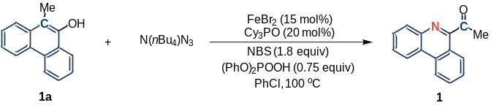
Entry | Variation from ‘standard conditions’ | Yield^{b} (%]
1 | None | 80
2 | w/o FeBr₂ | trace
3 | FeCl₂ instead of FeBr₂ | 71
4 | Fe(OTf)₂ instead of FeBr₂ | 75
5 | Fe(OAc)₂ instead of FeBr₂ | 32
6 | Fe(acac)₃ instead of FeBr₂ | 10
7 | Cu(OTf)₂ instead of FeBr₂ | <10
8 | [[CH₃(CH₂)₆CO₂]₂Rh]₂ instead of FeBr₂ | 34
9 | TMOPP-Co instead of FeBr₂ | trace
10 | Ru₃(CO)₁₃ instead of FeBr₂ | <10
11 | w/o Cy₃PO | 70
12 | In toluene | 75
13 | In THF | 70
14 | 10 mol% FeBr₂ and 15 mol% Cy₃PO instead | 61
ªUnless otherwise specified, all reactions were carried out using 1a (0.1 mmol), NBS (0.18 mmol), N(nBu₄)N₃ (0.3 mmol), (PhO)₂POOH (0.075 mmol), FeBr₂ (0.015 mmol), and Cy₃PO (0.02 mmol) in PhCl (1.0 mL) at 100 °C for 36 h. ^{b}Isolated yields after chromatography.

Table 2 | Substrate Scope of the Carbon–Nitrogen Transmutation in Polycyclic Arenol.^{a,b}
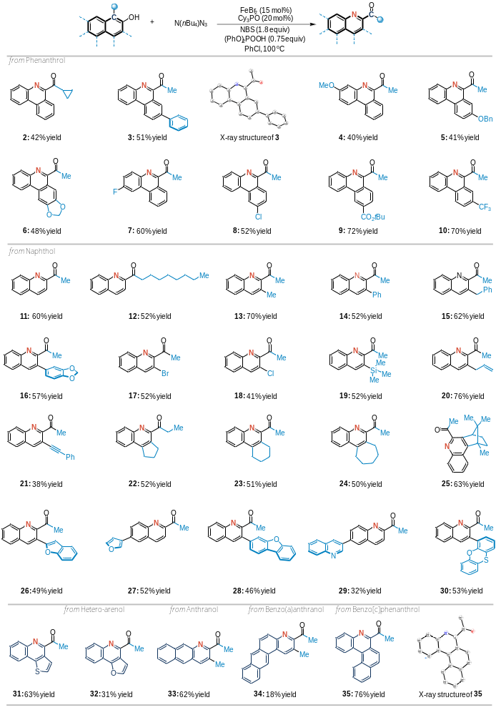
ªIsolated yields after chromatography are shown. ^{b}Reaction conditions: substrate (0.1 mmol), NBS (0.18 mmol), N(nBu₄)N₃ (0.3 mmol), (PhO)₂POOH (0.075 mmol), FeBr₂ (0.015 mmol), and Cy₃PO (0.02 mmol) in PhCl (1.0 mL) at 100 °C for 36 h.

