Additional files

Table S1 Rice cultivars and breeding materials assessed in this study
No. | Cultivar or breeding materials | Origin | Subspecies
1 | Guemi4 | China | indica
2 | Longke638S | China | indica
3 | Fengliangyou 4 | China | indica
4 | C liangyou 343 | China | indica
5 | R1686 | China | indica
6 | R5438 | China | indica
7 | R7810 | China | indica
8 | R1273 | China | indica
9 | R1308 | China | indica
10 | R8612 | China | indica
11 | R1234 | China | indica
12 | R1206 | China | indica
13 | R1212 | China | indica
14 | R1377 | China | indica
15 | R1988 | China | indica
16 | R534 | China | indica
17 | Huazhan | China | indica
18 | Nipponbare | Japan | japonica
19 | 9311 | China | indica
20 | Mianhui3728 | China | indica
21 | R1141 | China | indica
22 | R6444 | China | indica
23 | Zhendao819 | China | japonica
24 | Huahui272 | China | indica
25 | Yandao531 | China | japonica
26 | Zhegeng75 | China | japonica
27 | Longdao9 | China | japonica
28 | Hugeng5 | China | japonica
29 | Nongken31 | China | japonica
30 | Huarun2 | China | indica
31 | Liaoyan287 | China | japonica
32 | Fukuniski | Japan | japonica
33 | Jiangsugeng2 | China | japonica
34 | IR29 | Philippine | indica
35 | R1212 | China | indica
36 | R608 | China | indica
37 | Longdao5 | China | japonica
38 | Yuegeng0618 | China | japonica
39 | Huigeng602 | China | japonica
40 | Hugeng6 | China | japonica
41 | IR64 | Philippine | indica
42 | Teqing | China | indica
43 | IRTA129 |  | japonica

Table S2 Primers used in this study
Marker | Forward primer (5'-3') | Reverse primer (5'-3')
PIGM-1F/R | TGCTGAACAAGGTGTAGAGGTA | CATGGAACTCGTTTTCGTC
PIGM-2F/R | GTGACATCCAGTCCTACACAATCATAA | CCAGGTCCTACTTCCACAAAA
HD-1F/R | AACAAAGATACTTTTCTACTTC | GTGCCTCTGCATACGCCTTTCT
HD-2F/R | ACAATACGTTATGAAACAAGGC | ATACAGTTATACACATACTCAT

Table S3 Yield and quality trait performance of the hybrids of LZ36S in state and provincial regional test of new varieties
Hybrid variety | National or Provincial Approval Variety No. | Approved promotion area | DTM(d) | PH(cm) | NGP | SF(%) | TGW (g) | HRR (%) | CR (%) | LWR | AC (%) | GC (mm) | ASV
ZhenlaingyouTaisi | 20216014 | MRMLY | 135.8 | 128.6 | 190.2 | 83.7 | 25.8 | 67.3 | 2.0 | 3.2 | 15.2 | 65 | 7.0
ZhenlaingyouTaisi | 20231036 | MRWL | 152.5 | 119.9 | 163.5 | 81.7 | 26.3 | 58.9 | 4.3 | 3.3 | 16.5 | 68.0 | 5.2
ZhenlaingyouYuzhan | 20216142 | MRMLY | 136.2 | 129.3 | 197.4 | 83.1 | 25.6 | 60.2 | 1.6 | 3.8 | 15.0 | 71 | 6.0
ZhenlaingyouYuzhan | 20226038 | MRUY | 154.2 | 124.2 | 187.5 | 84.2 | 26.3 | 68.7 | 2.0 | 3.4 | 15.7 | 56 | 5.0
ZhenlaingyouYuzhan | 20226038 | LRSC | 118.5 | 116.5 | 156.0 | 75.3 | 25.4 | 66.7 | 2.5 | 3.6 | 17.1 | 60 | 6.2
ZhenlaingyouYuzhan | 20216005 | MRHN | 138.8 | 129.9 | 184.3 | 85.4 | 26.5 | 58.9 | 2.5 | 3.7 | 16.0 | 75 | 6.0
ZhenlaingyouYuzhan | 20231037 | MRWL | 152.8 | 119.9 | 171.0 | 81.3 | 26.0 | 58.5 | 2.9 | 3.4 | 15.4 | 66 | 5.0
ZhenlaingyouNongzhan | 20216004 | MRHN | 140.0 | 119.3 | 187.5 | 84.4 | 26.4 | 69.6 | 2.3 | 3.1 | 15.1 | 66 | 3.5
Zhenlaingyou1468 | 20216002 | MRHN | 139.2 | 120.0 | 187.6 | 87.0 | 25.8 | 57.7 | 1.5 | 3.0 | 16.3 | 70 | 5.0
Zhenlaingyou8612 | 20206139 | MRMLY | 133.8 | 127.2 | 211.3 | 82.7 | 26.3 | 70.4 | 1.9 | 2.9 | 15.7 | 69 | 3.3
Zhenlaingyou5438 | 20206138 | MRMLY | 133.1 | 125.0 | 202.3 | 85.8 | 25.7 | 66.9 | 2.3 | 3.3 | 16.0 | 69 | 6.0
Zhenlaingyou5438 | 20220010 | MRWL | 149.8 | 113.6 | 174.4 | 80.8 | 27.4 | 57.7 | 3.7 | 3.0 | 13.5 | 75 | 3.5
Zhenlaingyou3703 | 20206010 | MRHN | 134.6 | 125.0 | 197.3 | 83.9 | 24.1 | 60.1 | 3.4 | 2.9 | 14.5 | 70 | 3.3
Zhenlaingyou5688 | 20216135 | MRMLY | 136.3 | 122.9 | 196.9 | 85.2 | 23.8 | 64.3 | 3.3 | 3.0 | 14.2 | 80 | 5.0
ZhenliangyJinsi | 20226096 | MRMLY | 133.3 | 129.5 | 174.5 | 84.9 | 27.0 | 66.6 | 2.4 | 3.0 | 16.3 | 73.0 | 5.0
Zhenliangy6076 | 20226095 | MRMLY | 134.4 | 129.2 | 190.1 | 83.9 | 26.1 | 64.7 | 2.6 | 3.6 | 16.0 | 68.0 | 5.0
Zhenliangy5281 | 20220019 | MRMLY | 137.2 | 126.3 | 193.7 | 84.4 | 25.8 | 51.3 | 0.9 | 2.9 | 13.4 | 82.0 | 4.2
Zhenliangy1988 | 20220021 | MRHN | 136.4 | 123.7 | 175.7 | 87.4 | 27.3 | 66.6 | 8.6 | 2.9 | 13.1 | 75.0 | 3.3
Zhenliangy4811 | 20220019 | MRHN | 134.4 | 129.1 | 192.3 | 82.6 | 26.3 | 64.6 | 4.2 | 3.5 | 12.6 | 82.0 | 3.3
Zhenliangy2646 | 20226002 | MRHN | 140.3 | 124.8 | 194.9 | 82.5 | 25.1 | 62.1 | 4.9 | 3.2 | 14.6 | 88.0 | 5.5
Zhenliangy2646 | 20232061 | MRMLY | 134.5 | 128.4 | 186.3 | 84.7 | 24.6 | 64.2 | 4.0 | 3.2 | 16.0 | 67.0 | 5.0
Zhenliangy3485 | 20226003 | MRHN | 139.0 | 121.5 | 184.6 | 86.5 | 26.0 | 66.8 | 2.0 | 3.1 | 15.9 | 68.0 | 6.0
ZhenlaingyouHuabao | 20220022 | MRHN | 135.7 | 122.3 | 187.0 | 85.2 | 25.8 | 64.0 | 6.2 | 3.0 | 12.6 | 82.0 | 4.0
Zhenlaingyou7095 | 20231026 | MRMLY | 139.0 | 129.2 | 176.4 | 81.8 | 25.0 | 58.1 | 0.9 | 3.4 | 14.2 | 79.0 | 5.3
Mean |  |  | 138.33 | 124.39 | 185.95 | 83.68 | 25.85 | 63.12 | 3.04 | 3.23 | 15.04 | 71.83 | 4.86
MRMLY, middle-season rice in the middle and lower reaches of the Yangtze River; MRUY, middle-season rice in the uper reache of the Yangtze River; LRSC, late-season rice in South China; MRWL, Middle-season rice in Wuling mountainous area; MRHN, middle-season rice in Hunan province; DTM, days to maturing; PH, plant height; NGP, number of grains per panicle; SF, spikelet fertility; TGW, thousand-grains weight; HRR, head rice rate; CR, chalkiness rate; AC, Amylose content; GC, gel consistency; ASV, alkali spreading value; LWR, length-width ratio
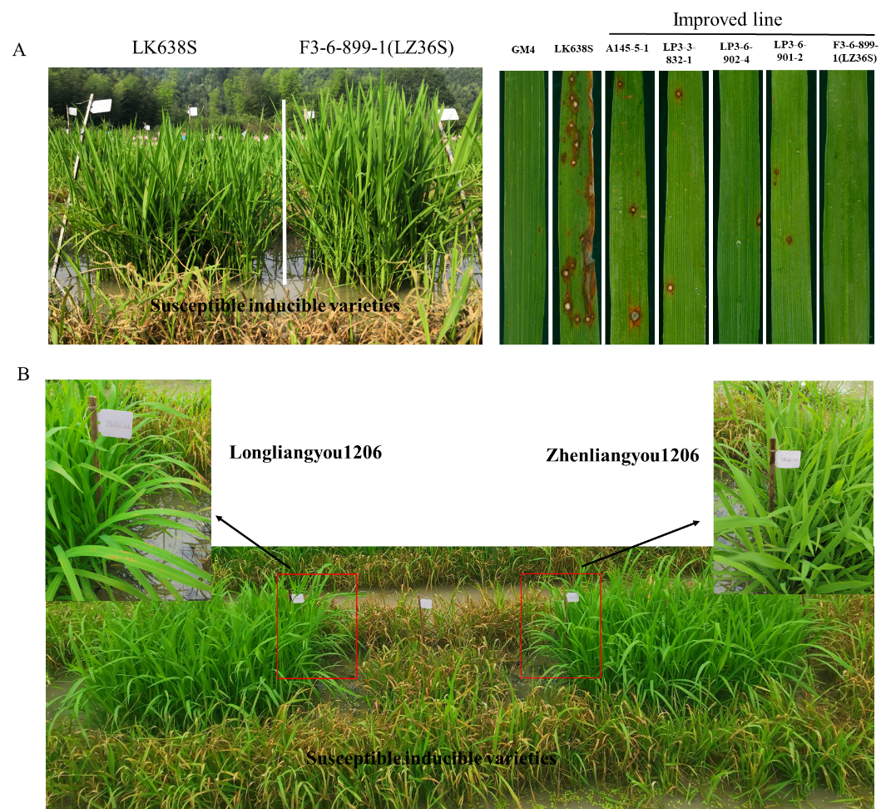
Figure S1. Blast resistance reaction of selected improved lines and parents (A), Longliangy1206 and Zhenliangy1206 (B) in open-field blast nursery.

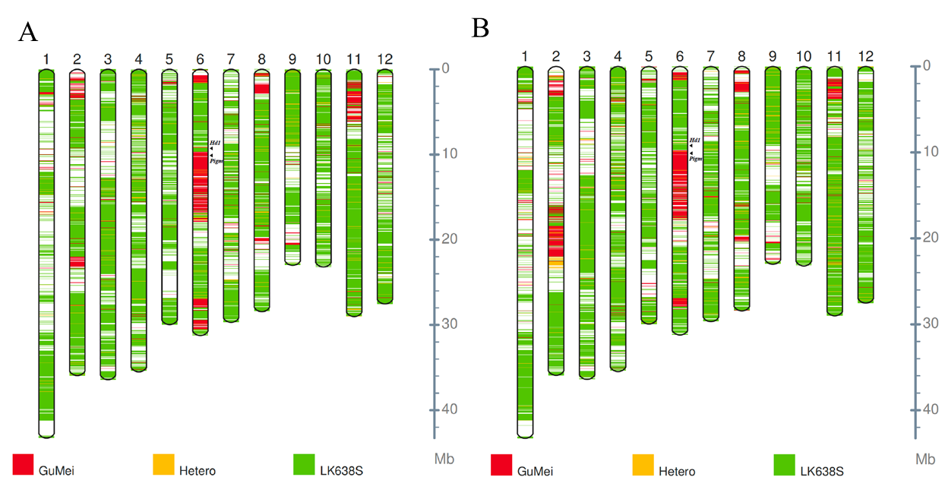
Figure S2. Graphical genotype map of LP36899-1(A) and LP36902-4 (B). Total 3,272,591 polymorphic SNPs between bi-parents were used for the construction of the genotype maps.

