Supplementary Fig 1. The effect of quercetin with four different concentrations on NK, T and B cells. A, Representative flow cytometry profiles showing CD3⁻NK1.1⁺ NK cells; Bar graphs for statistical results of splenic NK cells. B, Representative flow cytometry profiles showing CD3⁺ T cells; Bar graphs for statistical results of splenic CD3⁺ T cells. C, Representative flow cytometry profiles showing CD45R⁺ B cells; Bar graphs for statistical results of splenic CD45R⁺ B cells. Data represent mean ± SEM. *P < 0.05. ns, not significant, vs. Ctrl.

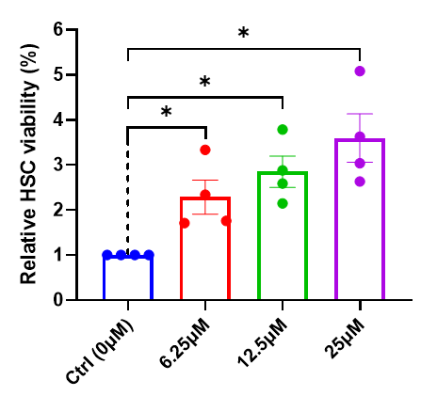
Supplementary Fig 2. The effect of quercetin with three different concentrations on HSCs. Data represent mean ± SEM. *P < 0.05.
Supplementary Fig 3. Identification of 189 differentially-expressed peptides between the control and quercetin-treated groups. Myh9 peptides appears with high frequency, marked with a red box.

