Supplementary data
Denitrificimonas halotolerans sp. nov., a novel species, isolated from landfill leachate.
ªKey Laboratory of Breeding Biotechnology and Sustainable Aquaculture (CAS), Institute of Hydrobiology, Chinese Academy of Sciences, Wuhan 430072, China
^{b} Jingchu university of technology, Jingmen 448000, China
^{c} China University of Geosciences (CUG), Wuhan 430074, China
^{d}University of Chinese Academy of Sciences, Beijing 100049, China
Corresponding author*:Dongru Qiu, email: qiu@ihb.ac.cn

Table
In all tables below, 1,2,3,4,5,6,7 represent the following strains respectively: 1=strain JX-1^{T}; 2=
Denitricimonas caeni HY-14^{T}; 3=Oblitimonas alkaliphila B4199^{T}; 4=Thiopseudomonas denitrificans X2^{T}; 5= Pseudomonas alcaliphila AL15-21^{T}; 6= Pseudomonas toyotomiensis HT-3^{T}; 7= Pseudomonas chengduensis MBR^{T}; +, postive; -, negative; W, weak.

TableS1 API20NE test results of the strain JX-1^{T} and its closest related species.
name | abbreviation | 1 | 2 | 3 | 4 | 5 | 6 | 7
Reduction of nitrate to nitrite | NO3 | - | - | - | - | + | - | +
Denitrification | NO2 | - | +/- | - | + | - | - | -
Indole production | TRP | - | - | +/- | - | - | - | -
- Glucose fermentation | GLU | - | - | - | - | + | + | -
Arginine DiHydrolase | ADH | - | - | - | - | - | - | -
UREase | URE | - | - | - | - | - | - | -
β-glucosidase(Aesculin hydrolysis) | ESC | + | - | - | - | - | - | -
Gelatinase | GEL | - | - | - | - | - | - | -
β-galactosidase | PNPG | - | - | - | - | + | + | +
D-glucose | GLU | W | - | -/+ | + | - | -/+ | -
L-arabinose | ARA | W | - | - | - | - | - | -
D-mannose | MNE | W | - | - | - | + | + | +
D-mannitol | MAN | W | - | -/+ | + | - | - | -
N-acetyl-glucosamine | NAG | W | - | - | - | - | - | -
D-maltose | MAL | W | - | - | - | + | + | +
Potassium gluconate | GNT | W | + | + | + | + | + | +
Capric acid | CAP | - | - | - | + | - | - | -
Adipic acid | ADI | W | + | - | - | + | + | +
Malic acid | MLT | + | - | - | + | + | + | +
Trisodium citrate | CIT | - | - | - | + | - | - | -
Phenylacetic acid | PAC | W | + | + | - | + | + | +

TableS2 API20E test results of the strain JX-1^{T}
Number | name | abbreviation | Reaction
1 | ß-galactosidase | ONPG | -
2 | Arginine dihydrolase | ADH | -
3 | Lysine decarboxylase | LDC | -
4 | Ornithine decarboxylase | ODC | -
5 | Citrate utilization | CIT | -
6 | H2S production | H2S | -
7 | Urease | URE | -
8 | Tryptophane deaminase | TDA | -
9 | Indole production | IND | -
10 | Acetoin production (Voges Proskauer) | VP | -
11 | Gelatinase | GEL | -
12 | glucose | GLU | -
13 | mannitol | MAN | W
14 | inositol | INO | -
15 | sorbitol | SOR | -
16 | rhamnose | RHA | W
17 | saccharose | SAC | -
18 | melibiose | MEL | W
19 | amygdalin | AMY | W
20 | arabinose | ARA | -

TableS3 ZYM test results of the strain JX-1^{T}
Number | name | Reaction
1 | Water | -
2 | Alkaline phosphatase | +
3 | Esterase(C4) | +
4 | Esterase lipase (C8) | +
5 | Lipase (C14) | +
6 | Leucine arylamidase | +
7 | Valine arylamidase | +
8 | Cystine arylamidase | W
9 | Trypsin | -
10 | α-chymotrypsin | -
11 | Acid phosphatase | W
12 | Naphtol-AS-BI-phosphohydrolase | W
13 | α-galactosidase | -
14 | β-galactosidase | -
15 | β-glucuronidase | -
16 | α-glucosidase | -
17 | β-glucosidase | -
18 | N-acetyl-β-glucosaminidase | -
19 | α-mannosidase | -
20 | α-fucosidase | -

TableS4 GEN III MicroPlate test results of the strain JX-1^{T}
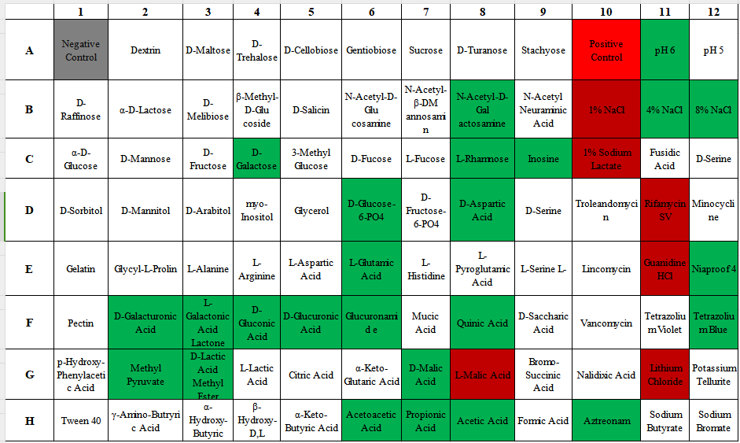

Table S5 Similarity values for the 16S rRNA gene sequences of the strain JX-1^{T} and its closest related species
Species | strain JX-1^{T} | Denitrificimonas  caeni  HY-14^{T} | Oblitimonas alkaliphila B4199^{T} | Thiopseudomonas denitrificans  X2^{T} | Pseudomonas alcaliphila AL15-21^{T} | Pseudomonas  Toyotomiensis HT-3^{T} | Pseudomonas  Chengduensis  MBR^{T}
strain JX-1^{T} | 100.00%
Denitrificimonas  caeni HY-14^{T} | 96.83% | 100.00%
Thiopseudomonas alkaliphila B4199^{T} | 95.63% | 95.64% | 100.00%
Thiopseudomonas denitrificans X2^{T} | 93.36% | 93.45% | 95.63% | 100.00%
Pseudomonas  alcaliphila AL15-21^{T} | 95.34% | 95.68% | 95.05% | 92.92% | 100.00%
Pseudomonas toyotomiensis HT-3^{T} | 95.13% | 95.61% | 94.98% | 92.85% | 99.73% | 100.00%
Pseudomonas chengduensis MBR^{T} | 95.13% | 95.68% | 94.91% | 92.94% | 99.66% | 99.97% | 100.00%

Table S6 The difference for G+C content of the strain JX-1^{T} and its closest related species.
Species | strain JX-1^{T} | Denitrificimonas  caeni  HY-14^{T} | Oblitimonas alkaliphila B4199^{T} | Thiopseudomonas denitrificans  X2^{T} | Pseudomonas alcaliphila AL15-21^{T} | Pseudomonas  Toyotomiensis HT-3^{T} | Pseudomonas  Chengduensis  MBR^{T}
strain JX-1^{T} | 0.00%
Denitrificimonas  caeni HY-14^{T} | 2.14% | 0.00%
Oblitimonas alkaliphila B4199^{T} | 1.24% | -0.90% | 0.00%
Thiopseudomonas denitrificans X2^{T} | 12.86% | 10.72% | 11.62% | 0.00%
Pseudomonas  alcaliphila AL15-21^{T} | 16.77% | 14.63% | 15.53% | 3.91% | 0.00%
Pseudomonas toyotomiensis HT-3^{T} | 16.49% | 14.35% | 15.25% | 3.91% | 0.28% | 0.00%
Pseudomonas chengduensis MBR^{T} | 16.20% | 14.06% | 14.96% | 3.91% | 0.57% | 0.29% | 0.00%

Table S7 The DDH values for genomes of the strain JX-1^{T} and its closest related species.
Species | strain JX-1^{T} | Denitrificimonas  caeni  HY-14^{T} | Oblitimonas alkaliphila B4199^{T} | Thiopseudomonas denitrificans  X2^{T} | Pseudomonas alcaliphila AL15-21^{T} | Pseudomonas  Toyotomiensis HT-3^{T} | Pseudomonas  Chengduensis  MBR^{T}
strain JX-1^{T} | 100.00%
Denitrificimonas  caeni HY-14^{T} | 20.30% | 100.00%
Oblitimonas alkaliphila B4199^{T} | 21.90% | 20.10% | 100.00%
Thiopseudomonas denitrificans X2^{T} | 19.40% | 18.20% | 20.10% | 100.00%
Pseudomonas  alcaliphila AL15-21^{T} | 18.50% | 17.70% | 22.10% | 19.60% | 100.00%
Pseudomonas toyotomiensis HT-3^{T} | 18.30% | 18.10% | 22.20% | 19.80% | 68.50% | 100.00%
Pseudomonas chengduensis MBR^{T} | 18.90% | 18.80% | 21.50% | 19.80% | 65.80% | 70.70% | 100.00%

Table S8 The ANI values for genomes of the strain JX-1^{T} and its closest related species.
Species | strain JX-1^{T} | Denitrificimonas  caeni  HY-14^{T} | Oblitimonas alkaliphila B4199^{T} | Thiopseudomonas denitrificans  X2^{T} | Pseudomonas alcaliphila AL15-21^{T} | Pseudomonas  Toyotomiensis HT-3^{T} | Pseudomonas  Chengduensis  MBR^{T}
strain JX-1^{T} | 100
Denitrificimonas  caeni HY-14^{T} | 76.06% | 100
Oblitimonas alkaliphila B4199^{T} | 71.20% | 71.76% | 100
Thiopseudomonas denitrificans X2^{T} | 69.03% | 69.99% | 68.94% | 100
Pseudomonas  alcaliphila AL15-21^{T} | 68.37% | 69.47% | 68.80% | 68.94% | 100
Pseudomonas toyotomiensis HT-3^{T} | 68.19% | 69.11% | 68.52% | 73.27% | 91.86% | 100
Pseudomonas chengduensis MBR^{T} | 68.40% | 68.40% | 68.31% | 73.38% | 91.76% | 94.53% | 100

Table S9 The AAI values for genomes of the strain JX-1^{T} and its closest related species.
Species | strain JX-1^{T} | Denitrificimonas  caeni  HY-14^{T} | Oblitimonas alkaliphila B4199^{T} | Thiopseudomonas denitrificans  X2^{T} | Pseudomonas alcaliphila AL15-21^{T} | Pseudomonas  Toyotomiensis HT-3^{T} | Pseudomonas  Chengduensis  MBR^{T}
strain JX-1^{T} | 100%
Denitrificimonas  caeni HY-14^{T} | 78.89% | 100.00%
Oblitimonas alkaliphila B4199^{T} | 67.59% | 68.40% | 100.00%
Thiopseudomonas denitrificans X2^{T} | 66.77% | 67.31% | 65.36% | 100.00%
Pseudomonas  alcaliphila AL15-21^{T} | 64.00% | 65.67% | 63.53% | 62.38% | 100.00%
Pseudomonas toyotomiensis HT-3^{T} | 64.00% | 65.49% | 63.73% | 62.58% | 94.96% | 100.00%
Pseudomonas chengduensis MBR^{T} | 63.27% | 65.37% | 63.66% | 62.18% | 94.24% | 96.11% | 100.00%

TableS10 Genome properties of the strain JX-1^{T} and its closest related species
Attributes | 1 | 2 | 3 | 4 | 5 | 6 | 7
Sequence size(bp) | 2,778,815 | 3,022,325 | 2,494,031 | 2,841,088 | 5327273 | 5,474,114 | 5,407,645
Number of contig | 62 | 24 | 1 | 9 | 29 | 61 | 77
GC content | 46.12% | 48.26% | 47.36% | 58.98% | 62.89% | 62.61% | 62.32%
Longest contig size | 381,161 | 551,419 | 2,494,031 | 733,649 | 698,290 | 575,744 | 922,148
Shortest contig size | 315 | 999 | 2,494,031 | 67,525 | 630 | 849 | 339
N50 value | 132445 | 312453 | 1 | 411115 | 454770 | 303430 | 248285
L50 value | 7 | 4 | - | 3 | 5 | 6 | 6
Number of coding | 2761 | 2956 | 2510 | 2772 | 5161 | 5293 | 5260
Total CDS | 2710 | 2910 | 2415 | 2695 | 5009 | 5227 | 5188
RNAs(tRNAs,rRNAs,  ncRNAs) | 51（44,3,4） | 46  （38,4,4） | 69（53,15,1） | 44  （38,2,4） | 62（54,4,4） | 66  （51,7,8） | 72  （64,3,5）
rRNA genes (5S,16S,23S) | (1,1,1) | (3,1,0) | (5,5,5) | (1,0,1) | (2,1,1) | (5,1,1) | (1,1,1)

Table S11 Subsystems of genes according to SEED database (RAST server).
Subsystem Feature Counts | 1 | 2 | 3 | 4 | 5 | 6 | 7
Amino Acids and Derivatives | 176 | 197 | 175 | 157 | 379 | 401 | 399
Carbohydrates | 122 | 118 | 92 | 95 | 209 | 222 | 211
Cell Division and Cell Cycle | 0 | 0 | 0 | 0 | 0 | 0 | 0
Cell Wall and Capsule | 29 | 33 | 19 | 28 | 34 | 38 | 35
Cofactors, Vitamins, Prosthetic Groups, Pigments | 132 | 142 | 137 | 116 | 189 | 191 | 188
DNA Metabolism | 68 | 61 | 60 | 67 | 73 | 74 | 79
Dormancy and Sporulation | 1 | 3 | 1 | 1 | 3 | 4 | 4
Fatty Acids, Lipids, and Isoprenoids | 55 | 42 | 51 | 49 | 88 | 85 | 77
Iron acquisition and metabolism | 11 | 5 | 11 | 6 | 25 | 17 | 25
Membrane Transport | 52 | 53 | 47 | 48 | 124 | 131 | 133
Metabolism of Aromatic Compounds | 21 | 11 | 17 | 11 | 64 | 63 | 51
Miscellaneous | 10 | 8 | 5 | 5 | 22 | 25 | 25
Motility and Chemotaxis | 13 | 63 | 0 | 61 | 120 | 111 | 109
Nitrogen Metabolism | 8 | 38 | 6 | 49 | 11 | 19 | 21
Nucleosides and Nucleotides | 57 | 63 | 60 | 62 | 93 | 87 | 91
Phages, Prophages,Transposable elements, Plasmids | 1 | 2 | 5 | 3 | 13 | 14 | 10
Phosphorus Metabolism | 21 | 21 | 19 | 21 | 27 | 30 | 26
Photosynthesis | 0 | 0 | 0 | 0 | 0 | 0 | 0
Potassium metabolism | 4 | 4 | 4 | 0 | 6 | 8 | 6
Protein Metabolism | 183 | 174 | 188 | 169 | 208 | 207 | 205
Regulation and Cell signaling | 20 | 25 | 13 | 27 | 39 | 35 | 41
Respiration | 44 | 45 | 44 | 43 | 111 | 117 | 107
RNA Metabolism | 46 | 45 | 41 | 39 | 61 | 51 | 57
Secondary Metabolism | 4 | 4 | 4 | 4 | 4 | 5 | 5
Stress Response | 38 | 46 | 39 | 36 | 95 | 105 | 106
Sulfur Metabolism | 21 | 5 | 3 | 19 | 26 | 26 | 28
Virulence, Disease and Defense | 34 | 51 | 31 | 30 | 49 | 71 | 69
total | 1171 | 1259 | 1072 | 1146 | 2073 | 2137 | 2108

TableS12 Gene related to phosphorus metabolism of strain JX-1^{T} and its closest related species. S=Subsystem; a=High affinity phosphate transporter and control of PHO regulon; b=Phosphate metabolism; c=Polyphosphate.
S | Role | 1 | 2 | 3 | 4 | 5 | 6 | 7
a | Phosphate regulon sensor protein PhoR (SphS) (EC 2.7.13.3) | + | + | + | + | + | + | +
a | Phosphate regulon transcriptional regulatory protein PhoB (SphR) | + | + | + | + | + | + | +
a | Phosphate transport system regulatory protein PhoU | + | + | + | + | + | + | +
a | Polyphosphate kinase (EC 2.7.4.1) | + | + | + | + | + | + | +
b | Exopolyphosphatase (EC 3.6.1.11) | + | + | + | + | + | + | +
b | Inorganic pyrophosphatase (EC 3.6.1.1) | + | + | + | + | + | + | +
b | Phosphate regulon sensor protein PhoR (SphS) (EC 2.7.13.3) | + | + | + | + | + | + | +
b | Phosphate regulon transcriptional regulatory protein PhoB (SphR) | + | + | + | + | + | + | +
b | Phosphate starvation-inducible protein PhoH, predicted ATPase | + | + | + | + | + | + | +
b | Phosphate transport regulator (distant homolog of PhoU) | + | + | + | + | + | + | +
b | Phosphate transport system regulatory protein PhoU | + | + | + | + | + | + | +
b | Polyphosphate kinase (EC 2.7.4.1) | + | + | + | + | + | + | +
b | Probable low-affinity inorganic phosphate transporter | + | + | + | + | + | + | +
b | Sodium-dependent phosphate transporter | + | + | + | + | + | + | +
b | Soluble pyridine nucleotide transhydrogenase (EC 1.6.1.1) | + | + | + | + | + | + | +
c | Exopolyphosphatase (EC 3.6.1.11) | + | + | + | + | + | + | +
c | Polyphosphate kinase (EC 2.7.4.1) | + | + | + | + | + | + | +
b | 2-aminoethylphosphonate ABC transporter ATP-binding protein (TC 3.A.1.9.1) | + | - | - | - | - | - | -
b | 2-aminoethylphosphonate:pyruvate aminotransferase (EC 2.6.1.37) | + | - | - | - | - | + | -
b | Phosphonoacetaldehyde hydrolase (EC 3.11.1.1) | + | - | - | - | - | + | -
b | NAD(P) transhydrogenase subunit beta (EC 1.6.1.2) | - | + | - | - | + | + | +
b | Predicted ATPase related to phosphate starvation-inducible protein PhoH | - | - | - | - | + | + | +
c | Polyphosphate kinase 2 (EC 2.7.4.1) | - | - | - | - | + | + | -

Table S13 Protein annotation via dbCAN3 meta server, using DIAMOND, HMMER,HMMER via CAZy, dbCAN and dbCAN_sub, respectively. The combination of these 3 tools provides the full annotation of carbohydrate-related enzymes. Tools information were: DIAMOND (E-Value < 1e-10²), HMMER (E-value < 1e-15, coverage > 0.35) .
CAZyme type | Total | HMMER-CAZy | DIAMOND-dbCAN | dbCAN_sub
Auxiliary Activities (AA) | 6 | 5 | 1 | 6
Carbohydrate Esterase (CE) | 3 | 2 | 2 | 1
Glycosil Hydrolases (GH) | 33 | 8 | 31 | 9
Glycosil Transferases (GT) | 46 | 20 | 29 | 22
Carbohydrate-binding Module (CBM) | 5 | 0 | 4 | 3
Total | 93 | 35 | 67 | 41

Figures
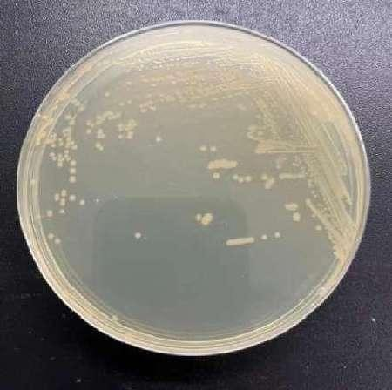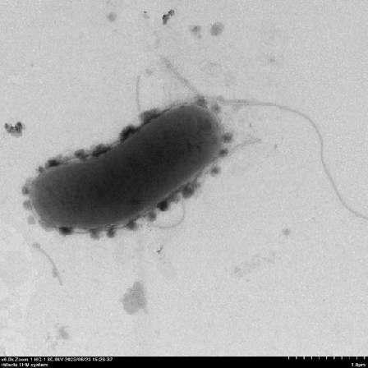

Figure S1 LB medium colony photos of strain JX-1^{T}(a); Transmission electron microscopy of strain JX-1^{T} (b).
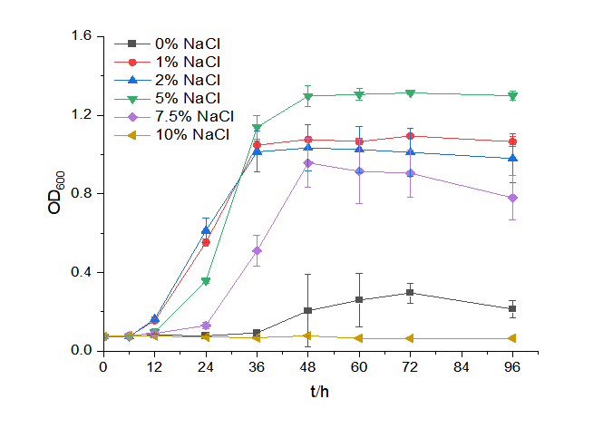

Figure S2 Salt-tolerant growth curve of strain JX-1^{T}

Figure S3 Ammonia nitrogen tolerance growth curve of strain JX-1^{T}
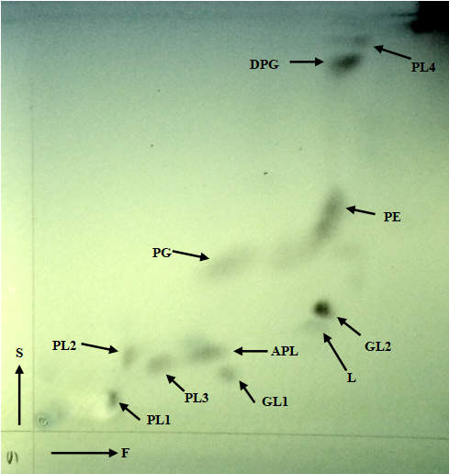

Figure S4 Two-dimensional thin-layer chromatography of the total polar lipids of strain JX-1^{T}

Spots were revealed by spraying with molybdatophosphoric acid reagent for the whole polar AL, aminolipid; APL, aminophospholipid; DPG, diphosphatidylglycerol; GL, glycolipid; L, unknown polar lipid; PE, phosphatidylethanolamine; PG, phosphatidylglycerol; PL, phospholipid.

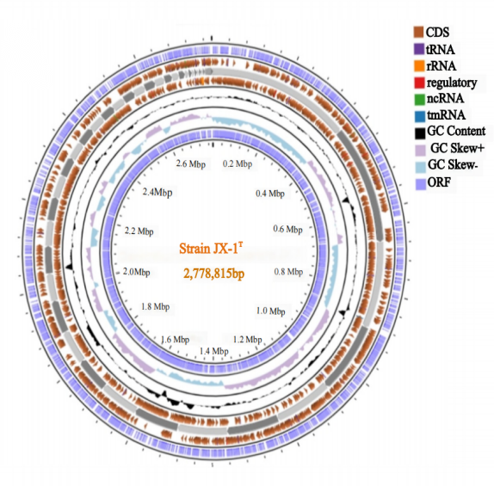

Figure S5 Genome circular representation of annotated genes of the strain JX-1^{T}
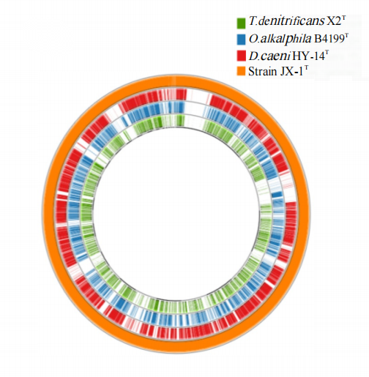
Figure S6 Schematic representation of BLAST comparisons amongst the four type species. D.HY-14^{T} =Denitricimonas caeni HY-14^{T}; O.alkaliphila B4199^{T}=Oblitimonas alkaliphila B4199^{T}; T. denitrificans X2^{T}
=Thiopseudomonas denitrificans X2^{T}. The abbreviations in the image below were the same as here.
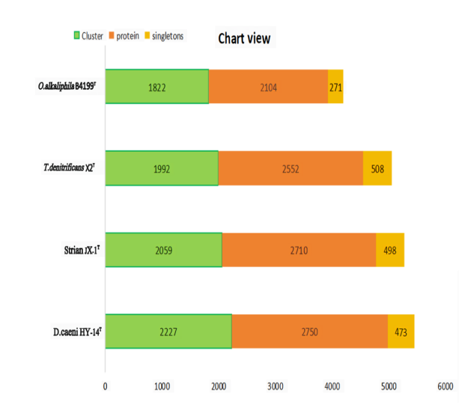

Figure S7 The Bar chart of Orthologous analysis amongst the four genomes
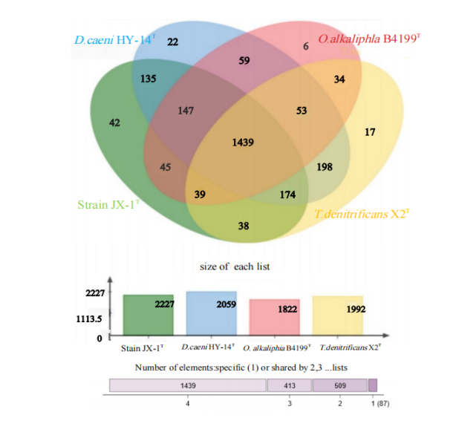

Figure S8 The Venn diagramand of Orthologous analysis amongst the four genomes.
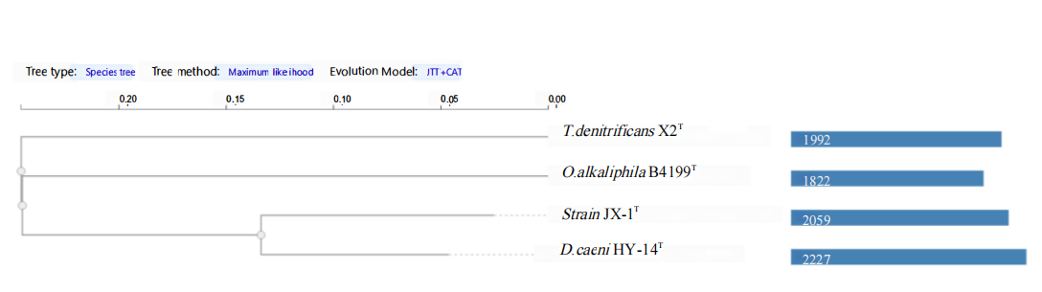

Figure S9 Phylogenetic analysis of Orthologous analysis amongst the four genomes.

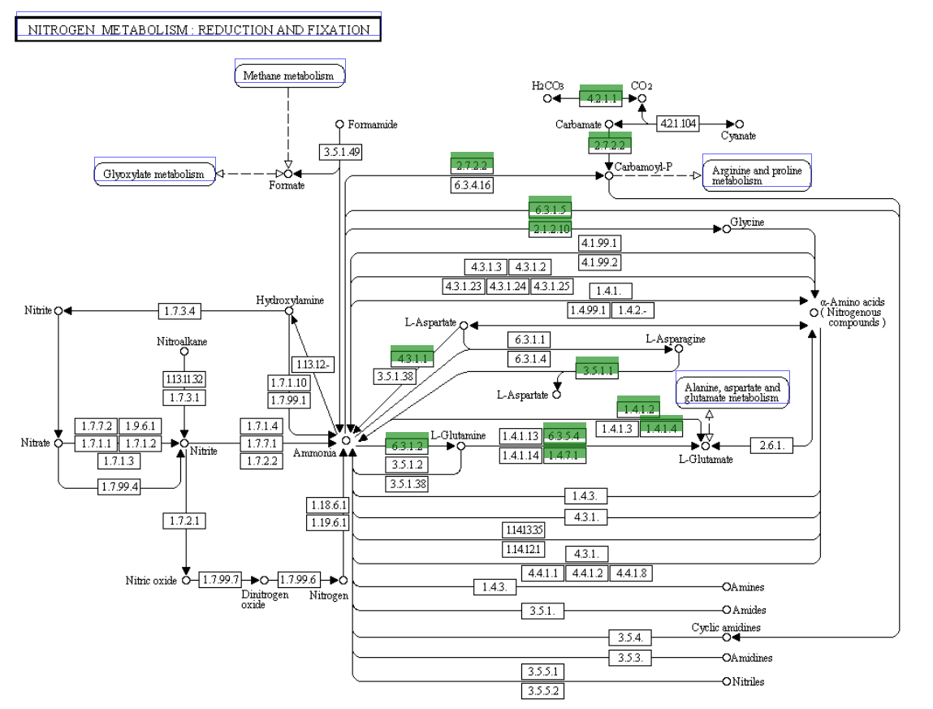

Figure S10 KEGG map Nitrogen metabolism for strain JX-1^{T}
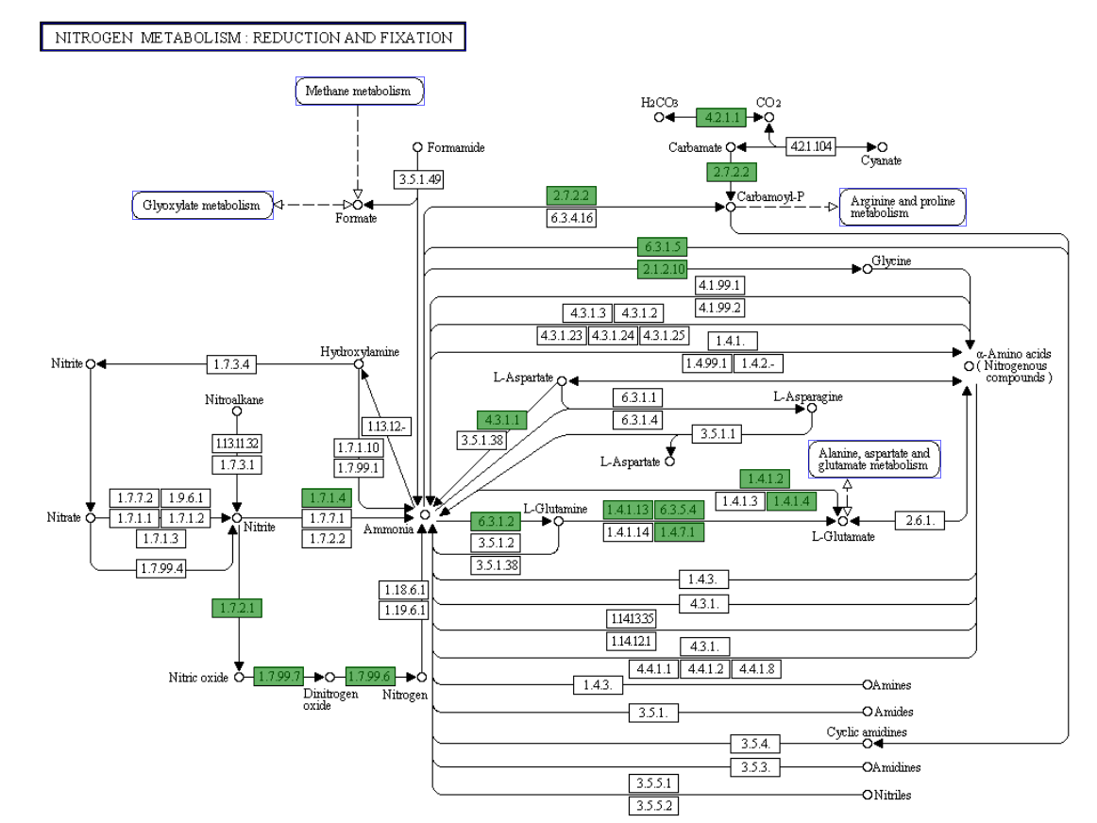

Figure S11 KEGG map Nitrogen metabolism for Denitrificimonas caeni HY-14^{T}
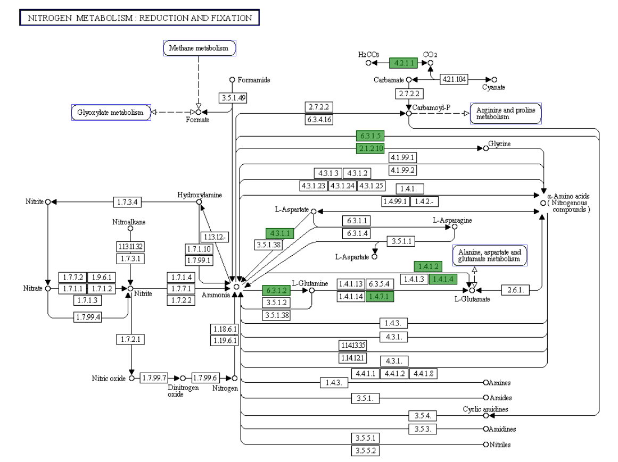

Figure S12 KEGG map Nitrogen metabolism for Oblitimonas alkaliphila B4199^{T}
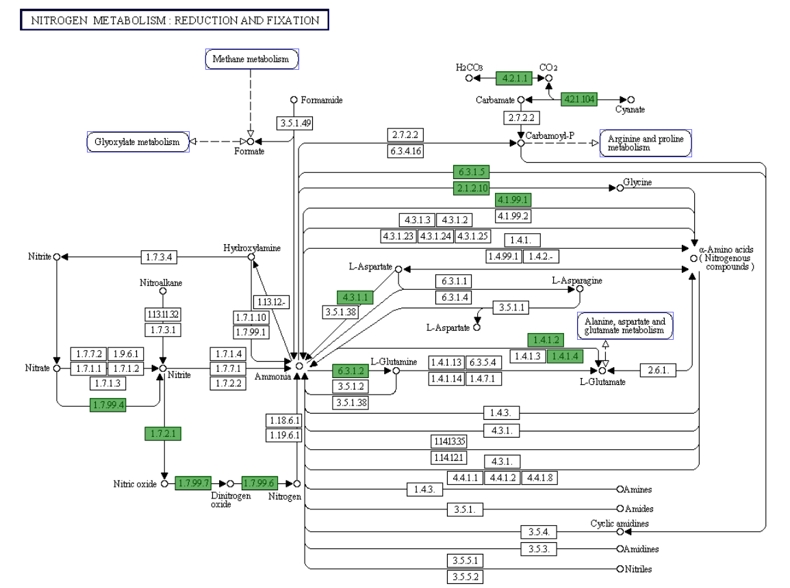

Figure S13 KEGG map Nitrogen metabolism for Thiopseudomonas denitrificans X2^{T}

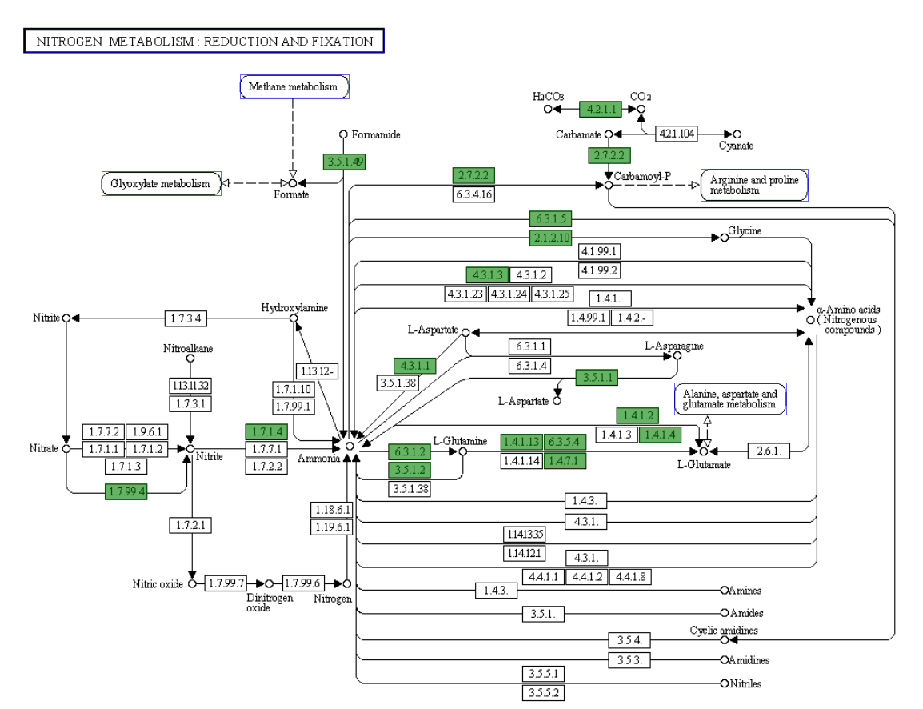Figure S14 KEGG map Nitrogen metabolism for Pseudomonas alcaliphila AL15-21^{T}
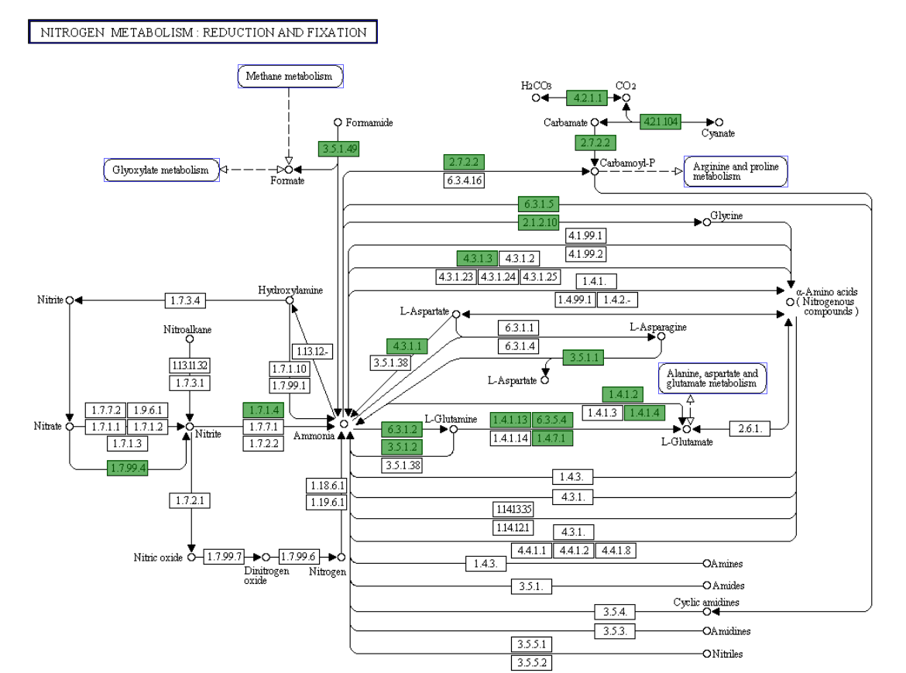

Figure S15 KEGG map Nitrogen metabolism for Pseudomonas toyotomiensis HT-3^{T}
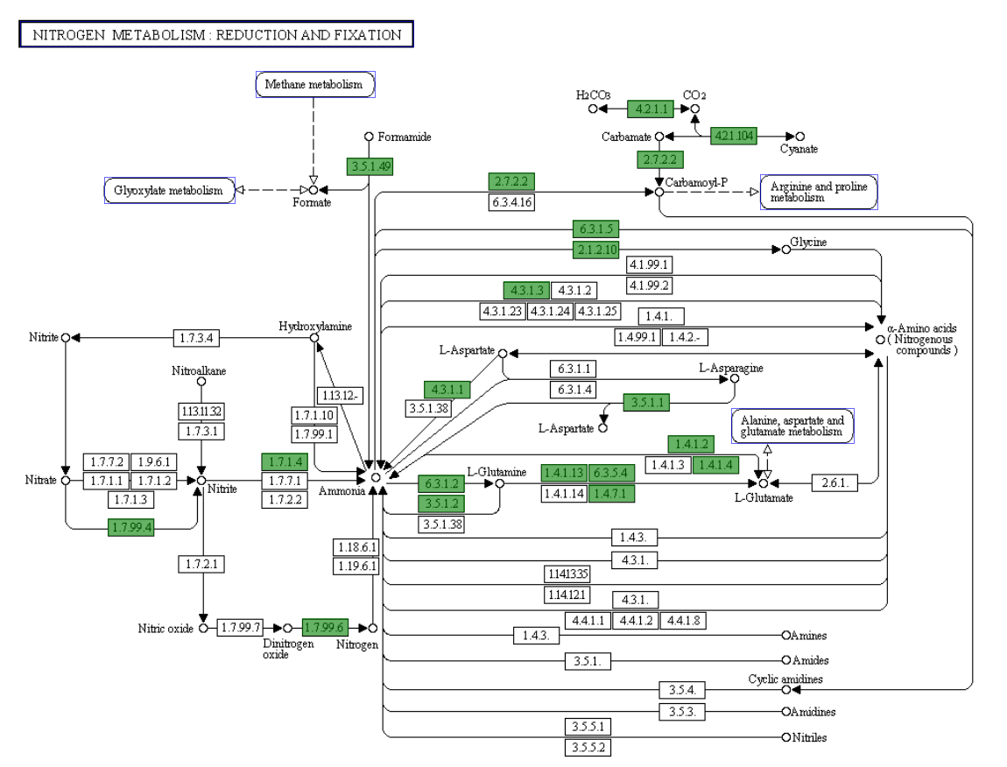

Figure S16 KEGG map Nitrogen metabolism for Pseudomonas chengduensis MBR^{T}

