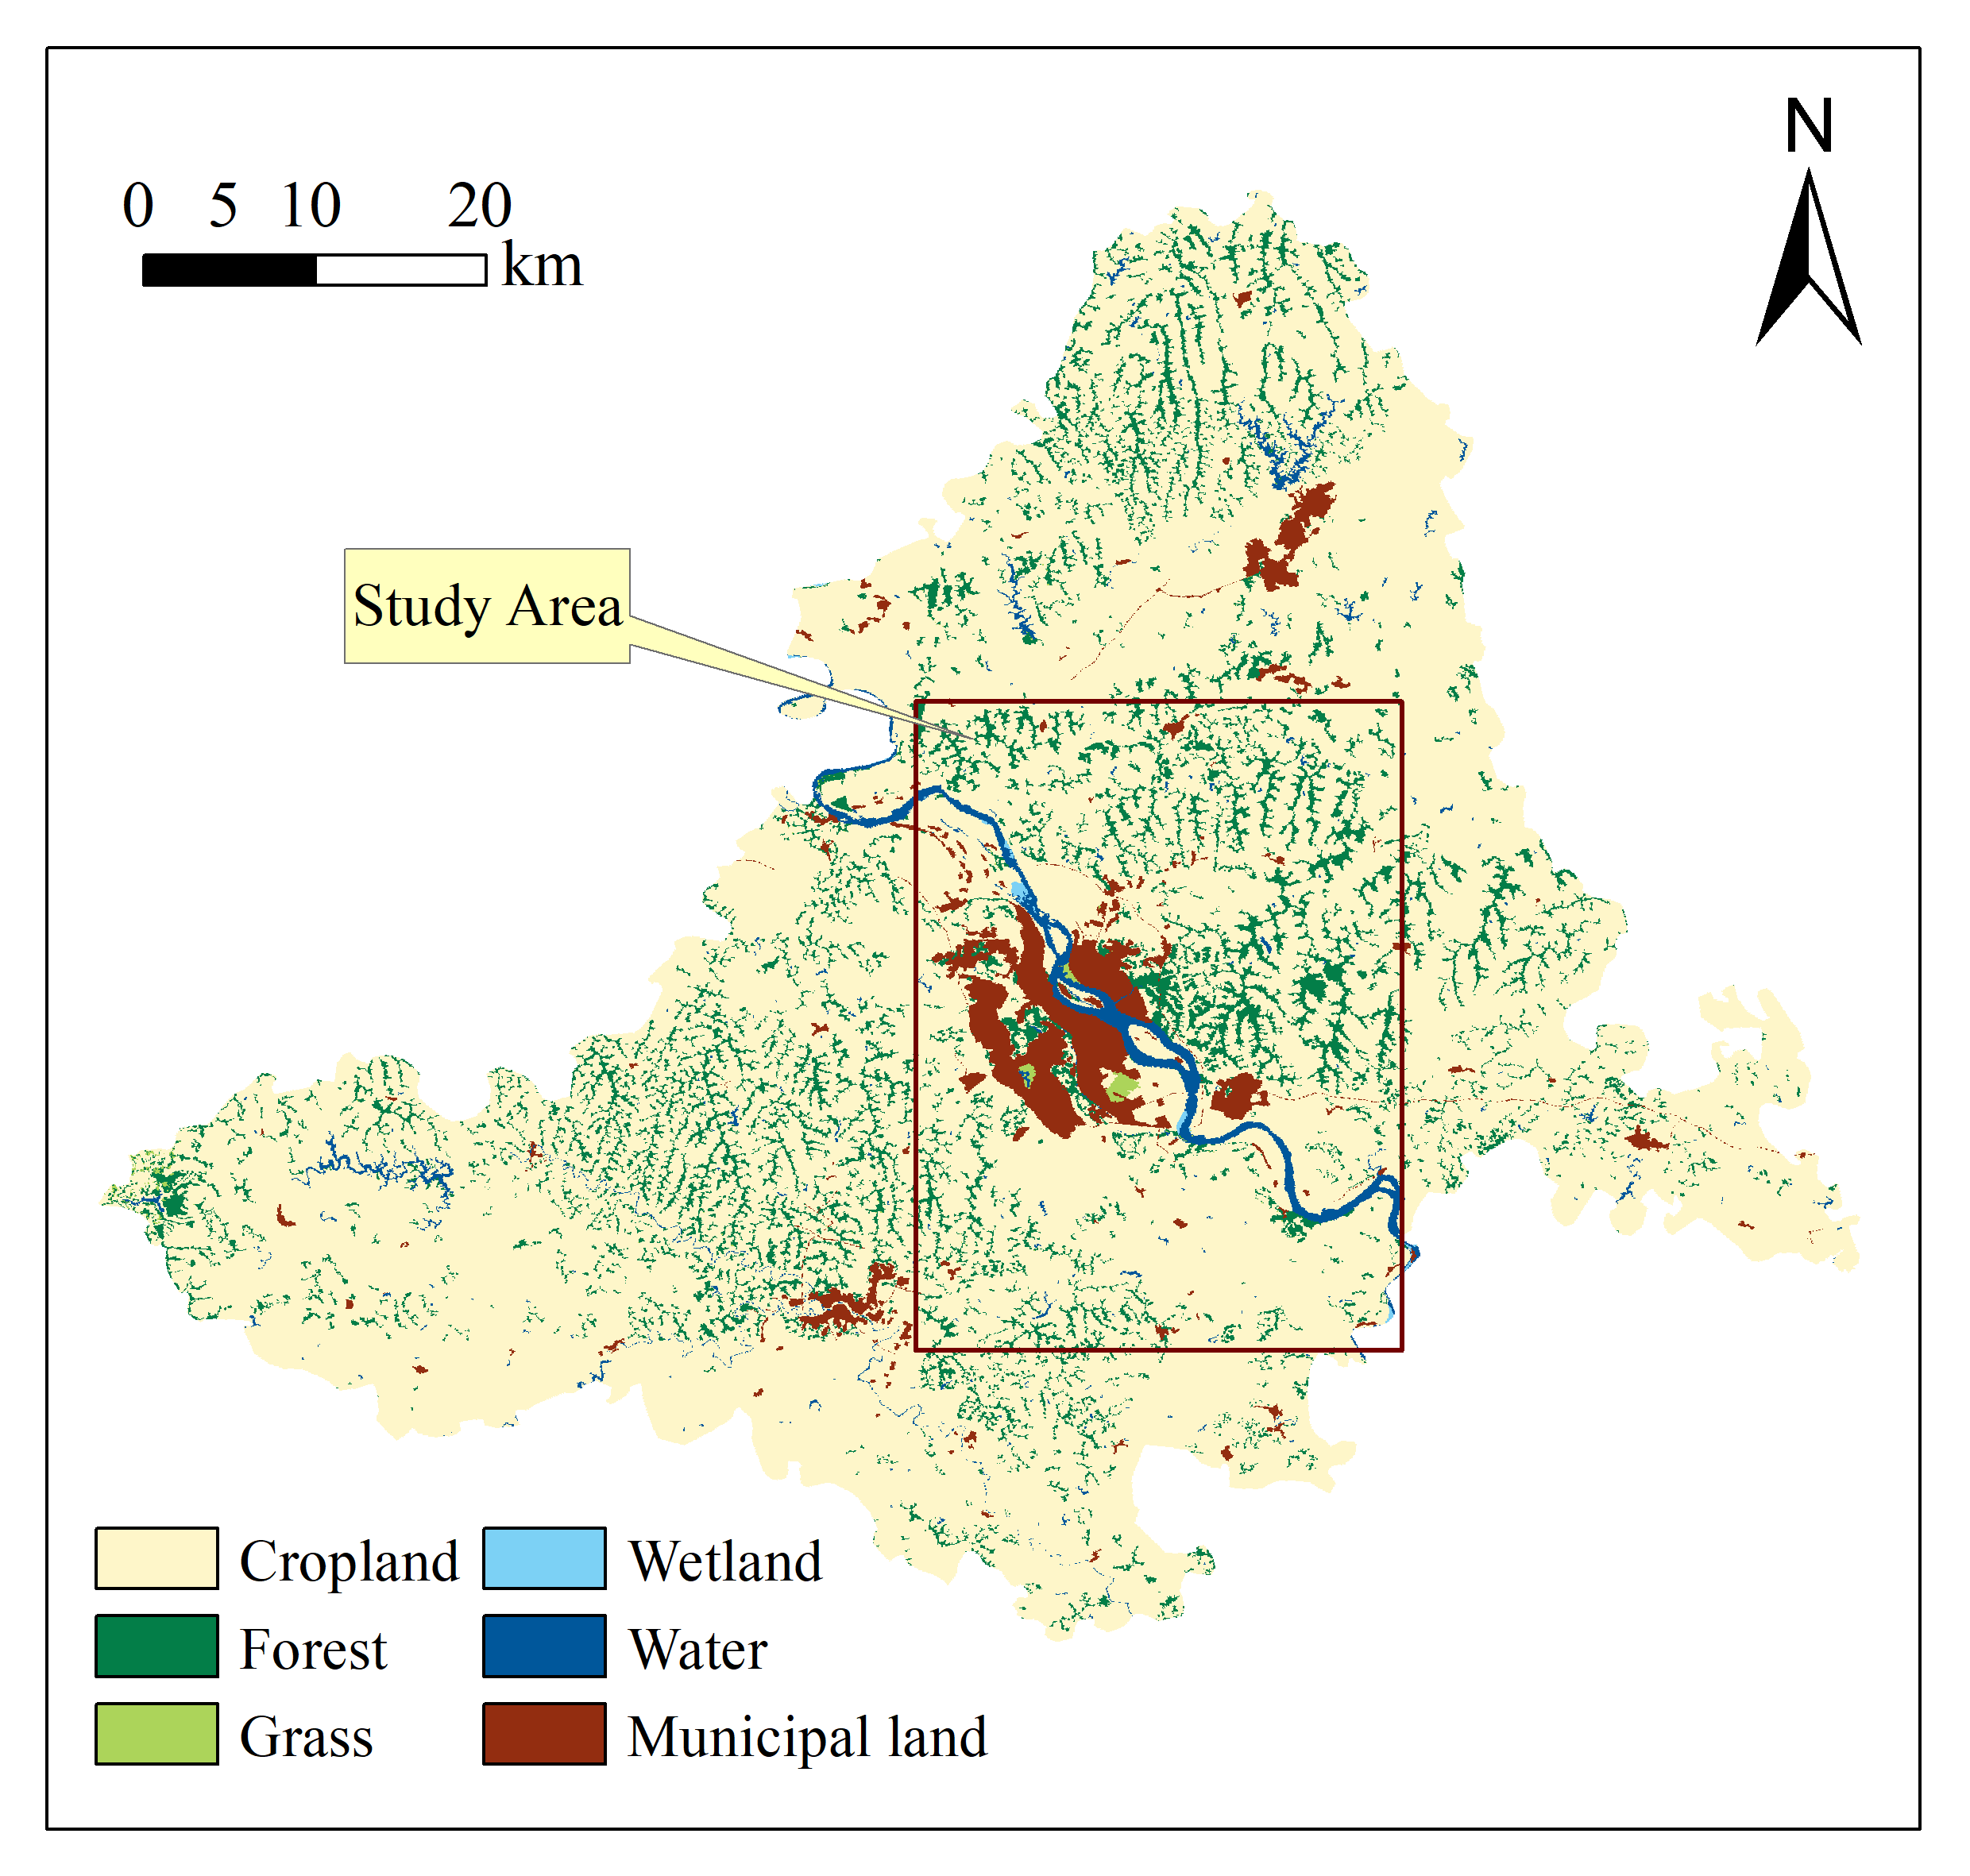
Fig. S1. Land use type map of the study area.
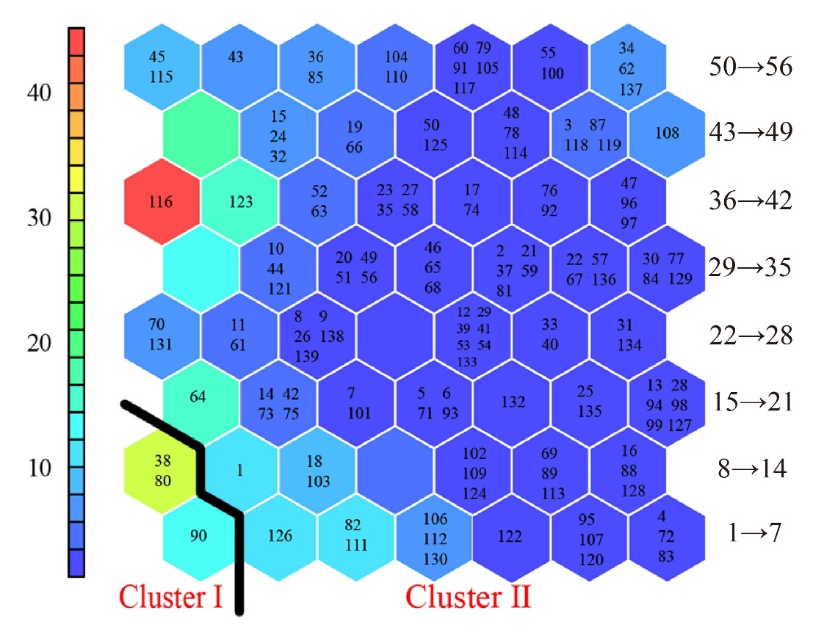
Fig. S2. Diagram of U-Matrix.

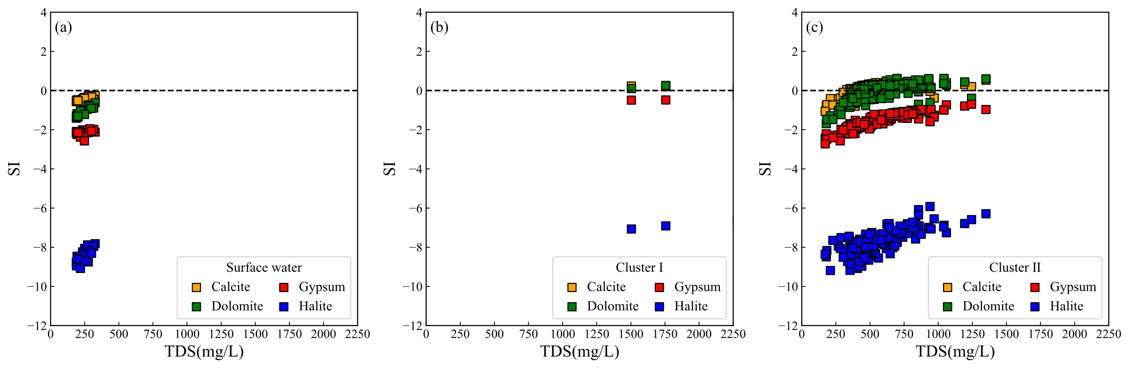
Fig. S3. Saturation index. Calcite, Gypsum, Dolomite, and Halite vs. TDS concentrations.

