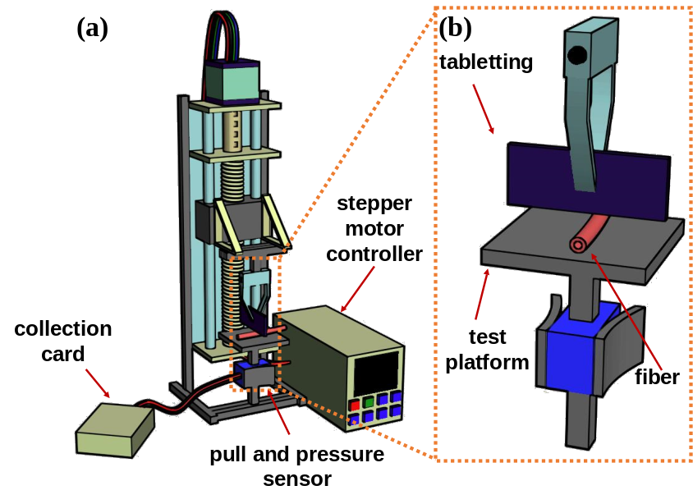
Figure S1. (a) Schematic diagram of compressive stress test platform;(b) Schematic diagram of force application test.

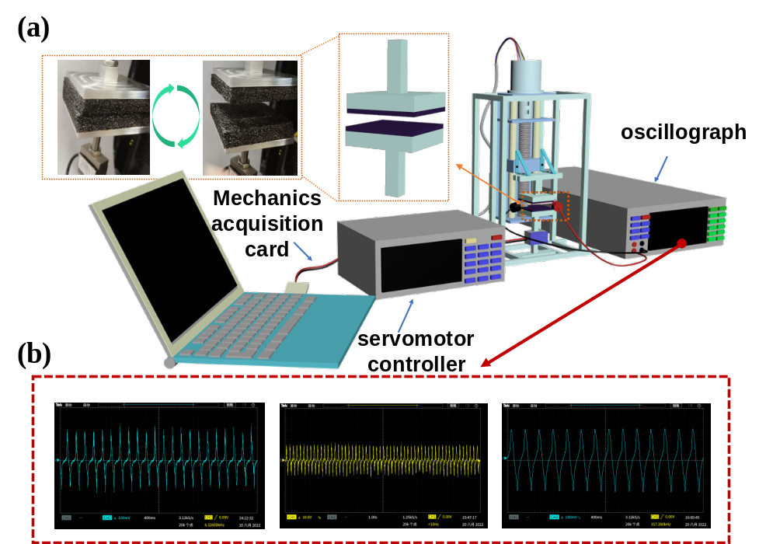
Figure S2. (a) Schematic diagram of the piezoelectric test platform. The illustration shows schematic diagram of the applied force area and the actual picture;(b) Screenshot of voltage, current and charge quantity signals.

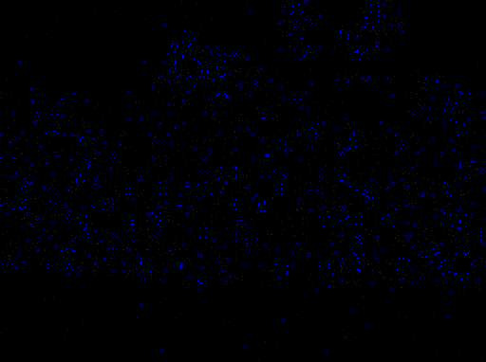
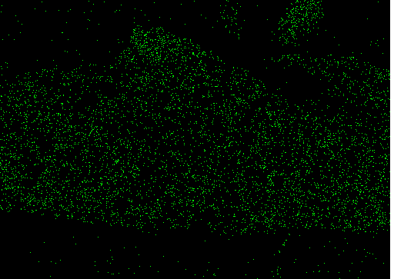
(b)
(a)
(b)
(b)

Cu
Ag

Figure S3. EDS spectra of the PVDF/LM/Cu@AgNP composite fibers. (a-b) surface of the external electrode layer;

Figure S4. The cross-sectional SEM images of PVDF hollow porous fibers formed by using different outside diameters of coaxial needles: (a₁) 0.9 mm, (a₂) 1.0 mm, (a₃) 1.1 mm, (a₄) 1.2 mm, (a₅) 1.3 mm.

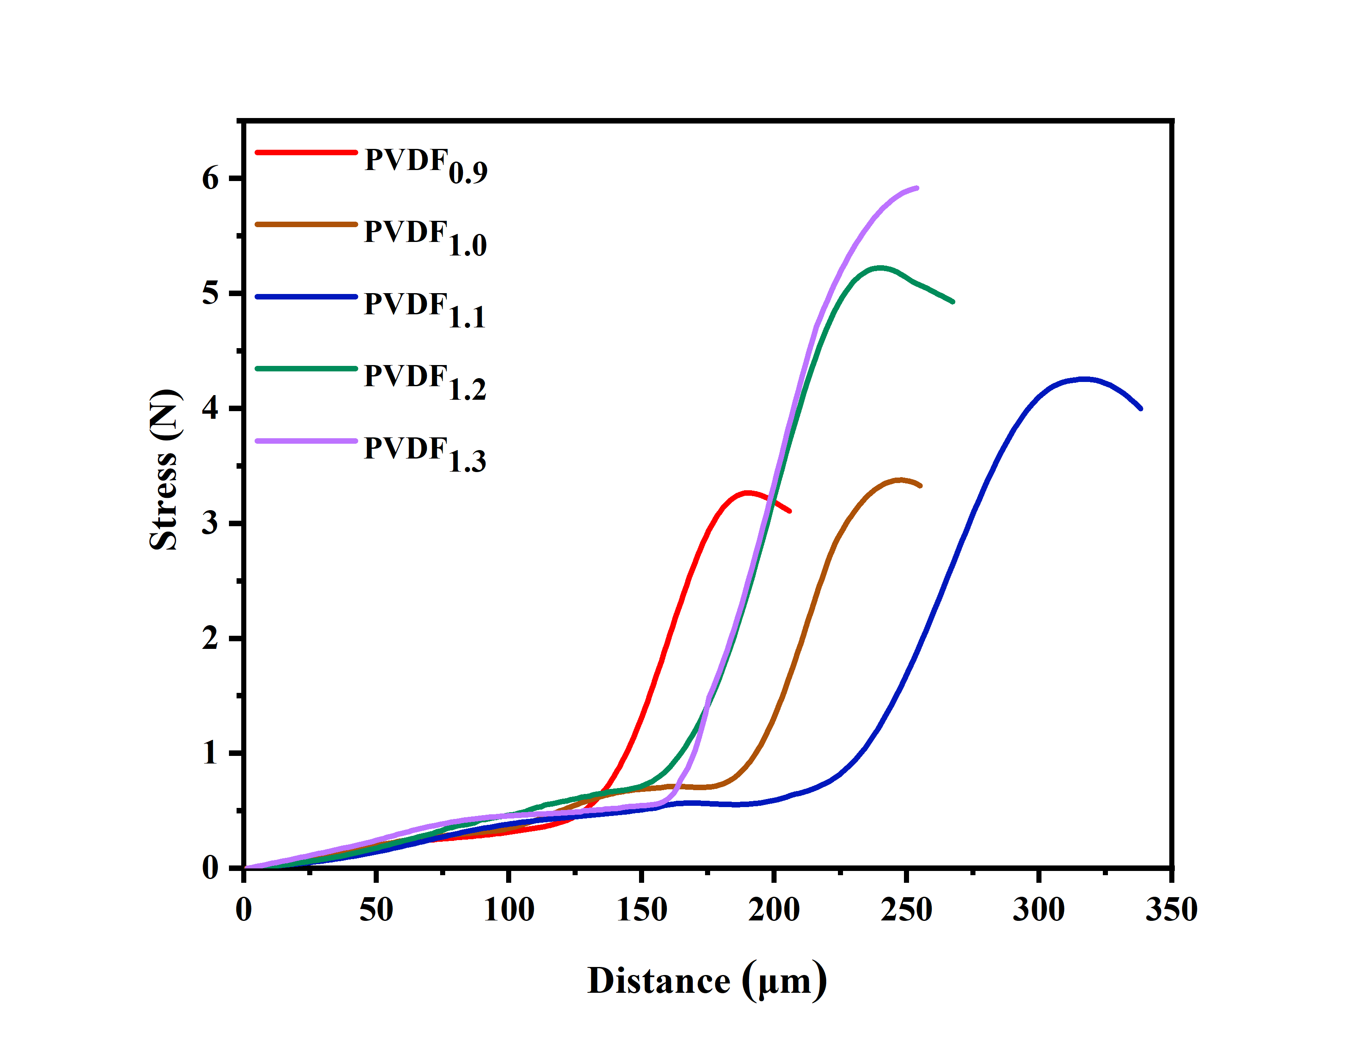Figure S5. Compression stress curve of PVDF hollow porous fibers with different coaxial needle outer diameters.

Thickness /μm | 1 | 2 | 3 | 4 | 5 | 6 | 7 | 8 | 9 | 10
① | 83.3 | 86.4 | 92.7 | 92.3 | 86.8 | 90.1 | 82.2 | 92.7 | 97.4 | 84.5
② | 90.1 | 95.8 | 85.3 | 97.4 | 94.3 | 98.3 | 95.8 | 92.3 | 100.6 | 94.3
③ | 89.5 | 99.0 | 92.3 | 86.8 | 85.6 | 89.5 | 108.9 | 85.9 | 86.8 | 111.9
Mean |  |  |  |  |  | 92.34
Standard deviation |  |  |  |  |  | 7.01
Figure S6. The wall thickness test method of PVDF hollow porous fiber, taking the outer diameter of the coaxial needle as 1.1 mm as an example.

Figure S7. The pore thickness distribution histograms of PVDF hollow porous fibers with different coaxial needle outer diameters:（a₁-a₅）inner layer;（b₁-b₅）middle layer;（c₁-c₅）outer layer.

Figure S8. The cross-sectional SEM images of PVDF hollow porous fibers formed by using different spinning solution concentrations: (a₁) 15 wt%, (a₂) 20 wt%, (a₃) 25 wt%, (a₄) 30 wt%; (b₁-b₄) High-magnification SEM images of these corresponded PVDF hollow porous fibers.
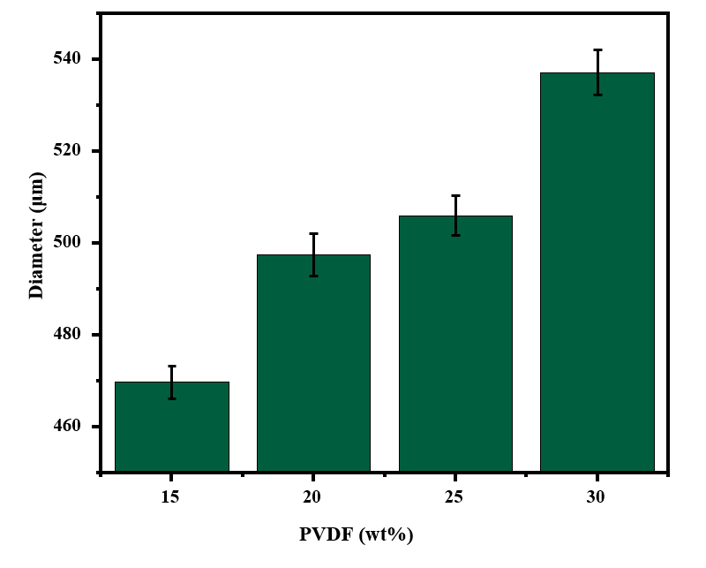
Figure S9. Diameter of the PVDF hollow porous fibers with different spinning solution concentrations.

Figure S10. Tensile stress and elongation at break of PVDF hollow porous fibers with different spinning solution concentrations.

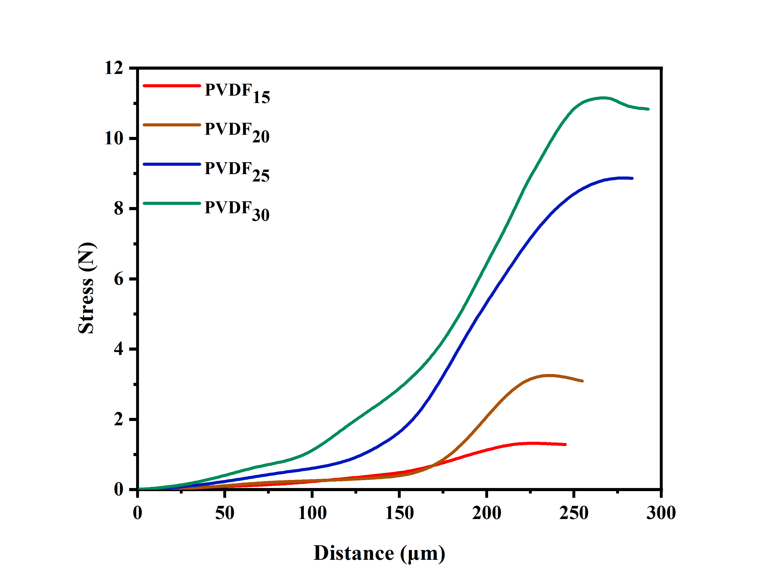Figure S11. Compression stress curve of PVDF hollow porous fibers with different spinning solution concentrations.

Figure S12. The PVDF hollow porous fibers with different spinning solution concentrations:(a) XRD patterns, (b) FTIR spectrums.

Figure S13. The β crystal content of PVDF hollow porous fibers with different spinning solution concentrations.

Figure S14. Wall thickness of the resultant PVDF hollow porous fibers with different spinning solution concentrations.

Figure S15. The wall thickness distribution histograms of PVDF hollow porous fibers with different spinning solution concentrations: （a₁-a₄）inner layer;（b₁-b₄）middle layer;（c₁-c₄）outer layer.

Figure S16. The V_{oc} of the PENG based on these samples of the PVDF/LM/Cu@AgNP composite fibers.

Figure S17. The triboelectric comparison of the selected optimized PENG in single electrode mode: (a) The relationship between output voltage and friction material; (b) The relationship between output voltage and voltage frequency; (c) The relationship between output voltage and applied spacer distance.

