Supplementary Fig. S1 Sequence alignment and coding protein analysis of two alternative splicing events.
A DNA sequence alignment of two transcripts.
B Sequence alignment of amino acids encoded by SiAAP9L and SiAAP9S.
C, D Coding sequences of SiAAP9L and SiAAP9S are subjected to the TMHMM-2.0 website for transmembrane domain prediction.
E, F Swiss Model website for predicting the protein tertiary structure of the SiAAP9L and SiAAP9S.

Supplementary Fig. S2 SiAAP9 is widely expressed in Arabidopsis by GUS staining analysis.
Representative images from 20 individual transgenic lines expressing SiAAP9 pro:GUS are shown: 4-DAG seedling (A), magnifications of the cotyledons (B) and root tips (C) of 4-DAG seedling, leaf from 21-DAG plants (D), epidermal cells (E), inflorescence (F), mature pistil (G), root (H), developing anther (I), developing seed (J). Bars = 2 mm for (A), (D), and (F), 100 μm for (B), (C), (E), (G), (H), (I) and (J).

Supplementary Fig. S3 Quantification of the expression levels in WT and SiAAP9-OX transgenic Arabidopsis lines that were grown on 1/2 MS medium.
A, B Detection of expression levels of WT, LOX-1#, LOX-2#, SOX-1# and SOX-2# through RT-qPCR and Western Blot. Data represent means ± SD (n=3). Significant difference is analyzed based on one-way ANOVA by Duncan test, lowercase letters at p < 0.05.

Supplementary Fig. S4 Amino acid concentration of seeds at mature stage in WT, LOX-1#, LOX-2#, SOX-1# and SOX-2# lines. Data represent the mean ± SD (n=3). Asterisks indicate significant differences based on one-way ANOVA followed by Duncan test: * p < 0.05, ** p < 0.01.

Supplementary Fig. S5 The phenotype analysis of WT and SiAAP9-OX transgenic Arabidopsis lines under 7 mM NO₃⁻.
A, E WT, LOX-1#, LOX-2#, SOX-1# and SOX-2# were vertically cultivated on 0 mM NO₃⁻ for 4 days (upper panels), then were transferred to 7 mM NO₃⁻ and allowed to grow for an additional 8 days (lower panels). The experiments were biologically repeated at least three times, yielding consistent results. Scale bar = 1 cm.
B, F Primary root length was measured in WT and SiAAP9-OX transgenic Arabidopsis lines at 12 days. Data represent the mean ± SD (n = 20).
C, G Primary root length was measured in WT and SiAAP9-OX transgenic Arabidopsis lines after transferring the plate at 8 days. Data represent the mean ± SD (n = 20).
D, H Fresh weight was measured in WT and SiAAP9-OX transgenic Arabidopsis lines at 12 days. Data represent the mean ± SD (n = 20).
B-D, F-H Significant difference is analyzed based on one-way ANOVA by Duncan test, lowercase letters at p < 0.05.

Supplementary Fig. S6 SiAAP9-OX transgenic Arabidopsis lines showed no significant response to nine amino acids, compared with WT.
A-I Nine amino acids are Ala (A), Gly (B), Val (C), Pro (D), Leu (E), Ile (F), Ser (G), Thr (H) and Asp (I).

Supplementary Fig. S7 SiAAP9-OX transgenic Arabidopsis lines showed no significant response to eight amino acids, compared with WT.
A-H Eight amino acids are Met (A), Cys (B), Phe (C), Try (D), Asn (E), Gln (F), Lys (G) and Arg (H).

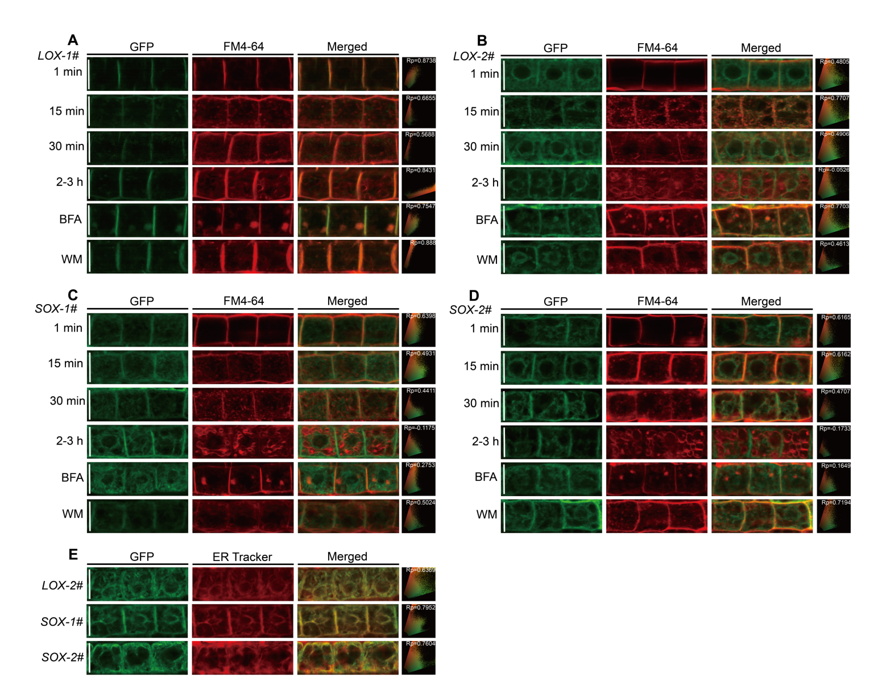
Supplementary Fig. S8 Subcellular localization of SiAAP9L and SiAAP9S in Arabidopsis were pulse labeled with FM4-64.
A-D Roots of four SiAAP9-OX transgenic Arabidopsis lines grown on 1/2 MS medium for 4 days were pulse labeled with FM4-64 for 1 min, 15 min, 30 min or for 2-3 h and followed by BFA treatment for 50 min or WM treatment for 1 h, respectively.
E Seedlings of LOX-2#, SOX-1# and SOX-2# grown on 1/2 MS medium for 4 days were stained with ER Tracker for 1 hour.
A-E Each image shows the corresponding Pearson correlation coefficient (Rp). Bar = 20 μm.

