Supplementary Materials for

Impact of rare non-coding variants on human complex traits and diseases through alternative polyadenylation outliers

Xudong Zou, Zhaozhao Zhao, Yu Chen, et al.

Corresponding author:
Wei Li, wei.li@uci.edu
Ting Ni, tingni@fudan.edu.cn;
Lei Li, lei.li@szbl.ac.cn
The PDF file includes the following:
Figures S1 to S21

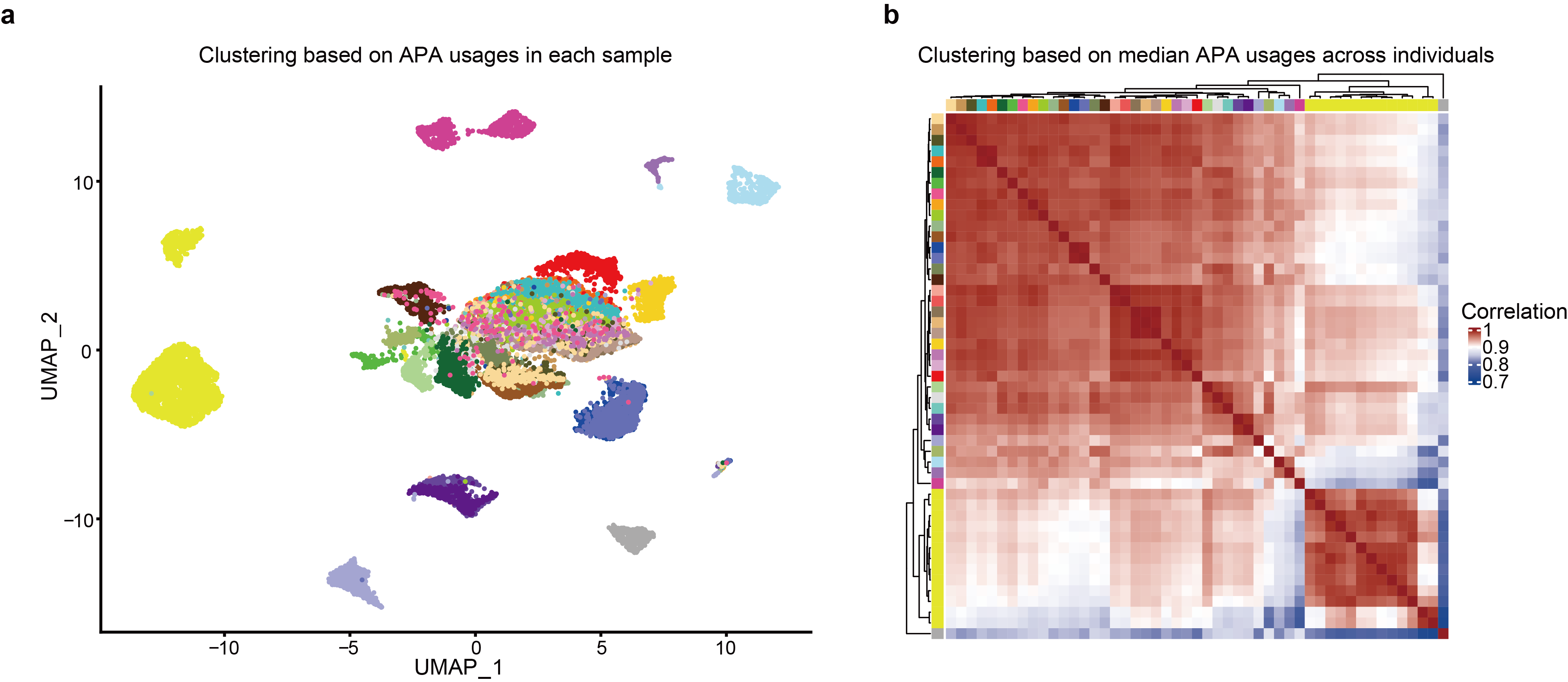
Supplementary Figure 1. Clustering of samples in GTEx v8 used in this studyby APA usages. a. UMAP plot shows the clusters of GTEx samples. The top 1,000 genes ranked by APA usage variations across samples are used to conduct the clustering. b. Heatmap describes tissue clustering by median APA usage across individuals in each tissue.

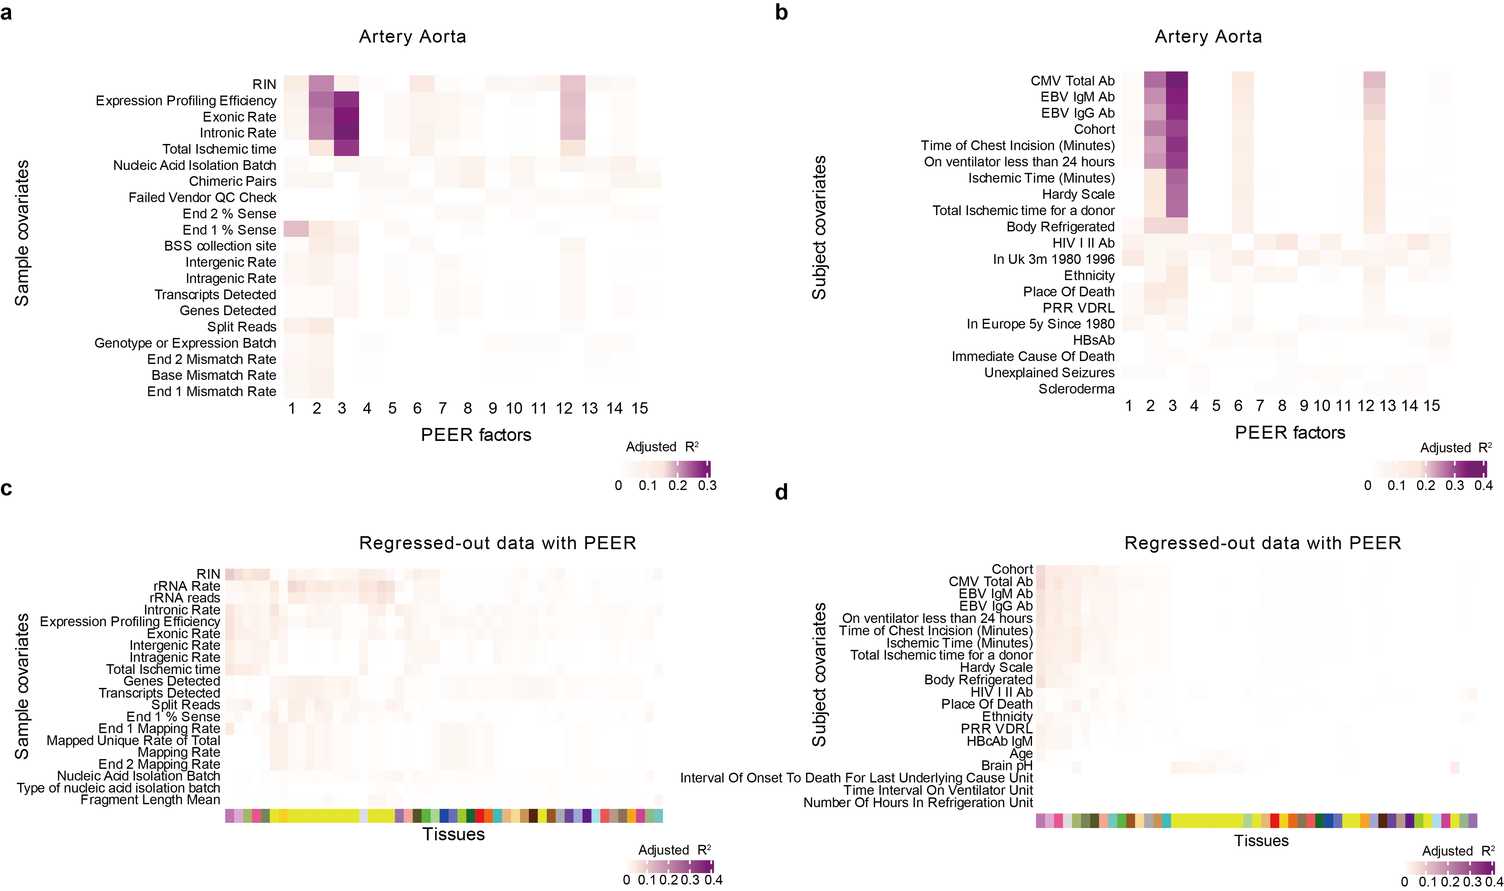
Supplementary Figure 2. PEER correction of APA quantifications. a-b. Adjusted R² between top 15 PEER factors and top 20 sample (a) and subject (b) covariates in an example tissue, Artery Aorta. Covariates were ranked by the average adjusted R² across all PEER factors and hierarchically clustered. The corresponding data for all tissues are provided in Supplementary Tables 1, 2. c-d. Adjusted R² between the total APA usage component removed by PEER in each tissue and the top 20 samples (c) and subject (d) covariates. The covariates were ranked by the average adjusted R² across all tissues, and both axes were hierarchically clustered. White denotes missing values; tissues are colored as in GTEx project tissue colors.

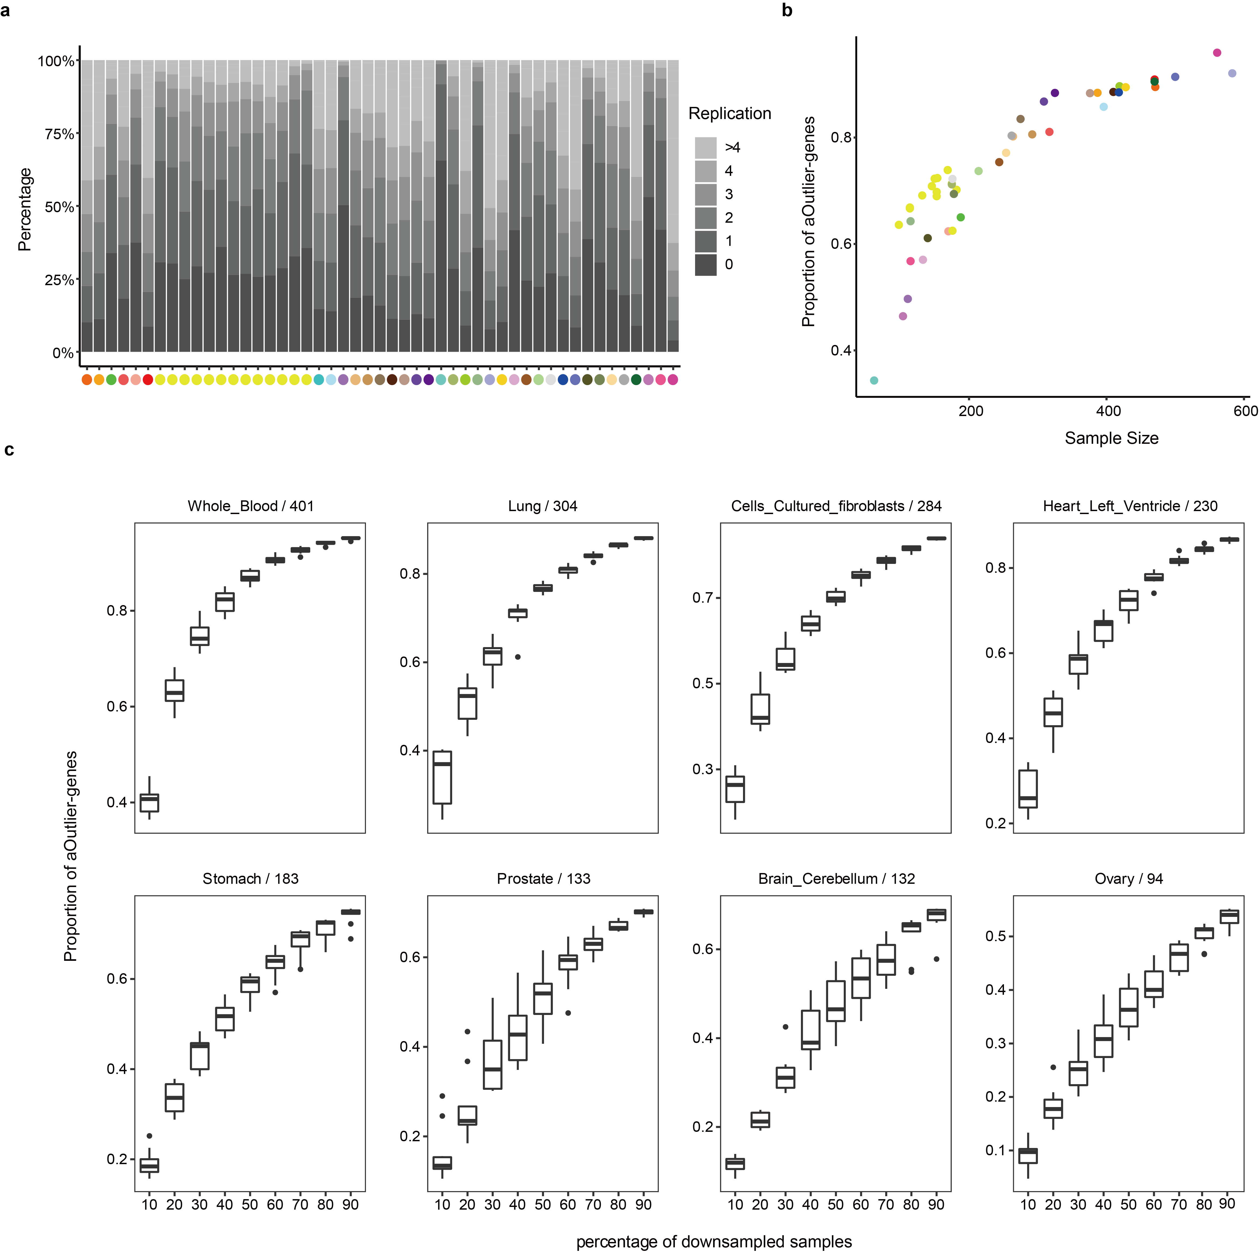
Supplementary Figure 3. Single-tissue aOutliers called from 49 human tissues. a. Proportion of genes with detected aOutliers (defined as gene-individual pair with absolute Z score>3 in that tissue). The proportions presented were stratified by replication number, representing the number of individuals detected as outliers for a specific gene. Each tissue in the X-axis was indicated by different colors as used by the GTEx Consortium. b. Relationship between the proportion of genes with aOutliers and sample size. c. Validation of the relationship between the proportion of genes with aOutliers and sample size in eight represented tissues. For each of the selected tissues, we randomly extracted 10% to 90% of the original samples available in that tissue and called aOutliers from extracted samples only. Box plots show the median and first and third quartiles, and whiskers extend up to 1.5 times the interquartile range.

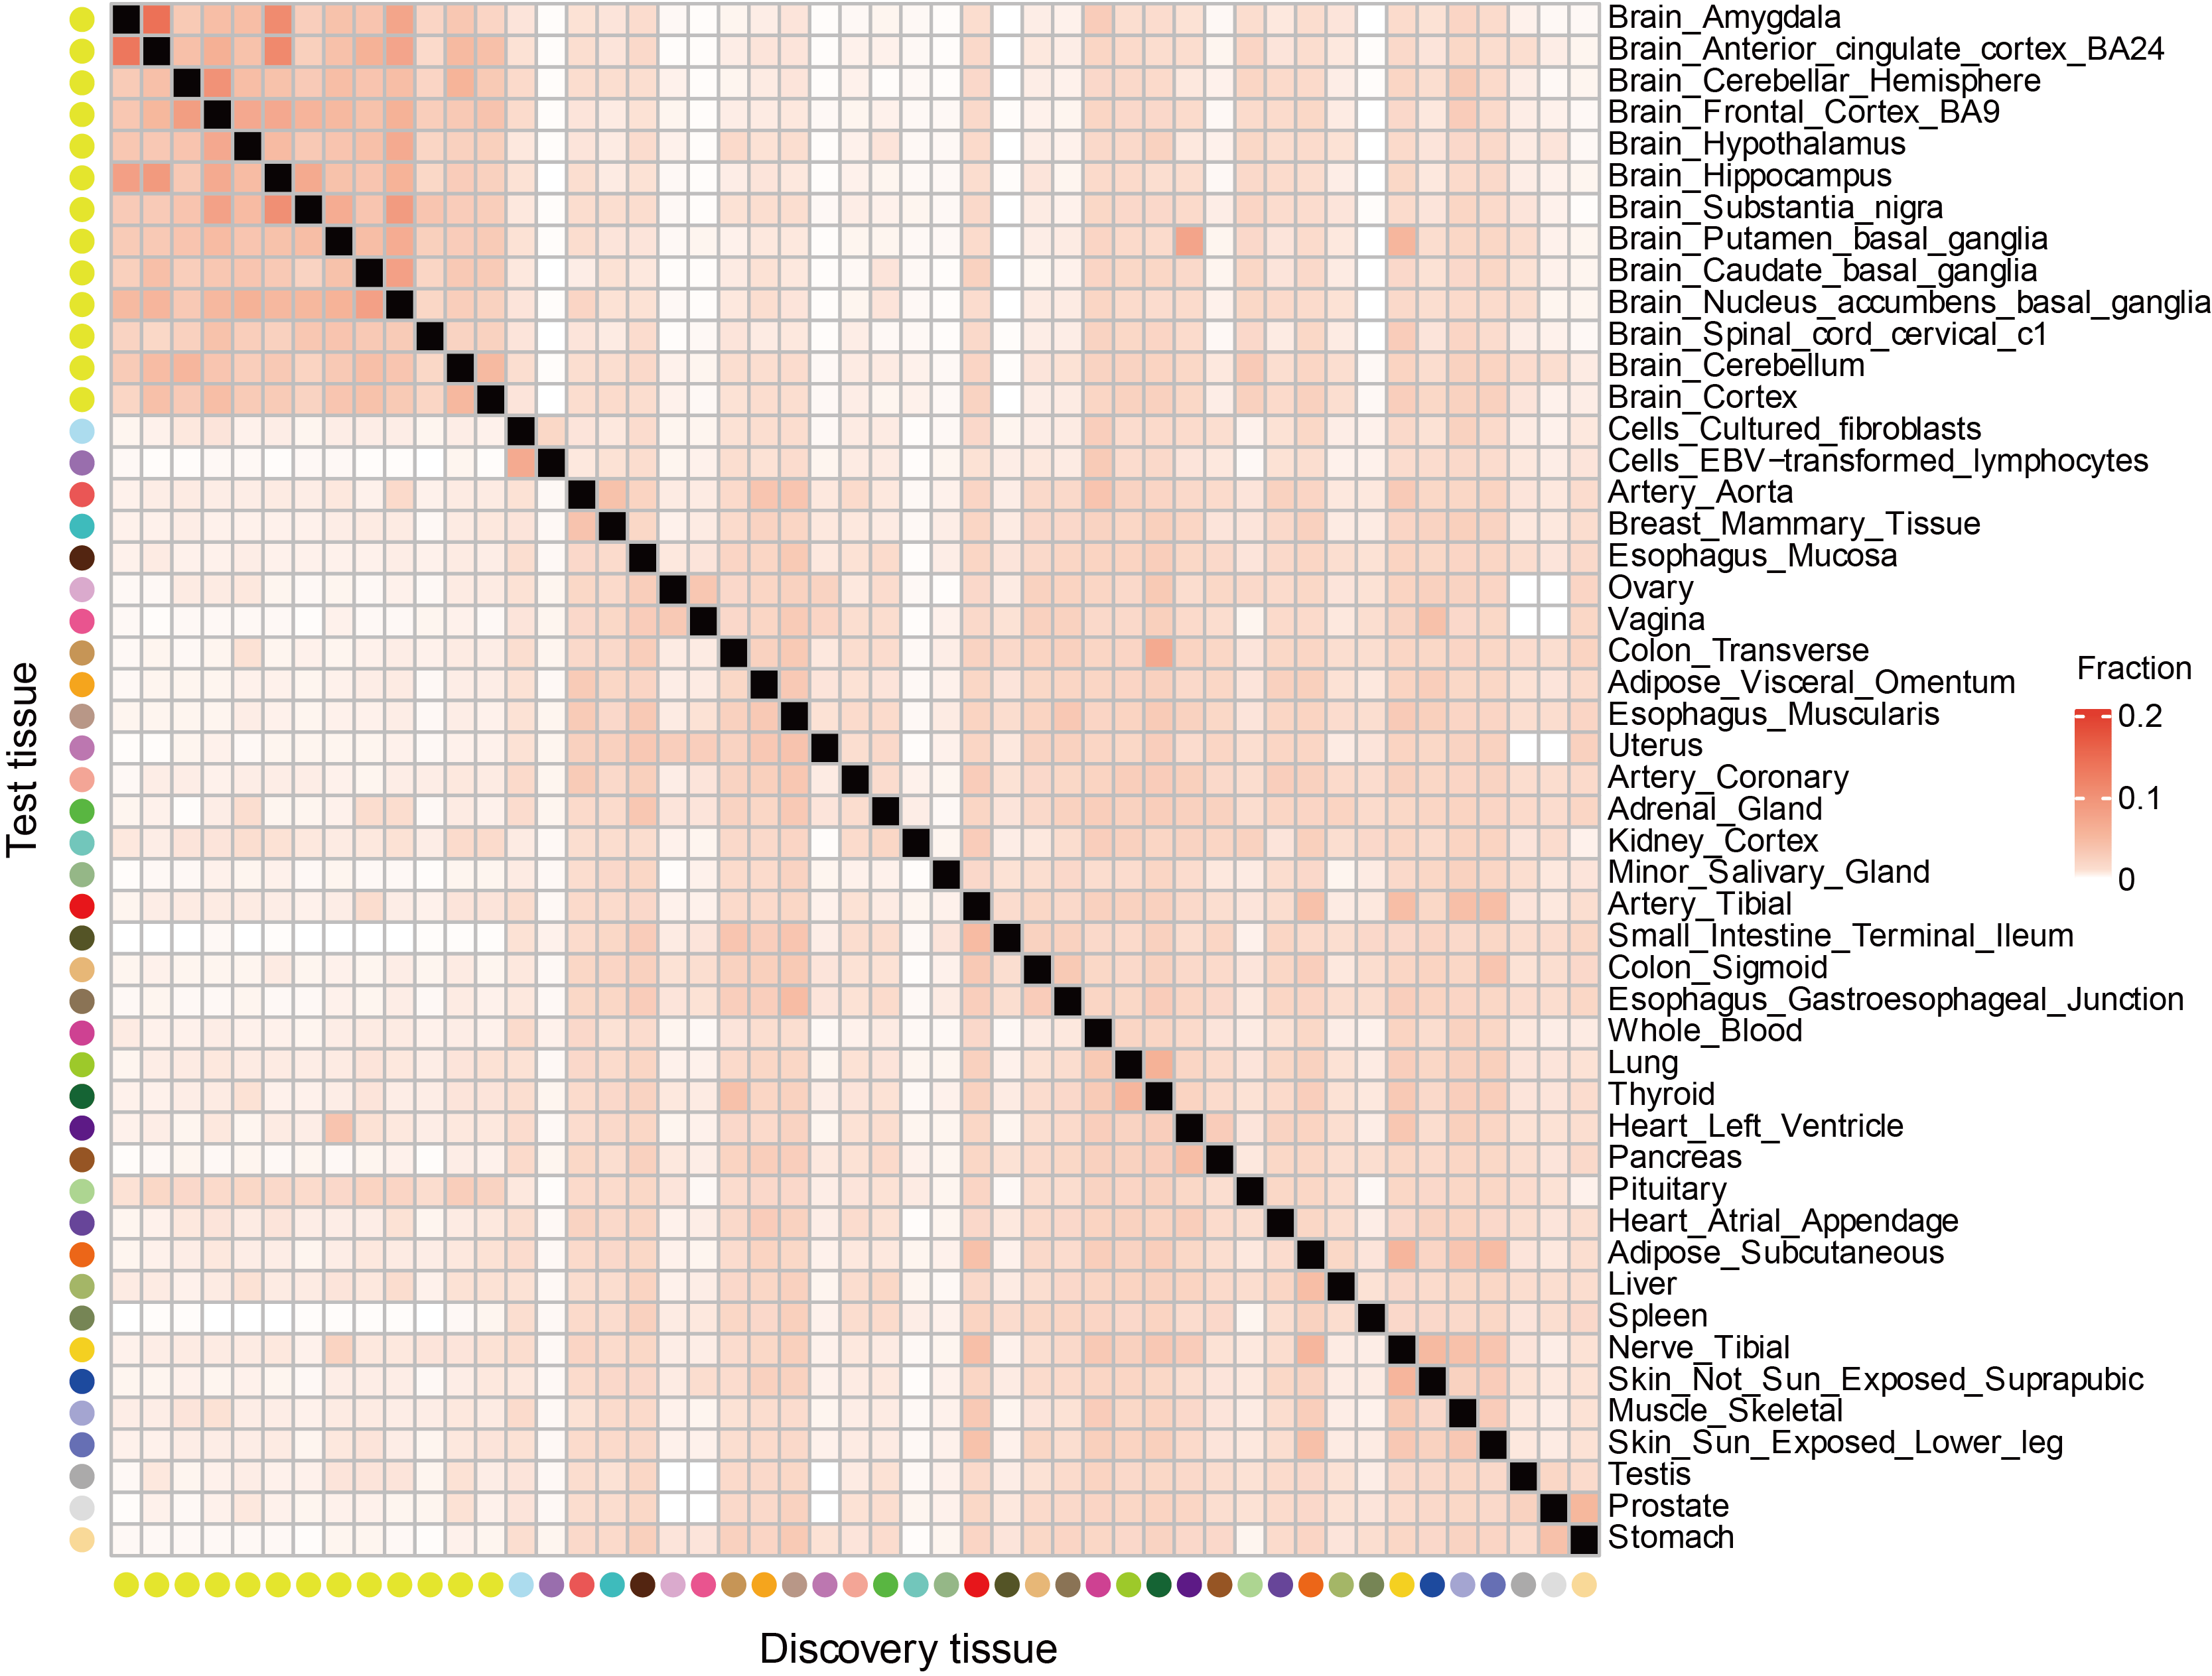
Supplementary Figure 4. Replication rate of single-tissue aOutliers. Replication of aOutliers was defined as an aOutlier identified in one tissue (discovery tissue) and has an absolute Z-score > 3 in another tissue (test tissue). The replication rate was calculated using APA transcripts detected in discovery and test tissue.

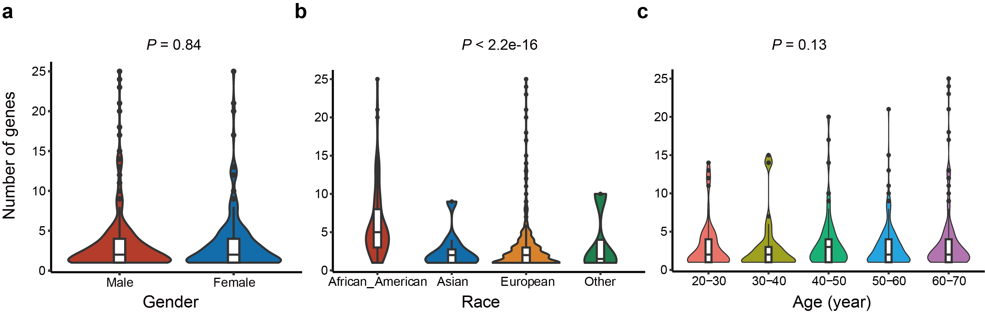
Supplementary Figure 5. Distribution of the number of multi-tissue aOutlier genes per individual. The individuals (n=589) are stratified by covariates, including gender (a), race (b), and age (c). We compared the number of aOutlier genes per individual for all three covariates using a two-sided Wilcoxon rank−sum test. For race, only the P value for the test between African-American and European groups was provided because the two groups have the largest sample size. For age groups, only the minimum P value across the multiple tests was indicated. Box plots in the middle of violins show the median and first and third quartiles, and whiskers extend up to 1.5 times the interquartile range. P-values were calculated using the two-sided Wilcoxon rank–sum test.

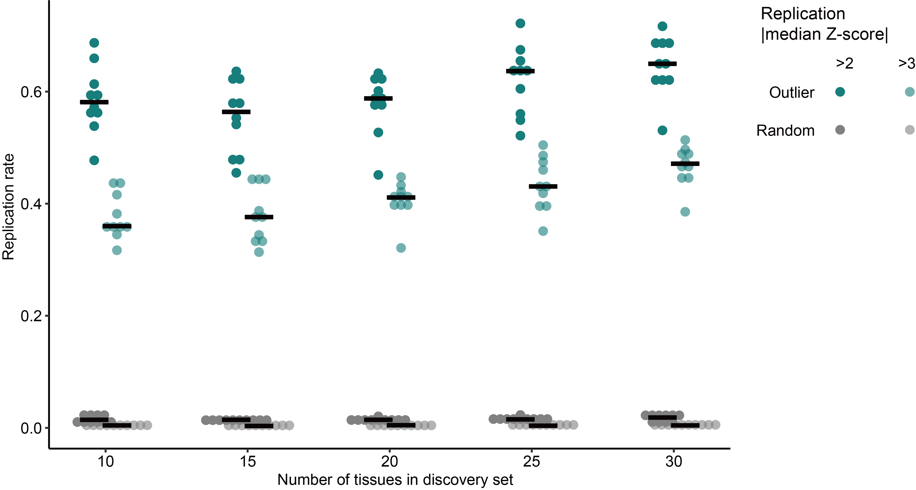
Supplementary Figure 6. Replication rate of multi-tissue aOutliers. The replication rate of multi-tissue aOutliers was assessed by cross-validation. The black horizontal bars indicate the medians. Dots in dark green represent replication rate estimated by |median Z-score| threshold of 2 and dots in light green represent replication rate estimated by a threshold of 3. Gray dots represent expected replication rate.

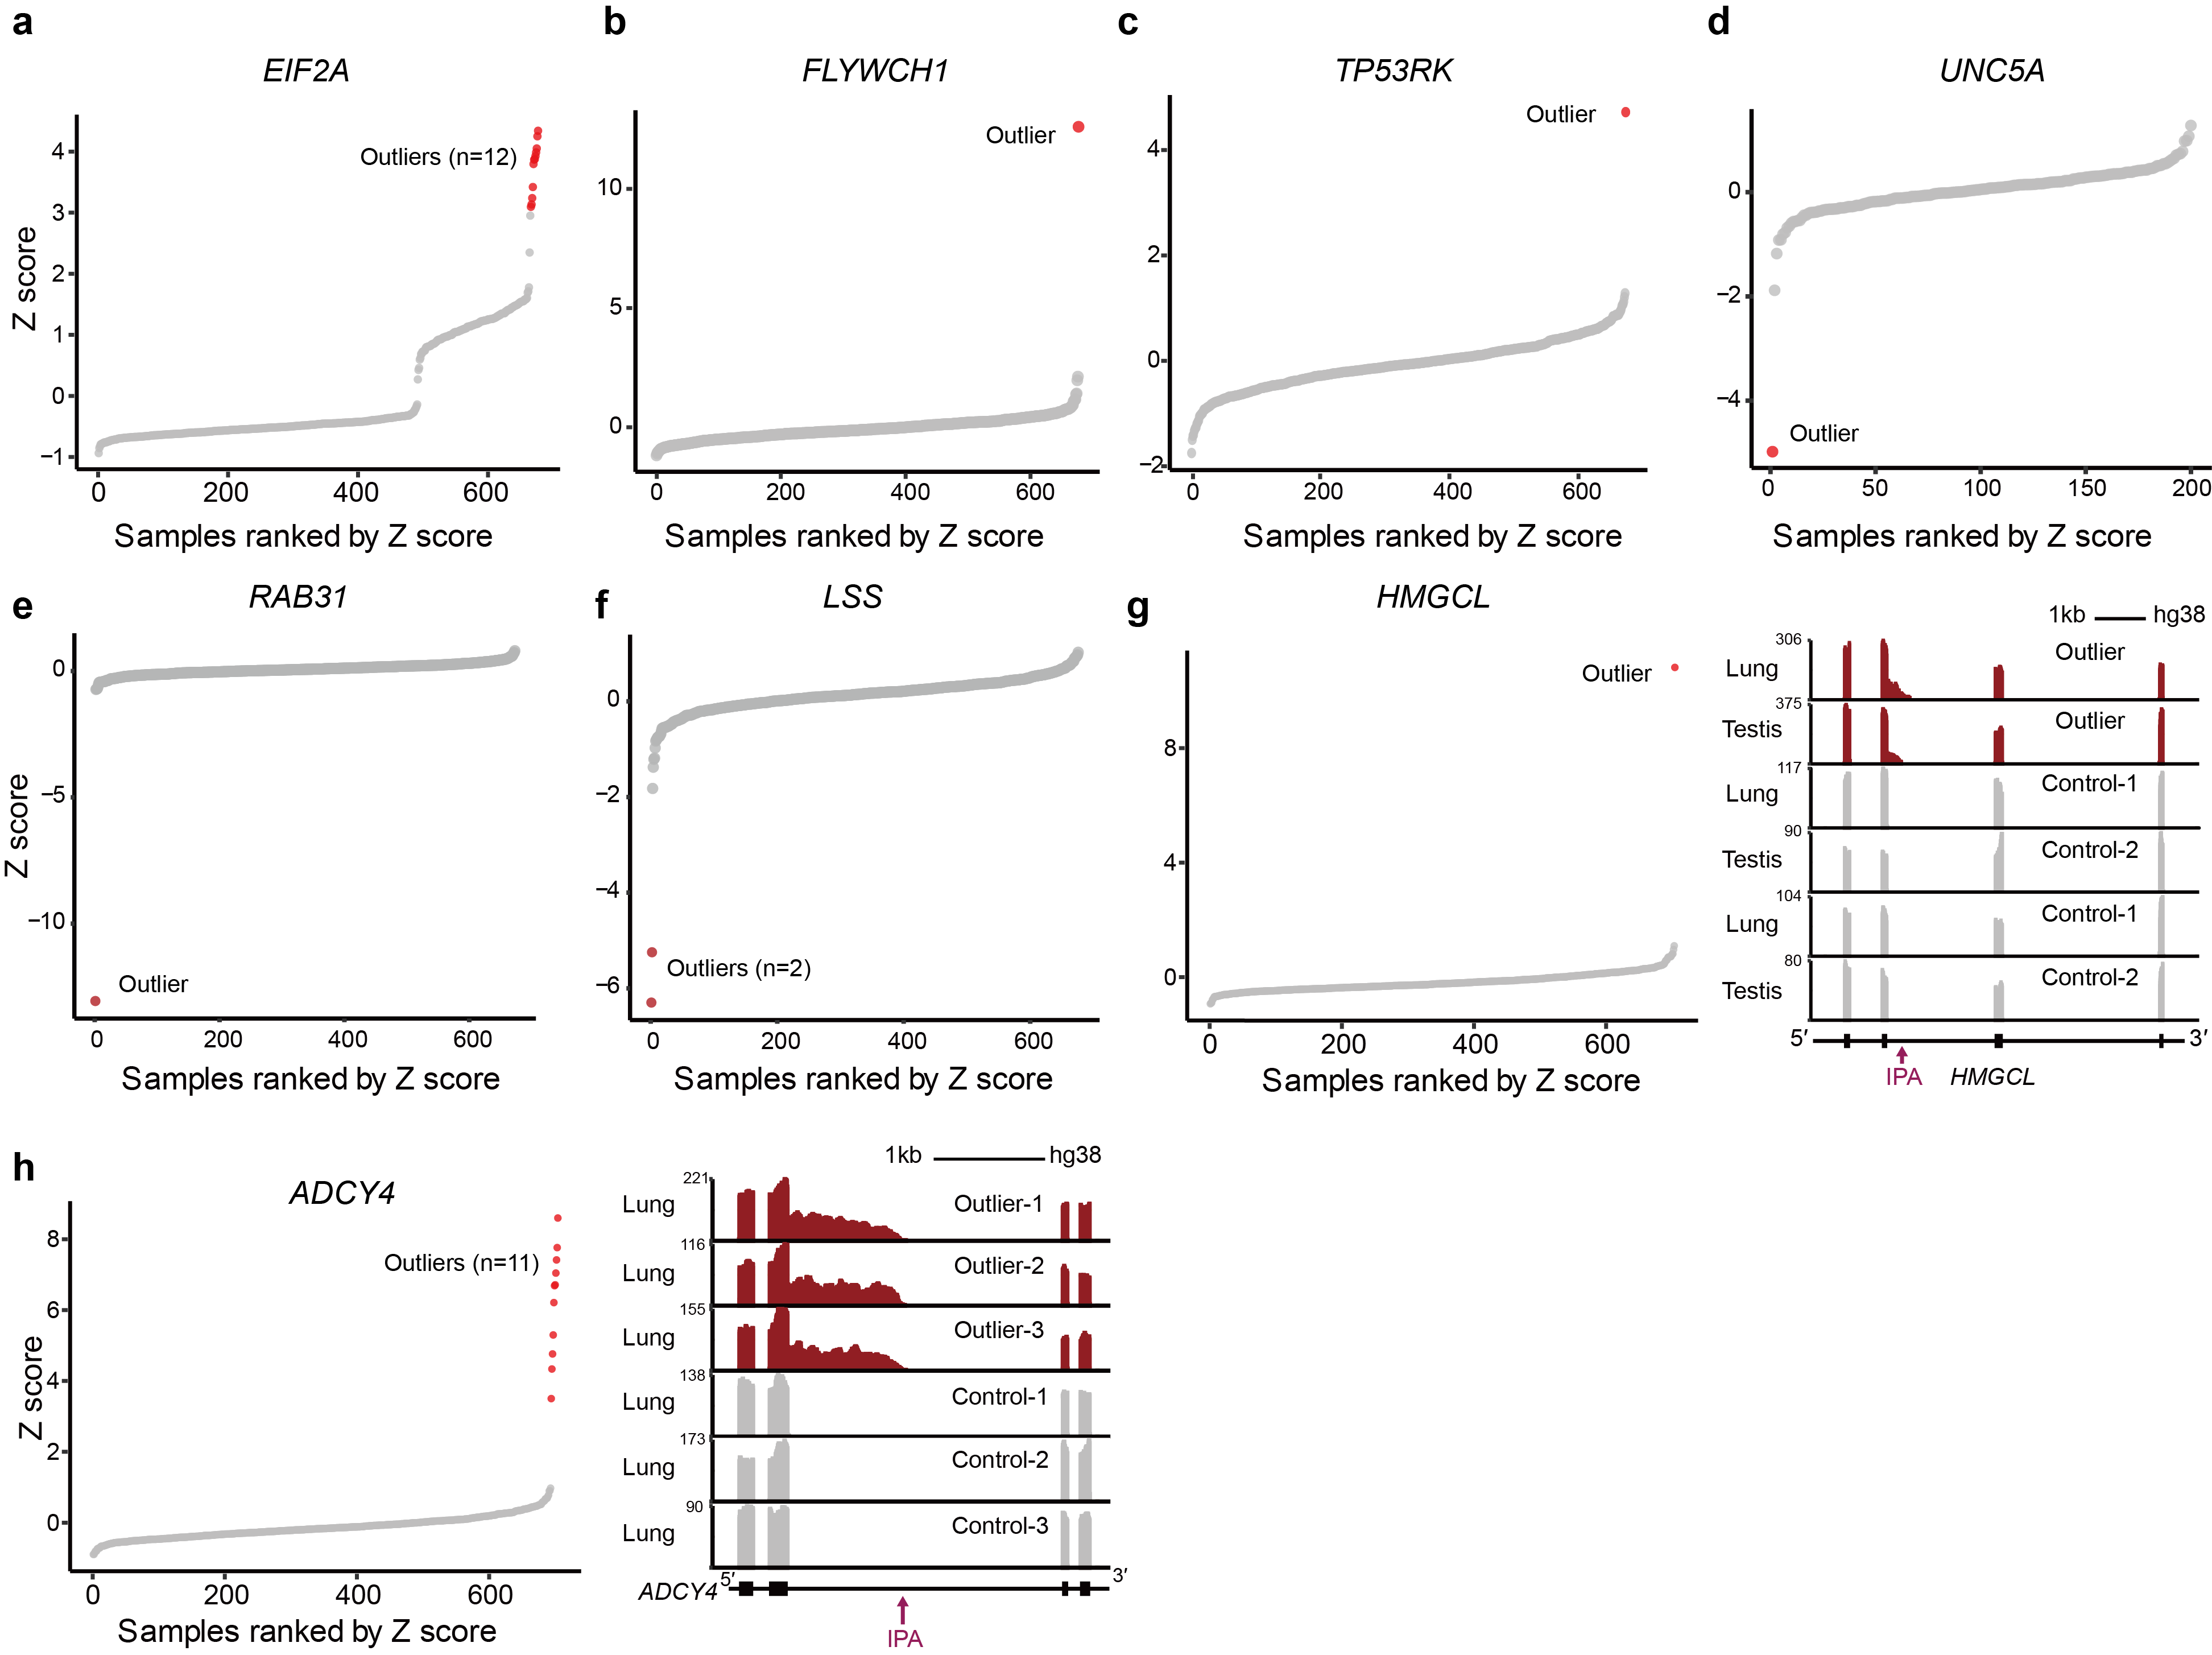
Supplementary Figure 7. Examples of aOutliers identified in well-known genes. a-f. Distributions of median Z-score of 3’UTR aOutliers associated with gene EIF2A, FLYWCH1, TP53RK, UNC5A, RAB31, and LSS. g-h. Distributions of median Z-score (left) and RNA-seq reads coverage plots (right) of intronic aOutliers associated with gene HMGCL and ADCY4. aOutlier individuals are indicated with red dots.

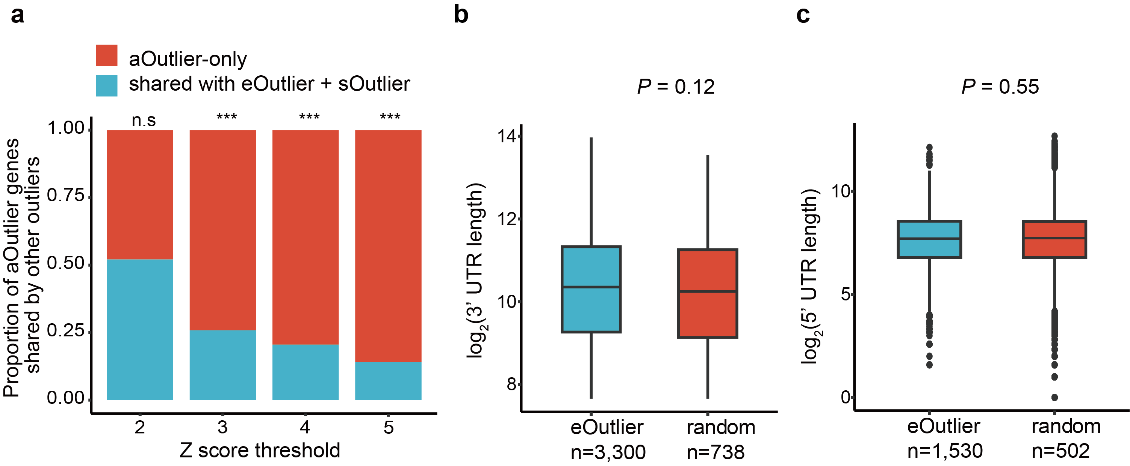
Supplementary Figure 8. Overlaps among aOutlier genes, eOutlier genes, and sOutlier genes, and comparisons of 3′ UTR length and 5′ UTR length between eOutlier genes and randomly drawn genes. a. The proportion of aOutlier genes was also detected by analysis of expression outliers (eOutliers) and splicing outliers (sOutlier) in the same dataset. Statistic significance was estimated by Fisher’s exact test. b-c. A random gene set was randomly selected from all tested genes, and the number of genes equals that of aOutlier genes. The significance and P values were estimated using the Wilcoxon rank−sum test. Box plots show the median and first and third quartiles, and whiskers extend up to 1.5 times the interquartile range.

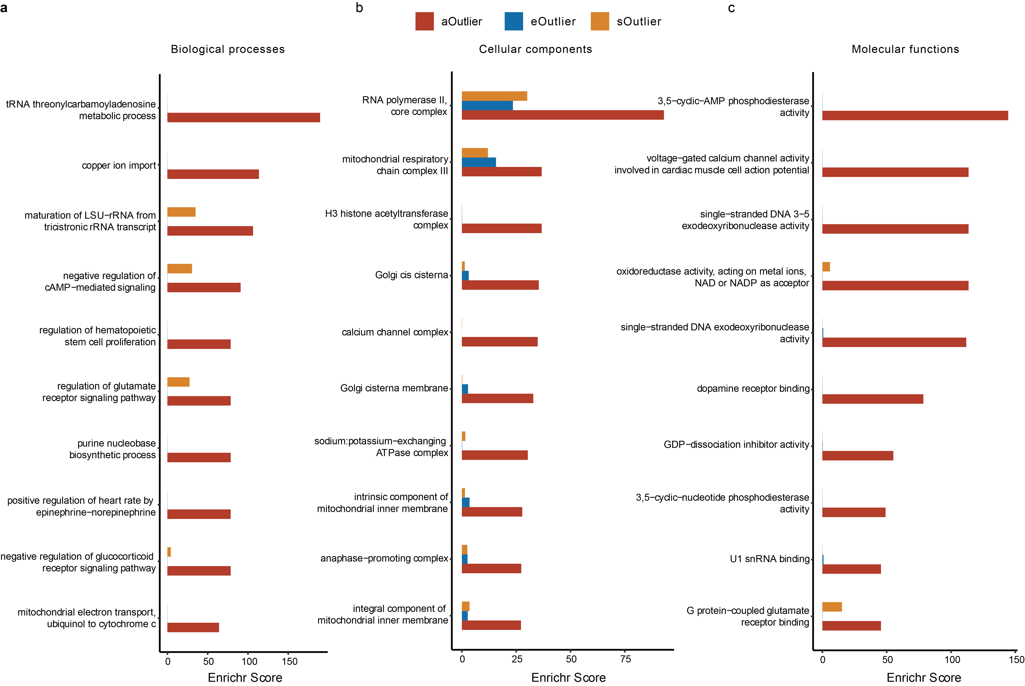
Supplementary Figure 9. Gene ontology enrichment analysis reveals different terms for genes associated with aOutliers (red), eOutliers (blue), and sOutliers (orange), respectively. a. Top 10 biological processes enriched in the above three gene sets. b. Top 10 cellular components enriched in the three gene sets. c. Top 10 molecular function terms enriched in the three gene sets. For all types of gene ontology, the enrichment score from Enrichr was presented.

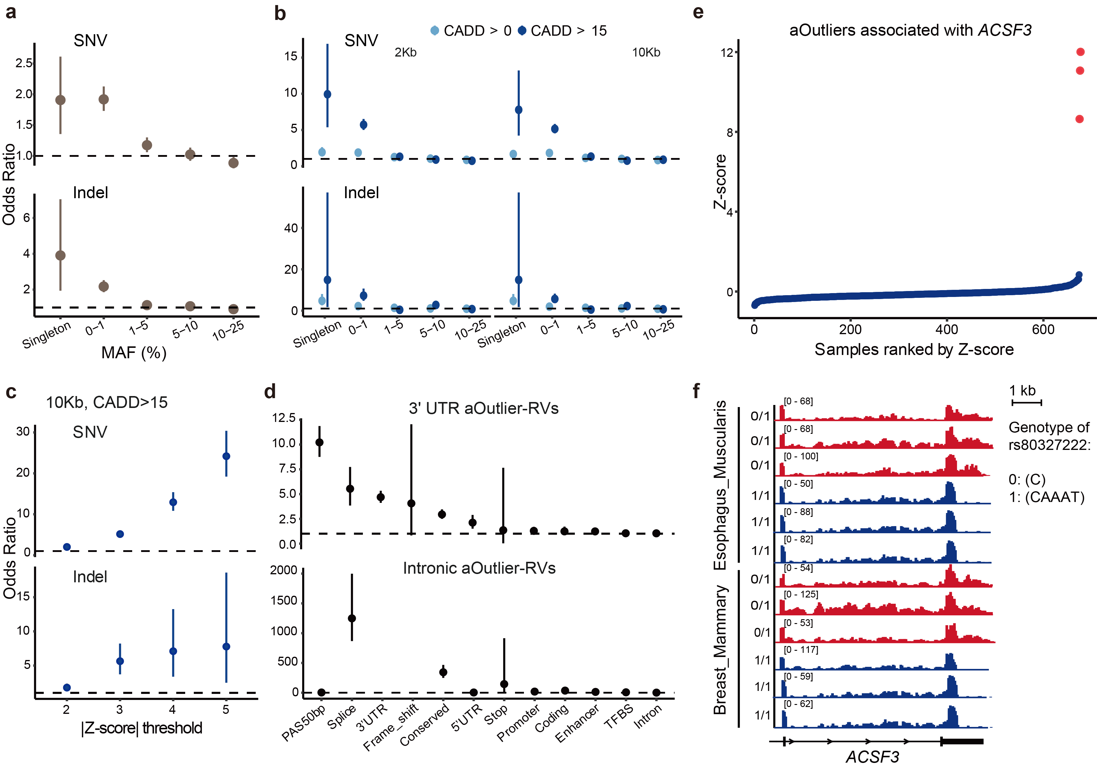
Supplementary Figure 10. RVs are significantly enriched among multi-tissue aOutliers. a. Enrichment of variants in multi-tissue aOutliers compared to nonoutliers. Variants were stratified by minor allele frequency (MAF). Singleton represents rare variants that was present in one sample in GTEx. b. RVs within 2 kb or 10 kb of aOutlier genes are significantly enriched in outlier individuals compared with nonoutlier individuals. The RVs were stratified by CADD score (CADD score>0 or CADD>15). RVs with CADD score>25 that are present in Figure 3 are not presented here because there are rare indels with CADD score>25. Enrichment was presented as an odds ratio, and 95% CIs were also given. c. RVs (SNVs and Indels) enrichment are increased in more extreme aOutliers defined by higher |Z-score| threshold. d. Enrichment of RVs of different functional categories in 3′ UTR aOutliers (top) and intronic aOutliers (bottom) separately. Data are presented as odds ratio and 95% CIs. e. Distribution of Z-score (median value across tissues) of ACSF3 in all subjects. Three outlier samples were indicated as red dots. f. Reads coverage of outlier individuals (red) and nonoutliers (blue) in the 3′ UTR of ACSF3.

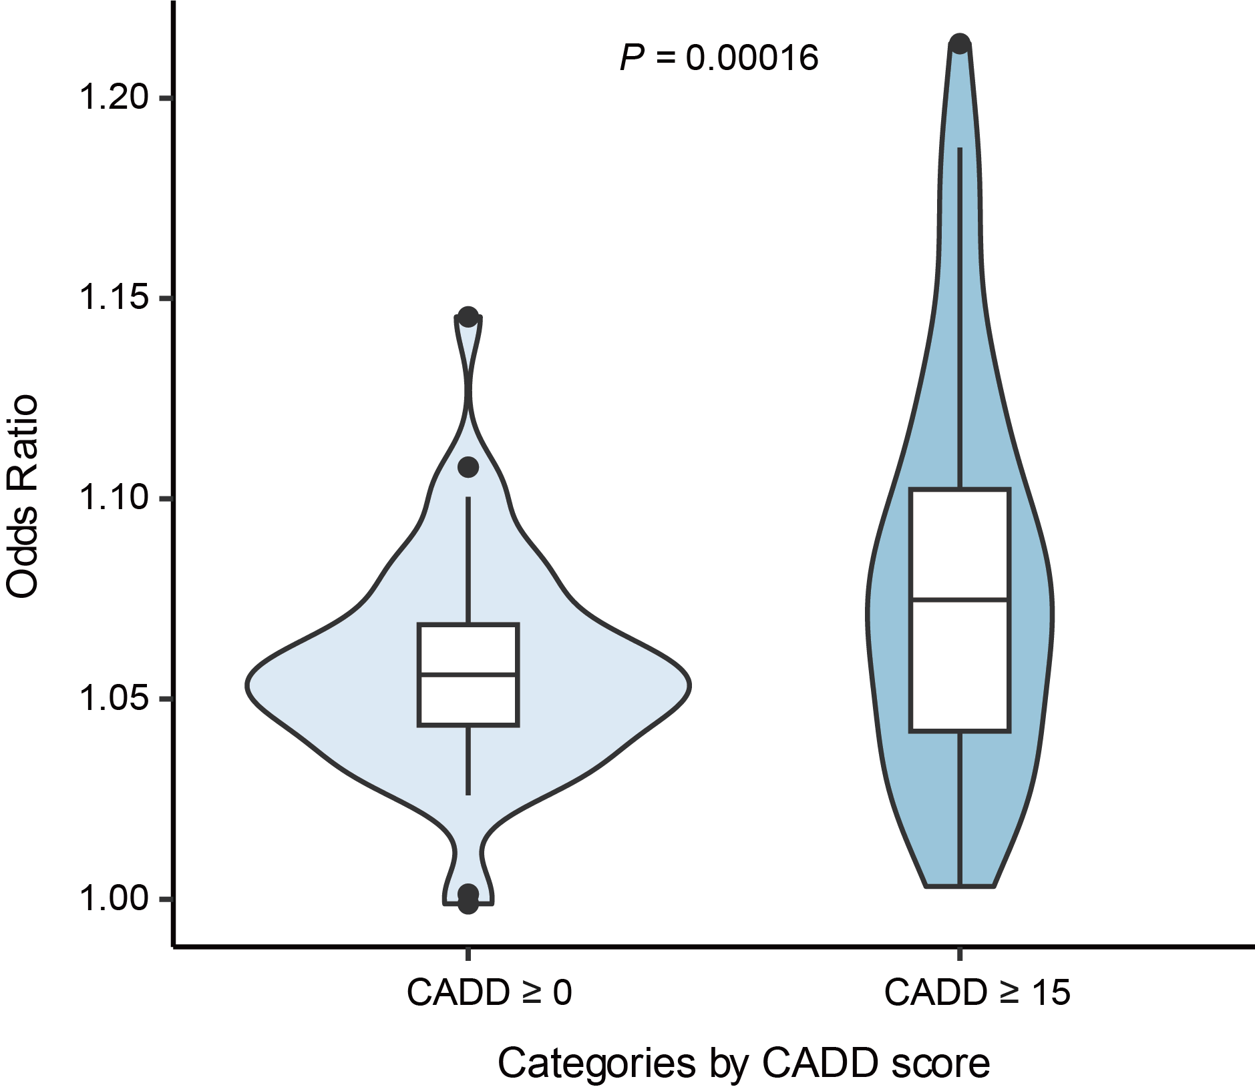
Supplementary Figure 11. RVs are significantly enriched among single tissue aOutleirs. Distribution of RV (including SNV and Indel) enrichment odds ratios across tissues. P values of the difference between the two groups stratified by CADD scores were obtained from paired samples using the Wilcoxon rank−sum test. Box plots in the middle show the medians and first and third quartiles, and whiskers extend up to 1.5 times the interquartile range.

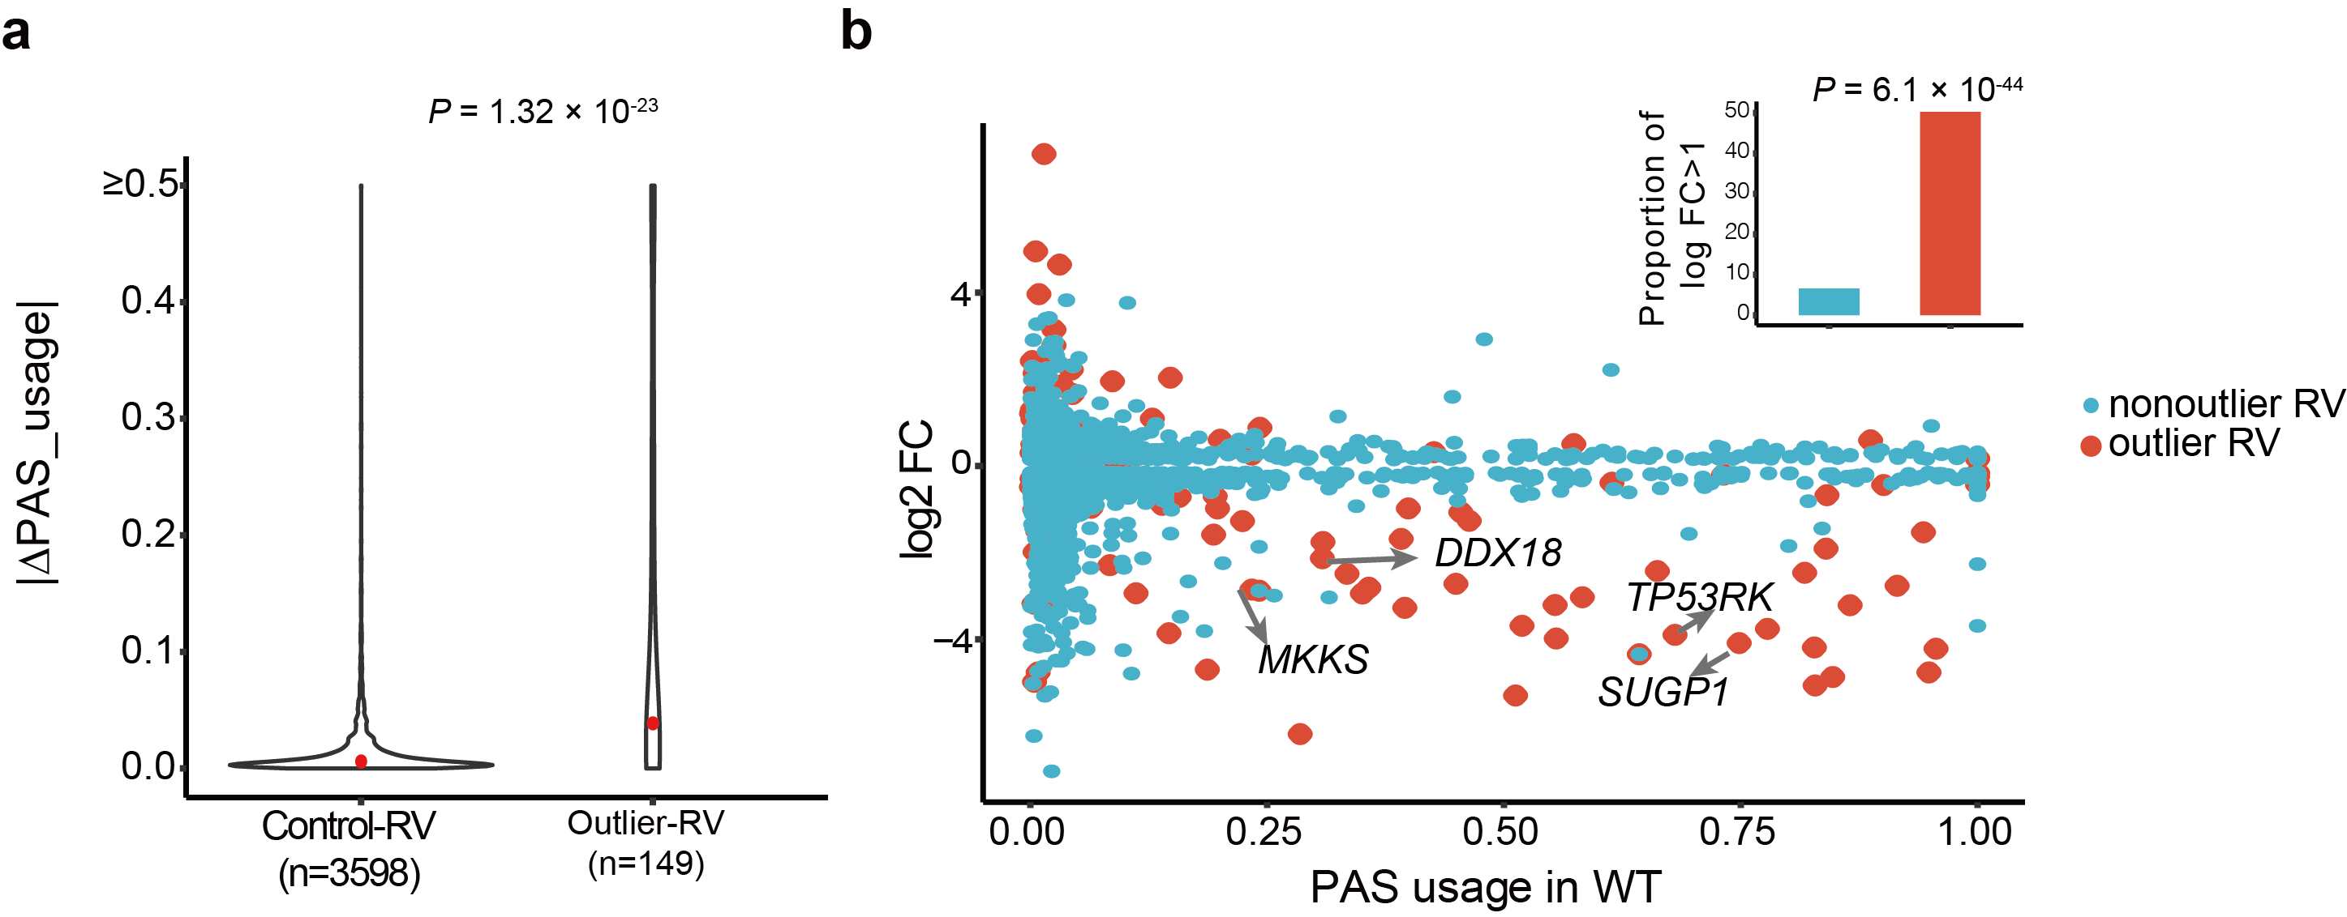
Supplementary Figure 12. Multi-tissue aOutlier RVs present a significant effect on modulating APA usage. a-b. RVs associated with multi-tissue aOutliers have a larger effect (DPAS usage) on APA usage than those associated with nonoutliers (control). Both DPAS usage (a) and proportion of large-effect (absolute logFC>1) RVs (b) were compared between aOutliers and nonoutliers. P values were calculated by single-tailed Wilcoxon rank−sum test. P values were calculated from the single-tailed Wilcoxon rank−sum test.

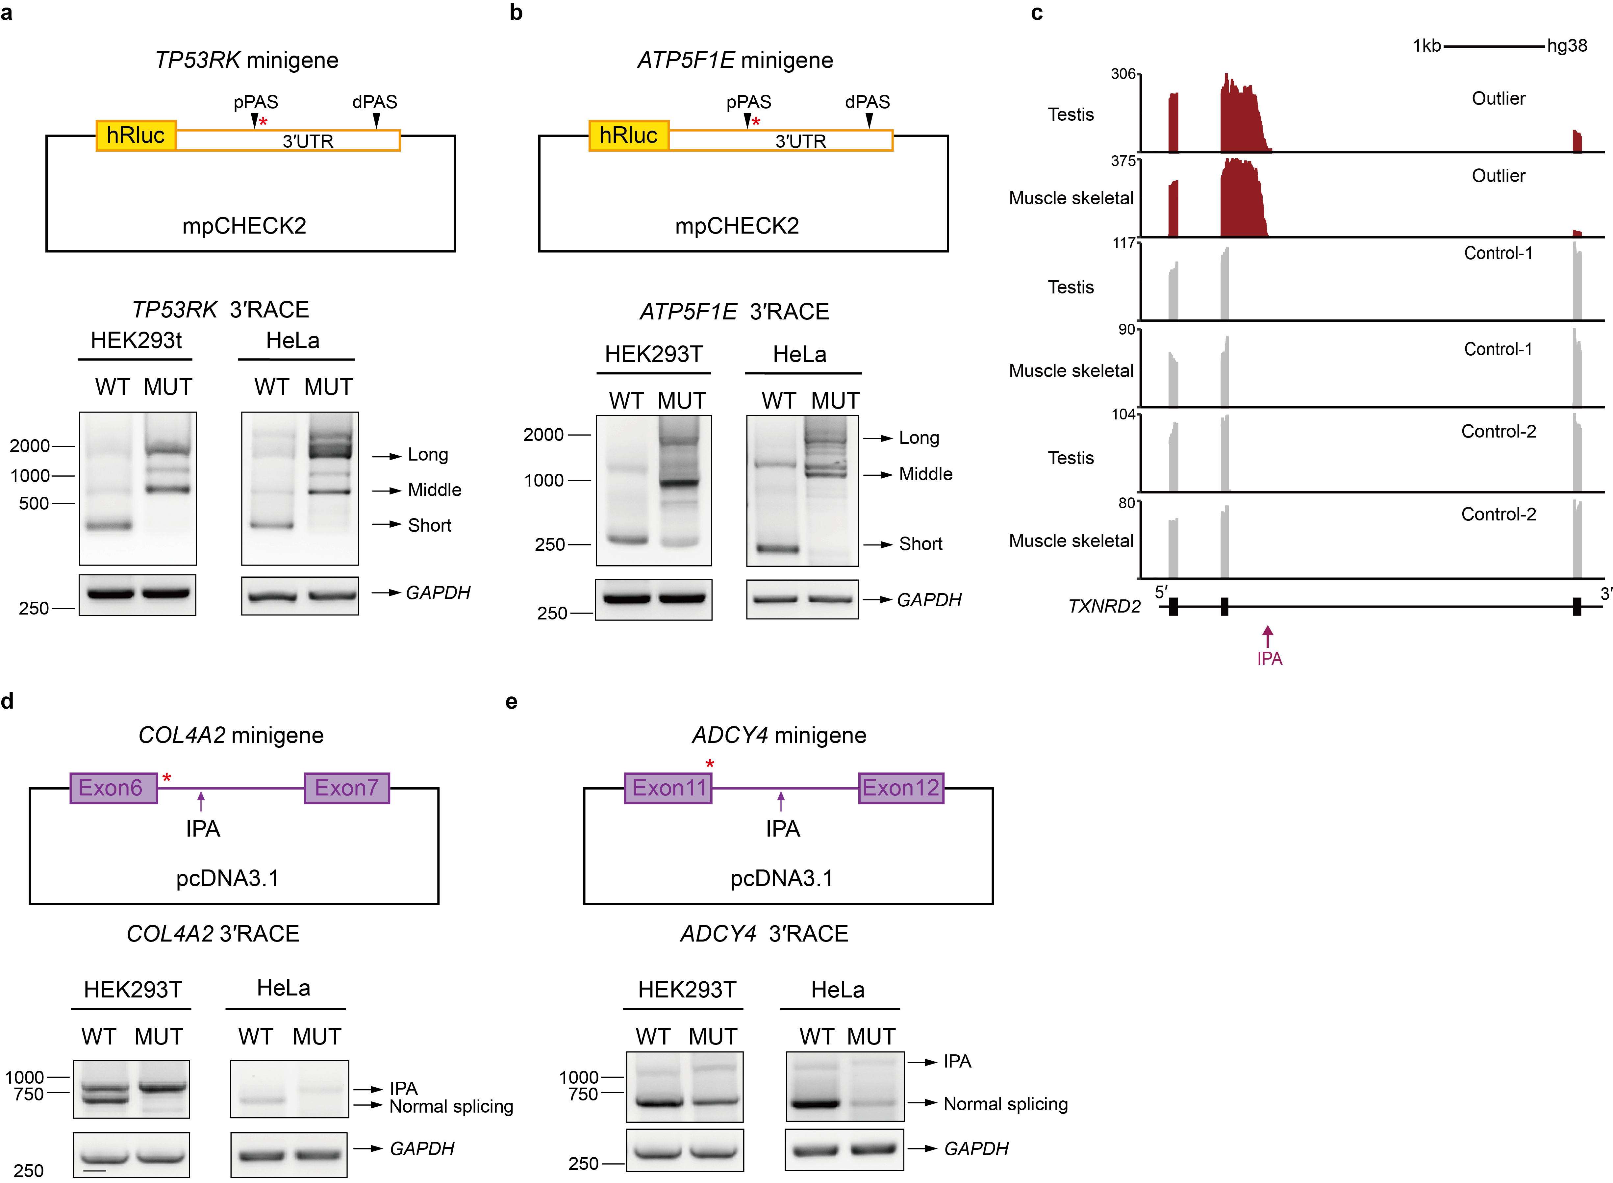
Supplementary Figure 13. Minigene and 3′ RACE assays validate the effects of aOutlier-associated RVs. a-b. Minigenes (top) contain rare variants (red asterisk) in 3′ UTR of genes TP53RK and ATP5F1E, and 3′ RACE results (bottom) of corresponding minigenes. c. RNA-seq reads coverage of gene TXNRD2 exon 6-8 and intron regions between them. Tracks for outlier individuals are indicated in red, and those for non-outlier individuals are indicated in gray. d-e. Minigene of intronic APA events of COL4A2 and ADCY4 containing rare variants (red asterisk) in the splice donor site and results of 3′ RACE of the corresponding minigenes.
Supplementary Figure 14. Potential APA regulators for aOutliers. a. Bar plot shows the P values of enriched RNA binding motifs from DeepBind altering by aOutlier-associated RVs. b. Percentages of CLIP-seq (K562 cell line) peaks located in 3′ UTR regions. RBPs are ranked by the percentage of peaks located in 3′ UTRs. c-d. Differential APA events identified in LARP4-knockdown (KD) (c) and CSTF2T-KD (d) samples compared to control samples. Two example genes with differential APA in LARP4-KD and CSTF2T-KD samples, respectively, were labeled. e. Scatter plot and RNA coverage plot show aOutliers in SREBF2. f. Locations of rare variants (red) in SREBF2 and the binding regions of LARP4 were obtained from the eCLIP assay in the HepG2 cell line. g-i. Differential APA events were identified in TIA1-KD (g), UPF1-KD (h), and SAFB2-KD (i) samples compared to corresponding control samples. Lengthened APA events are indicated with blue dots and shortened APA events are indicated with red dots. P values are calculated from two-sided binomial test.

Supplementary Figure 15. aOutliers improve prediction of rare functional variants. a. Overview of aWatershed model. b. Distribution of PR-AUC of aWatershed models for the three outlier signals under training data of different ratios of positive and negative instances (from 1:1 to 1:100). c. Comparison of PR-AUC of aWatershed model (red) with RIVER (blue) and GAM model (orange). For each of the three model, the PR-AUC was estimated from model trained and evaluated with different data sets corresponding to that shown in (b). The error bar represents standard error, and the P values were estimated from paired t-test. d. Left panel: Comparison of aWatershed score (posterior) (x-axis) to APARENT predicted APA effect score (y-axis). APARENT prediction score was presented as tanh normalized. Dot was colored by the value of aWatershed score and two example RVs were highlighted with black stars and labeled with associated gene names. Right panel: The prediction results of APARENT on the two example RVs highlighted at the left panel. The predicted APA effect was presented as the differential peak height which means the cleavage effiency of the poly(A) site. e. Distribution of median Z-score of aOutlier gene MTHFD2 across individuals. Outlier individuals were indicated as red dots. f. Reads coverage plot describing the usage of distal poly(A) site in 3′ UTR of MTHFD2 in outlier individuals (red) and nonoutlier individuals (gray).

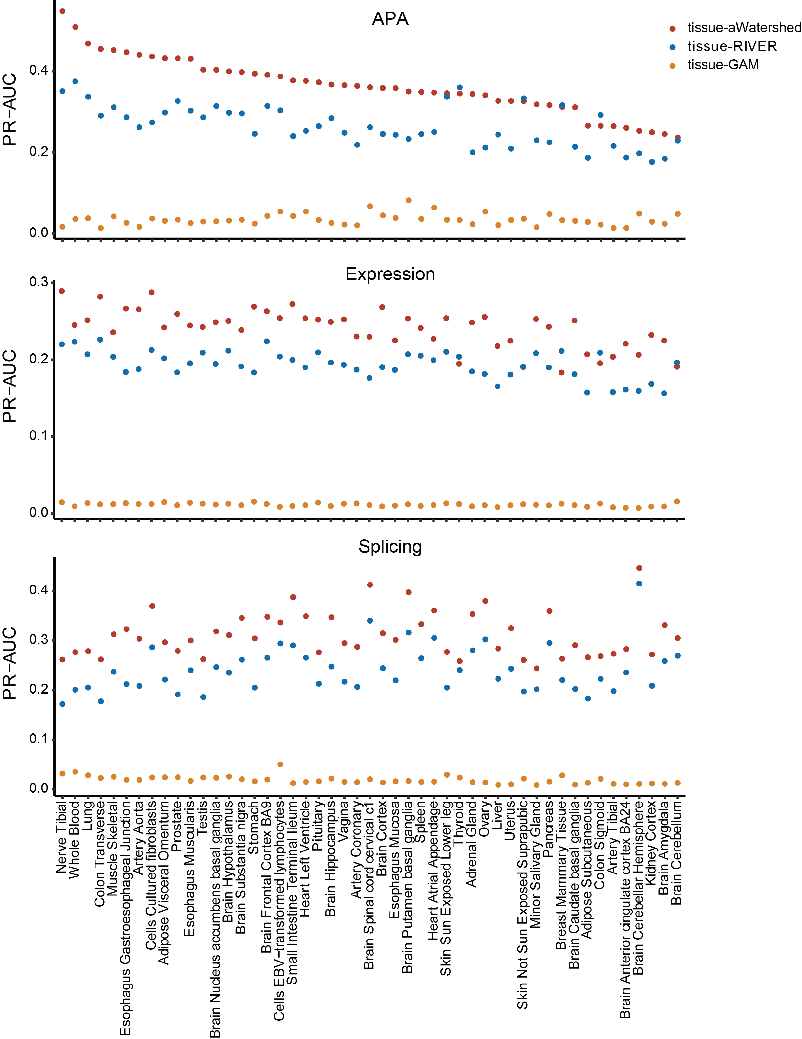
Supplementary Figure 16. Area under precision recall curves in single tissues. Area under precision recall curves (PR-AUC; y-axis) in a single tissue (x-axis) for tissue-aWatershed (red), tissue-RIVER (blue), and tissue-GAM (orange) model when applied outliers detected in individual tissues for all three outlier types (rows). Precision recall curves in each tissue was generated using held out pairs of individuals (N2pair) where both individuals share the same RVs and have outlier signal for the gene of interest.

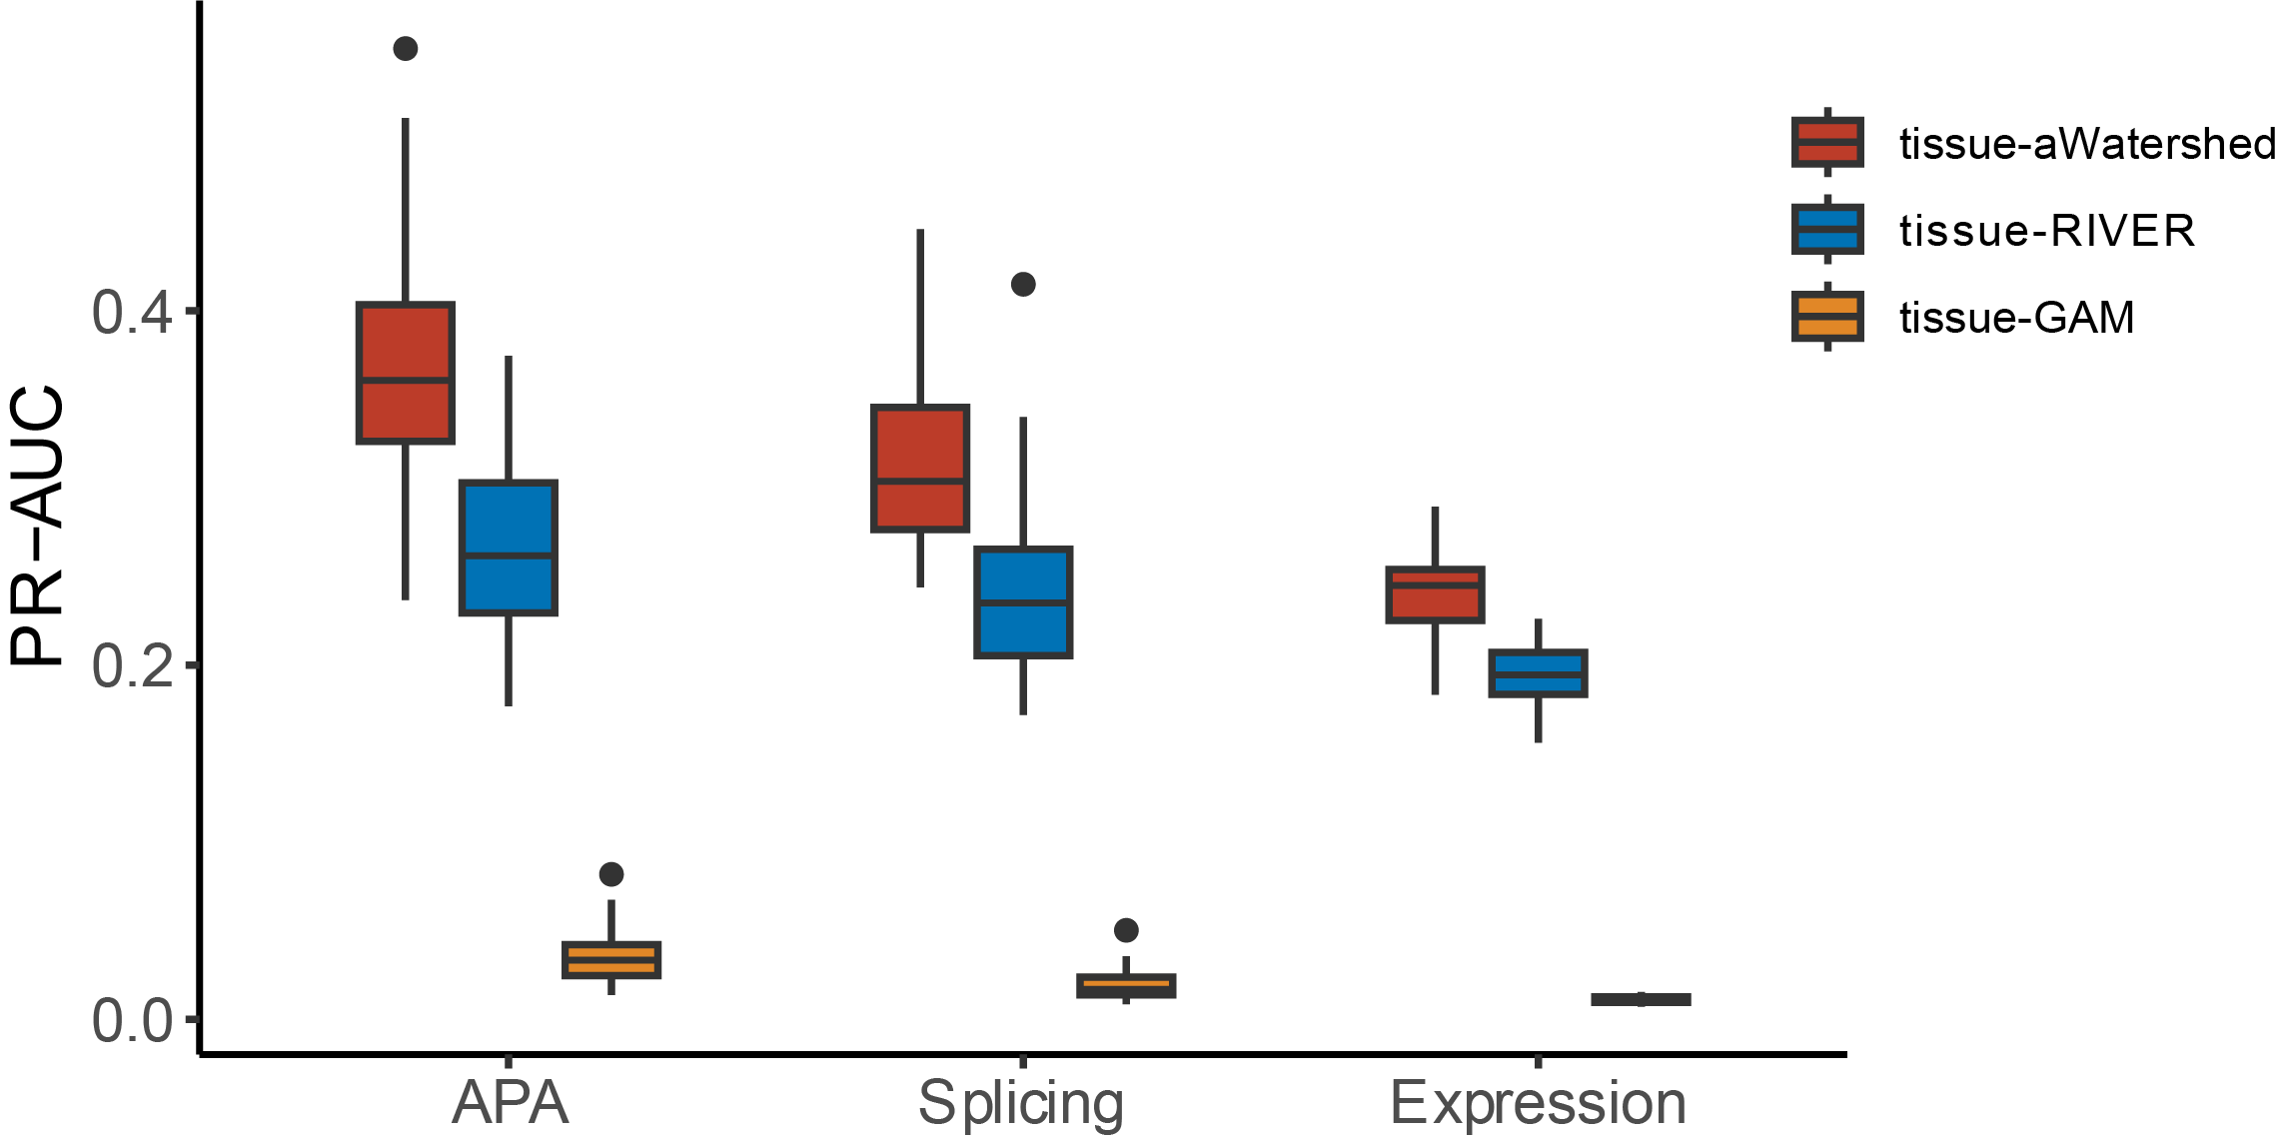
Supplementary Figure 17. Comparison of PR-AUC among the three types of tissue models. The PR-AUC (y-axis) of the three types of tissue models, including tissue-aWatershed (red), tissue-RIVER (blue), and tissue-GAM (orange), in 49 tissues for the three types of outliers (x-axis) were compared. Box plots show the median and first and third quartiles, and whiskers extend up to 1.5 times the interquartile range.

Supplementary Figure 18. Cross-reference between APA RVs and impacting genes prioritized by aWatershed and disease genes annotated in OMIM database. a. The intersection between aWatershed prioritized genes (red) and known disease genes in OMIM (blue). b. Manhattan plot shows the aWatershed prioritized RVs. Y-axis denotes the aOutlier posterior for each RV, and RVs were prioritized by a posterior threshold of 0.5. Genes associated with RVs having a posterior > 0.9 were highlighted with bigger dots and gene labels. Three well-known and well-studied disease genes were highlighted by red dots.

Supplementary Figure 19. aWatershed prioritize RVs have larger GWAS trait effect size. a. Distribution of median odds across 1000 permutation test of traits from UKBB. GWAS summary data of traits with evidence of colocalization on 3'aQTL and with more than 5,000 SNPs overlapped with RVs in GTEx cohort were remained, resulting in 491 traits. P values were calculated from the paired-sample and one-sided Wilcoxon rank-sum test (n=491). Box plots show the median and first and third quartiles, and whiskers extend up to 1.5 times the interquartile range. b. Distribution (red) of odds estimated from permutation test assessing how often randomly drawn aWatershed-prioritized RVs have larger effect sizes in GWAS of sitting height than matched non-prioritized RVs across genes. The null distribution (in gray) of odds was obtained from a permutation test by randomly drawning two RVs from a non-prioritized RV set only. P value was calculated from the one-sided Wilcoxon rank‒sum test. c. Manhattan plot (left) across 20 Mb in chromosome 2 for GWAS signals of sitting height (20015_irnt) in the UKBB. The aOutlier prioritized RV rs112567314 in the colocalized region was highlited by the red triangle, and the GWAS lead SNP is indicated by a blue diamond. The blue square denotes RVs prioritized by eOutliers or sOutliers in the same region. UKBB MAF vs. effect size for all variants within 1Mb of the aOutlier prioritized RV was shown on the right.

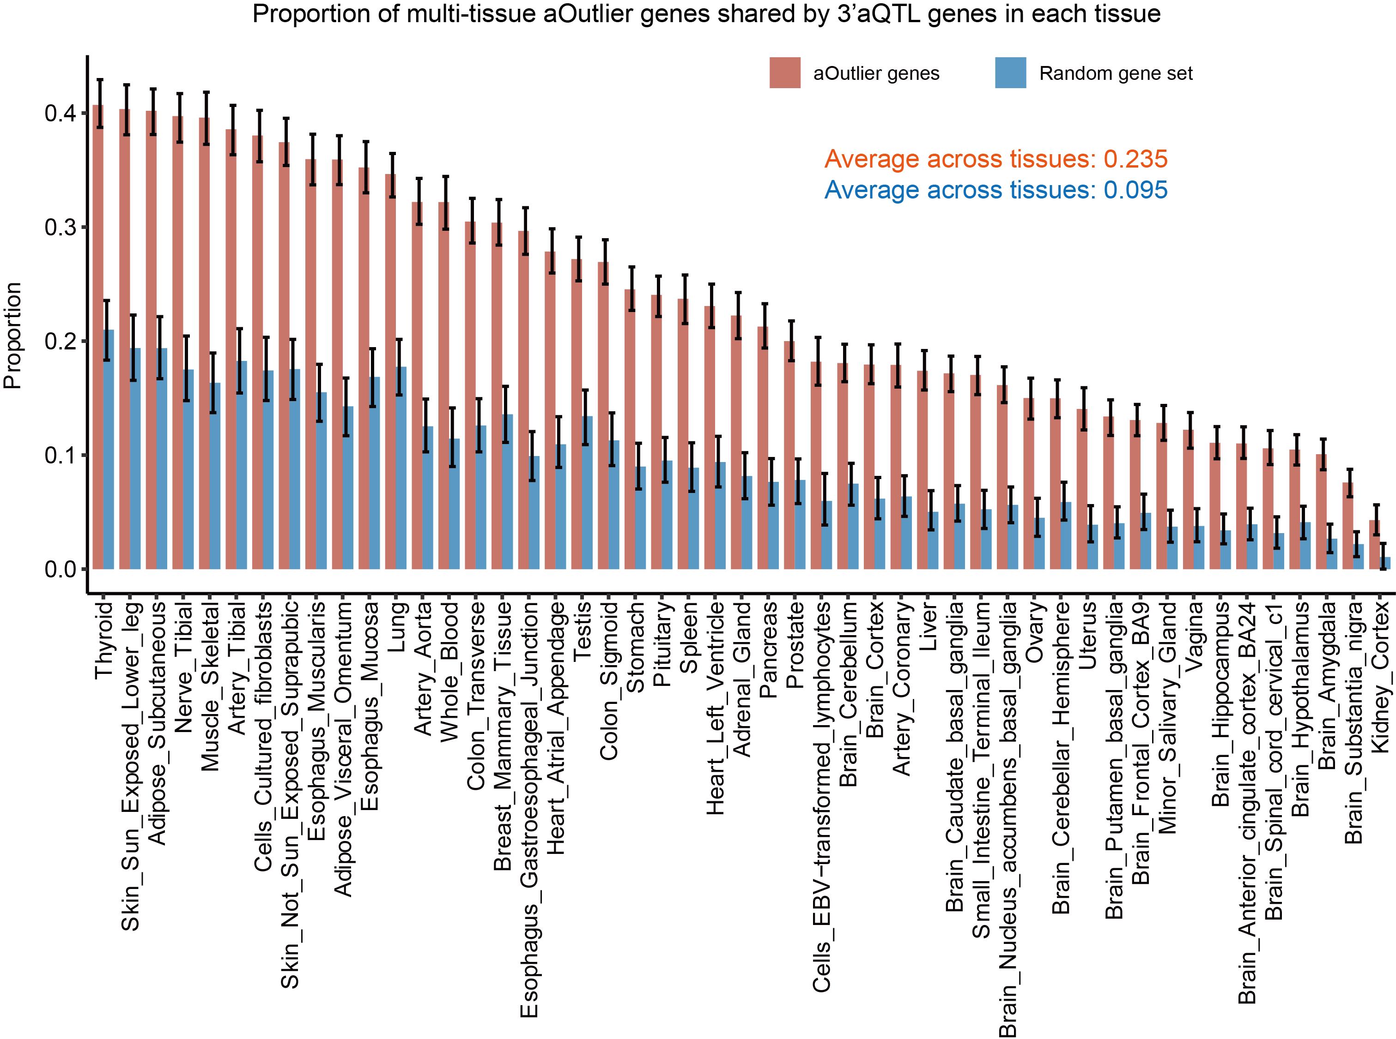
Supplementary Figure 20. Convergence of rare and common variants on modulating APA usage. The bar plot shows the proportions of multi-tissue aOutlier genes shared by significant 3’aQTL genes in the same tissue. The proportions were estimated by a bootstrapping method and the 95% confidence intervals were also calculated (error bar). To make a comparison, we also estimated the background proportion in each tissue by calculating the proportion of a randomly drawn gene set of size equal to the number of multi-tissues aOutlier genes in that tissue, shared by 3’aQTL genes.

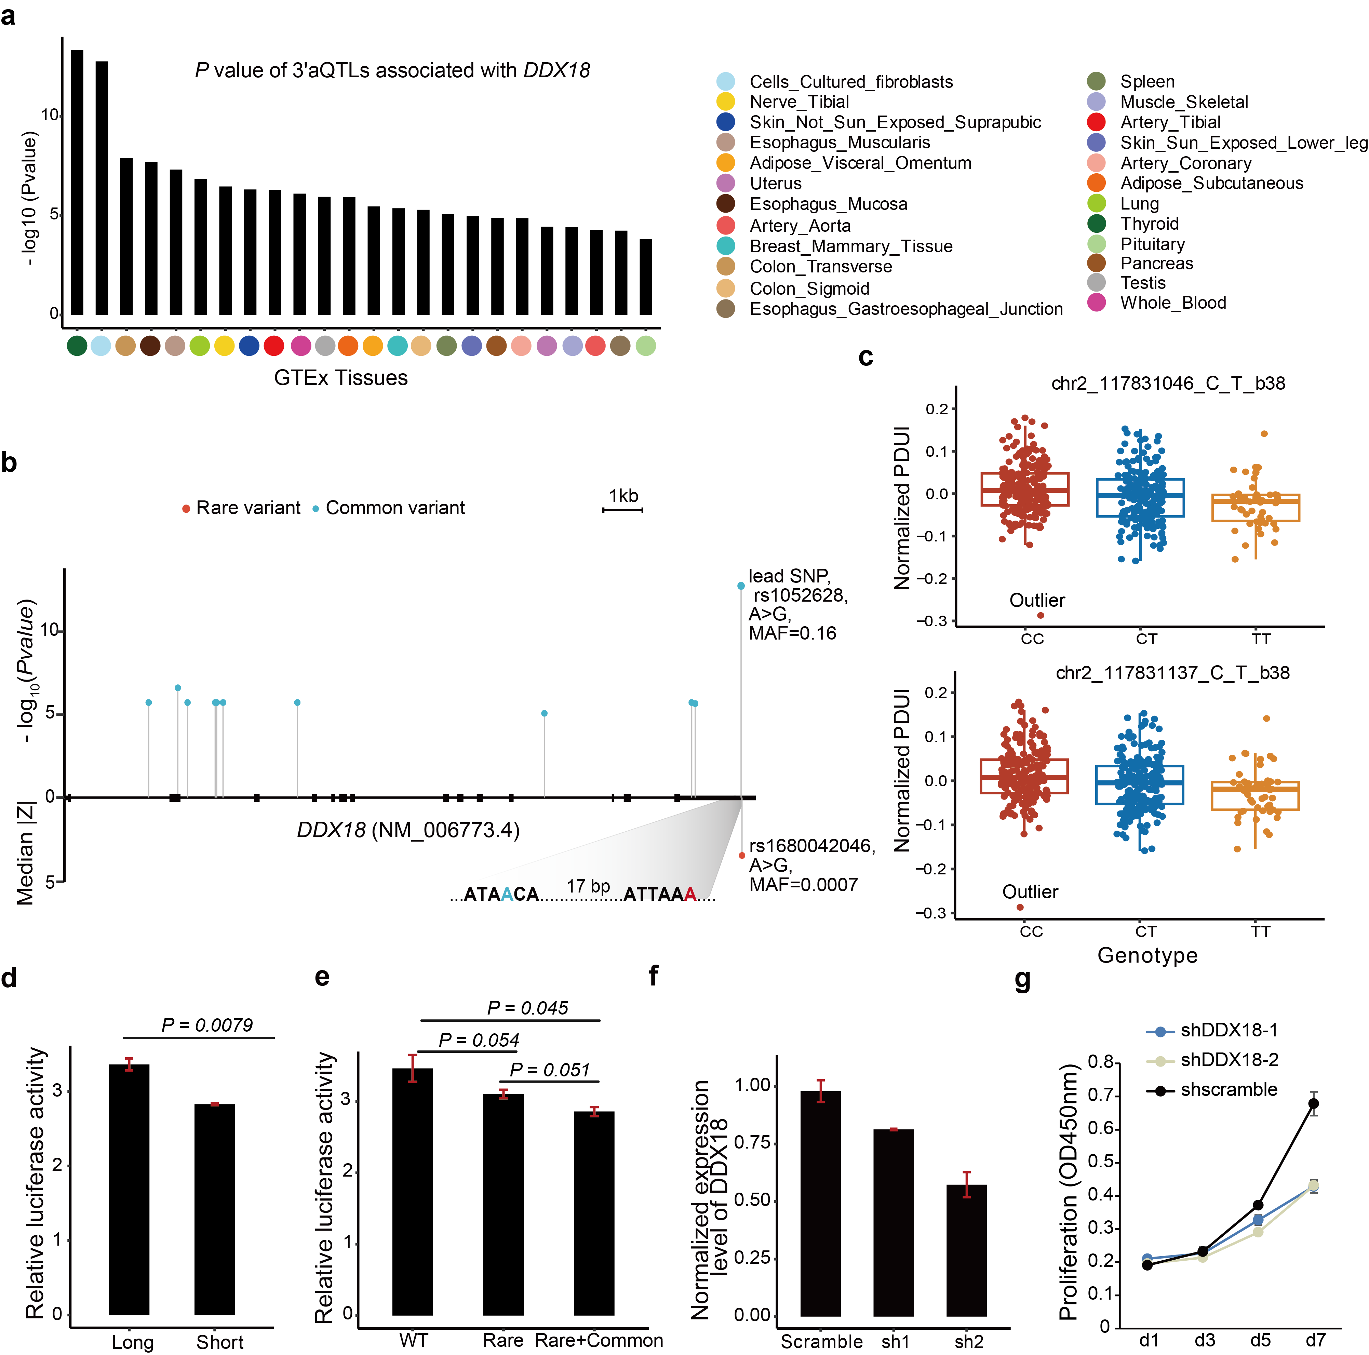
Supplementary Figure 21. Convergence effects of rare and common variants on regulating 3′ UTR of DDX18. a. P values of lead SNPs associating with APA usage of DDX18 across 24 human tissues in GTEx. b. Distribution of the 11 3′aQTL variants (blue) and RVs (red) in the gene body of DDX18. Data are presented as −log₁₀(P-value) for 3′aQTL variants and median |Z| for the RV. c. Box plots show the associations between the two 3′ UTR common variants and APA usage of DDX18 in tissue Cells-Cultured fibroblast. The outlier individual harboring aWatershed-prioritized RV was labeled with “Outlier”. d. Luciferase activity of the reporter systems containing the short and long 3′ UTR isoforms of DDX18 in MCF7 cells. P value was estimated by a one-sided paired sample t-test, and the error bar represents standard error (n=3 independent experimental replicates). e. Luciferase activity of the reporter systems containing reference and alternative allele of the rare and common variant located within DDX18 3′ UTR in MCF7 cells. "Rare" means the reporter only contains the rare variant, and "Rare+Common" means the reporter contains both the rare and common variants. P values were estimated from a one-sided paired sample t-test. The error bar represents standard error across replicates (n=3). The bar plot shows the effect of RV, common variant, joint of RV, common variant, and computed additive effect on APA of DDX18. Student t-test was used to test the difference between expected additive effect and joint effect. Box plots show the median and first and third quartiles, and whiskers extend up to 1.5 times the interquartile range. f. Bar plots show the expression level of DDX18 after knockdown by shRNAs. Error bars represent standard error across three replicates (n=3). g. Proliferation of MCF7 cells with or without DDX18 knockdown by shRNAs. Proliferation was estimated at days 1, 3, 5, and 7. Data presented as median value (the dot) and 95% CIs.

