Supplementary Information

Laser Emitting Cytometry for Label-Free Nucleolus Fingerprinting

Guocheng Fang¹, Zhen Qiao², Hui Zhu¹, Jun Xie¹, Tian Zhou¹, Zhongshu Xiong¹, Dayong Jin³,
Yu-Cheng Chen^{1 *}

¹School of Electrical and Electronics Engineering, Nanyang Technological University, 50 Nanyang Ave., Singapore 639798, Singapore.

²School of Optical-Electrical and Computer Engineering, University of Shanghai for Science and Technology, No. 516 Jun Gong Road, Shanghai 200093, China

³Institute for Biomedical Materials and Devices (IBMD), Faculty of Science, University of Technology Sydney, Sydney, NSW, Australia

Corresponding Email: yucchen@ntu.edu.sg

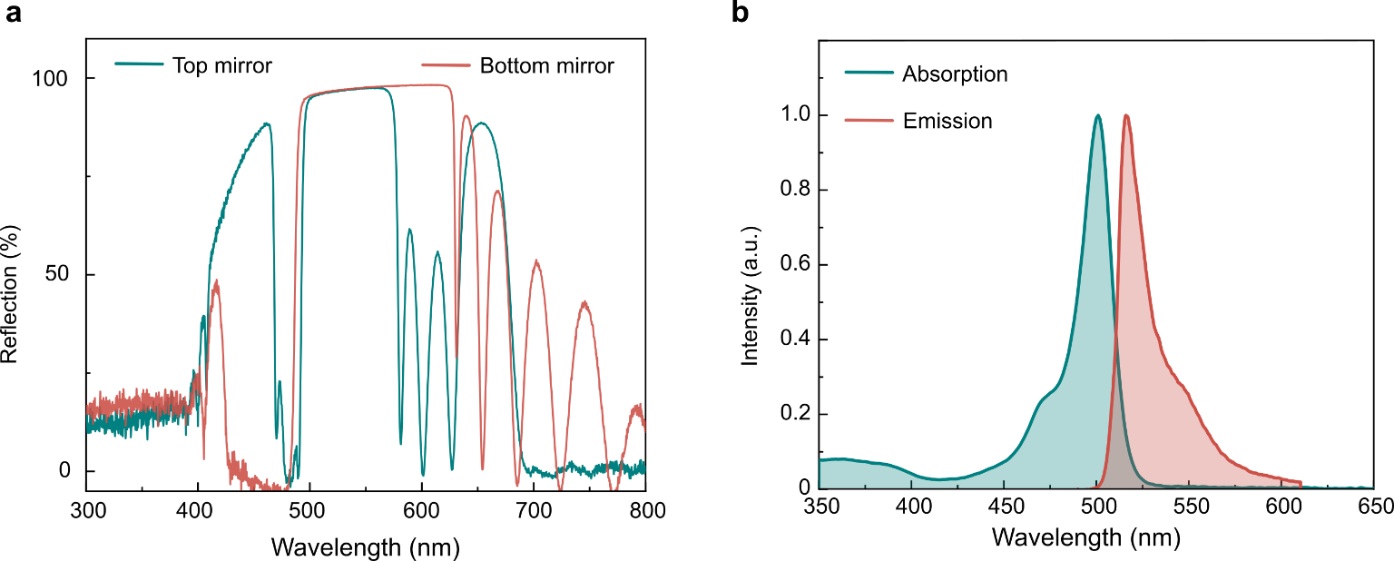

Supplementary Fig. S1. Characterization of the mirrors and the fluorescent dye. (a) Reflectance spectra of the top mirror (cyan curve) and bottom mirror (red curve). The reflectivity of the mirrors at 500-570 nm is about 99.8% for the top mirror and 99.9% for the bottom mirror. (b) Absorption (cyan curve) and emission (red curve) spectra of Bodipy-1 in toluene.

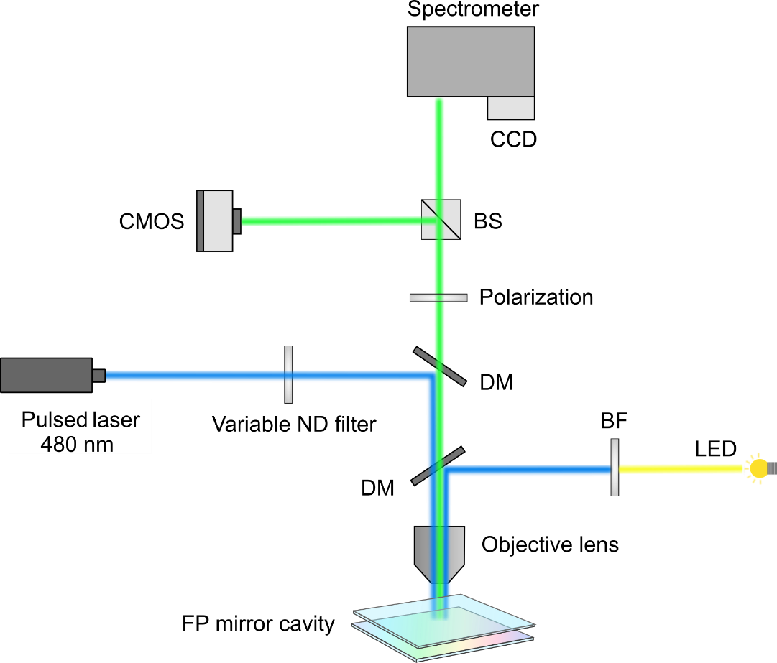

Supplementary Fig. S2. Illustration of the experimental setup. The laser emission was split by a beam splitter and then propagated into the spectrometer and the CMOS camera, allowing the recording of the emission spectrum and transverse mode pattern. The LED excitation was used to observe the fluorescent images. BS: beam splitter, DM: dichromic mirror, BF: bandpass filter, ND: neutral density.

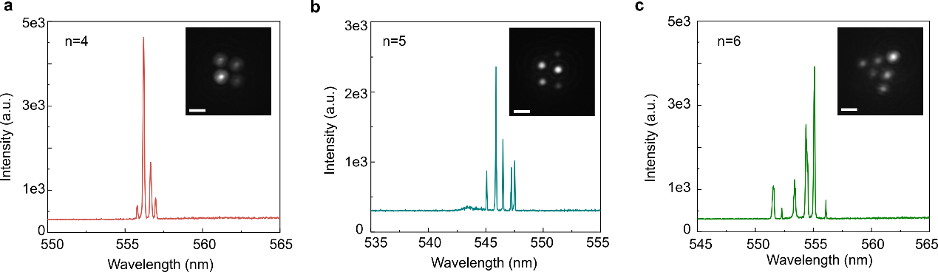

Supplementary Fig. S3. Lasing spectra and the laser emission images of 5 μm microspheres. (a-c) Spectra and laser emission images when four, five, and six microspheres were pumped simultaneously. $n$ represents the lasing peak number within an FSR. Scale bar: 5 μm.

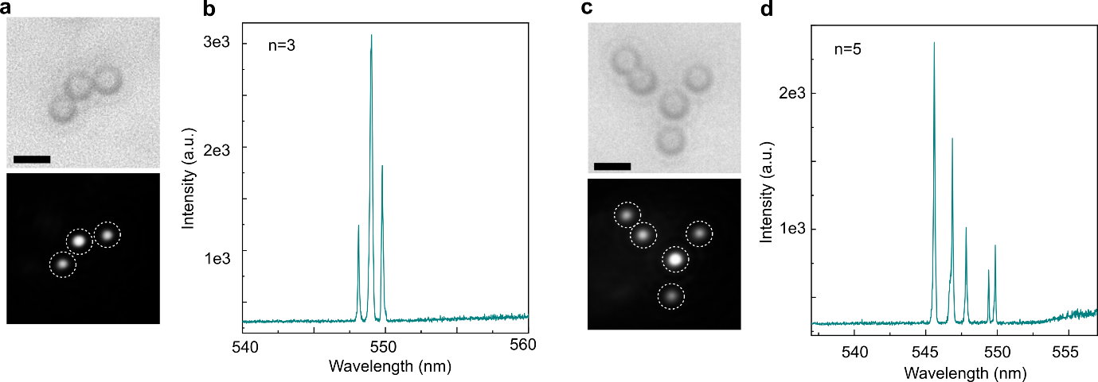
Supplementary Fig. S4. Lasing spectra and the laser emission images of 3 μm microspheres. (a-b) Bright-field image, laser emission image, and spectrum when three microspheres were pumped simultaneously. (c-d) Bright-field image, laser emission image, and spectrum when five microspheres were pumped simultaneously. Scale bar: 5 μm.

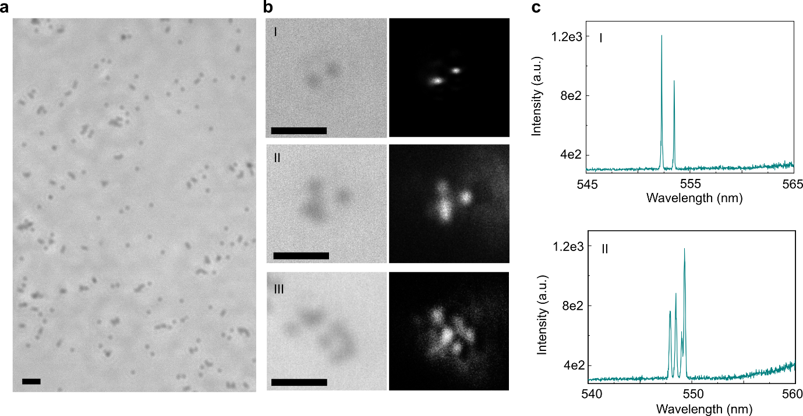
Supplementary Fig. S5. Lasing spectra and the laser emission images of 1 μm microspheres. (a) Bright-field image of the microspheres. (b) Bright-field images and the respective laser emission images (I: 2 microspheres, II: four microspheres, III: >7 microspheres). (c) Spectra corresponding to I and II microspheres. Scale bar: 5 μm.

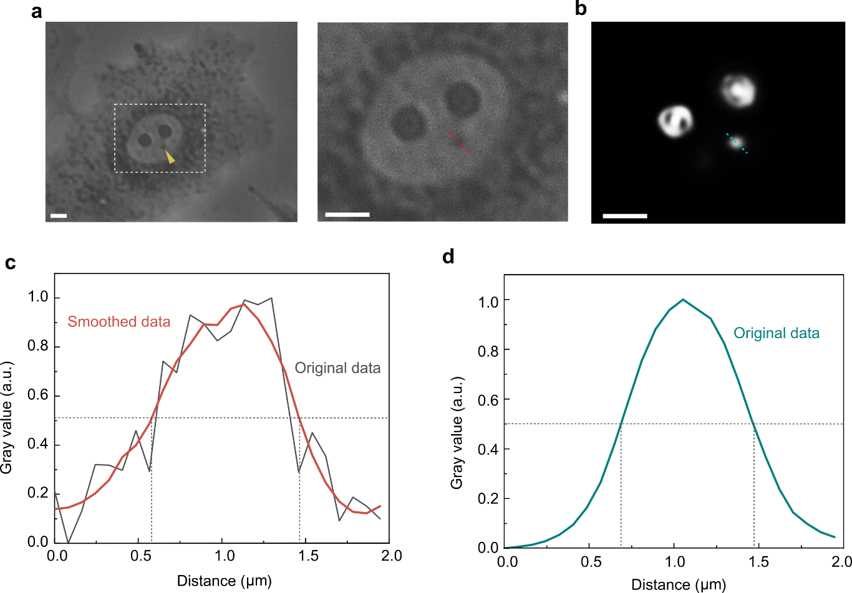

Supplementary Fig. S6. Characterization of the spatial resolution of the laser emission imaging for nucleolus. (a) Phase contrast image of a spreading A549 cell and the enlarged view of the nucleolus region. (b) Laser emission image of the nucleoli. (c) Normalized gray value profile of the dotted red line under the phase contrast image (gray curve: the original data; red curve: smoothed data). (d) Normalized gray value profile of the dotted red line on the lasing emission image. The nucleolus has a diameter of ~0.85 μm (indicated by the yellow arrow). Scale bar: 10 μm.

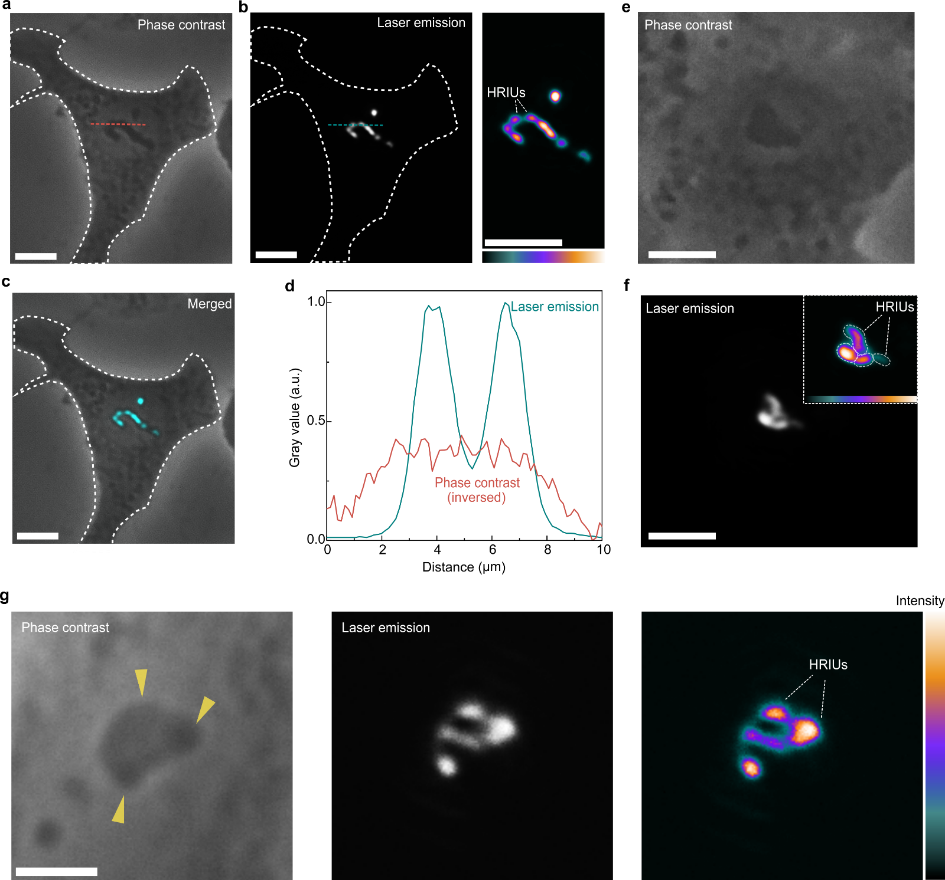

Supplementary Fig. S7. Higher refractive index units (HRIUs) for laser emission. (a-c) Phase contrast image of an A549 cell and its corresponding nucleolar laser emission image. A rod-like nucleolus located at the nucleus's center is observed. Spot-like laser emission patterns that contribute to the nucleolus's morphology are evident, suggesting the potential presence of several HRIUs within the nucleolus. The phase contrast image, however, does not provide precise information regarding the refractive index difference. Scale bar: 10 μm. (d) Normalized gray value profile of the dotted line in phase contrast image and lase emission image. (e-f) A triangle nucleolus that contains several HRIUs. Scale bar: 5 μm. (g) A large nucleolus that showed various shades under phase contrast image. The pattern showed good alignment with the HRIUs on the laser emission image. Scale bar: 5 μm.

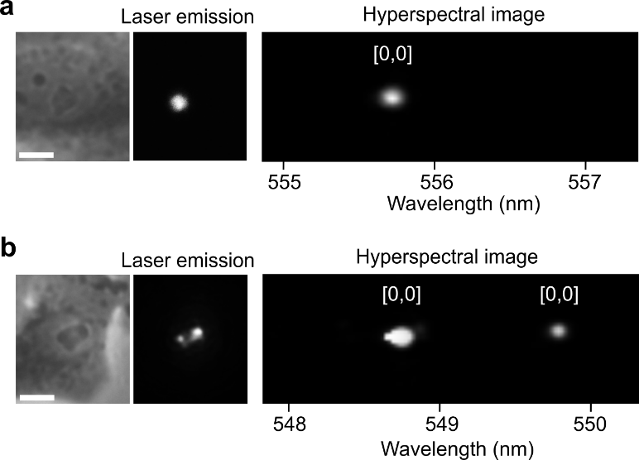
Supplementary Fig. S8. Laser emission with the hyperspectral image. (a) A nucleolus with a single round laser emission spot. The hyperspectral image indicates the laser emission pattern originates from a [0,0] single mode. (b) A nucleolus with two laser spots (two HRICs) contributing to the laser pattern. The hyperspectral image demonstrates that the laser pattern is constructed from two [0,0] single modes. Scale bar: 5 μm.

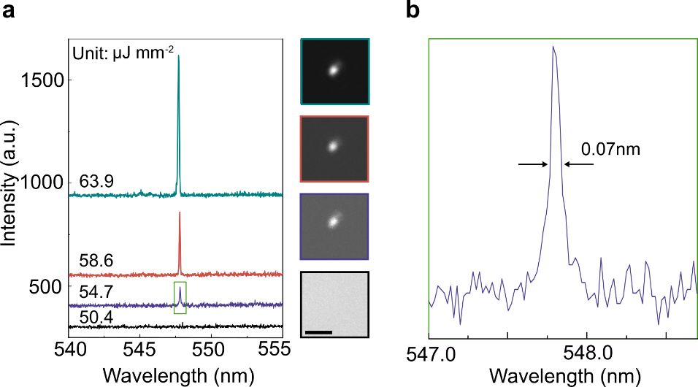

Supplementary Fig. S9. (a) Lasing spectra of a 1.1 μm diameter nucleolus under varied pump energies. The curves are vertically displaced to enhance clarity. The adjacent images depict the respective laser emission images in relation to the applied pump energies. Scale bar: 5 μm. It demonstrated that this nucleolus has a threshold of around 54 μJ mm⁻². (b) Zoom-in image of the spectrum at pump energy of 54.7 μJ mm⁻². The FWHM is ~ 0.07 nm.

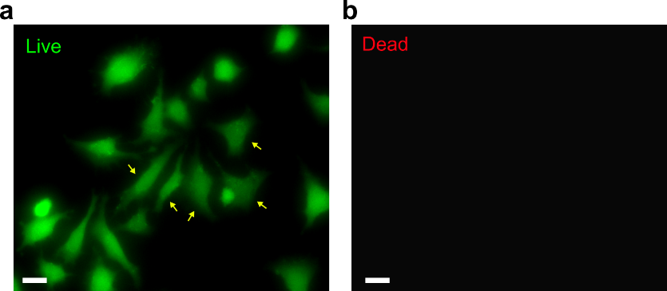

Supplementary Fig. S10. Cell viability assessment after 2-minute laser exposure. (a) Image depicting cells stained with Calcine-AM. (b) Image illustrating cells stained with Propidium Iodide. Scale bar: 20 μm. Arrows indicate cells exposed to the pump light for 2 mins (pump energy: 68.3 μJ mm⁻², ~ 6000 pulses).

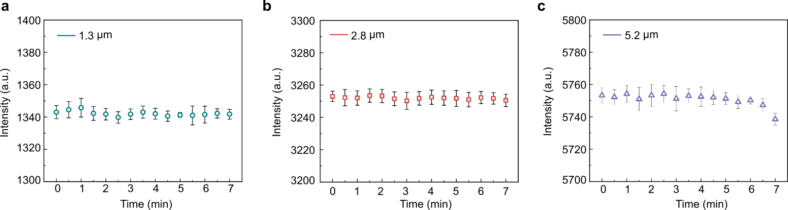
Supplementary Fig. S11. Stability test of the laser emission at a pump energy of 68.3 μJ mm⁻². (a) Laser emission intensity of a nucleolus with a diameter of ~1.3 μm. (b) Laser emission intensity of a nucleolus with a diameter of ~2.8 μm. (c) Laser emission intensity of a nucleolus with a diameter of ~5.2 μm.

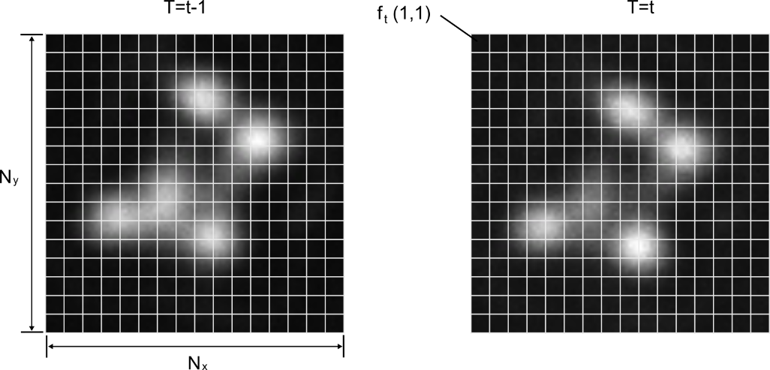
Supplementary Fig. S12. Calculation of the alterations in the laser emission image.

The average difference of the gray value of each pixel between the pattern at time t-1 and t can be given by
$\overline{g}=\frac{1}{N_{x}N_{y}}\sum_{x=1}^{N_{x}}{\sum_{y=1}^{N_{y}}{[|f_{t}}}\left(x,y\right)-f_{t-1}(x,y)|]$ (S1)
where $N_{x}$ and $N_{y}$ is the number of pixels in the x and y dimentions, $f_{t}(x,y)$ is the gray value of pixel at the position (x,y) at time t. The standard deviation of total pixel change at t is defined as the laser pattern change, which can be given by
$s=\sqrt{\frac{1}{N_{x}N_{y}}\sum_{x=1}^{N_{x}}{\sum_{y=1}^{N_{y}}{{[{|f}_{t}\left(x,y\right)-f_{t-1}\left(x,y\right)|-\overline{g}]}^{2}}}}$ (S2)

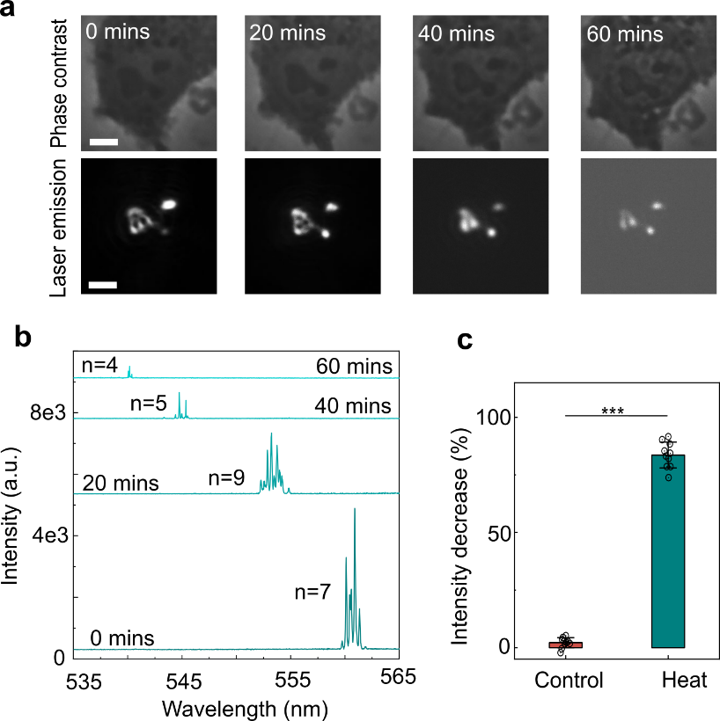
Supplementary Fig. S13. Alterations in the laser emission image when the cells were incubated at 40 °C. (a) Changes in laser emissions over time. Scale bar: 5 μm. (b) Changes in laser spectrum. (c) Comparison of the laser spectrum intensity.

Apart from the evident spatial alterations in laser emission images, we observed a significant decrease in laser intensity, particularly after 40 minutes. This decline is likely a result of protein translocation from the nucleoli to the nucleoplasm or cytoplasm under stress, such as the protein NPM1¹. Concurrently, the phase contrast images at 40 and 60 mins displayed a subtle change in the gray level of the nucleolus, with nucleoplasm appearing slightly blurred. We quantified the change in laser intensity, revealing a ~83.4% drop in laser intensity, whereas the control group without heat shock exhibited only a 2.1% decrease. The intensity reduction in the control group might be attributed to dye photobleaching after prolonged excitation. Furthermore, the laser spectral peaks demonstrated a noticeable blue shift over time, and the peak number exhibited a slight fluctuation.

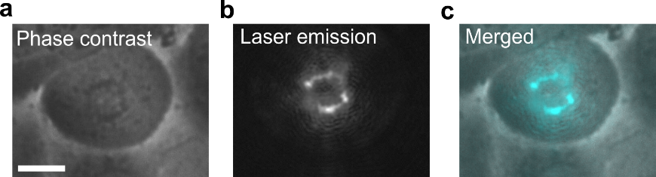

Supplementary Fig. S14. Laser emission at the beginning of anaphase. (a) Phase contrast image. The chromosomes start to move towards the centrosome. (b) Laser emission image. The laser intensity was significantly reduced under the same pump energy. (c) Merged image. Scale bar: 10 μm.

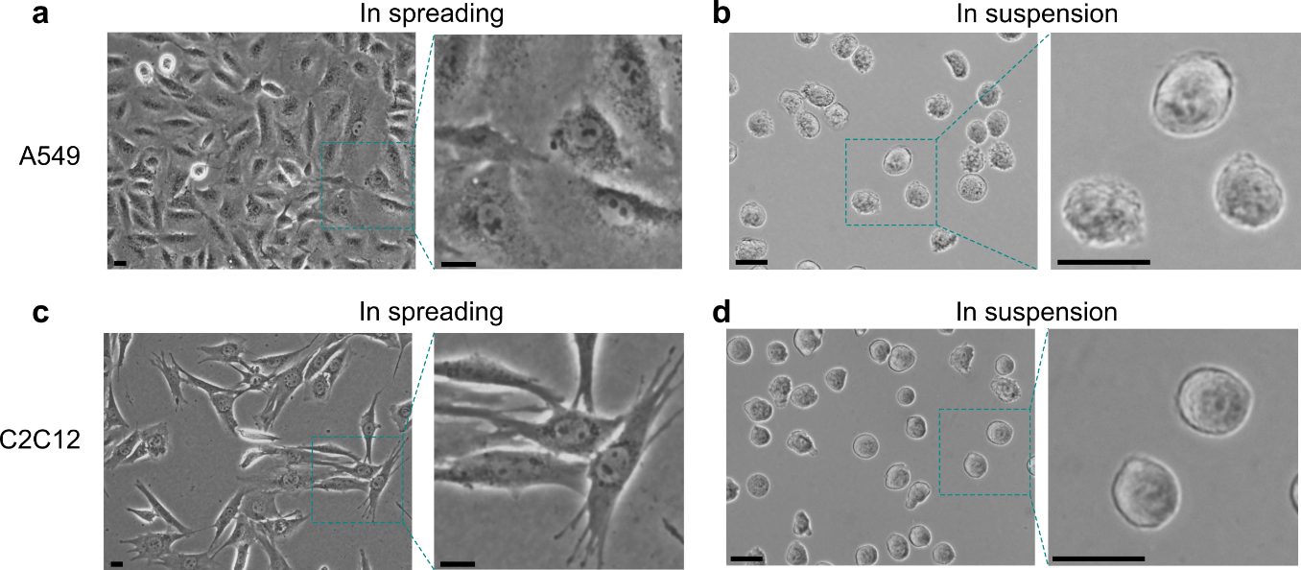

Supplementary Fig. S15. Phase contrast image of cells in spreading state and in suspension. (a-b) Live A549 cells. (c-d) Live C2C12 cells. Scale bar: 20 μm.

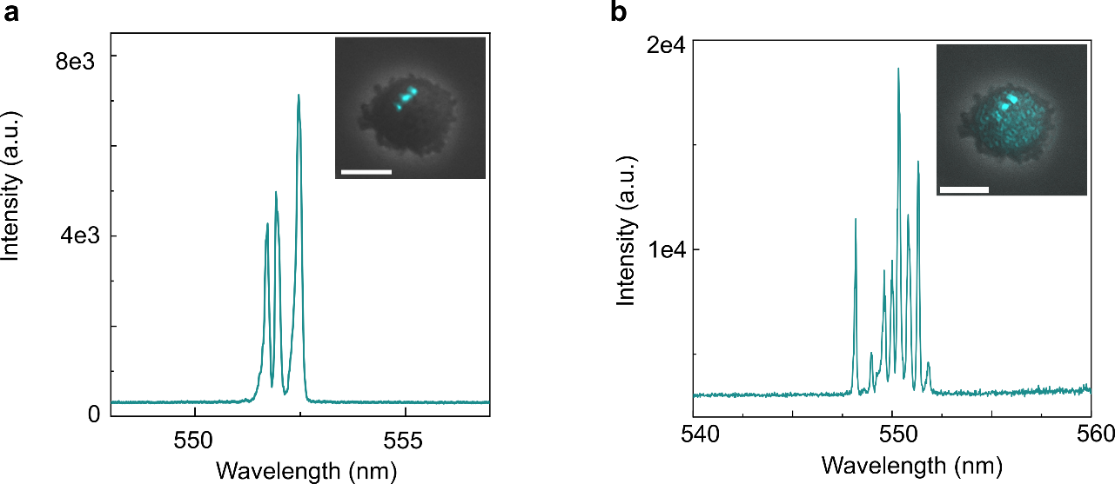

Supplementary Fig. S16. Laser spectra when the suspended cells were pumped under various pump energy. (a) Laser spectrum when only the nucleolar area generated the laser emission. Insert is the laser pattern image merged with the phase contrast image. The pump energy was ~68.3 μJ mm⁻². (b) Laser spectrum when the whole cell area generated the laser emission. Insert is the laser emission image merged with the phase contrast image. The pump energy was ~143.5 μJ mm⁻². Scale bar: 10 μm. The laser peak number increases when the whole cell is excited.

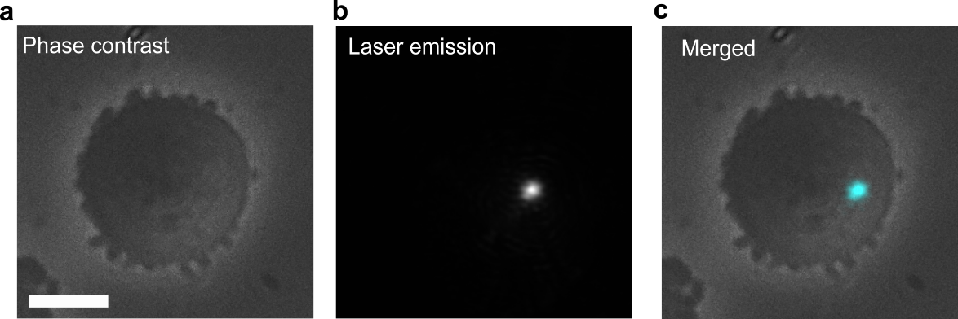

Supplementary Fig. S17. Nucleolus laser emission of the cell in Fig. 5f when the pump energy was ~68.3 μJ mm⁻². (a) Phase contrast image. (b) Laser emission image. (c) Merged image. Scale bar: 10 μm.

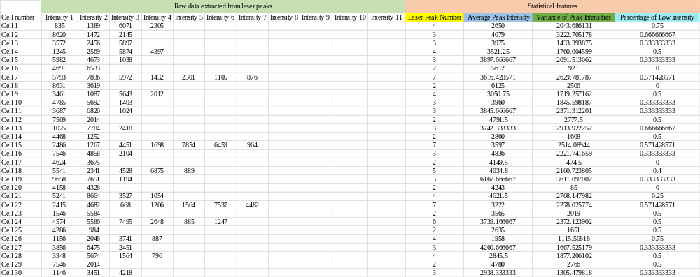

Supplementary Fig. S18. Data extracted from the laser spectrum for high-throughput nucleolus fingerprinting (Data from A549 cells was shown here as an example).

Reference

1. Yang, K. et al. A redox mechanism underlying nucleolar stress sensing by nucleophosmin. Nat Commun 7, 13599 (2016).

Movie S1.
Video-rate microscopy to observe the laser emission from nucleoli in a spreading A549 cell. To spatially scan the entire cell, we reduced the pump spot size by using a 20X objective. In this case, the nucleolus can be selectively pumped either individually or spontaneously. For better comparison with the nucleoli under phase contrast, we maintained the bright-field illumination open during scanning. The pump light was intentionally not completely filtered to better visualize the scanning process. To enhance imaging, we utilized the auto-contrast function in the Nikon Ni-E software. As the pump spot scanned over the nucleolar area, we observed brilliant laser emissions emanating from within the nucleoli. In contrast, no noticeable laser emissions were observed from the non-nucleolar regions. Scale bar: 10 µm.

Movie S2.
Video-rate microscopy to observe the laser emission from nucleoli under varying pump energies. The pump energy was incrementally increased from ~ 68.3 μJ mm⁻² to around 201.7 μJ mm⁻², and then subsequently decreased to the initial value of ~ 68.3 μJ mm⁻². During this process, we could clearly observe changes in the nucleolus laser emission that corresponded to the alterations in pump energy. Scale bar: 10 µm.

Movie S3.
Video-rate microscopy to observe the laser emission from nucleoli in a suspended A549 cell. During the pump spot scan over the nucleolar area, we observed distinct and intense laser emissions. Conversely, when scanning over non-nucleolar regions, we did not observe notable laser emissions. Scale bar: 10 µm.

