Supporting Information for
Does Increasing the Spatial Resolution in Dynamical Downscaling Impact Climate Change Projection of Indian Summer Monsoon, Population and GDP?
C. B. Jayasankar^{1,2,*,#}, K. Rajendran^{3,4}, and Sajani Surendran^{3,4}
¹Center for Study of Science, Technology & Policy (CSTEP), Bangalore, India.
²Center for Ocean-Atmospheric Prediction Studies, Florida State University, Tallahassee, USA.
³CSIR Fourth Paradigm Institute (CSIR-4PI), NAL Belur Campus, Bangalore, India.
⁴Academy of Scientific and Innovative Research (AcSIR), CSIR-4PI, Bangalore, India.
*E-mail: cbjayasankar@gmail.com
#ORCID ID: 0000-0001-5926-6653

Contents of this file

- Figure S1
- Figure S2
- Figure S3
- Figure S4

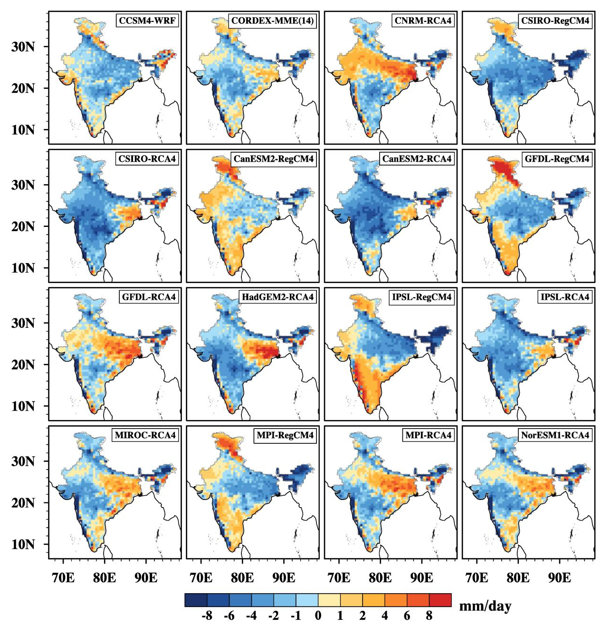

Figure S1: The climatological June to September (JJAS) rainfall bias with respect to IMD observation over India for CCSM4-WRF, multi-model ensemble (MME) of 14 CORDEX-SA models (CORDEX-MME), and 14 individual CORDEX-SA models.

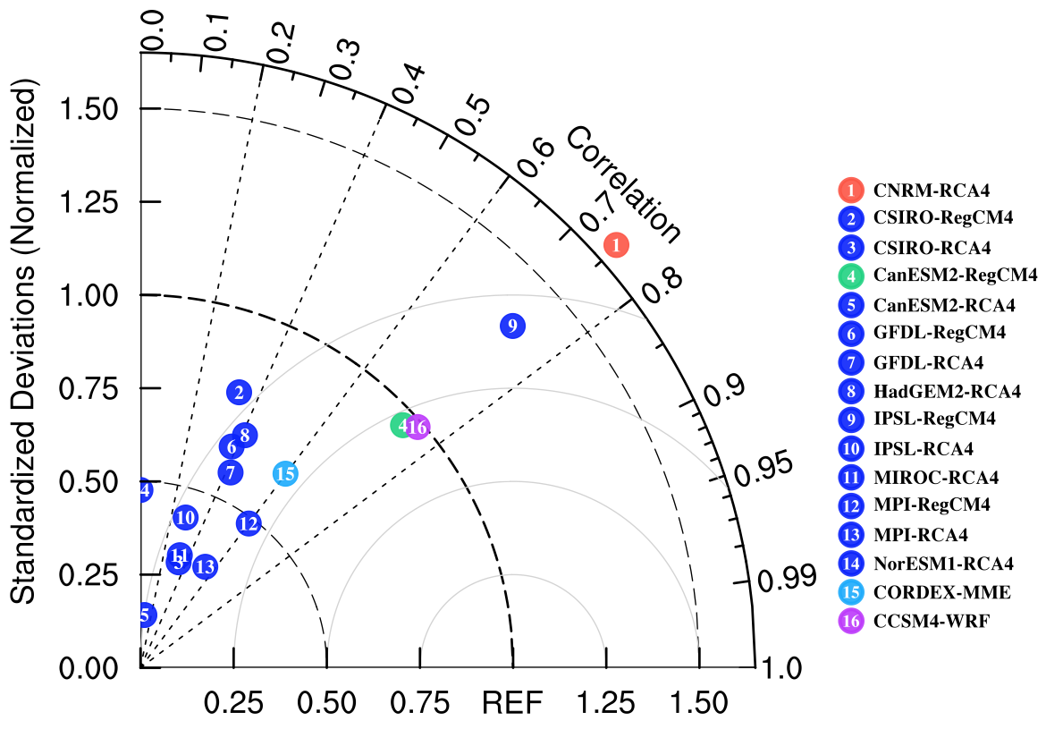

Figure S2: Taylor diagram for mean JJAS rainfall climatology over WG region from individual CORDEX-SA simulations, its Multi-Model Ensemble (MME) mean and CCSM4-WRF simulation.

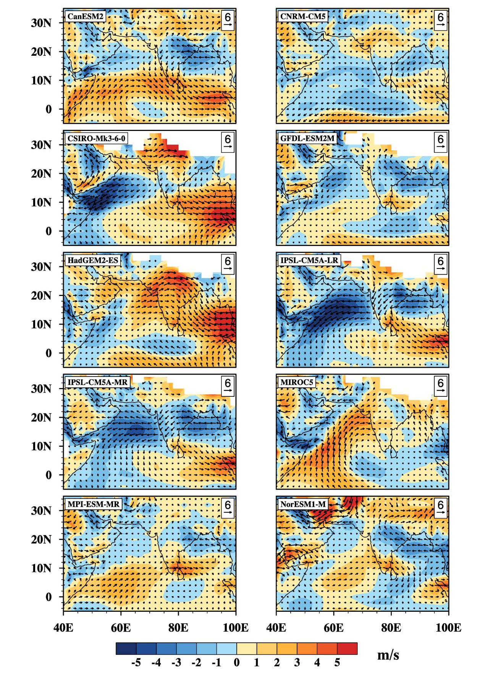
Figure S3: The climatological June to September (JJAS) wind bias (both the wind speed and direction) with respect to ERA-Interim of 10 parent CMIP5 GCMs of CORDEX-SA models.
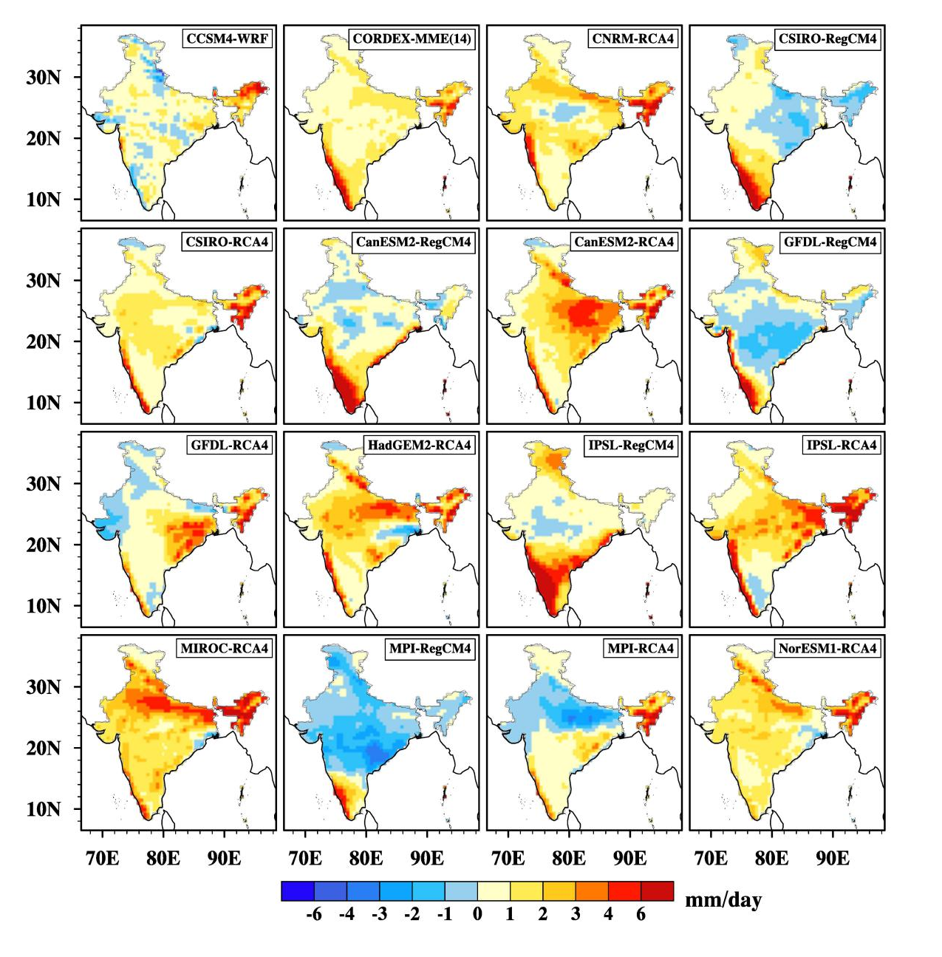
Figure S4: Projected change in climatological JJAS mean rainfall over India at the end of the 21st century (2090-2099) from CCSM4-WRF, multi-model ensemble (MME) of 14 CORDEX-SA models, and 14 individual CORDEX-SA models under the RCP8.5 scenario.

