Supporting Information

3D Woven Liquid Metals for High-Frequency Stretchable Circuits
Md Saifur Rahman, Anand P. Tiwari, Simon A. Agnew, and William J. Scheideler*

Thayer School of Engineering
Dartmouth College, Hanover, NH 03755, United States
E-mail: william.j.scheideler@dartmouth.edu

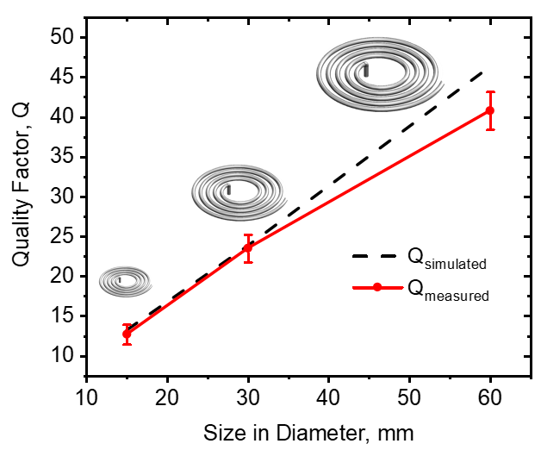
Figure S1. Simulated and experimentally measured Q factor vs a 5-turn coil's size. The inset shows the render of differently sized coils.

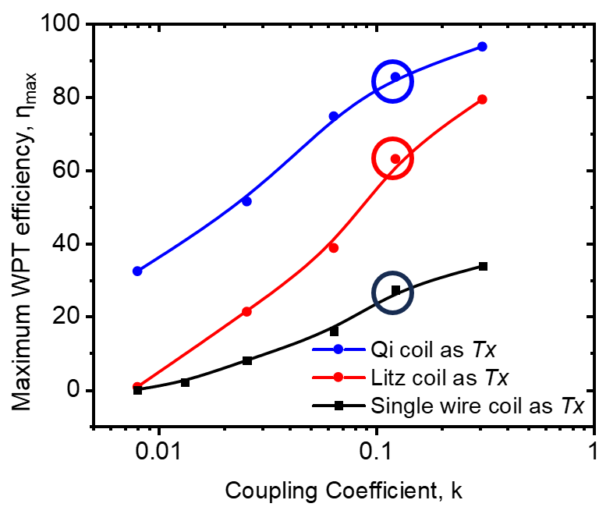
Figure S2. Comparison of the experimentally measured maximum power efficiency vs. coupling efficient k factor for the three pairs of Rx and Tx coils, an Rx Qi coil with Tx litz coil, an Rx Qi coil with Tx single wire coil, and an Rx Qi coil with Tx Qi coil. The circles highlight a comparison at k - 0.12 showing that the single wire Tx coil achieves just 32% of the Qi coil's maximum power efficiency, whereas the Tx litz coil yields 73% of the state of the Qi coil efficiency for wireless power transfer.

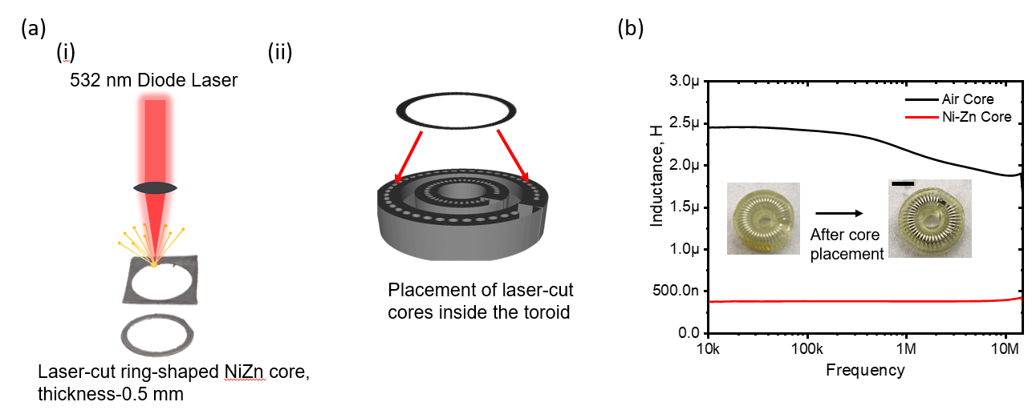

Figure S3. a) Fabrication of a toroid (44 turns) with NiZn ferrite core. i) Laser cutting of a ring-shaped NiZn core material. ii) Placement of the core inside the half-printed toroid structures. b) Inductance as a function of frequency for air core and Ni-Zn core toroid. The scale bar is 5 mm in the insets showing the printed toroids with and without the magnetic core material embedded.

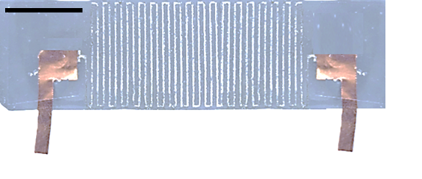
Figure S4. A laser-etched liquid metal serpentine line forming a strain sensor on Ecoflex. The scale bar is 2 cm. Contacts were formed with Cu foils as pictured.

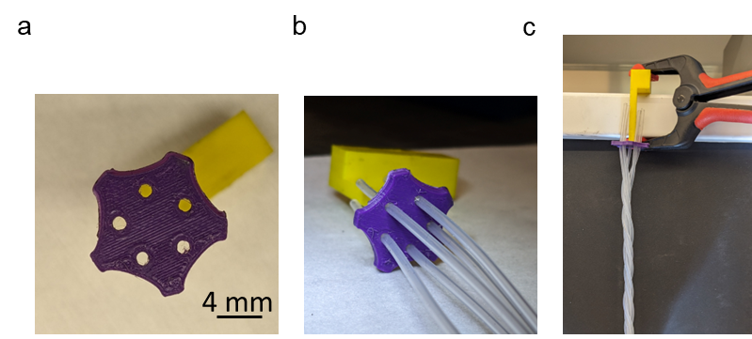
Figure S5. a) A 3D-printed fixture for winding the silicone litz strands into a litz wire bundle. b) PDMS tubes are inserted into the structure. As shown in (c), strands are twisted by braiding with the help of the separator and a clamp.

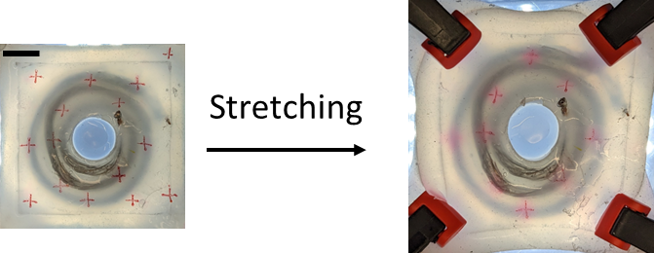
Figure S6. Stretchable litz wire coils are being stretched biaxially with the help of clamps. The fiducial markers are used to quantify the level of biaxial strain. The scale bar is 1 cm.

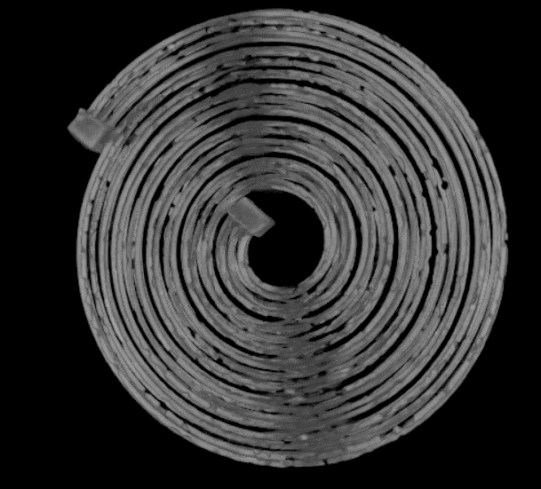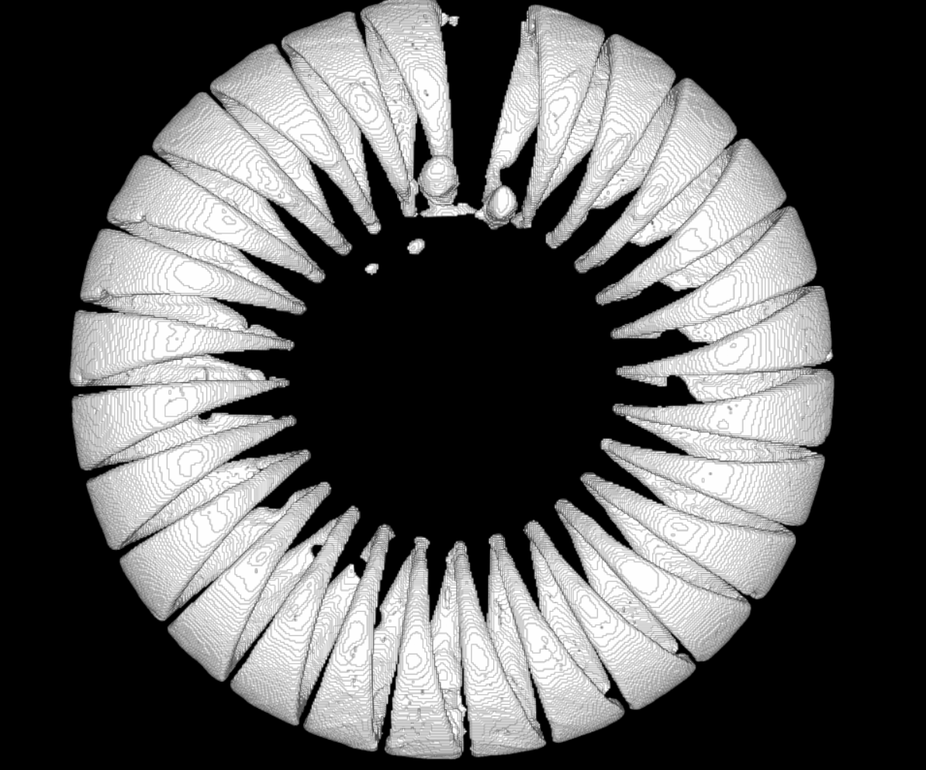
a
b

Figure S7. A top down view of the ImageJ full 3D reconstruction based on the measured 3D MicroCT image slices for the a) litz wire coil and b) toroid with optimal trace geometry. The scale bar is 5 mm in both images.

