Engineering self-cleavage fusion system for the Production of Chimera Spider Silk Proteins
Bixia Zhou², Yufan Huang², Yongqin Su³, Bingrui An¹, Mi Shen¹, Ke Zheng⁴, Cheng Cheng¹*, Bingfang He^{1,2}*
1. School of Pharmaceutical Sciences, Nanjing Tech University, No. 30 Puzhu South Road, Nanjing, 211816, China.
2. College of Biotechnology and Pharmaceutical Engineering, Nanjing Tech University, No. 30 Puzhu South Road, Nanjing, 211816, China.
3. 2011 College, Nanjing Tech University, No.30 Puzhu South Road, Nanjing,211816, China.
4. Biomass Molecular Engineering Center and Department of Materials Science and Engineering, School of Forestry and Landscape Architecture, Anhui Agricultural University, Hefei, Anhui, 230036, China.

Additional File 1
The following files are available free of charge.
Strains, plasmids, and primers used in this study; Table S1, Proportion of secondary structure of chimera spider silk protein in solid state; Table S2, The hydropathicity/hydrophobicity of repetitive units; Figure. S1, Fourier Transform infrared spectra of chimeric NTRep2CT (black line) 、NTRep4CT (red line) and NTRep6CT (blue line); Figure. S2, Fourier Transform infrared spectra (amide I band) and fitted spectra of chimeric NTRep2CT(A)、NTRep4CT(B) and NTRep6CT(C); Figure. S3.
Table S1: Strains, plasmids, and primers used in this study.
Strain/plasmid/Sequence/primer | Genotype or description/sequence | Definition
Strains
E. coli DH5α | F-，φ80dlacZΔM15，Δ(lacZYA-argF)U169，deoR，recA1，endA1，hsdR17(rk-，mk+)，phoA，supE44，λ-，thi-1，gyrA96，relA1 | Host for cloning
E. coli BL21（DE3） | F-，ompT，hsdS（rBB-mB－），gal，dcm（DE3） | Host used for expression
Plasmids
pET43.1a | Novagen | Plasmid backbone
pET43.1a-NT2RepCT | pET43.1a carrying the NT2RepCT gene without the fusion tag NusA and the Mini-Intein ∆I-CM gene | This study
pET43.1a-NT4RepCT | pET43.1a carrying the NT4RepCT gene without the fusion tag NusA and the Mini-Intein ∆I-CM gene | This study
pET43.1a-NT6RepCT | pET43.1a carrying the NT6RepCT gene without the fusion tag NusA and the Mini-Intein ∆I-CM gene | This study
pET43.1a - NusA - Intein | pET43.1a carrying the fusion tag NusA and the Mini-Intein ∆I-CM gene | Synthesized by Genewiz (Suzhou, China).
pET43.1a-Intein-NT2RepCT | pET43.1a - NusA - Intein carrying the NT2RepCT gene | This study
pET43.1a-Intein-NT4RepCT | pET43.1a - NusA - Intein carrying the NT4RepCT gene | This study
pET43.1a-Intein-NT6RepCT | pET43.1a - NusA - Intein carrying the NT6RepCT gene | This study
Sequences
NT | SHTTPWTNPGLAENFMNSFMQGLSSMPGFTASQLDDMST  IAQSMVQSIQSLAAQGRTSPNKLQALNMAFASSMAEIAAS  EEGGGSLSTKTSSIASAMSNAFLQTTGVVNQPFINEITQLV  SMFAQAGMNDVSA | N-terminal domain from Euprosthenops australis MaSp1
CT | VTSGGYGYGTSAAAGAGVAAGSYAGAVNRLSSAEAASRV  SSNIAAIASGGASALPSVISNIYSGVVASGVSSNEALIQALLE  LLSALVHVLSSASIGNVSSVGVDSTLNVVQDSVGQYVG | C-terminal domain from Araneus ventricosus MiSp
Rep | GNSGRGQGGYGQGSGGNAAAAAAAAAAAAAAAGQGGQG  GYGRQSQGAGSAAAAAAAAAAAAAAGSGQGGYGGQGQG  GYGQSGNS | Core repeat region (Rep) from Euprosthenops australis MaSp1
Intein | ALAEGTRIFDPVTGTTHRIEDVVGGRKPIHVVAAAKDGTLHA  RPVVSWFDQGTRDVIGLRIAGGAILWATPDHKVLTEYGWRAA  GELRKGDRVAQPRRFDGFGDSAPIPARVQALADALDDKFLHD  MLAEELRYSVIREVLPTRRARTFGLEVEELHTLVAEGVVVHNM | an intrinsic peptide, Mini-Intein ∆I-CM
Primers
F1 | CCCAAGCTTGCTCTGGCTGAAGGTACCCGTA | Upstream for amplification of NTRep2CT fragment
R1 | CCGCTCGAGGCCCACATACTGGCCAACGCTA | Downstream for amplification of NTRep2CT fragment
F2 | CTAGCTAGCGGTAATAGCGGCCGCGGTCA | Upstream for amplification of R2 fragment
R2 | CGGACTAGTACTATTACCACTCTGACCATAACCGC | Downstream for amplification of R2 fragment
F3 | GAATGATGTGAGTGCAGCTAGCGGTAATAGCGGCCGCG | Upstream for amplification of R4 fragment in NusA-Intein fusion vector
R3 | TAACCACCACTGGTCACACTAGTACTATTACCACTCTGAC | Downstream for amplification of R4 fragment in NusA-Intein fusion vector
Note: Restriction sites are underlined in Table S1.
Table S2: Proportion of secondary structure of chimera spider silk protein in solid state
Spider silk | α-helix/β-turn | β-sheet | Random coil
NT2RepCT | 21.1% | 39.1% | 39.8%
NT4RepCT | 23.8% | 38.3% | 37.9%
NT6RepCT | 17.5% | 41.3% | 41.2%

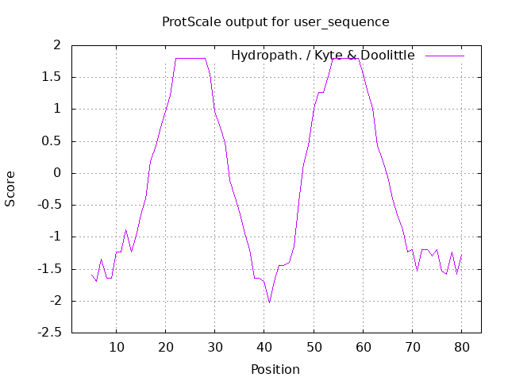
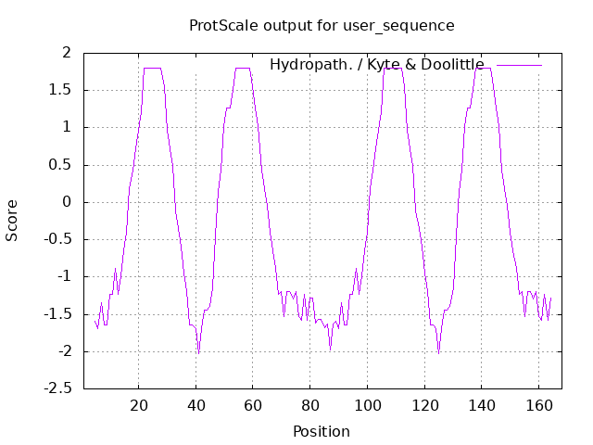
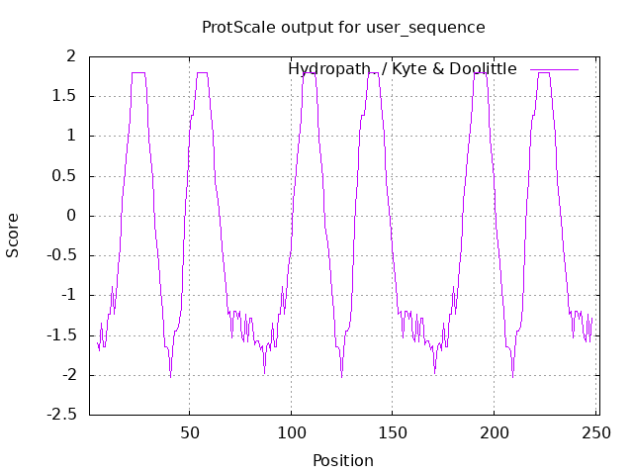
Figure. S 1: The hydropathicity/hydrophobicity of repetitive units.
2 Rep
4 Rep
6 Rep
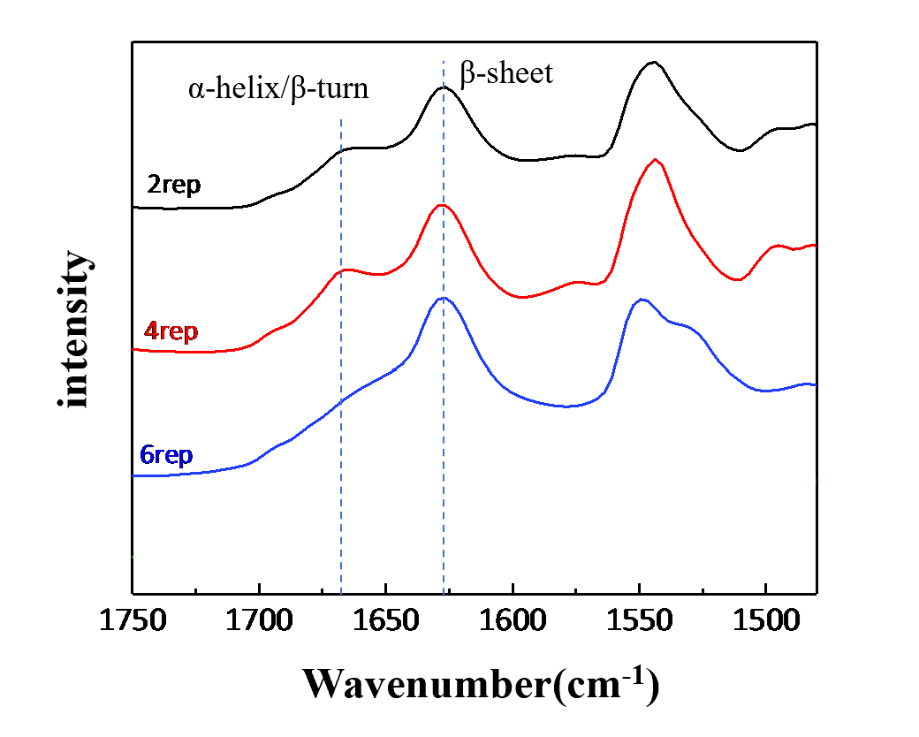
Figure. S2: Fourier Transform infrared spectra of chimeric NT2RepCT (black line) 、NT4RepCT (red line) and NT6RepCT (blue line).
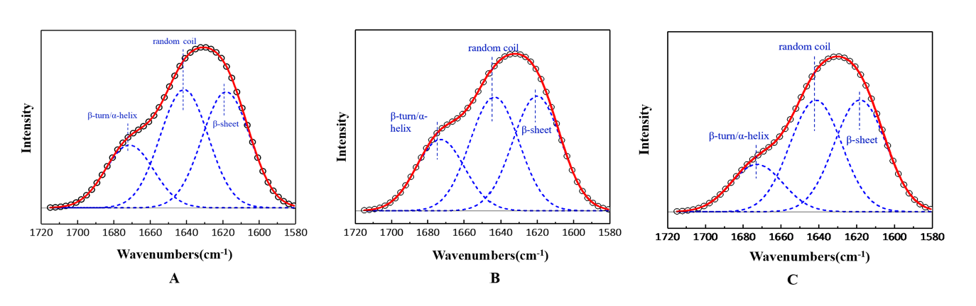
Figure. S3: Fourier Transform infrared spectra (amide I band) and fitted spectra of chimeric NT2RepCT(A)、NT4RepCT(B) and NT6RepCT(C).

