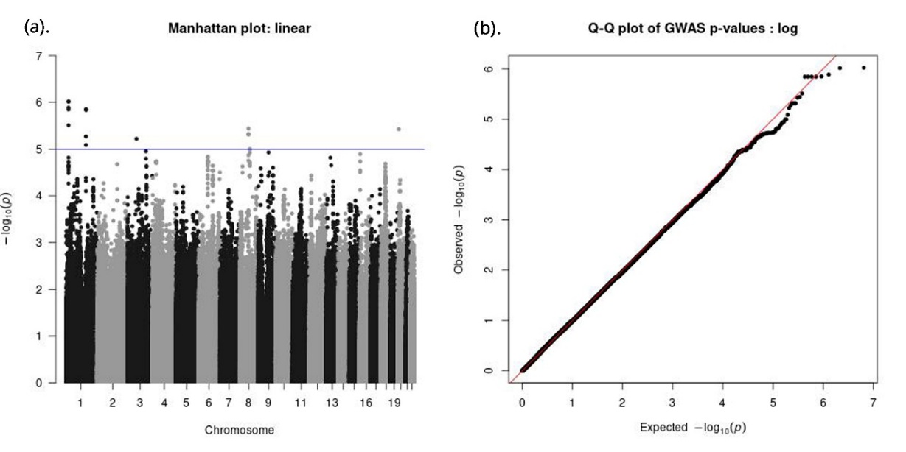
Figure.S1 Manhattan plot and Q-Q plot for cognition (GIF = 1.011)

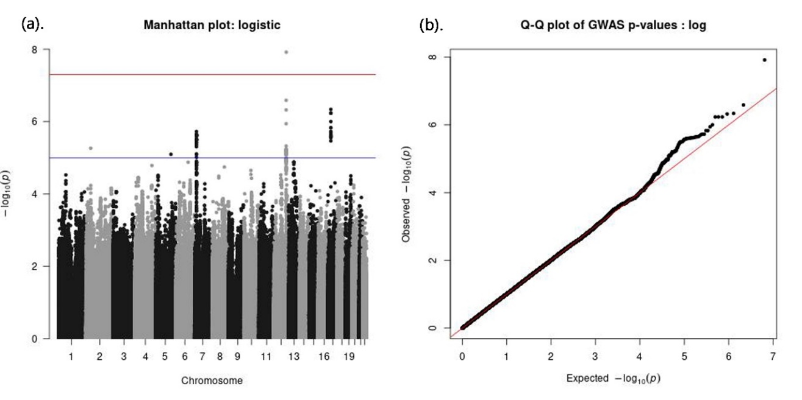
Figure.S2 Manhattan plot and Q-Q plot for drinking status (GIF = 1.019)

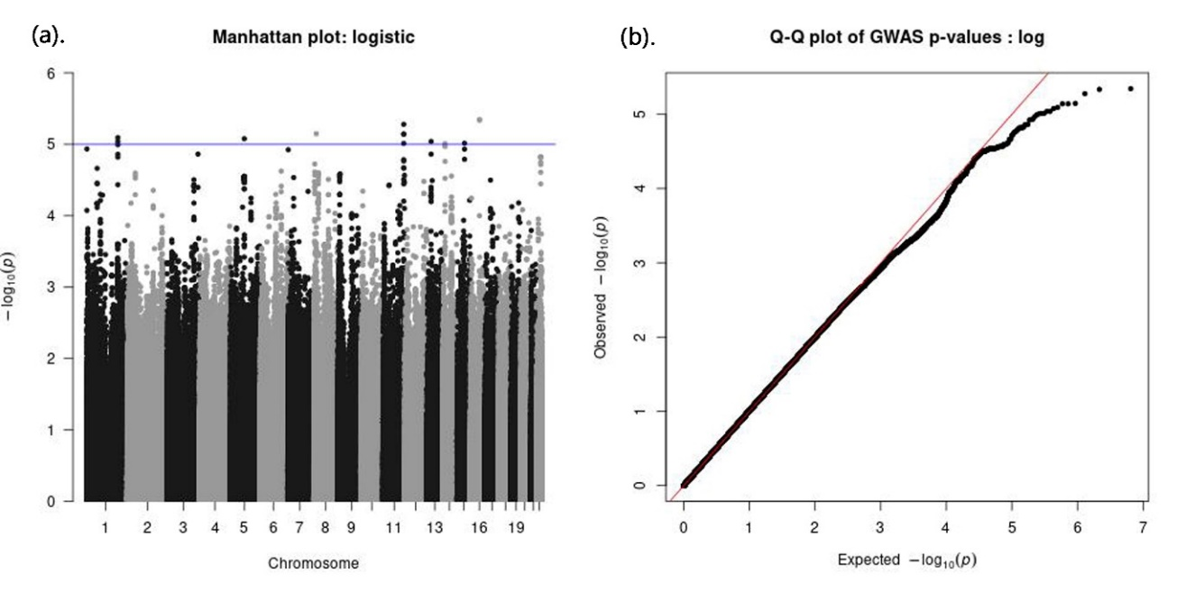
Figure.S3 Manhattan plot and Q-Q plot for fish intake frequency (GIF = 1.023)

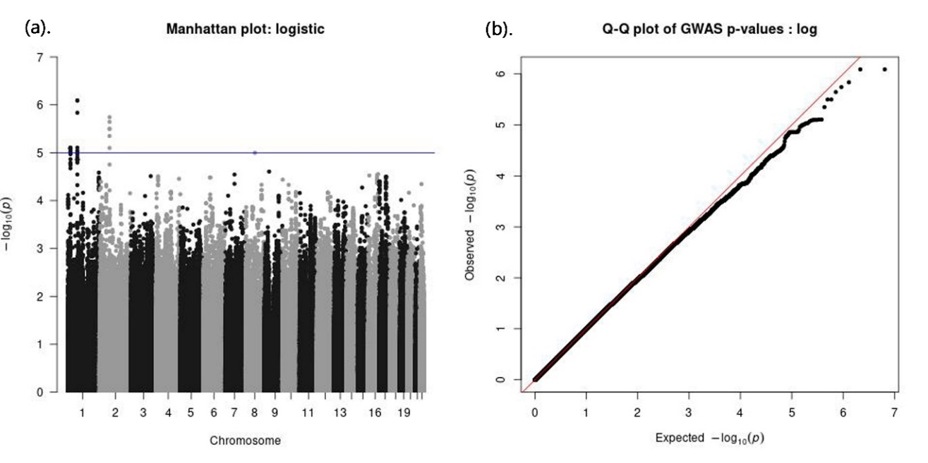
Figure.S4 Manhattan plot and Q-Q plot for fruit intake frequency (GIF = 1.008)
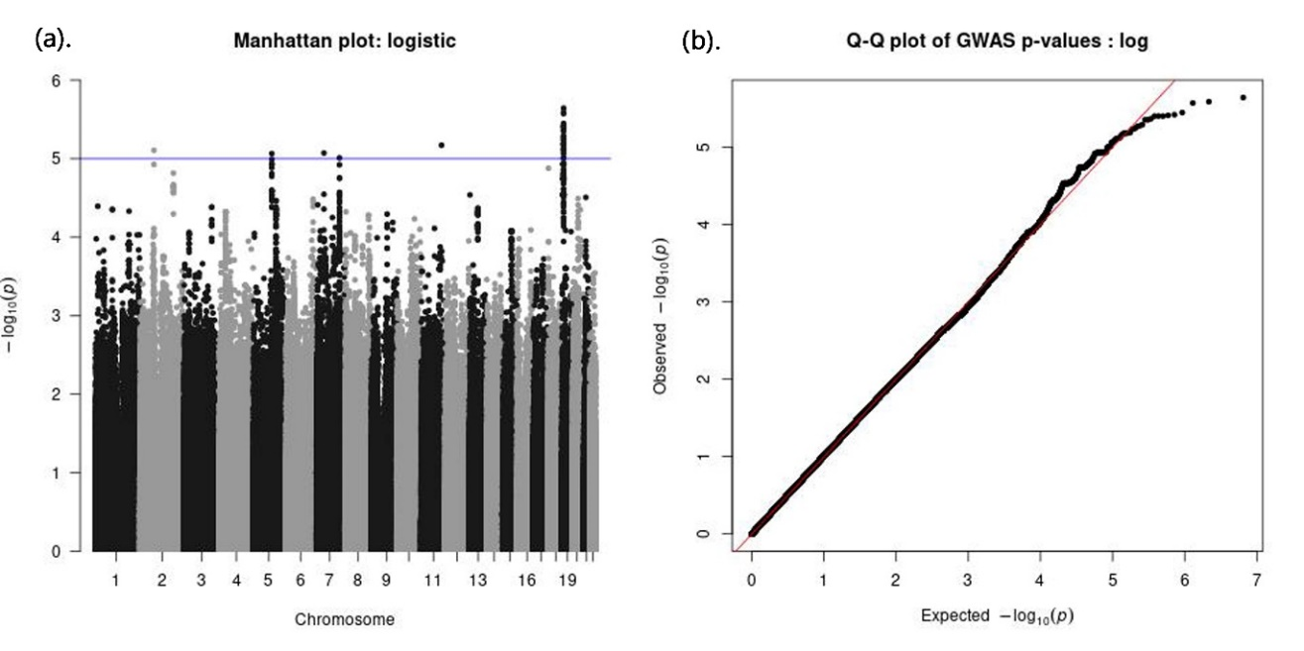
Figure.S5 Manhattan plot and Q-Q plot for garlic intake frequency (GIF = 1.020)

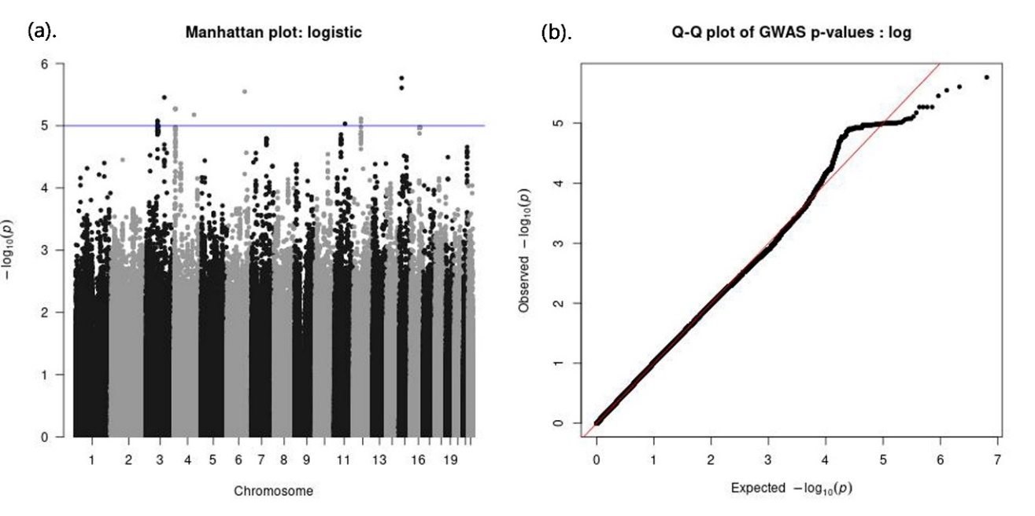
Figure.S6 Manhattan plot and Q-Q plot for legume intake frequency (GIF = 1.022)

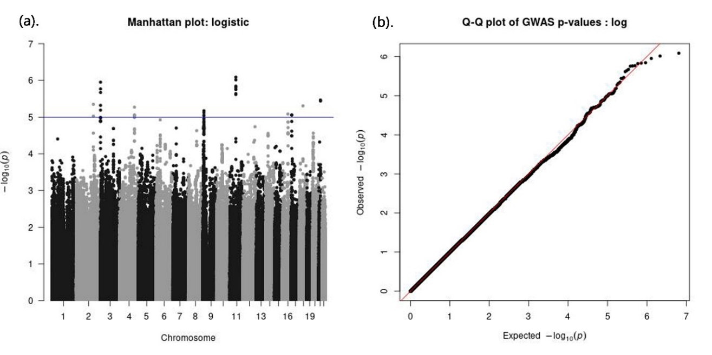
Figure.S7 Manhattan plot and Q-Q plot for meat intake frequency (GIF = 1.010)

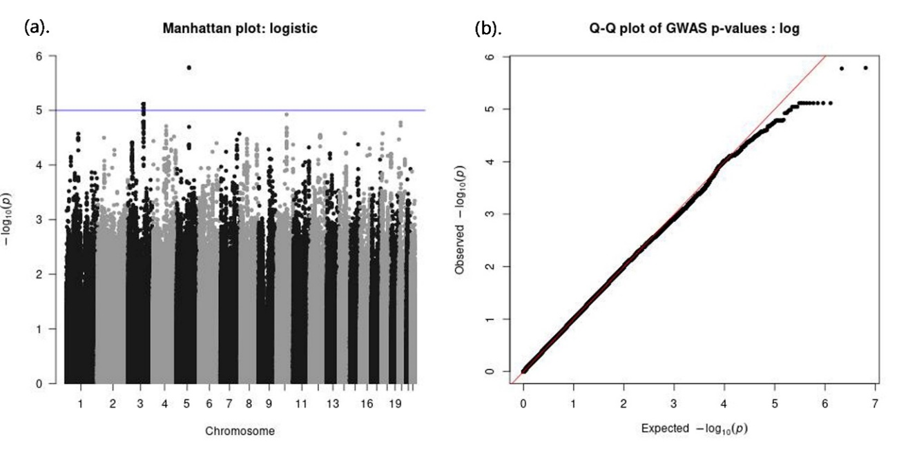
Figure.S8 Manhattan plot and Q-Q plot for sugar intake frequency (GIF = 1.031)

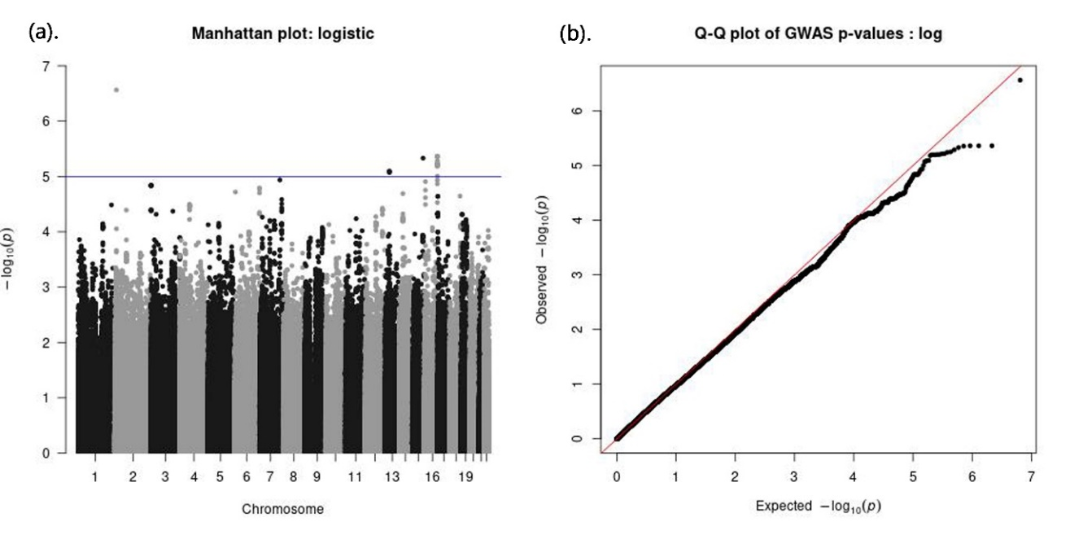
Figure.S9 Manhattan plot and Q-Q plot for vegetable intake frequency (GIF = 1.028)

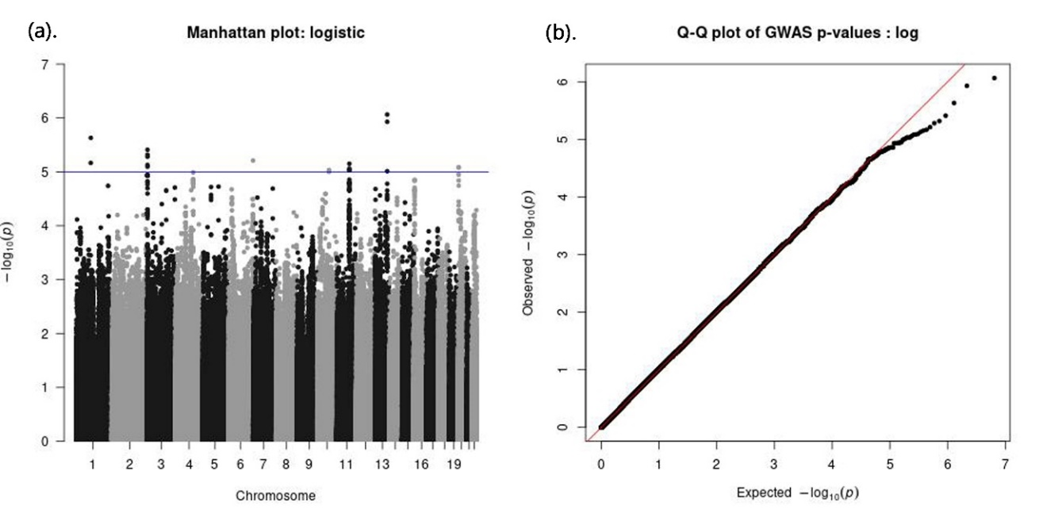
Figure.S10 Manhattan plot and Q-Q plot for exercise status (GIF = 1.017)

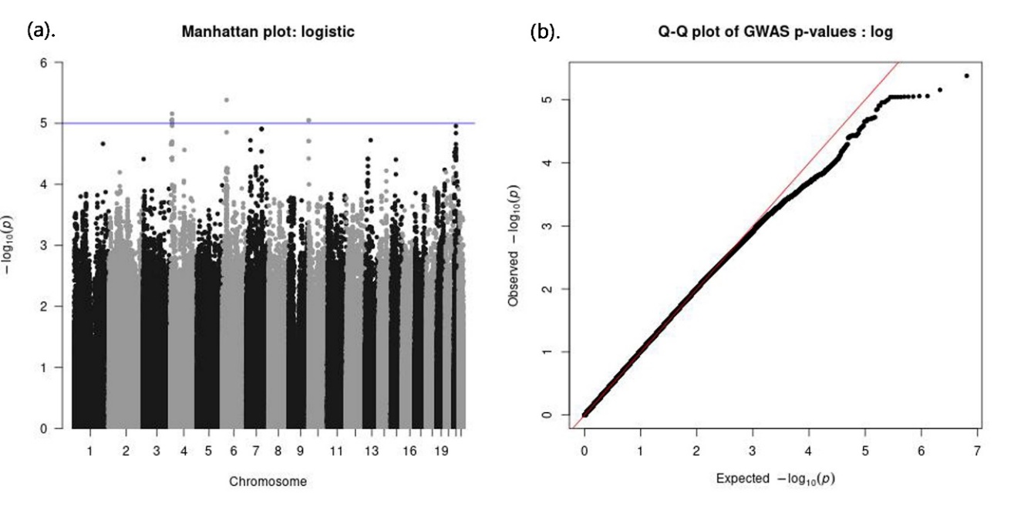
Figure.S11 Manhattan plot and Q-Q plot for housework (GIF = 1.034)

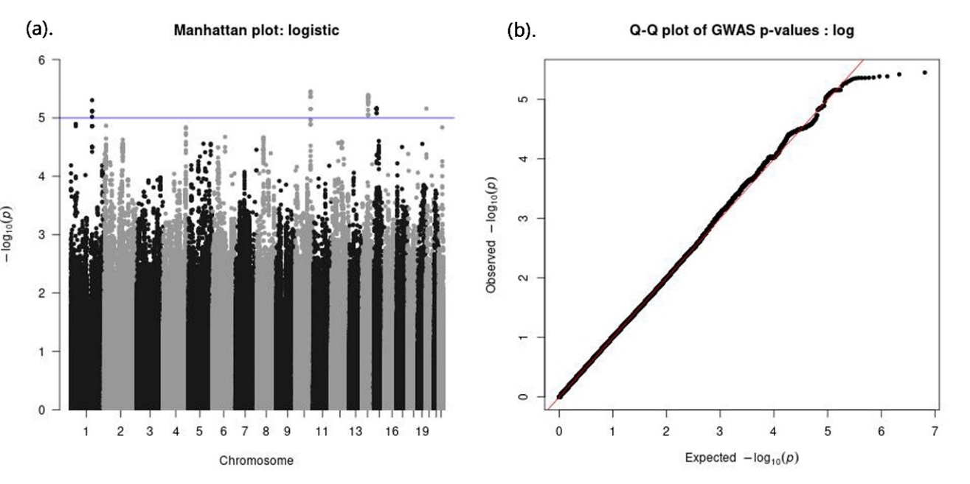
Figure.S12 Manhattan plot and Q-Q plot for mahjong (GIF = 1.029)

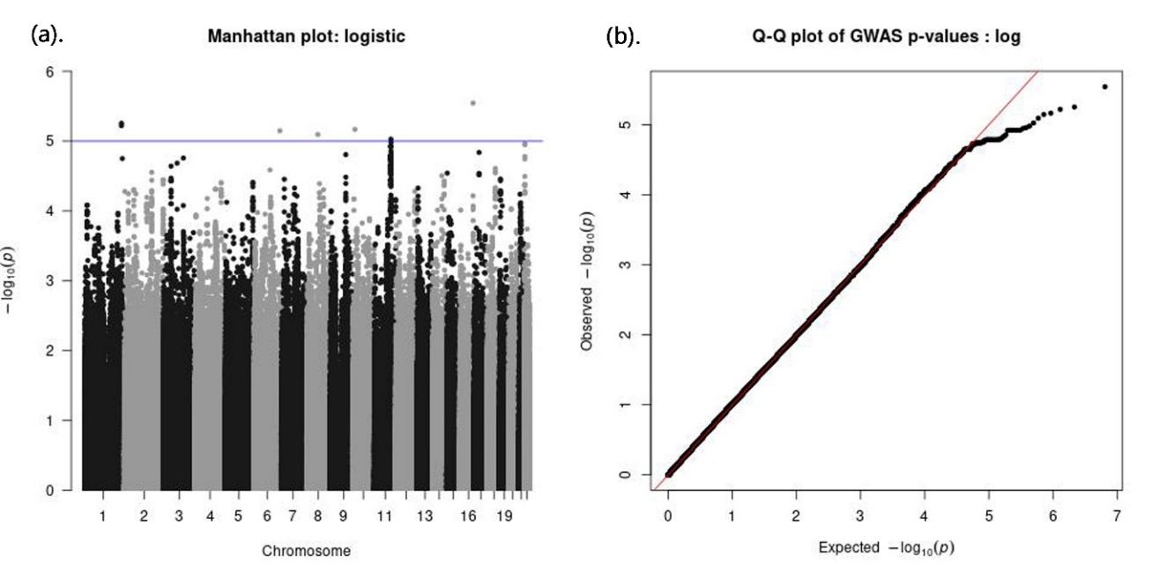
Figure.S13 Manhattan plot and Q-Q plot for open-air activity (GIF = 1.025)

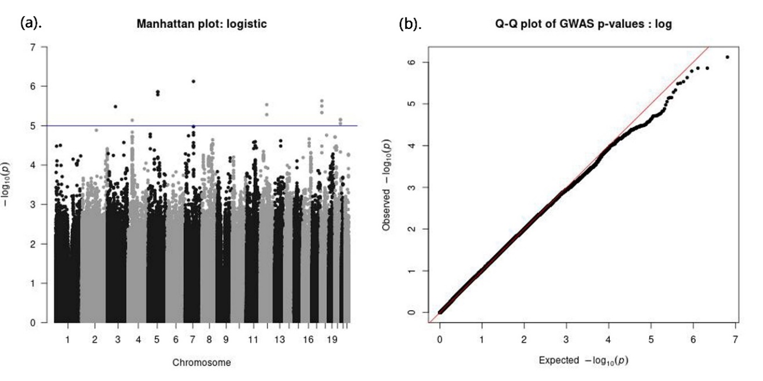
Figure.S14 Manhattan plot and Q-Q plot for pet ownership (GIF = 1.041)

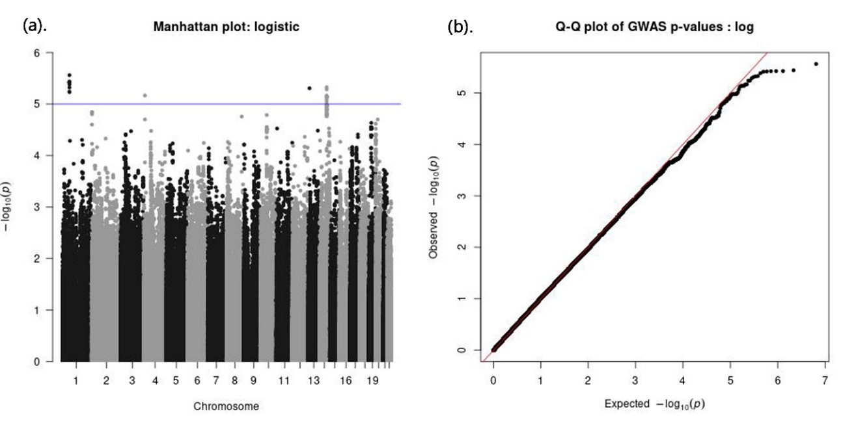
Figure.S15 Manhattan plot and Q-Q plot for reading (GIF = 1.036)

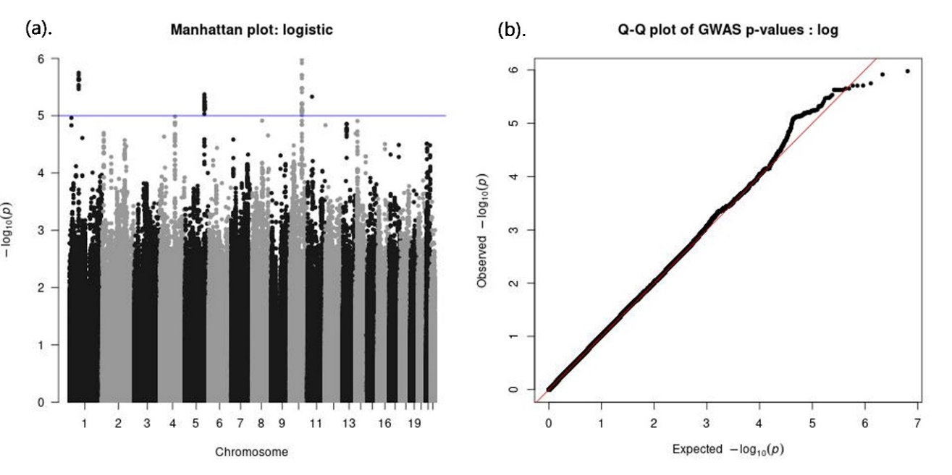
Figure.S16 Manhattan plot and Q-Q plot for TV/radio (GIF = 1.021)
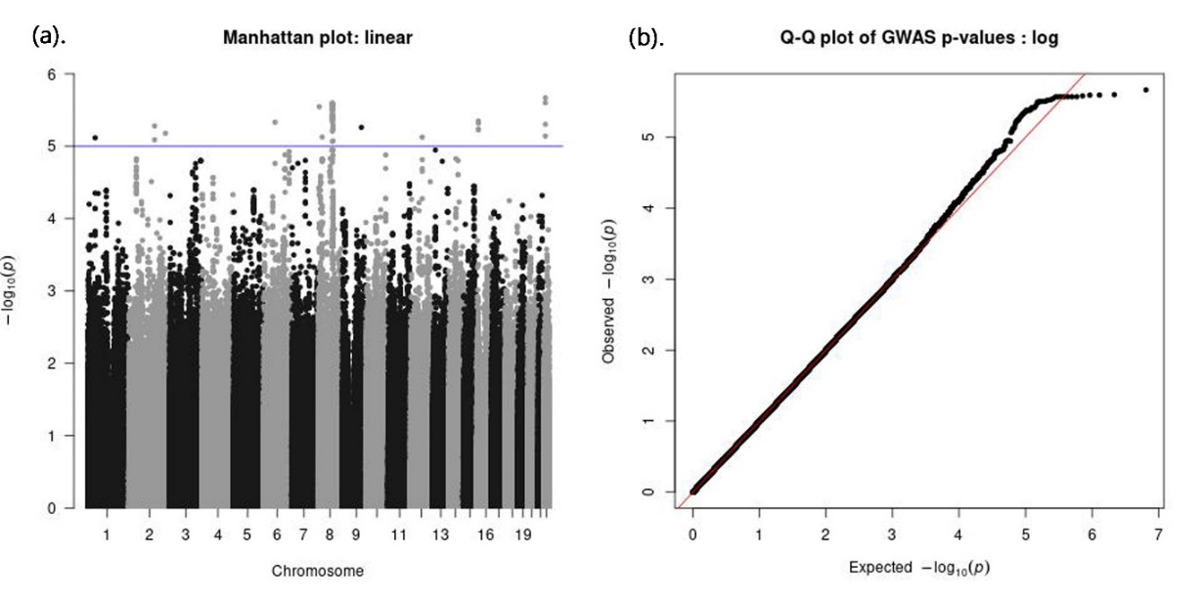
Figure.S17 Manhattan plot and Q-Q plot for education (GIF=1.006)

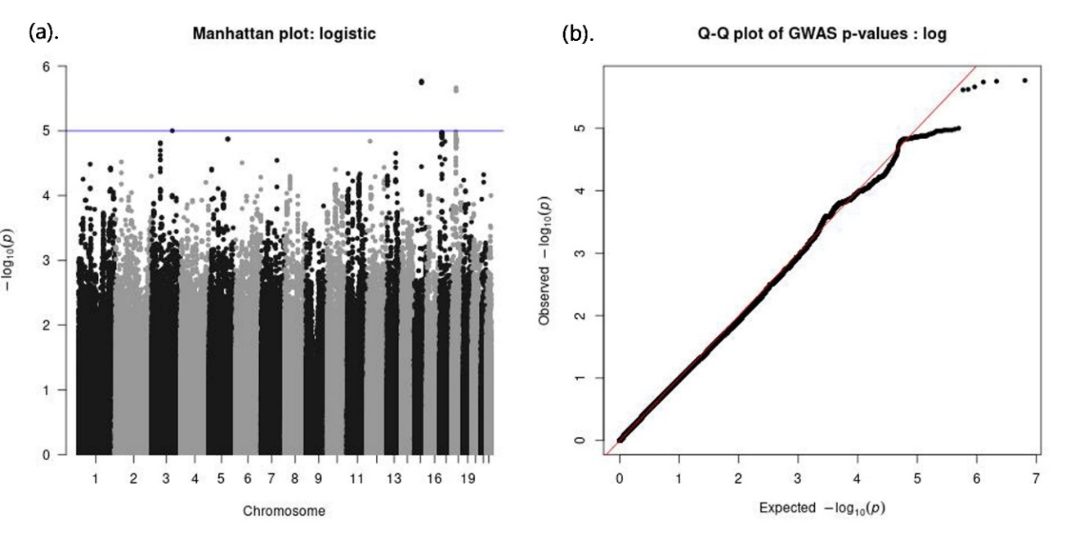
Figure.S18 Manhattan plot and Q-Q plot for stroke/CVD (GIF=1.018)

