Supplemental information for:
The variability of muscle-blubber interface temperature with activity level in a captive Risso’s dolphin (Grampus griseus)

Kino Sakai^{1*}, Daisuke Fukui², Hiroshi Shirouzu³, Yurie Watanabe³, Daiki Inamori³, Noriko Funasaka⁴, Kagari Aoki^{1,5}, Kentaro Q. Sakamoto¹

- Atmosphere and Ocean Research Institute, The University of Tokyo, Chiba 277-8564, Japan
- Ise Kizuna Animal Hospital, Mie 516-0066, Japan
- Taiji Whale Museum and Aquarium, Wakayama 649-5171, Japan
- Cetacean Research Center, Graduate School of Bioresources, Mie University, Mie 514-8507, Japan
- Faculty of Life and Environmental Sciences, Teikyo University of Science, Yamanashi 409-0193, Japan

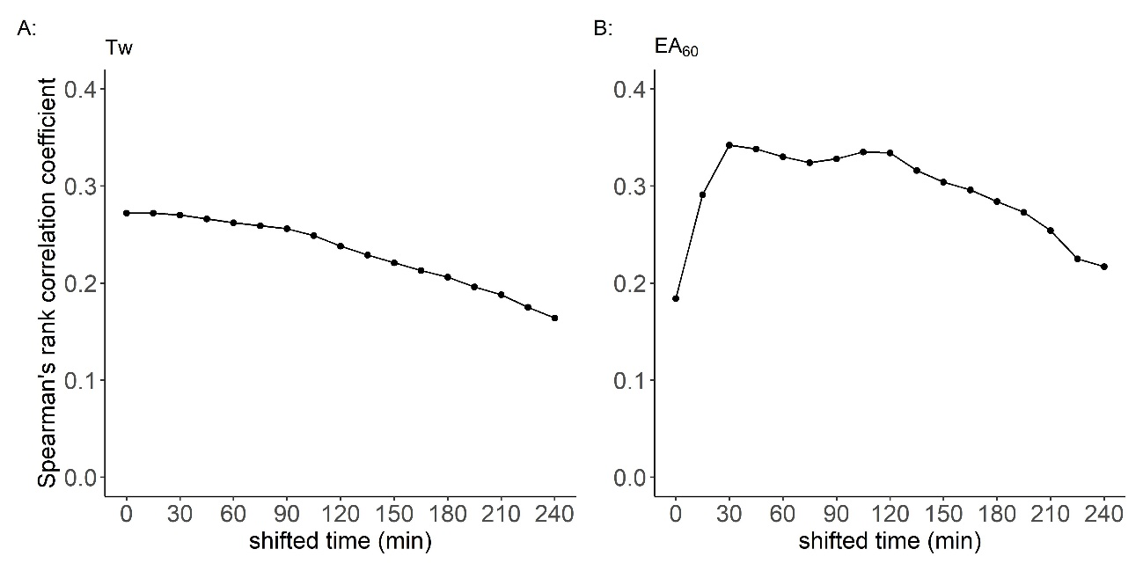 Fig. S1. Spearman’s rank correlation coefficient between (A) the temperature of the muscle-blubber interface (Tmbi) vs the water temperature (Tw) and (B) Tmbi vs External Acceleration averaged over 60 s (EA₆₀). Tw or EA₆₀ was shifted backward every 15 min with respect to Tmbi for 4 h. The maximum coefficient was 0.27 at 0 or 15 min shifted for Tw and 0.34 at 30 min shifted for EA₆₀, respectively.

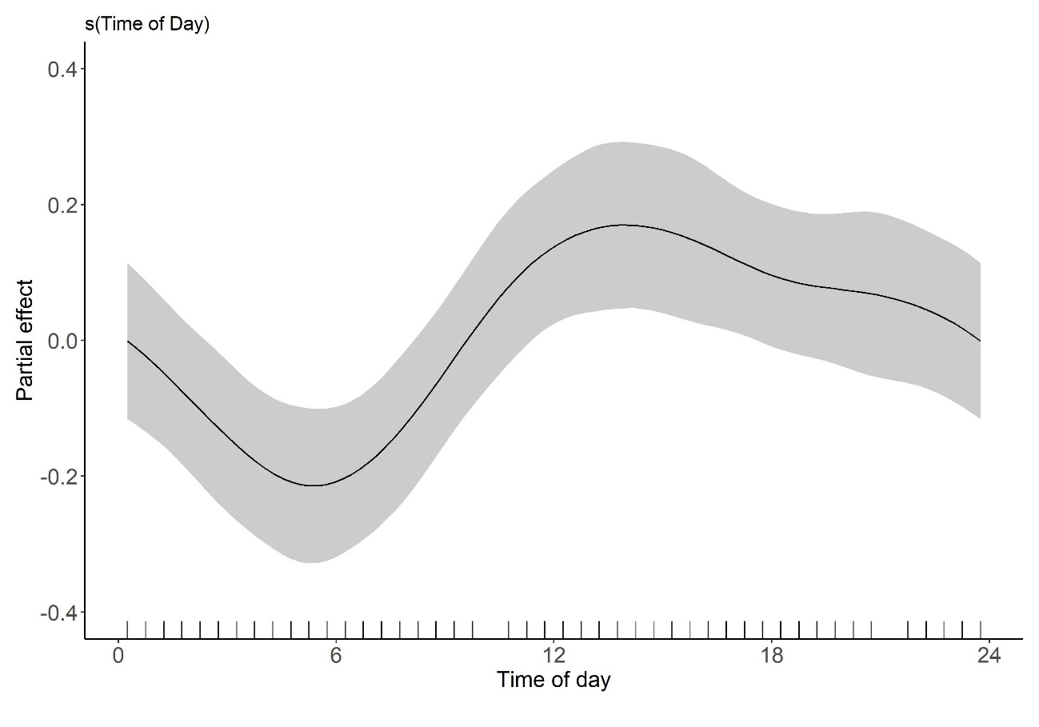
Fig. S2. Partial effects of selected explanatory variables on the heart rate (HR). The variation of HR was best explained by the time of day according to the best-fit model of general additive models (GAMs). The y-axis represents the partial effect of each variable. The tick symbols on the x-axis are the data points observed in this study. The shaded areas indicate the 95% confidence intervals.

