Supplementary materials
Partner quality matters - overyielding in a maize/soybean mixture depends on initiator of common mycorrhizal networks
Yalin Liu^{1, 2}, Thomas W. Kuyper³, Lin Zhang¹, Chunjie Li¹*
¹ State Key Laboratory of Nutrient Use and Management (SKL-NUM), College of Resources and Environmental Science, National Academy of Agriculture Green Development, China Agricultural University, Beijing 100193, China
² Centre for Crop Systems Analysis, Wageningen University, P.O. Box 430, 6700 AK, Wageningen, the Netherlands
³ Soil Biology Group, Wageningen University, P.O. Box 47, 6700 AA, Wageningen, the Netherlands
Contents
Method S1 Schematic diagram of the compartmented microcosm 2
Method S2 Shoot biomass, nitrogen content and phosphorus content in all treatments 3
Method S3 Phosphorus concentration and nitrogen concentration of maize and soybean in all treatments 4
Method S4 N:P ratio of maize and soybean in all treatments 5
Method S5 Shoot biomass, nitrogen content and phosphorus content of maize and soybean at system level in all treatments 6
Method S6 Nodule number and dry nodule weight of soybean in all treatments 7
Method S7 δ¹⁵N of maize (a), δ¹⁵N of soybean (b), %Ndfa (c) and Ndfa (d) of soybean in all treatments 8
Method S8 Two-way ANOVA testing the effect of CMNs, cropping system and their interaction effects on shoot biomass, nitrogen and phosphorus concentration and content, N:P and δ¹⁵N values of maize and soybean 9
Method S9 Two-way ANOVA testing the effect of CMNs, cropping system and their interaction effects on AMF colonization, mycorrhizal growth response of nitrogen and phosphorus content, nodule number and weight, nitrogen fixation of soybean 10

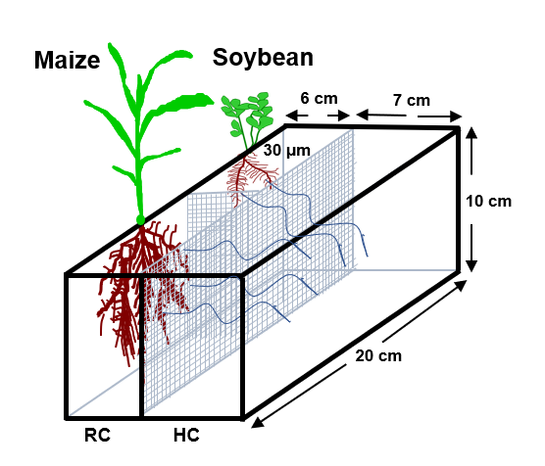
Method S1 Schematic diagram of the compartmented microcosm
Fig. S1 Schematic diagram of the compartmented microcosm used to determine the role of CMNs in monoculture and mixture of maize and soybean. RC: root compartment; HC: hyphal compartment. RC was uniformly subdivided by 30-μm nylon mesh into two RCs. RC and HC were separated by 30-μm nylon mesh.

Method S2 Shoot biomass, nitrogen content and phosphorus content in all treatments
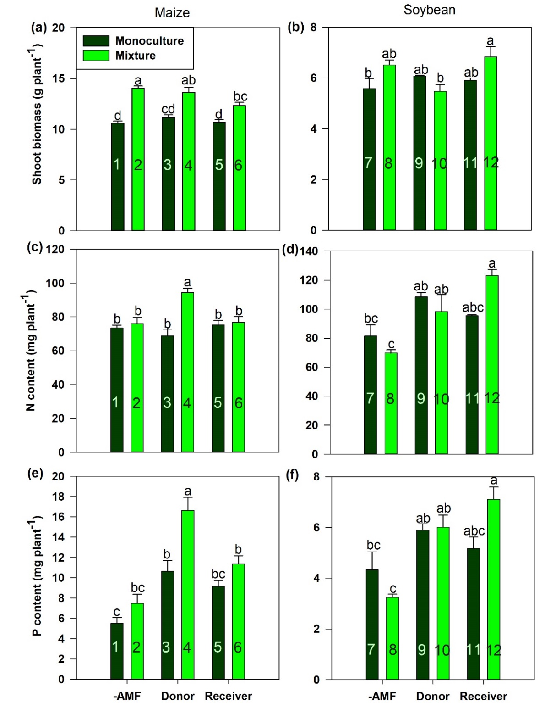 Fig. S2 Shoot biomass (a, b), N content (c, d) and P content (e, f) of maize and soybean in all treatments. The seedlings inoculated with AMF were defined as donor plant while the neighbor seedlings with sterilized inoculum as receiver. Different letters indicate significant differences between treatments for maize or soybean (Tukey HSD test, P < 0.05). Bars represent mean values ± standard error. The same labels apply to all other figures.

Method S3 Phosphorus concentration and nitrogen concentration of maize and soybean in all treatments
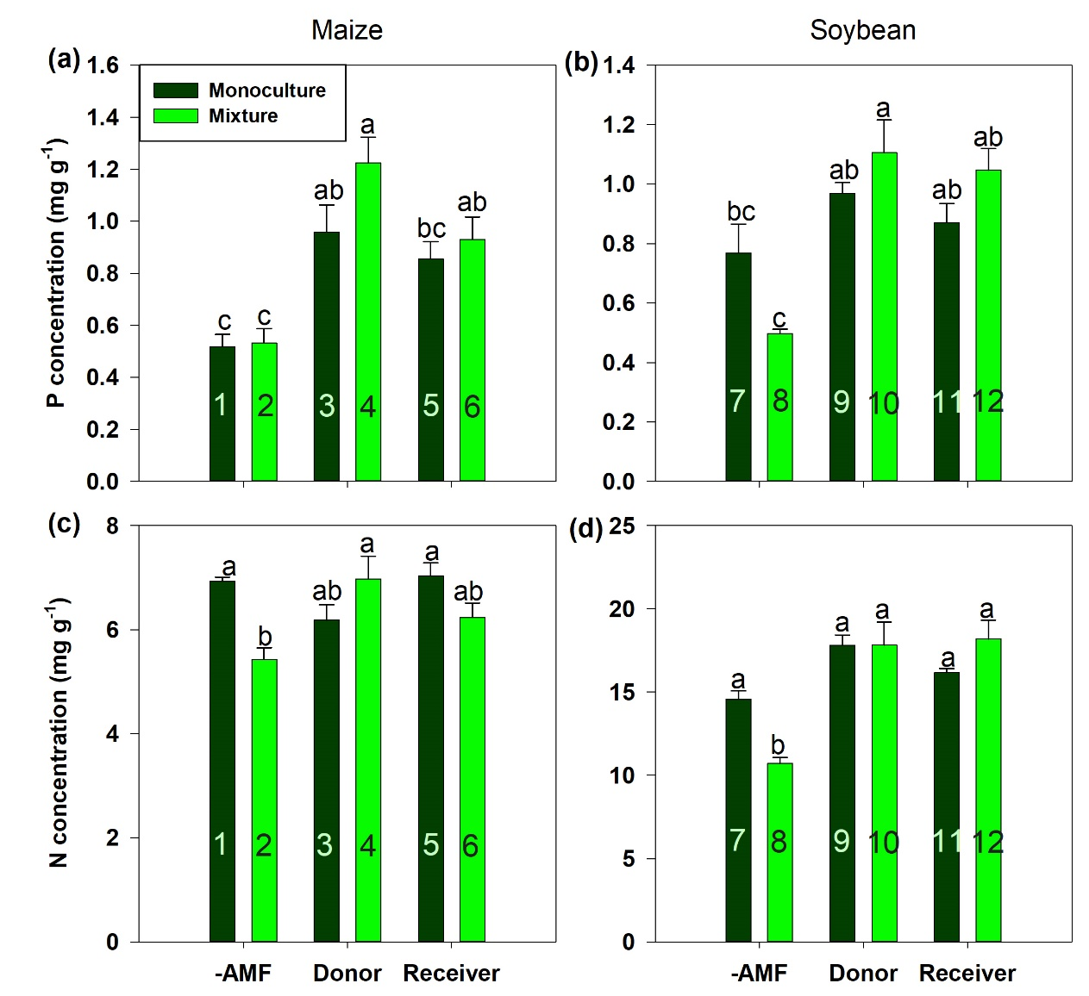 Fig. S3 Phosphorus concentration (a, b) and nitrogen concentration (c, d) of maize and soybean in all treatments. The seedlings inoculated with AMF were defined as donor plant while the neighbor seedlings with sterilized inoculum as receiver.

Method S4 N:P ratio of maize and soybean in all treatments
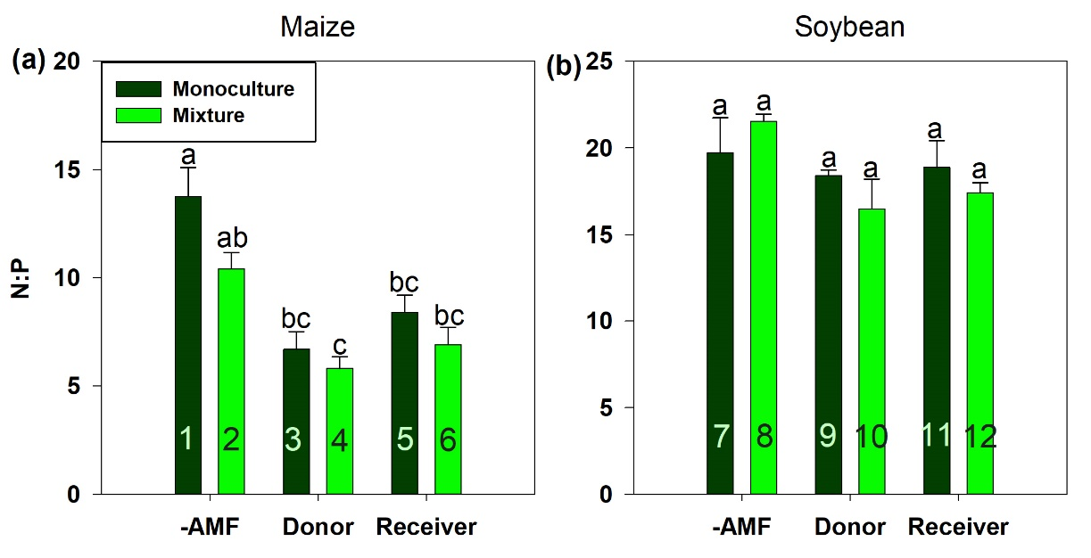Fig. S4 N:P ratio of maize (a) and soybean (b) in all treatments. The seedlings inoculated with AMF were defined as donor plant while the neighbor seedlings with sterilized inoculum as receiver.

Method S5 Shoot biomass, nitrogen content and phosphorus content of maize and soybean at system level in all treatments
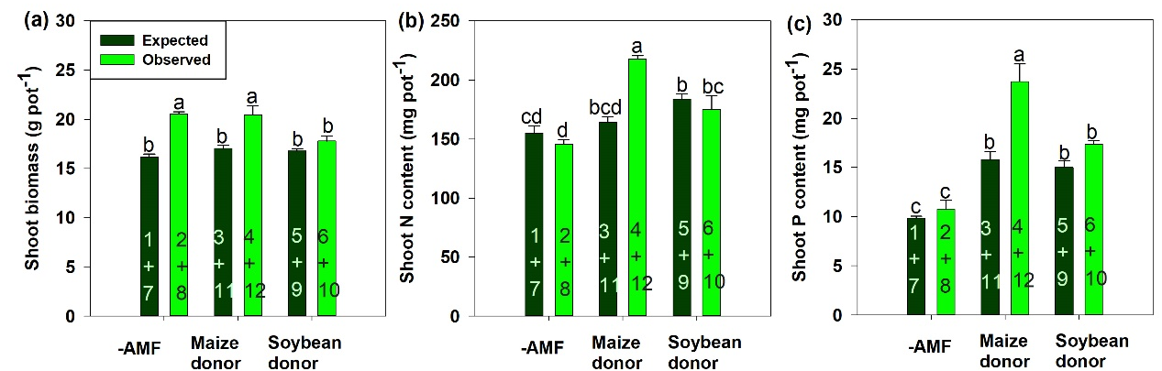Fig. S5 Shoot biomass (a), N content (b) and P content (c) of maize and soybean at system level in all treatments. The seedlings inoculated with AMF were defined as donor plant. When maize as donor, the expected values was calculated by maize as donor in monoculture + soybean as receiver in monoculture; When soybean as donor, the expected values was calculated by soybean as donor in monoculture + maize as receiver in monoculture.

Method S6 Nodule number and dry nodule weight of soybean in all treatments
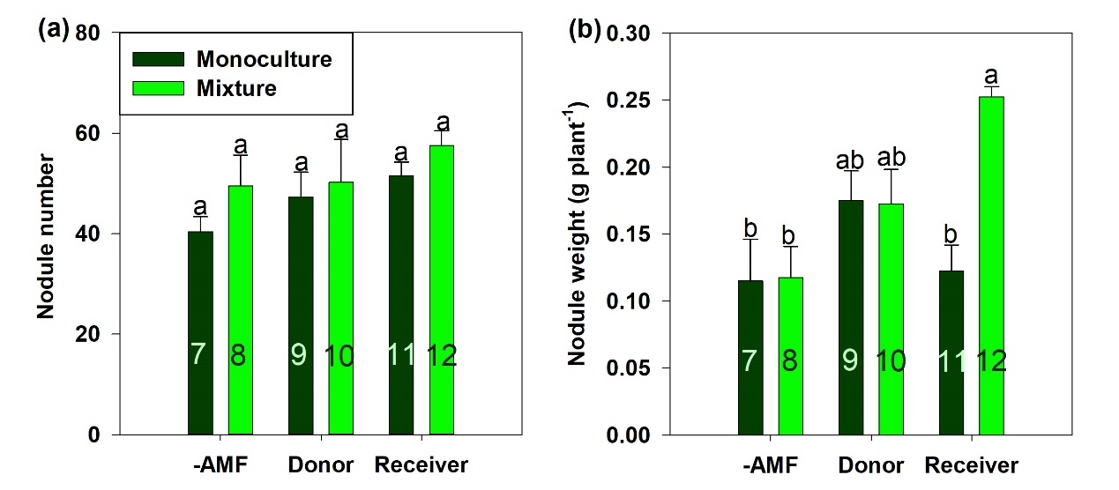Fig. S6 Nodule number (a) and dry nodule weight (b) of soybean in all treatments. The seedlings inoculated with AMF were defined as donor plant while the neighbor seedlings with sterilized inoculum as receiver.

Method S7 δ¹⁵N of maize (a), δ¹⁵N of soybean (b), %Ndfa (c) and Ndfa (d) of soybean in all treatments
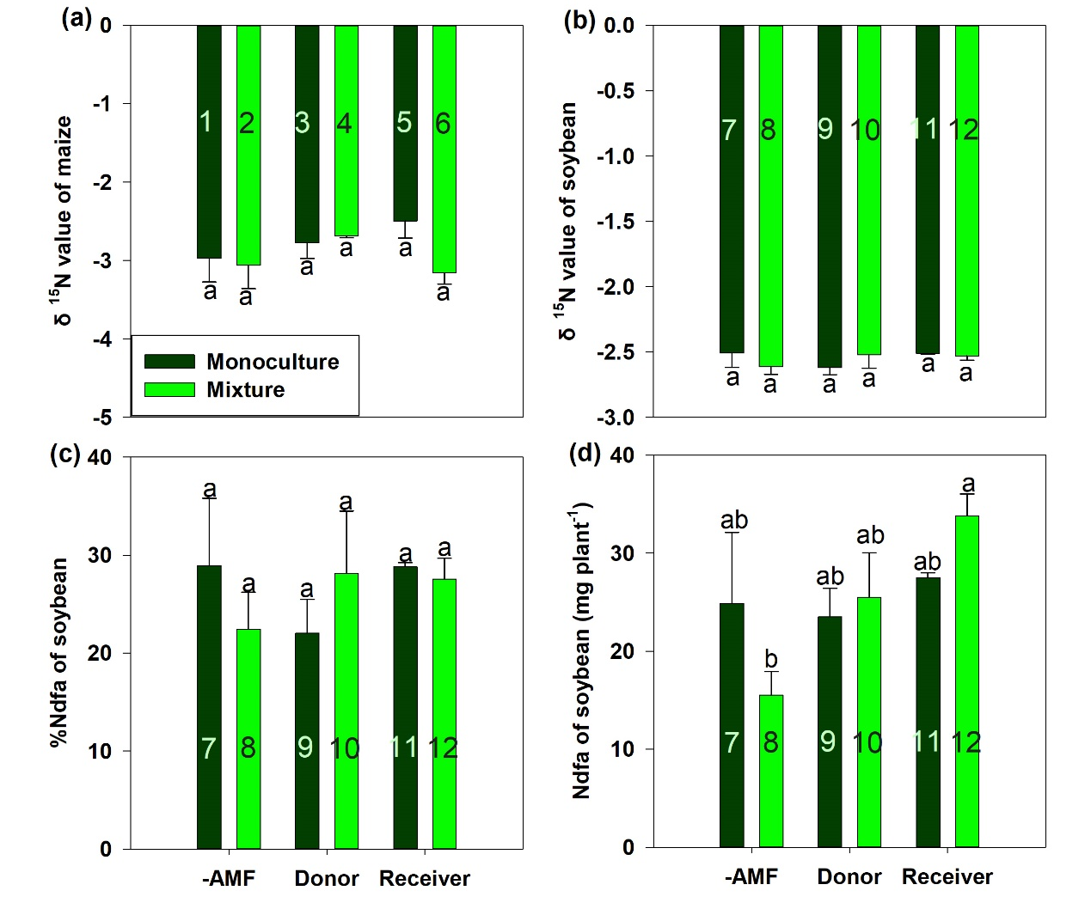Fig. S7 δ¹⁵N of maize (a), δ¹⁵N of soybean (b), %Ndfa (c) and Ndfa (d) of soybean in all treatments. The seedlings inoculated with AMF were defined as donor plant while the neighbor seedlings with sterilized inoculum as receiver.

Method S8 Two-way ANOVA testing the effect of CMNs, cropping system and their interaction effects on shoot biomass, nitrogen and phosphorus concentration and content, N:P and δ¹⁵N values of maize and soybean
Table S1 Results of two-way ANOVA testing the effect of CMNs (three levels: -CMNs; Donor; Receiver), cropping system (two levels: sole; mixed) and their interaction effects on shoot biomass, N and P concentration and content, N:P and δ¹⁵N values of maize and soybean in all treatments.
Crop species | Source of variation | Shoot biomass | Shoot P concentration | Shoot P content | Shoot N concentration | Shoot N content | N:P ratio
Maize | CMNs | 0.023 | 0.000 | 0.000 | 0.238 | 0.082 | 0.000
Maize | Cropping | 0.000 | 0.086 | 0.000 | 0.041 | 0.001 | 0.016
Maize | CMNs×Cropping | 0.036 | 0.281 | 0.073 | 0.002 | 0.001 | 0.365
Soybean | CMNs | 0.130 | 0.000 | 0.000 | 0.000 | 0.000 | 0.058
Soybean | Cropping | 0.081 | 0.809 | 0.397 | 0.382 | 0.706 | 0.626
Soybean | CMNs×Cropping | 0.017 | 0.012 | 0.013 | 0.007 | 0.008 | 0.313

Method S9 Two-way ANOVA testing the effect of CMNs, cropping system and their interaction effects on AMF colonization, mycorrhizal growth response of nitrogen and phosphorus content, nodule number and weight, nitrogen fixation of soybean
Table S2 Results of two-way ANOVA testing the effect of CMNs (three levels: -CMNs; Donor; Receiver), cropping system (two levels: sole; mixed) and their interaction effects on AMF colonization and mycorrhizal growth response and N content via hyphae in all treatments.
Crop species | Source of variation | AMF colonization | MGR of biomass | MGR of N content | MGR of P content | δ¹⁵N values |  | Nodule number | Nodule weight | %Ndfa | Ndfa
Maize | CMNs | 0.068 | 0.034 | 0.196 | 0.007 | 0.434
Maize | Cropping | 0.119 | 0.003 | 0.012 | 0.732 | 0.231
Maize | CMNs×Cropping | 0.002 | 0.316 | 0.004 | 0.170 | 0.228
Soybean | CMNs | 0.581 | 0.036 | 0.361 | 0.829 | 0.763 |  | 0.203 | 0.013 | 0.763 | 0.050
Soybean | Cropping | 0.218 | 0.005 | 0.003 | 0.000 | 0.884 |  | 0.169 | 0.031 | 0.884 | 0.912
Soybean | CMNs×Cropping | 0.393 | 0.009 | 0.011 | 0.047 | 0.384 |  | 0.840 | 0.014 | 0.384 | 0.149

