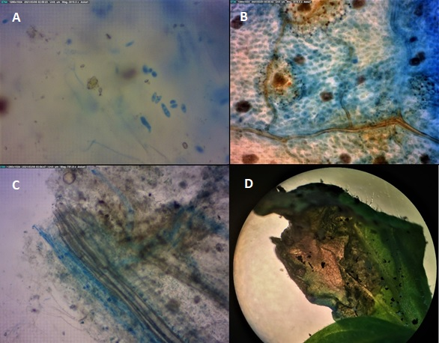
Supplementary Figure 1: Microscopic and macroscopic of Fusarium infection in tomato plants. The pathogen penetration was confirmed by trypan blue staining. A: Microconidia, macroconidia and germination spore of Fol. B and C: Root colonization of Fol in tomato plants and D: Foliar symptoms of pathogen infection.
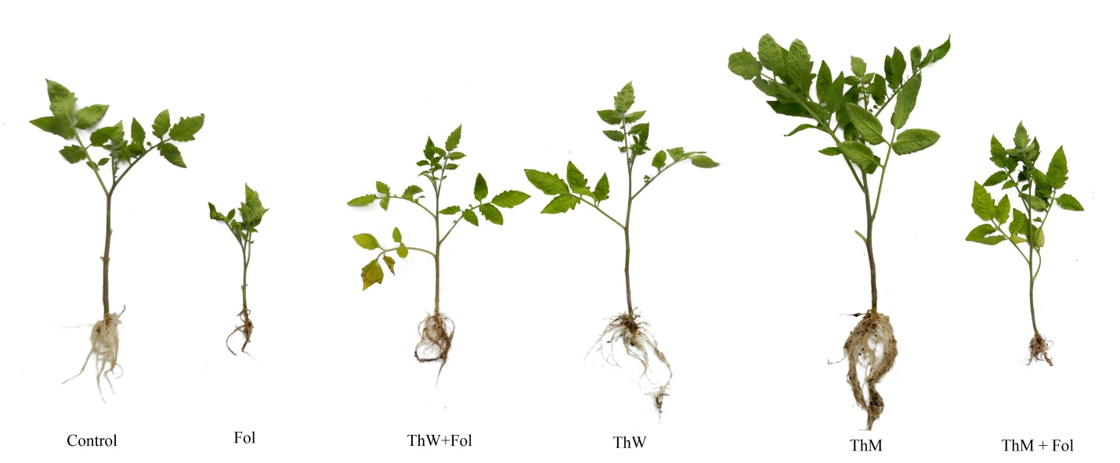
Supplementary Figure 2: Pretreatment of tomato plants by wild-type (ThW) and Mutant Trichoderma (ThM) enhance plant performance under normal and upon Fusarium (Fol) infection conditions. Representative image showing differences in tomato plants grown on soil treated with ThW and ThM and inoculated with Fol at 14 dpi.

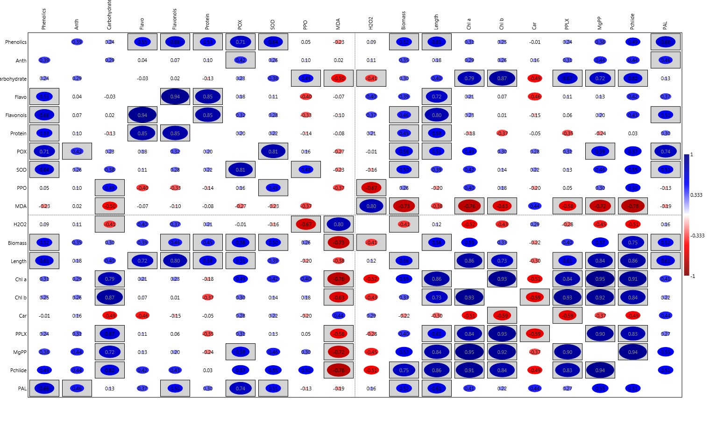
Supplementary Figure 3: Pearson correlation matrix analysis of assayed parameters. The P value < 0.05 is boxed.

