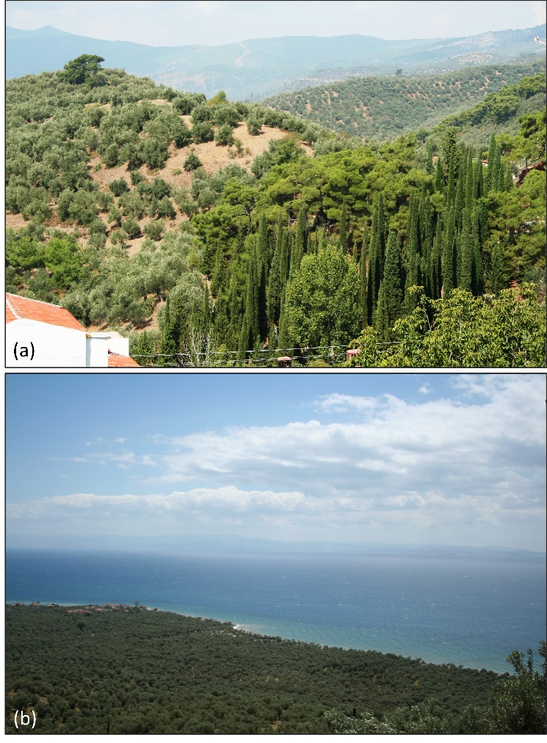
Supplementary Material 1 (SM-1): Some examples of the Mediterranean ecogeography from the southern part of the Kaz Mountain exposed to the Edremit Bay: (a) An ecogeography including pistachio pine (Pinus pinea), red or Turkish pine (Pinus brutia Ten) and the Mediterranean tall cypress (Supressus sempervirens var pyramidalis) and olive groves in the historical Nusratlı Village, which was established on a low plateau and hilly geomorphological landscape on the southern skirts of Kaz Mountain overlooking the Edremit Bay; (b) Dense olive groves grown on the geomorphological unit of an alluvial fan extending to the sea, near the district of Altınoluk town, on the southern skirts of Kaz Mountain overlooking the Edremit Bay.

SM-2: Vegetation types of the study area according to the (IGBP) (MCD12C1, https://doi.org/10.5067/MODIS/MCD12C1.006)

SM-3: Seasonal total precipitation (mm) changes of the Northwest Aegean Section for two scenarios in the 21st century compared to the reference period (1971-2000) and for three periods in the future (2024-2048, 2049-2073 and 2074-2098)
SM-4: Geographical distributions of winter Season total precipitation (mm) changes of the Northwest Aegean Section for two scenarios in the 21st century (1971-2000) and for three future periods (2024-2048, 2049-2073 and 2074-2098).
SM-5: Geographical distributions of average precipitation total (mm), mean air temperature (°C) and average wind velocity (m/s) in the North Aegean Sub-region for the period of 1950-2023 a) October b) Winter season c) April d) Spring season: e) July f) Summer season g) October h) Autumn season.
SM-6: Projected changes of longest dry and wet period (days) in olive tree phenological stages according to RCP scenarios.

SM-7: Present (1971-2000) climatology and projected rainy days and extreme rainy days precipitation amounts according to RCP scenarios in the phenological stages of olive tree swelling, ripening, and harvesting.
SM-8: Present (1971-2000) climatology and future changes in minimum/maximum values of maximum/minimum air temperatures (°C) according to RCP scenarios in olive tree swelling phenological stage.

