Supporting Information

The role of water and iodine in supramolecular assembly of a 2D coordination of benzimidazole derivate: X-ray crystallography and DFT calculations

Sahaj A. Gandhi¹*, Saurabh S. Soni ², Urmila H. Patel³ and Deepali Kotadia²

¹Department of Physics, Bhavan’s Shri I. L. Pandya Arts –Science and Smt. J. M. Shah Commerce College, Dakor, Gujarat, India
²Department of Chemistry, Sardar Patel University, Vallabh Vidyanagar, Gujarat, India
³Department of Physics, Sardar Patel University, Vallabh Vidyanagar, Gujarat, India

* Corresponding author: e-mail sahajg7@gmail.com, and ORCID No. : 0000-0002-3650-3780

Corresponding author address:
Department of Physics, Bhavan’s Shri I. L. Pandya Arts –Science and Smt. J. M. Shah Commerce College, Dakor, Gujarat - 388225, India
Tel: +(91) (02699) (244454).
Fax: +(91) (02699) (244412).

Table of Contents

- The details of data collection refinement parameters
- Slow evaporation Method
- Molecular Docking using Hex Software
- Study of Biological Activity

- The details of data collection refinement parameters are in Table S1.
Table S1 Crystal data and structure refinement parameters for the title compound
Empirical formula | C9H11N2, I, H2O
Formula weight | 292.11
Temperature | 298(2) K
Wavelength | MoKα (0.71073 Å)
Crystal system | Monoclinic
Space group | P2₁/c
Crystal size | 0.08 × 0.04 × 0.03 mm³
a | 8.9323(4) Ǻ
b | 7.1654(3) Ǻ
c | 17.6425(8) Ǻ
β | 101.432(2)°
Cell Volume | 1106.78(8) Å³
Z | 4
Calculated density | 1.753 Mg/m³
F(000) | 568
θ range for data collection | 2.326 to 27.756°
Index ranges | -11 ≤ h ≤ 11; -9 ≤ k ≤ 6; -21 ≤ l ≤ 22
Reflections collected/unique [R(int)] | 9452/ 2128 [0.024]
Completeness to θ max (%) | 0.999
Refinement method | Full Matrix Least Square of |F|²
Data/restrains/parameters | 2128/7/ 128
Goodness-of-fit on F² | 1.077
Final R indices | R1 = 0.0311, wR2 = 0.0858
R indices (all data) | R1 = 0.0387, wR2 = 0.0912
Largest diff. peak and hole | 1.11 and -0.50 e Å⁻³
Software used to data collection | Bruker Kappa Apex-II
Software used to cell refinement | Bruker SAINT
Software used to solve the structure | SHELXS - 97
Software used to refine the structure | SHELXL - 2016

Note: All hydrogen atoms have been geometrically fixed and permitted to ride on the corresponding non-hydrogen atoms with C-H = 0.93 to 0.98 and Uiso (H) = 1.5 Uequ (C) for all the H linked to the carbon atom. Non-hydrogen atoms have been refined anisotropically.
- Slow evaporation Method
Transparent needle shaped diffraction quality single crystals (Figure S1) of the DBZIW, 1,3-Dimethyl-3H-benzimidazol-1-ium iodide monohydrate, compound is grown by slow evaporation technique using ethanol.

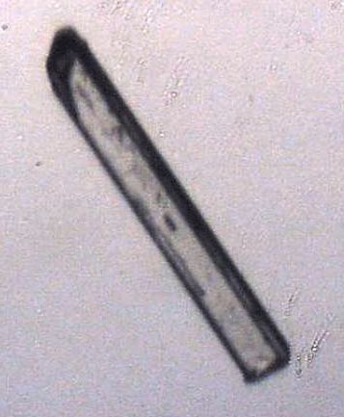
Figure S1 Photograph of the single crystal

3. Molecular Docking using Hex Software
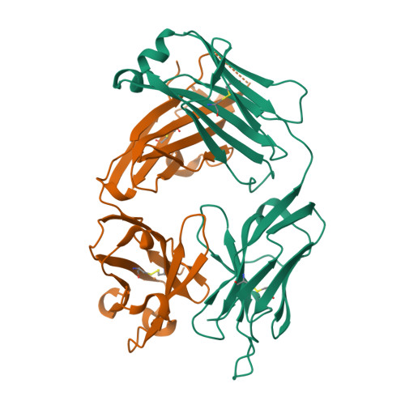
Fig. S2 Crystal structure of protein receptor Data Bank (PDB) ID 4QT5

Table S2 Used docking study parameters for molecular docking study of Hex Software

Correlation type | Shape + electro + DARS
Grid dimension | 0.6
Receptor range | 180
Ligand range | 180
Twist range | 360
Distance range | 40

- Study of Biological Activity
The biological reaction of the has been investigated in order to link the structure-function relationship. Using the Multidisc agar cup technique, the substance's antibacterial activity has been evaluated. A concentration gradient is created when an antibiotic is applied to an agar cup that has already been previously inoculated with a test organism. Zones of inhibition are created as a result. The antibacterial properties of the synthetic title chemical have been evaluated against a panel of test organisms, including S. aureus and S. typhi. The sizes of the zones of inhibition (Figure S3) represent the sensitivity of the test organism to the iodine-containing benzimiodazole derivatives synthesized. The measurement of the zone of inhibitions is displayed in Table S3.
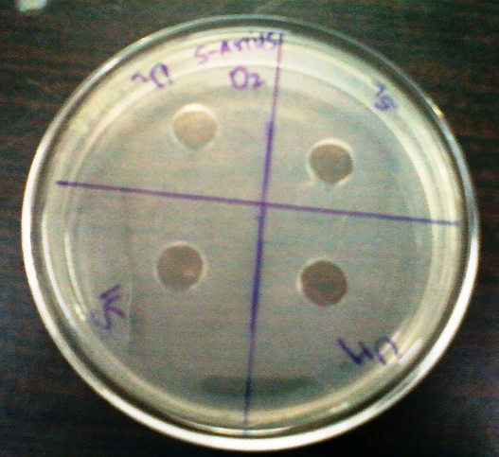 | 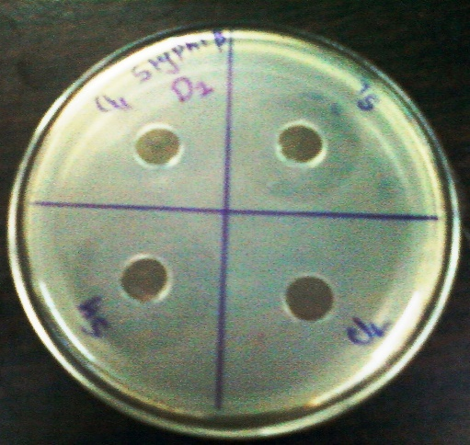
S. aurious | Styphi B

Figure S3 Measurement of zone of inhibition of the title compound

Table S3 Measurement of zone of inhibition of the title compound
Test Organism | S_{H} | S_{L} | U_{H} | U_{L}
S. aureus | 15 | 12 | 11 | 9
S. typhi | 24 | 22 | 18 | 12
S_{H} : Streptomycin High |  |  | S_{L} : Streptomycin Low
U_{H} : Title compound High |  |  | U_{L} : Title compound Low

