Appendices

Variance-Bias Tradeoff

The use of the machine learning method as a prediction tool is specifically designed to produce prediction results with the smallest error. The machine learning method decomposes prediction error into two components, namely bias and variance. Bias is an error that results from inaccurate assumptions related to data, while variance is an error that results from model sensitivity due to changes in the underlying data.
In general, bias and variance will be affected by the complexity of the model which consists of: 1) the number of variables in the model; 2) the number of parameters studied by the model; 3) the initial parameters values specified; and 4) the number of relationships between variables captured in the model. Variance and bias represent a tradeoff; the more complex the model, the higher the variance and the lower the bias, and vice versa. As the ultimate goal, we will seek a model with optimal complexity that minimizes the total error arising from either variance or bias. However, with the latest advancements in deep learning as a subset of machine learning, such as ChatGPT or other Large Language Models (LLM), the variance-bias tradeoff might not hold due to the emergent properties of complex systems.
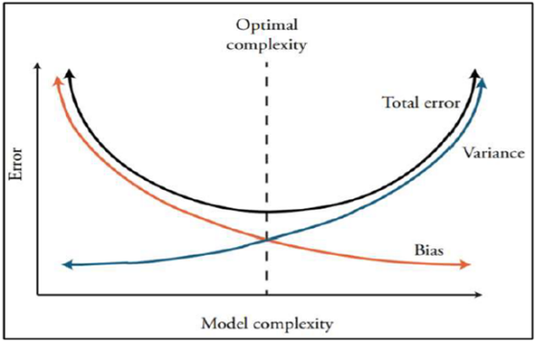
Figure 10. Illustration of Variance-Bias Tradeoff in which the more complex the model, in which the higher the variance and the lower the bias, and vice versa.
Source: Hall (2018)

Association/Relationship Measure
To determine the variables used in estimation using machine learning models, six association/relationship measures will be used as variable selection criteria in this study. They are Maximal Information Coefficient (MIC), Maximal Normalized Mutual Information (Max NMI), Kendall Correlation. Spearman Correlation, Pearson Correlation, and Distance Correlation.
- Maximal Information Coefficient (MIC) is a measure of association that can capture functional and non-functional relationships between variables. For functional relationships, MIC can be associated with R² (coefficient of determination). It is based on the concept of mutual information, which measures the amount of information that two variables share. MIC finds the maximum value of the Pearson correlation coefficient between the variables over all possible partitions of the data. It ranges from 0 to 1, with higher values indicating a stronger relationship.
- Mutual Information (MI) is a measure of the relationship between two random variables that are sampled simultaneously. Specifically, MI measures how much information is communicated from one variable to another. Normalized Mutual Information (NMI) is a measure of MI that is normalized so that it is at a value between 0 and 1. Maximal Normalized Mutual Information (Max NMI) is normalized to take into account the entropy of the variables.
- Kendall and Spearman Correlation is a non-parametric test to measure the strength of dependency between two variables. There are both measures of association that are appropriate for ordinal data, which means that the values of the variables have a natural ordering. Kendall Correlation counts the number of concordant and discordant pairs of observations (i.e., pairs where the values of both variables are either both increasing or both decreasing, or one variable is increasing while the other is decreasing), while Spearman Correlation is based on the ranks of the observations rather than their raw values. Both measures range from -1 to 1, where values closer to 1 indicate a stronger association.
- Pearson Correlation is a parametric test to measure the strength of a linear relationship between variables, which means that it is sensitive to outliers and may not be appropriate for data that are not normally distributed. It is based on the covariance of the two variables divided by the product of their standard deviations. The assumptions needed are that the variables must be normally distributed, linear, and homoscedastic.
- Distance Correlation is a measure of the relationship between non-linear random variables. It goes beyond Pearson’s correlation because it can spot more than linear associations and it can work multi-dimensionally. Distance correlation ranges from 0 to 1, where 0 implies independence between X & Y and 1 implies that the linear subspaces of X & Y are equal.
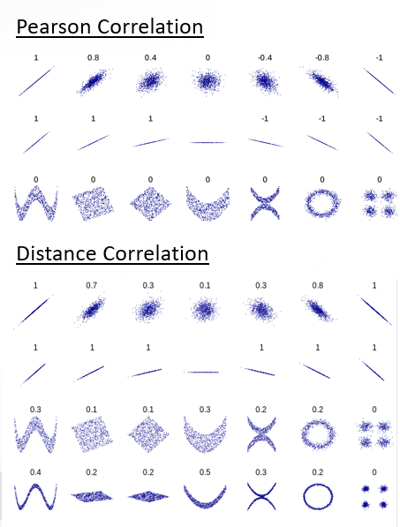
Figure 11. Comparison of Pearson and Distance Correlation. The Pearson correlation does not reflect many aspects of nonlinear relationships.
Source: DenisBoigelot.R SVG Plot. Original Work Published 9 May 2011. Retrieved from https://en.wikipedia.org/wiki/File:Correlation_examples2.svg. Last Accessed 26 September 2023

Clustering Method
Model-based clustering is a technique that aims to identify groups of data points within a dataset based on their underlying statistical distributions. This approach involves assuming that the data points in each group belong to a certain probability distribution, and then estimating the parameters of these distributions to identify the groups. One popular type of model-based clustering is the normal mixture model, which assumes that the data points in each group are normally distributed with a different mean and standard deviation. The normal mixture model assumes that the dataset is generated by a mixture of K normal distributions, each with its own mean and variance. The algorithm estimates the parameters of these K normal distributions, as well as the mixing proportions of the K groups, which determine the probability of each data point belonging to each group.
The estimation of the normal mixture model parameters is typically done using the Expectation-Maximization (EM) algorithm. In the Expectation step (E-step), the algorithm estimates the probability of each data point belonging to each group, based on the current estimate of the distribution parameters. In the Maximization step (M-step), the algorithm updates the estimates of the distribution parameters based on the probabilities estimated in the E-step. The EM algorithm iteratively repeats these steps until convergence, resulting in the final estimates of the distribution parameters and the group assignments of each data point.
One advantage of model-based clustering, and specifically the normal mixture model, is that it can identify groups with different shapes and variances. Additionally, the algorithm can provide estimates of uncertainty in the group assignments and the distribution parameters, which can be useful for assessing the quality of the clustering results. However, the normal mixture model assumes that the data points in each group are normally distributed, which may not be appropriate for all types of data. Additionally, the performance of the algorithm can be sensitive to the initial parameter estimates and the number of groups specified.

Model Selection

The process of estimation and projection using machine learning involves a variety of model options. This study, however, narrows the selection to four commonly used models in similar research as mentioned in literature review: Elastic Net, Random Forest, XGBoost, and Support Vector Machine. Each model will be generally described and can be further explored such as in James et al (2013) work. The tools and framework used in this research are R-based tools following Kuhn (2013,2020,2022) and Biecek (2018).
Elastic Net is a form of penalized regression by combining dimension reduction and variable selection in one step. This regularization method also provides robust results on potential correlations between predictors also known as the problem of multicollinearity. Multicollinearity occurs when two or more predictor variables in a linear regression model are highly correlated with each other, leading to unstable estimates of the regression coefficients and reduce the model's ability to generalize to new data. The trick is to add a penalty to the OLS regression so that all the coefficients are slightly downward biased which causes the addition of new information will not widen the predictions. This is known as regularization in machine learning terms.
$$\hat{β}=\arg{\min_{\hat{β_{j}}}\left\{\sum_{i=1}^{n}{\left.\left(Y-X\hat{β}\right)+\text{Penalty}(\hat{β}\right)}\right\}}$$
Elastic net regression combines two penalties, namely LASSO (Least Absolute Shrinkage and Selection Operator) and Ridge. L1 regularization, also known as LASSO, adds a penalty term to the regression equation that penalizes the absolute value of the coefficients and encourages sparsity by setting some of the coefficients to zero. LASSO penalty apply the following equation:
$$\text{Penalty}(\hat{β})=λ\sum_{j=1}^{p}{\left|β\right|}$$
Meanwhile, L2 regularization, also known as Ridge regression, adds a penalty term that penalizes the square of the coefficients and encourages the coefficients to be small but non-zero. Ridge penalty apply the following equation:
$$\text{Penalty}(\hat{β})=λ\sum_{j=1}^{p}{{\left(\hat{β}\right)}^{2}}$$
By combining L1 and L2 regularization, Elastic Net can achieve a balance between sparsity and stability, which can improve the model's ability to generalize to new data.
A decision tree is a modeling technique that represents relationships in the form of a tree structure using iterative partitioning, where predictors are split into two sets starting with the initial division that minimizes the largest prediction error. When used for predicting continuous variables, a decision tree is referred to as a regression tree. Decision tree models offer several benefits, such as computational efficiency, the ability to model non-linear relationships, and robustness to missing data. However, the model is not well-suited for predicting linear relationships and is prone to overfitting. To address the overfitting issue in regression trees, Random Forest and Gradient Boosting methods are commonly used as alternative models.
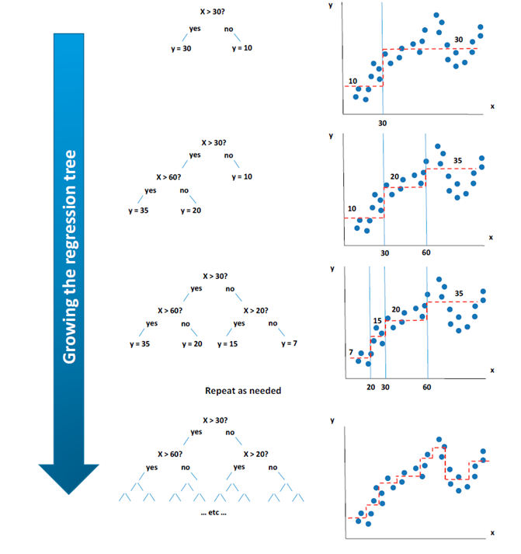
Figure 12. Illustration of Decision Tree, a modeling technique that represents relationships in the form of a tree structure, where predictors are split into two sets starting with the initial division that minimizes the largest prediction error.
Source: Tiffin (2016)
Random Forest is an ensemble learning method that combines multiple decision trees to improve the accuracy and robustness of the model. Each decision tree is trained on a random subset of the training data and a random subset of the predictor variables, which helps to reduce overfitting and increase the diversity of the trees in the ensemble. The final prediction is then made by aggregating the predictions of all the trees in the forest. This bagging technique (bootstrap aggregation) helps to reduce overfitting and improve the accuracy and robustness of the model. Random Forest is a powerful and flexible algorithm that can be used for both classification and regression tasks.
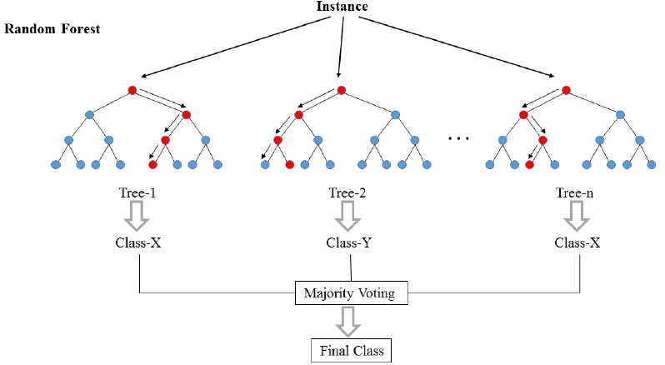
Figure 13. Illustration of Random Forest, a method that combines multiple decision trees.
Source: TIBCO.Random Forest Simplified. Original Work Published 26 September 2022. Retrieved from https://community.tibco.com/s/article/Random-Forest-Template-for-TIBCO-Spotfire.Last Accessed 26 September 2023

Meanwhile, XGBoost (eXtreme Gradient Boosting) is another ensemble learning method that is similar to Random Forest but uses a different approach to combine the individual models. XGBoost uses a gradient boosting framework, where each decision tree is trained to correct the errors of the previous trees, in order to improve the overall accuracy of the ensemble. XGBoost is known for its speed, scalability, and ability to handle large datasets with high-dimensional features.

Support Vector Machine (SVM) is a non-parametric technique that aims to identify hyperplanes that maximize the distance between classes in the feature space while ensuring that the perpendicular distance between two adjacent points of different classes is maximized. SVM is advantageous because it is effective in high dimensions, especially when the number of dimensions exceeds the number of samples, it efficiently utilizes memory, and it can employ various kernel functions for the decision function. However, the model may be prone to overfitting, which can be addressed by carefully selecting kernel functions and utilizing cross-validation. This is particularly important when the number of features is greater than the number of samples.
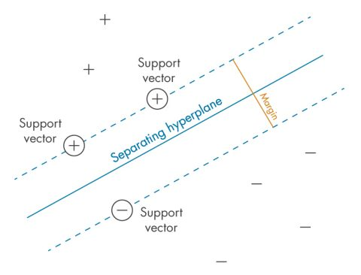
Figure 14. Illustration of Support Vector Machine, a non-parametric technique that aims to identify hyperplanes that maximize the distance between classes in the feature space while ensuring that the perpendicular distance between two adjacent points of different classes is maximized
MathWorks.Defining The “Margin” Between Classes – The Criterion That Svms Seek To Optimize. Retrieved from https://de.mathworks.com/discovery/support-vector-machine.html.Last Accessed 26 September 2023
Instead of relying on individual models that produce inconsistent or inconclusive predictions, this study also proposes the possibility to use of ensemble models that combine predictions from multiple model results. The ensemble model follows the Diversity Prediction Theorem introduced by Page (2010) where the collective/crowd error of various models will be equal to the average individual error minus the prediction diversity. Therefore, when the diversity in a group is large, the collective error is small.
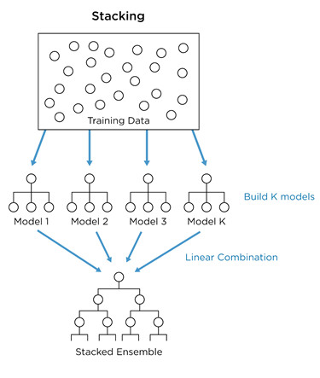
Figure 15. Illustration of Ensemble Model, combining predictions from multiple model results.
Jay Budzik. Budzik Figure 1 Ensemble Learning. Original Work Published September 2019. Retrieved from https://www.kdnuggets.com/2019/09/ensemble-learning.html.Last Accessed 26 September 2023

