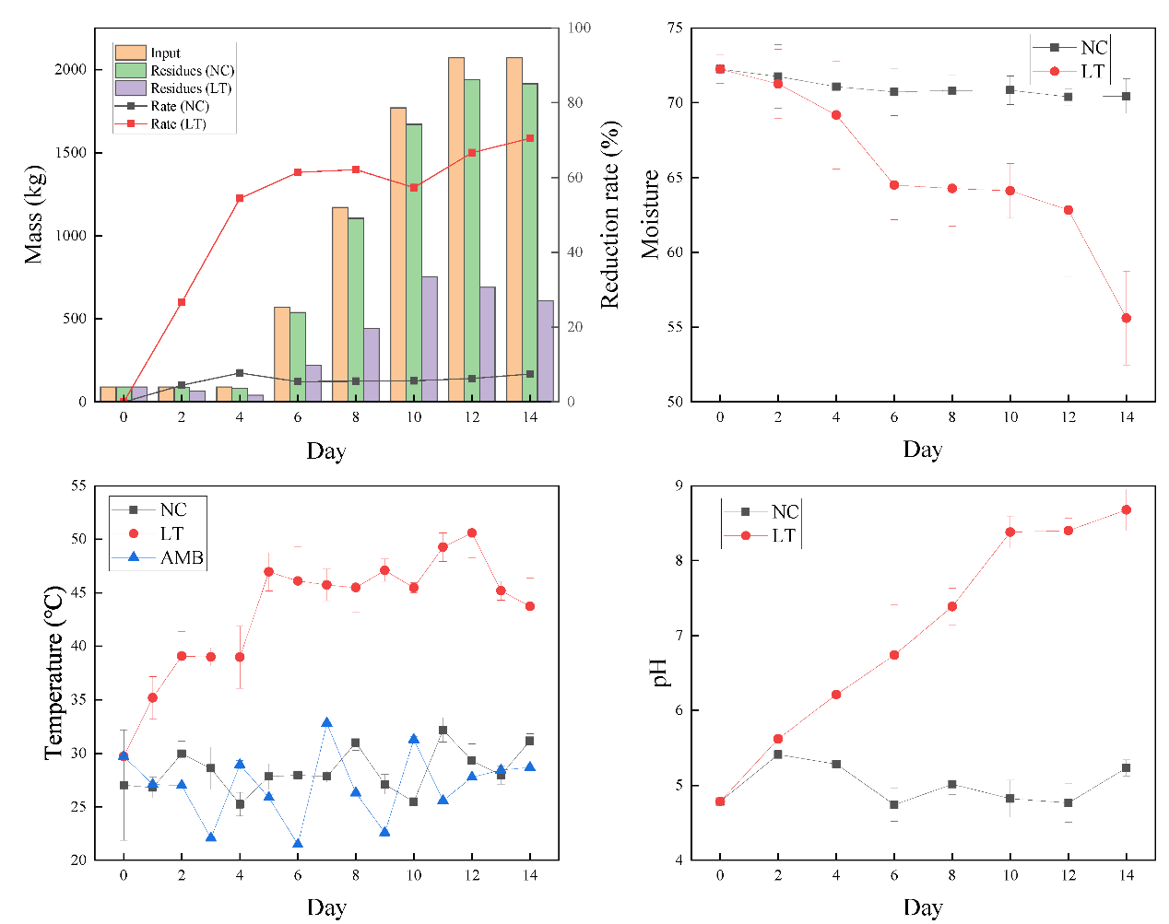
Fig. S1 dynamic changes in mass and reduction rate (a), moisture (b), temperature (c), and pH (d) during bioconversion. NC: natural compost; LT: larvae treatment; AMB: ambient temperature
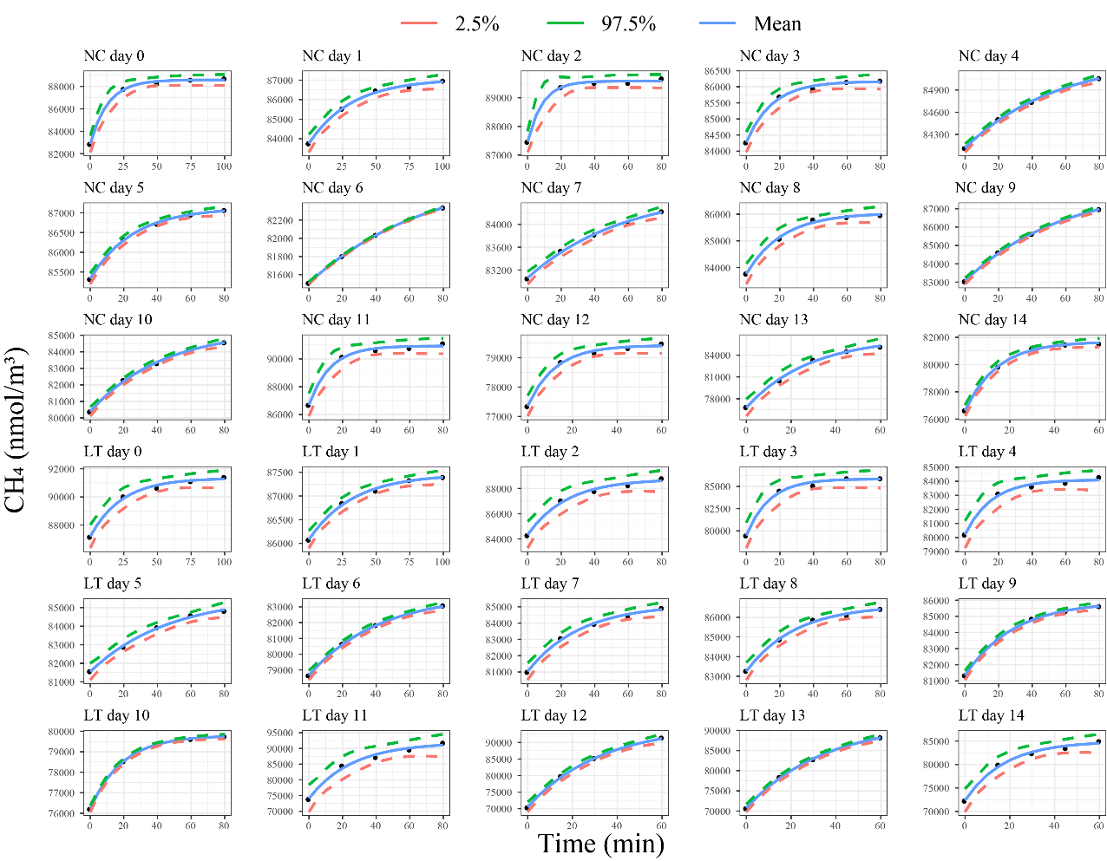
Fig. S2 Nonlinear fitting diagram of methane (CH₄) emissions

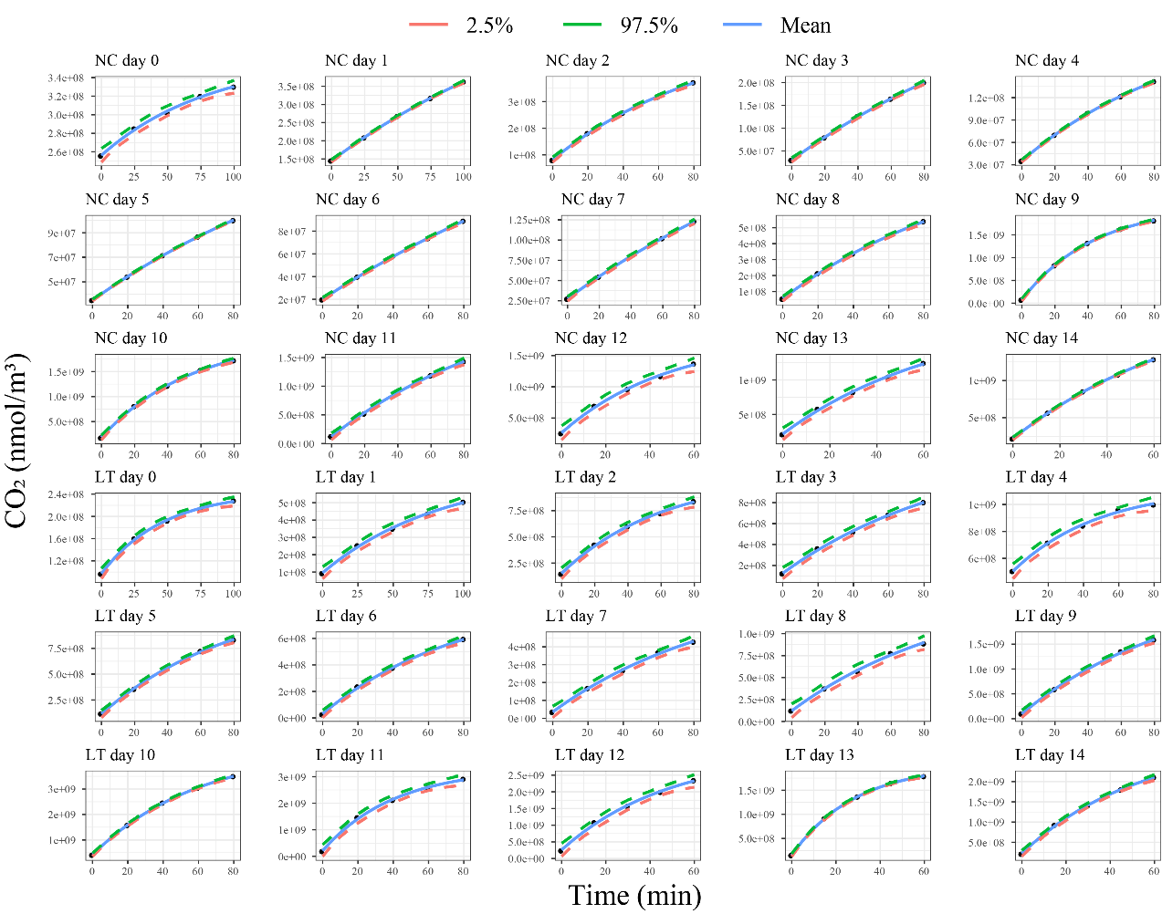
Fig. S3 Nonlinear fitting diagram of carbon dioxide (CO₂) emissions

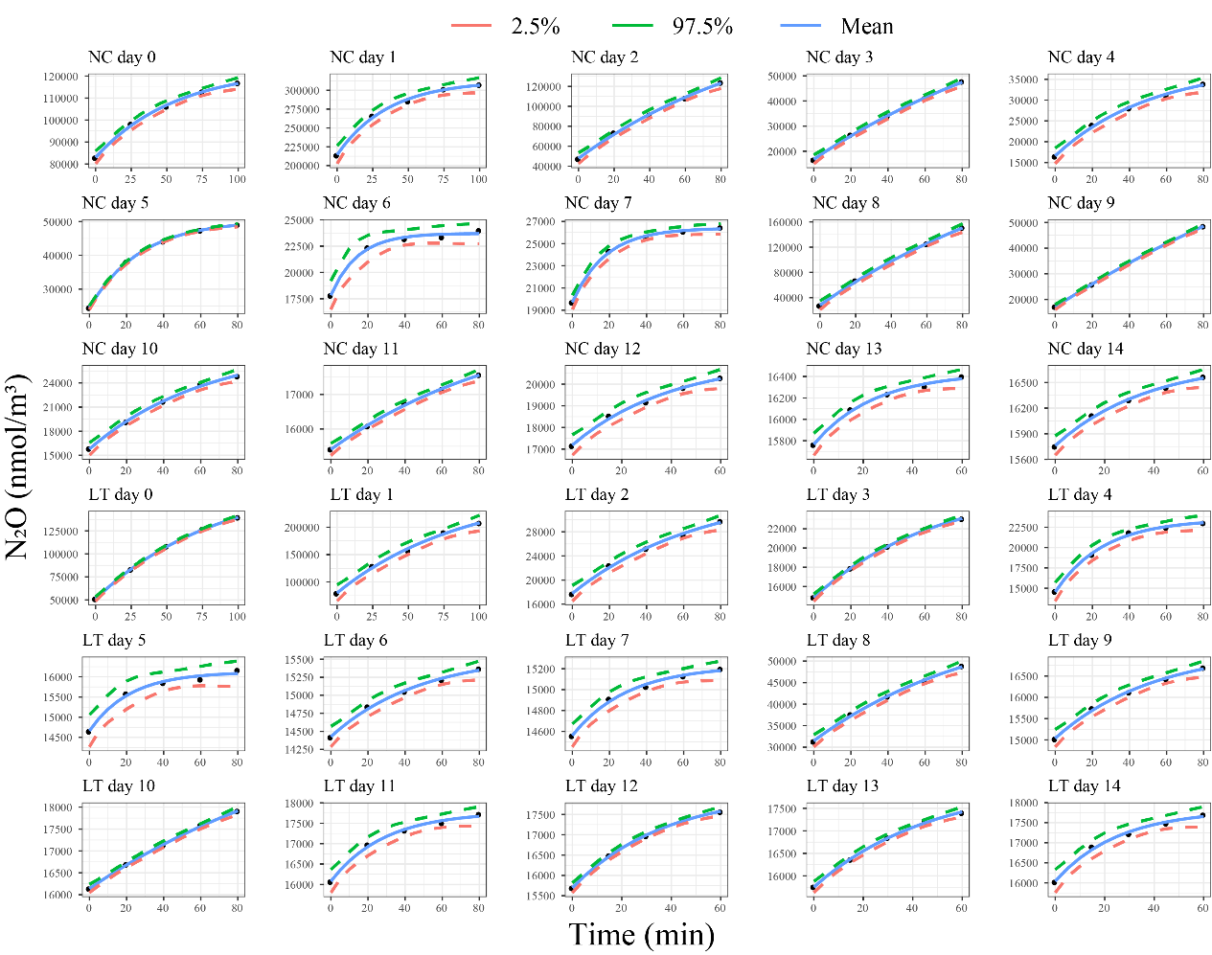
Fig. S4 Nonlinear fitting diagram of nitrous oxide (N₂O) emissions

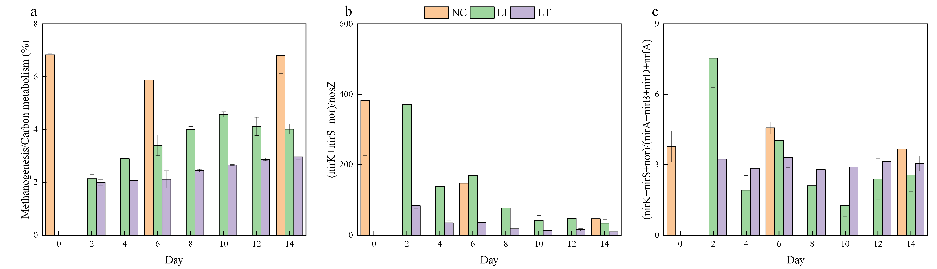
Fig. S5 The proportion of related genes. The proportion of methanogenesis in carbon metabolism (a), (nirK + nirS + nor)/nosZ (b), and (nirK + nirS + nor)/(nirA + nirB + nirD + nrfA) (c)

Table S1 Summary of nonlinear fitting results for greenhouse gases
Model | Exponential model fit
Equation | 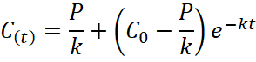
Gas | CH₄ |  |  | CO₂ |  |  | N₂O
Parameter Estimate | P/k | C₀ | 1/k | 10⁶P/k | 10⁶C₀ | 1/k | P/k | C₀ | 1/k
NC 0 | 87059 | 83762 | 31.80 | 361.9 | 256.3 | 82.66 | 123500 | 83020 | 56.24
NC 1 | 87059 | 83762 | 31.80 | 702.1 | 144.8 | 201.1 | 312887 | 214383 | 35.88
NC 2 | 89578 | 87467 | 8.777 | 577.5 | 82.01 | 91.27 | 197525 | 47896 | 113.9
NC 3 | 86168 | 84278 | 15.37 | 494.3 | 29.87 | 174.5 | 90245 | 16817 | 147.8
NC 4 | 85339 | 84118 | 54.65 | 229.3 | 35.24 | 100.6 | 38304 | 16605 | 51.95
NC 5 | 87128 | 85327 | 25.41 | 206.9 | 35.10 | 167.3 | 50350 | 24520 | 27.48
NC 6 | 82747 | 81508 | 72.22 | 244.5 | 20.08 | 218.3 | 23717 | 17845 | 14.38
NC 7 | 84586 | 83063 | 56.96 | 314.6 | 27.56 | 197.9 | 26402 | 19707 | 17.66
NC 8 | 86044 | 83763 | 21.33 | 1002 | 55.49 | 111.9 | 320770 | 28177 | 147.7
NC 9 | 88304 | 83057 | 58.41 | 2155 | 75.54 | 43.76 | 119918 | 17024 | 218.1
NC 10 | 85339 | 80390 | 43.12 | 2183 | 182.0 | 53.91 | 28661 | 15789 | 64.15
NC 11 | 90933 | 86697 | 12.58 | 2745 | 122.9 | 115.2 | 19360 | 15410 | 101.8
NC 12 | 79416 | 77361 | 12.23 | 1808 | 264.3 | 48.96 | 21148 | 17188 | 40.37
NC 13 | 86426 | 76799 | 28.13 | 1966 | 218.2 | 68.81 | 16436 | 15767 | 24.30
NC 14 | 81680 | 76630 | 14.30 | 2247 | 218.9 | 80.34 | 16748 | 15762 | 37.17
LT 0 | 91333 | 87186 | 23.35 | 244.2 | 97.12 | 46.46 | 180700 | 51100 | 86.50
LT 1 | 87460 | 86082 | 32.73 | 680.7 | 96.03 | 84.56 | 270454 | 80135 | 89.74
LT 2 | 88743 | 84332 | 23.24 | 1083 | 152.1 | 60.74 | 35031 | 17791 | 69.59
LT 3 | 85845 | 79488 | 13.70 | 1359 | 127.1 | 100.6 | 26528 | 14833 | 65.39
LT 4 | 84109 | 80215 | 15.91 | 1126 | 504.3 | 48.50 | 23461 | 14559 | 26.02
LT 5 | 85624 | 81550 | 46.69 | 1278 | 114.3 | 82.08 | 16119 | 14663 | 21.85
LT 6 | 83777 | 78654 | 41.37 | 910.8 | 31.07 | 78.59 | 15569 | 14426 | 48.61
LT 7 | 85159 | 81034 | 31.43 | 738.9 | 35.64 | 96.91 | 15229 | 14561 | 30.05
LT 8 | 86612 | 83254 | 29.05 | 1556 | 122.1 | 102.3 | 61187 | 31471 | 92.33
LT 9 | 85933 | 81339 | 29.07 | 2711 | 98.02 | 93.81 | 17141 | 15041 | 53.64
LT 10 | 79790 | 76220 | 18.91 | 4638 | 417.8 | 60.98 | 20315 | 16140 | 144.2
LT 11 | 91847 | 74089 | 25.71 | 3321 | 214.3 | 40.80 | 17777 | 16080 | 28.81
LT 12 | 95079 | 70510 | 32.62 | 3192 | 261.8 | 49.03 | 18055 | 15696 | 37.45
LT 13 | 91931 | 70752 | 34.62 | 2024 | 154.9 | 28.48 | 18072 | 15751 | 47.09
LT 14 | 84929 | 72353 | 17.50 | 2997 | 224.2 | 52.98 | 17820 | 16042 | 25.32

