[Supporting Information]

Discerning Potent CSF-1R inhibitors for Targeting and Therapy of Neuroinflammation using Computational Approaches
Anupriya Adhikari*¹, Anwesh Pandey*²
¹Department of Chemistry, Graphic Era Hill University, Dehradun, Uttarakhand-248002, India.
²Deptartment of Physics, Babasaheb Bhimrao Ambedkar University, Lucknow, UP-226025, India

*E-mail: anupriyamahar@gmail.com, apdapbbau@gmail.com

Figure S1. 3D representation of the best docked pose of the reference ligands with labelled H-bonding interactions (Å)
Figure S2. The H-bonding donor (pink) and acceptor (green) regions of the best docked pose of the reference ligands
Figure S3. 3D representation of the best docked pose of the proposed ligands with labelled H-bonding interactions (Å)
Figure S4. The H-bonding donor (pink) and acceptor (green) regions of the best docked pose of the proposed ligands
Figure S5. Figure representing the RMSD of Protein ($C_{α}$), Ligand and Complex for entire 100ns trajectory of each protein-ligand complex
Figure S6. The alignment heat map of the superimposed (a) protein backbone and (b) ligands, taken at interval of 10ns for entire 100ns trajectory of each complex
Figure S7. Heat map representing the per-residue energy contribution taken at interval of 10ns for entire 100ns trajectory of each complex
Figure S8. Per-residue energy contribution of the top 10 residues for entire 100ns trajectory of each complex
Table S1. The alignment RMSD (Å) of the superimposed (a) protein backbone and (b) ligands, taken at interval of 10ns for entire 100ns trajectory of each complex
Table S2. Free Energy Components for proposed ligands taken at interval of 10ns for entire 100ns trajectory of each complex
Table S3. Free Energy Components for reference ligands taken at interval of 10ns for entire 100ns trajectory of each complex
Table S4(a). Table representing the pertinent residues participating in H-bonding as obtained through snapshots taken at an interval of 10ns from the trajectory of each of the protein-ligand complex.
Table S4(b). Table representing the pertinent residues participating in π-type of interactions as obtained through snapshots taken at an interval of 10ns from the trajectory of each of the protein-ligand complex.
Table S4(c). Table representing the pertinent residues participating in other interactions as obtained through snapshots taken at an interval of 10ns from the trajectory of each of the protein-ligand complex.

CPPC (Ref-1) | GW2580 (Ref-2) | AZ683 (Ref-3)
OMPyO (Ref-4) | JNJ40346527 (Ref-5) | PLX5622 (Ref-6)

Figure S1. 3D representation of the best docked pose of the reference ligands with labelled H-bonding interactions (Å)
CPPC (Ref-1) | GW2580 (Ref-2) | AZ683 (Ref-3)
OMPyO (Ref-4) | JNJ40346527 (Ref-5) | PLX5622 (Ref-6)

Figure S2. The H-bonding donor (pink) and acceptor (green) regions of the best docked pose of the reference ligands
Lig-1 | Lig-2 | Lig-3
Lig-4 | Lig-5 | Lig-6
Lig-7 | Lig-8 | Lig-9
Lig-10

Figure S3. 3D representation of the best docked pose of the proposed ligands with labelled H-bonding interactions (Å)

Lig-1 | Lig-2 | Lig-3
Lig-4 | Lig-5 | Lig-6
Lig-7 | Lig-8 | Lig-9
Lig-10

Figure S4. The H-bonding donor (pink) and acceptor (green) regions of the best docked pose of the proposed ligands
 | Protein ($C_{α}$) | Ligand | Complex
Lig-3
Lig-4
Lig-5
Ref-1
Ref-5
Ref-6

Figure S5. Figure representing the RMSD of Protein ($C_{α}$), Ligand and Complex for entire 100ns trajectory of each protein-ligand complex

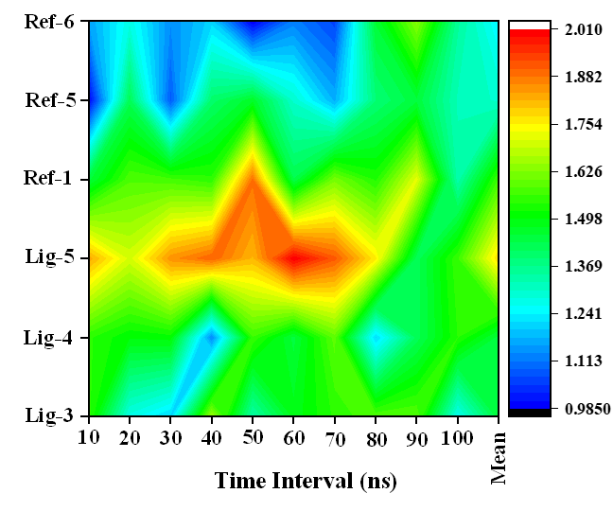 | 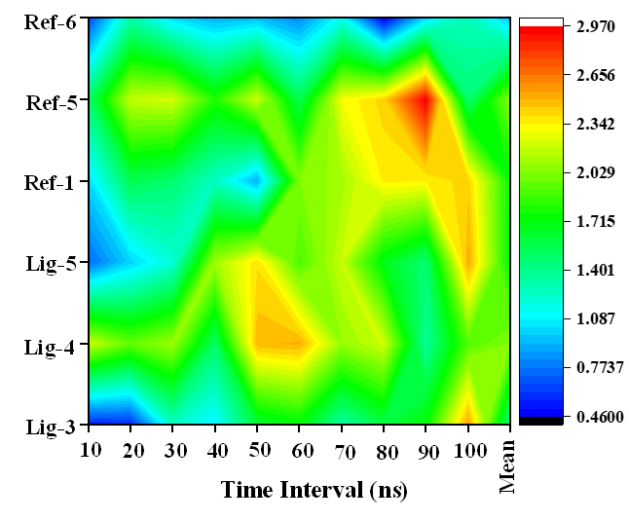
(a) Protein Alignment Heat Map | (b) Ligand Alignment Heat Map

Figure S6. The alignment heat map of the superimposed (a) protein backbone and (b) ligands, taken at interval of 10ns for entire 100ns trajectory of each complex
(a) Ligand-3 | (b) Ligand-4 | (c) Ligand-5
(d) Reference-1 | (e) Reference-5 | (f) Reference-6

Figure S7. Heat map representing the per-residue energy contribution taken at interval of 10ns for entire 100ns trajectory of each complex
(a) Ligand-3 | (b) Ligand-4 | (c) Ligand-5
(d) Reference-1 | (e) Reference-5 | (f) Reference-6

Figure S8. Per-residue energy contribution of the top 10 residues for entire 100ns trajectory of each complex
Table S1. The alignment RMSD (Å) of the superimposed (a) protein backbone and (b) ligands, taken at interval of 10ns for entire 100ns trajectory of each complex
Time | Protein Alignment RMSD |  |  |  |  |  | Time | Ligand Alignment RMSD
Time | Lig-3 | Lig-4 | Lig-5 | Ref-1 | Ref-5 | Ref-6 | Time | Lig-3 | Lig-4 | Lig-5 | Ref-1 | Ref-5 | Ref-6
10ns | 1.554 | 1.545 | 1.832 | 1.447 | 0.993 | 1.157 | 10ns | 0.548 | 2.205 | 0.742 | 1.034 | 1.485 | 0.643
20ns | 1.275 | 1.500 | 1.704 | 1.578 | 1.425 | 1.278 | 20ns | 0.578 | 1.964 | 1.010 | 1.550 | 2.187 | 1.318
30ns | 1.214 | 1.508 | 1.852 | 1.568 | 1.085 | 1.137 | 30ns | 1.254 | 2.092 | 1.210 | 1.471 | 2.220 | 1.035
40ns | 1.657 | 1.132 | 1.903 | 1.547 | 1.402 | 1.210 | 40ns | 1.088 | 1.504 | 2.100 | 1.259 | 1.808 | 0.924
50ns | 1.339 | 1.559 | 1.815 | 1.889 | 1.471 | 0.986 | 50ns | 1.600 | 2.486 | 2.387 | 0.920 | 2.208 | 0.959
60ns | 1.485 | 1.448 | 2.007 | 1.435 | 1.301 | 1.124 | 60ns | 1.718 | 2.512 | 1.909 | 2.027 | 1.547 | 0.829
70ns | 1.545 | 1.593 | 1.912 | 1.617 | 1.173 | 1.062 | 70ns | 1.332 | 2.076 | 2.191 | 2.109 | 2.293 | 1.150
80ns | 1.581 | 1.216 | 1.760 | 1.536 | 1.390 | 1.458 | 80ns | 1.574 | 2.207 | 1.682 | 2.354 | 2.420 | 0.465
90ns | 1.585 | 1.423 | 1.421 | 1.720 | 1.450 | 1.633 | 90ns | 1.736 | 1.365 | 1.460 | 2.342 | 2.961 | 1.027
100ns | 1.267 | 1.541 | 1.559 | 1.337 | 1.323 | 1.354 | 100ns | 2.552 | 1.931 | 2.527 | 2.427 | 1.462 | 1.283
Mean | 1.450 | 1.447 | 1.777 | 1.567 | 1.301 | 1.239 | Mean | 1.398 | 2.034 | 1.722 | 1.749 | 2.059 | 0.963

Table S2. Free Energy Components for proposed ligands taken at interval of 10ns for entire 100ns trajectory of each complex
Time  (ns) | Lig-3 (kJ/mol) |  |  |  |  | Lig-4 (kJ/mol) |  |  |  |  | Lig-5 (kJ/mol)
Time  (ns) | VDW | ELE | POL | SASA | BIND | VDW | ELE | POL | SASA | BIND | VDW | ELE | POL | SASA | BIND
10ns | -204.94 | -65.27 | 235.29 | -21.00 | -55.91 | -167.79 | -57.61 | 194.85 | -19.94 | -50.49 | -201.92 | -19.33 | 272.85 | -20.95 | 30.64
20ns | -209.43 | -37.46 | 190.79 | -23.55 | -79.65 | -151.10 | -62.54 | 160.05 | -17.20 | -70.80 | -198.44 | -42.13 | 274.77 | -22.64 | 11.57
30ns | -205.12 | -61.32 | 214.51 | -22.46 | -74.39 | -163.90 | -62.84 | 176.67 | -18.67 | -68.75 | -208.04 | -53.92 | 284.51 | -20.89 | 1.65
40ns | -197.91 | -87.06 | 257.04 | -23.57 | -51.50 | -181.05 | -33.34 | 159.66 | -17.32 | -72.04 | -134.16 | -184.35 | 421.70 | -18.70 | 84.49
50ns | -178.84 | -44.84 | 210.15 | -20.32 | -33.85 | -131.77 | -22.37 | 125.25 | -14.74 | -43.63 | -144.84 | -146.85 | 386.90 | -19.54 | 75.68
60ns | -199.48 | -75.67 | 230.78 | -23.02 | -67.40 | -134.17 | -36.83 | 121.53 | -14.99 | -64.46 | -135.66 | -146.36 | 394.80 | -20.80 | 91.98
70ns | -209.36 | -69.47 | 244.87 | -21.98 | -55.93 | -154.73 | -4.29 | 109.70 | -17.72 | -67.05 | -142.86 | -107.82 | 380.83 | -20.21 | 109.95
80ns | -223.98 | -70.05 | 213.35 | -22.30 | -102.98 | -148.17 | -9.71 | 114.37 | -17.25 | -60.76 | 0.00 | 26.59 | 52.78 | 1.71 | 81.07
90ns | -213.34 | -49.32 | 232.57 | -22.81 | -52.90 | 0.00 | 0.11 | 36.39 | -0.33 | 36.16 | -143.19 | -135.68 | 383.08 | -18.54 | 85.67
100ns | -190.16 | -73.77 | 219.07 | -23.02 | -67.87 | -144.53 | -35.77 | 142.53 | -16.95 | -54.72 | -156.17 | -145.68 | 374.02 | -18.31 | 53.86
Mean | -203.26 | -63.42 | 224.84 | -22.40 | -64.24 | -137.72 | -32.52 | 134.10 | -15.51 | -51.65 | -146.53 | -95.55 | 322.62 | -17.89 | 62.66

Table S3. Free Energy Components for reference ligands taken at interval of 10ns for entire 100ns trajectory of each complex

Time  (ns) | Ref-1 (kJ/mol) |  |  |  |  | Ref-5 (kJ/mol) |  |  |  |  | Ref-6 (kJ/mol)
Time  (ns) | VDW | ELE | POL | SASA | BIND | VDW | ELE | POL | SASA | BIND | VDW | ELE | POL | SASA | BIND
10ns | -185.77 | -69.35 | 449.18 | -21.13 | 172.93 | -199.91 | -22.01 | 181.75 | -22.26 | -62.42 | -143.61 | -48.35 | 153.69 | -19.67 | -57.93
20ns | -159.52 | -111.05 | 411.50 | -18.91 | 122.03 | -202.41 | -17.78 | 161.97 | -20.75 | -78.97 | -139.13 | -35.69 | 111.92 | -17.06 | -79.96
30ns | -198.70 | -11.50 | 363.45 | -21.53 | 131.72 | -204.45 | -23.36 | 144.20 | -18.88 | -102.48 | -171.55 | -59.95 | 176.23 | -20.42 | -75.69
40ns | -173.11 | -15.67 | 236.14 | -19.49 | 27.87 | 0.00 | 0.03 | 64.53 | -2.88 | 61.68 | -173.83 | -35.19 | 142.36 | -18.78 | -85.45
50ns | -163.62 | -27.85 | 316.27 | -18.10 | 106.70 | 0.00 | 0.12 | 26.91 | -0.99 | 26.03 | -177.94 | -47.38 | 154.71 | -19.68 | -90.29
60ns | -182.06 | -103.03 | 445.62 | -21.82 | 138.72 | -199.52 | -20.44 | 148.64 | -20.10 | -91.41 | -142.81 | -35.10 | 133.10 | -17.93 | -62.75
70ns | -162.83 | -90.96 | 473.03 | -18.70 | 200.55 | -194.44 | -15.15 | 131.14 | -18.08 | -96.53 | -164.64 | -29.97 | 136.65 | -16.69 | -74.65
80ns | 0.00 | 18.00 | 59.32 | -2.25 | 75.06 | 0.00 | 0.02 | -3.29 | 0.55 | -2.72 | -145.03 | -34.80 | 133.87 | -16.57 | -62.52
90ns | 0.00 | 0.07 | 126.28 | 1.93 | 128.26 | 0.00 | 0.02 | -48.40 | -0.61 | -49.00 | -129.89 | -41.63 | 135.44 | -17.26 | -53.34
100ns | -156.92 | 19.55 | 386.76 | -18.45 | 230.94 | 0.00 | -0.14 | 19.62 | 0.20 | 19.68 | -137.15 | -29.75 | 138.74 | -15.99 | -44.15
Mean | -138.25 | -39.18 | 326.75 | -15.85 | 133.48 | -100.07 | -9.87 | 82.71 | -10.38 | -37.61 | -152.56 | -39.78 | 141.67 | -18.00 | -68.67

Table S4(a). Table representing the pertinent residues participating in H-bonding as obtained through snapshots taken at an interval of 10ns from the trajectory of each of the protein-ligand complex.
 | 0ns | 10ns | 20ns | 30ns | 40ns | 50ns | 60ns | 70ns | 80ns | 90ns | 100ns
Lig-3 | Asp796  Asp802 | Asp796 Ala 590 | Asp796  Ala590 | Ala590 Asp 796 | Ala 590 Asp796 | Asp796 | Ala590 Asp796 | Asp796 Arg801 Asp802 | Asp796  Ala590 | Ala590  Asp796 | Asp796  Lys616 Ala590
Lig-4 | Thr663  Asp802 | - | - | - | Leu588 | Asp802 | - | - | - | - | -
Lig-5 | Asp796  Lys616  Cys666  Leu588 Thr663 | Asp796  Asp796  Cys666 | Asp796 Lys616 | Asp796  Asp796 Cys666 | Asp796  Cys666 | Asp796  Cys666 | Asp796  Lys616  Cys666 | Asp796  Lys616  Cys666 | - | Cys666 | Cys666
Ref-1 | Asp796 Lys616  Lys616 | Asp796 | - | Asp796 Lys616 | Asp796  Lys616 | - | Phe797 | Lys616 | - | - | -
Ref-5 | Arg801  Cys666 | Cys666 | Cys666  Cys666 | Cys666  Cys666 | - | - | Cys666  Cys666 | Cys666  Cys666 | - | - | -
Ref-6 | Glu664  Arg801  Arg801 Ala590 Cys666 | Glu664  Arg801 Asp802  Cys666 | Glu664  Arg782  Cys666 | Glu664  Arg801  Cys666 | Glu664  Asp802  Ala590 Cys666 | Glu664  Cys666 | Glu664  Asp802  Cys666 | Glu664  Ala590 Cys666 | Glu664  Asp670  Cys666 | Glu664  Asp670 Cys666 | Glu664  Cys666

Table S4(b). Table representing the pertinent residues participating in π-type of interactions as obtained through snapshots taken at an interval of 10ns from the trajectory of each of the protein-ligand complex.
 | 0ns | 10ns | 20ns | 30ns | 40ns | 50ns | 60ns | 70ns | 80ns | 90ns | 100ns
Lig-3 | Lys616  Phe797 | - | Lys616 | Lys616 | Lys616 | Lys616  Phe797 | Lys616 | Lys616  Phe797 | Lys616 | Lys616 Phe797 Val596 | Phe797
Lig-4 | Arg801  Phe797 | Phe797 | Phe797 | Lys616  Phe797 | Phe797  Cys666 | - | Phe797 | - | Phe797 | - | -
Lig-5 | Arg801 Asp610 | - | Phe797  Val596 | Phe797  Met637 | - | Tyr665 | Phe797  Cys666 | - | - | Phe797  Cys666 | -
Ref-1 | Phe797 | Phe797 | - | - | - | - | Phe797  Phe797 | Phe797 | - | - | -
Ref-5 | - | - | - | - | - | - | - | - | - | - | -
Ref-6 | Leu588 Ala800 | Phe797  Leu588 | Phe797  Leu588  Ala800 | Gly589  Gly589 | Phe797  Leu588  Ala800 | Phe797  Gly589  Gly589 | Arg801  Tyr665  Leu588  Ala800 | Phe797 Tyr665 | Phe797  Leu588  Asp670 | Leu588 | Phe797 Tyr665  Leu588

Table S4(c). Table representing the pertinent residues participating in other interactions as obtained through snapshots taken at an interval of 10ns from the trajectory of each of the protein-ligand complex.
 | 0ns | 10ns | 20ns | 30ns | 40ns | 50ns | 60ns | 70ns | 80ns | 90ns | 100ns
Lig-3 | Ala614 Leu785 Cys666 Gly795 Met637 Val596  Ala800 | Ala614 Val596 Gly795 Ala800 Gly589 | Leu785 Cys666 Leu588 Gly795 Val647 Val596 Ala800 | Leu 785 Ala614 Val647 Val596 Ala800 Gly589 | Val647 Gly795 Leu785 Ala614 Val596 Ala800 Gly589 | Gly795 Val647 cys666 Ala614 Leu785 Val596 Ala800 | Val647 Gly795 Leu785 Ala614 Val596 Ala800 Gly589 | Leu785 Ala614 Val647 Gly795 Val596 Ala800 | Leu785 Cys795 Gly795 Val647  Val596 Ala800 Gly589 | Val647 Gly795 Ala614 Ala800 Gly589 | Ala614 Cyc666 Leu785 Val647 Gly795 Val596 Ala800 Gly589
Lig-4 | Val596  Cys666  Leu785  Val647  Ala614  Leu588  Val661  Met637 Gly589 | Val596  Gly589 Leu785  Val647 | Val596 Ala800  Leu588 | Val596 Cys666  Leu785 Val647  Ala614  Leu588 | Val596  Arg801 Leu785  Ala800  Ala614 | Val596  Arg801 Phe797 Leu588 | Ala800 Ile803  Phe797 | - | Arg801 Ala800  Leu588 | - | Cys666 Leu785  Phe797 Arg801
Lig-5 | Ala614  Val596  Ala800 Glu633  Tyr665  Gly795 Met637 Val647 Glu664 | Ala614  Val596 Leu785  Leu588  Val647  Gly795 Lys616  Glu664 | - | Ala614 Val596  Gly795 Leu588  Tyr665  Lys616 Val647 Arg801  Glu664 | Ala614  Val596  Leu785  Leu588  Phe797 Lys616 Thr663 | - | Ala614  Val596  Leu785  Leu588 Phe797 Thr663 Val647 Arg801 | Ala614  Val596  Leu785  Leu588  Phe797 Thr663 Val647 | - | Ala614  Val596  Leu785  Leu588  Tyr665  Lys616  Ala800 | Ala614 Val596 Leu785 Leu588
Ref-1 | Leu588  Leu785  Cys666  Val596  Ala800  Gly795  Val647  Ala614 | Leu588  Leu785 Cyc666 Val596  Lys616  Ala614 Asp670  Val647  Gly795 | Leu588  Lys616 Cyc666  Asp670  Tyr665 | Leu588  Leu785 Val647 Val596 Arg801 Asp802 Asp806 | Leu588  Leu785  Cys666  Val596  Tyr665  Phe797  Ala614  Val647 | Leu588  Asp802 Arg801 Val596  Ala614 | Leu588  Leu785 Lys616 Val596 Ala800 | Leu588 | - | - | Val596 Asp802 Ala590 Ala800
Ref-5 | Ala800 Ala614  Leu588  Phe797 Val596 Leu785  Glu664 Arg782 | Ala800  Ala614  Leu588 Phe797 Gly669 | Ala800 Ala614  Leu588  Glu664 Val596 Leu785 | Ala800  Ala614  Leu588 Phe797  Tyr665 Leu785  Lys586 Val647 Val596 | - | - | Ala800 Ala614  Leu588  Phe797  Val596 Leu785 Glu664  Val647  Lys616 Tyr665 | Ala800  Ala614  Leu588  Lys616 Glu664 Leu785  Lys586  Val647 | - | - | -
Ref-6 | Ala614  Leu785  Tyr665 Val647  Val596 Asp670 Gly589 | Ala614  Leu785  Tyr665 Val647  Val596  Asp670 Gly589 | Ala614  Leu785 Tyr665  Val647  Leu588 | Ala614  Leu785 Tyr665  Gly589  Val596 | Ala614  Leu785  Tyr665  Gly589  Val596  Val647  Arg801 | Ala614  Leu785  Ala590 Ala800 Leu588 Val596 | Ala614  Leu785 Tyr665 | Ala614  Leu785  Gly589 Ala800  Leu588 | Ala614  Leu785 Gly669 Ala800 Val596 | Ala614  Leu785  Tyr665  Val647 Ala800 Gly669 | Ala614  Leu785  Arg801

