Figure S1 – Focused view of Phase 1 thermal and SO₂ emissions
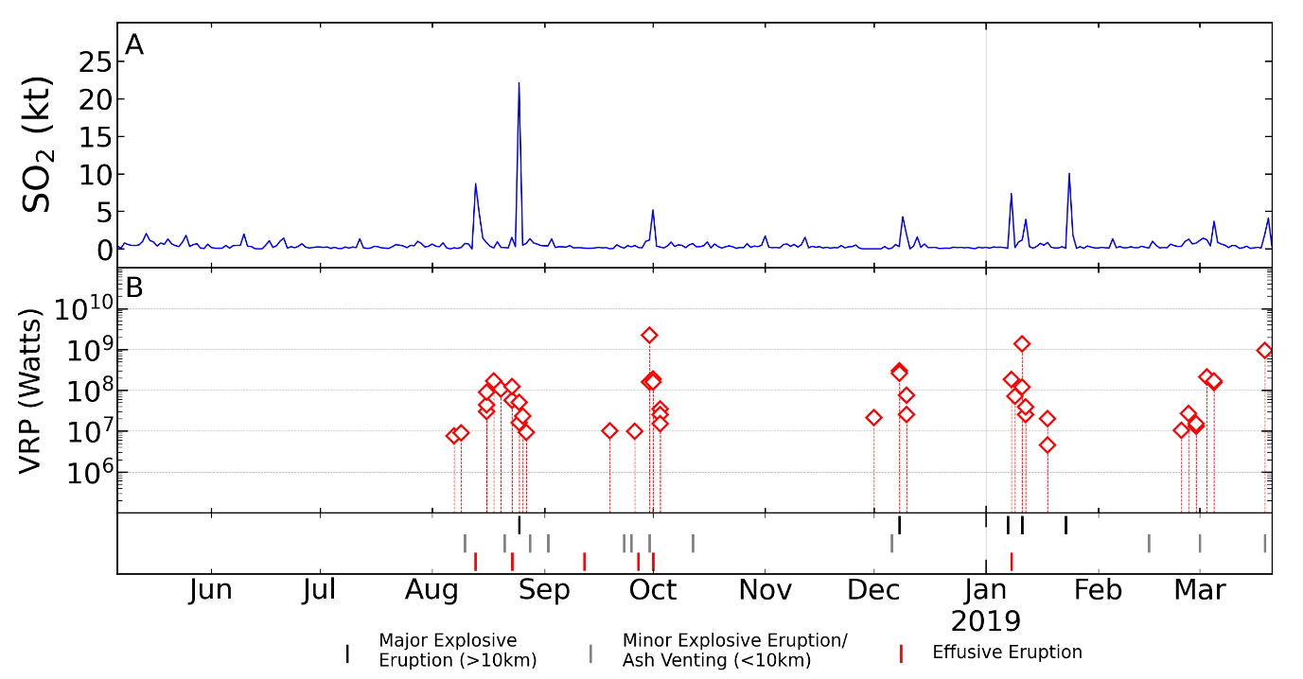
Figure S1 – Focused view of detected thermal anomalies and SO₂ emissions during Phase 1 showing that eruptions with coincident elevated SO₂ emissions are often preceded by the appearance of thermal anomalies. The 8 January 2019 and 23 January 2019 major eruptions do not show this but is thought that meteorological cloud or volcanic plume cover may have obscured the thermal signal of these eruptions.
Table S2 – MODTRAN Parameters

MODTRAN Parameter | Value
Atmosphere Model | Tropical
Water Column (atm-cm) | 5119.4
Ozone Column (atm-cm) | 0.27727
CO2 (ppmv) | 400
CO (ppmv) | 0.15
CH4 (ppmv) | 1.8
Ground Temperature (K) | 299.7
Ground Albedo | 0
Aerosol Model | Rural
Visibility (km) | 23
Sensor Altitude (km) | 99
Sensor Zenith (km) | 45
Transmittance
Band 11 (1.6 µm) | 0.892
Band 12 (2.5 µm) | 0.941

Table S1 – Input parameters for MODTRAN (MODerate resolution atmospheric TRANSmission) (Berk et al., 2014) to estimate the transmittance values used in calculating surface temperatures from Sentinel-2’s bands 11 & 12.
Figure S2 – Pearson’s Correlations of Thermal and SO₂ emission by phase.
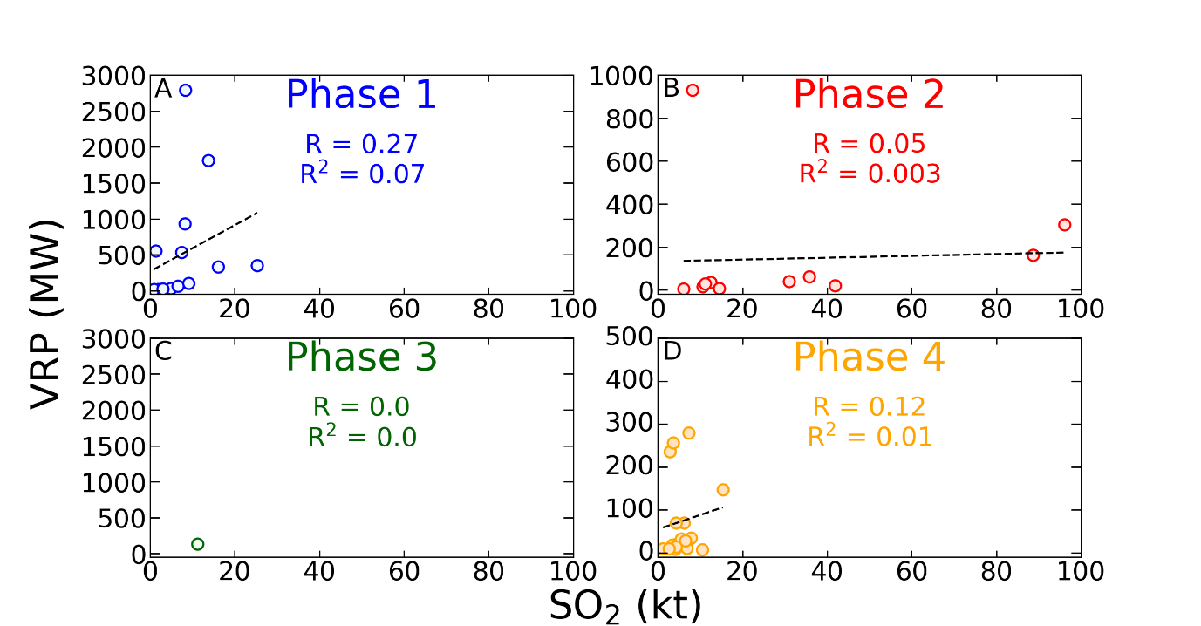
Figure S2 Weekly total SO2 emissions versus weekly total volcanic radiative power. R and R² values calculated using Pearson’s Correlation by degassing phase.

Figures S3, S4 and Table S2 – Estimation of Lava Flow Volumes (DRE)
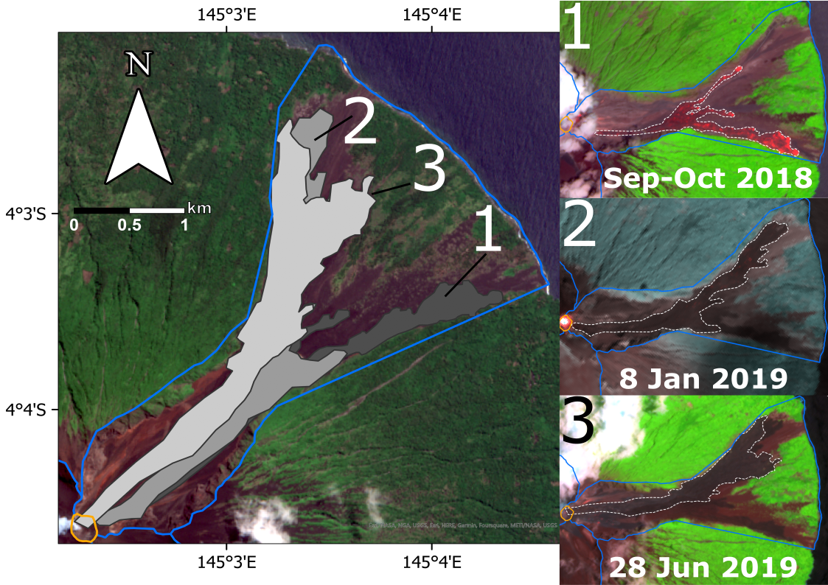
Figure S3 Inundation areas of the three largest lava flows during 2018-2021. 1) - 12th September –1st October 2018 (dark grey) Sentinel-2 composite image Bands 4, 8A and 12 from 2nd October 2018 overpass. 2) 8th January 2019 (middle grey) Landsat 8 composite Bands 5 and 7 – 22nd January 2019 (light grey). Sentinel-2 composite image Bands 4, 8A and 12 from 13th August 2019 overpass.
An orthomosiac and a digital elevation model (DEM) of the lower portion (from ~400 to ~25 m asl) of the September & October 2018 lava flow created from unoccupied aircraft system (UAS) using Agisoft Metashape (FIGURE S4).
Elevation contour lines were generated from the DEM using ArcGIS at 50 m intervals. Straight lines was drawn between the points where each contour line meets the lava flow boundary. These straight lines represent a simplistic assumed path of the contour lines prior to the emplacement of the lava flow and therefore the elevation of the surface beneath the emplaced lava flow. The elevation of the lava flow DEM was extracted every 1 m along the assumed pre-lava flow contour, the difference between this value and the contour lines associated elevation gives an approximate thickness of the lava flow at that point. The average thickness was calculated by taking the mean of all of the calculated thickness along all of the assumed pre-lava flow contour lines. The mean thickness was 3.5 m.
The inundation areas of the lava flows identifiable from Landsat, ASTER & Sentinel 2 were measured using ArcGIS (FIGURE S3). These areas were then multiplied by the mean thickness of the September & October 2018 lava flow to give the volume of each lava flow. The Dense Rock Equivalent (DRE) was calculated using a porosity of 18.8%. The porosity of a sample of the September & October 2018 lava flow was measured using a pycnometer. This sample was provided by Rabaul Volcanological Observatory.

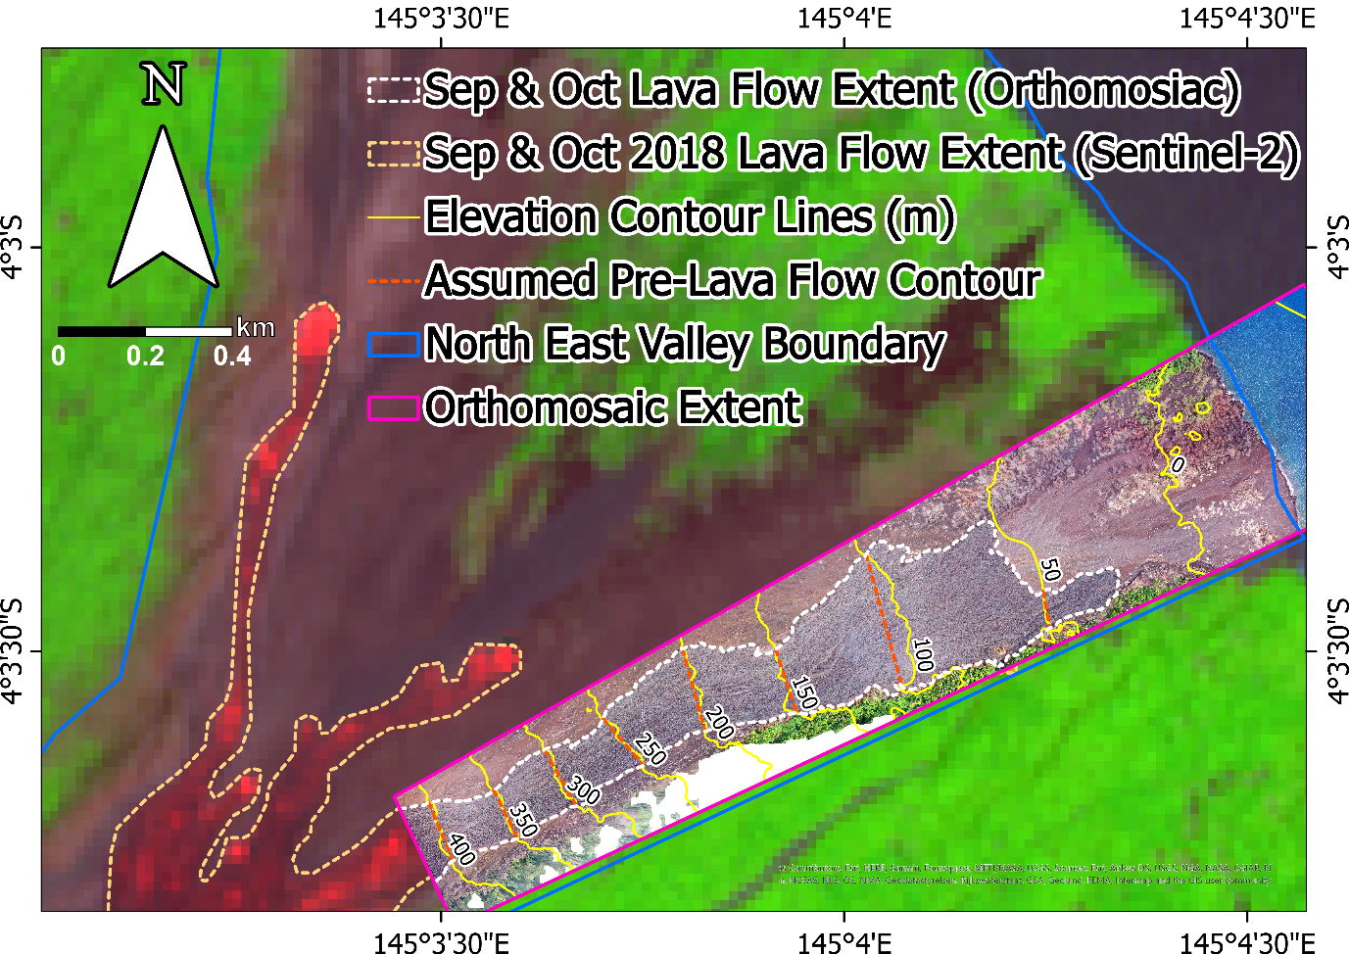
Figure S4 The lower portion of the September & October lava flow (extent marked in light orange dashed lines) identified in composite Sentinel-2 imagery on 2 October 2018. Overlain is the orthomosiac of the lava flow (limits marked by pink bounding box) constructed from UAS imagery from late October 2018 (courtesy of Dr Keiran Wood, University of Manchester, UK and Dr Emma Nicholson, University College London). A DEM was constructed using this orthomosaic corresponding to the same pink bounded area. Lava flow thickness estimates produced using the difference between the measured elevation of the lava flow surface and the approximated straight continuation (dark orange dashed lines) of the elevation contours (yellow lines). Full method detail given below.

Date | Location | Area (m²) | Volume (m³) | DRE (km³)
12th September – 1st October 2018 | NE Valley | 895,413 | 3,133,947 | 2.55 × 10⁻³
8th January 2019 | NE Valley | 1,398,598 | 4,895,094 | 3.98 × 10⁻³
28th June 2019 | NE Valley | 1,625,595 | 5,689,583 | 4.62 × 10⁻³
13th August 2019 | NE Valley | 169,249 | 592,372 | 4.81 × 10⁻⁴
26th August 2021 | SW Valley | 228,924 | 801,233 | 6.51 × 10⁻⁴
21St October2021 | SW Valley | 45,462 | 159,118 | 1.29 × 10⁻⁴
Table S2 Satellite measured lava flow inundation areas with volumes calculated from mean thickness of the September - October 2018 lava flows. Dense rock equivalent was calculated by removing the porosity (18.8%). The porosity of a sample of the 28th June 2019 lava flow was measured using a pycnometer.

Table S3 – Manam’s SO₂ emissions by phase placed in Carn et al. 2017 global volcanic emission rankings
Phase | Time-averaged SO₂ emissions (kt day⁻¹) | Global SO₂ Rank  (Carn et al. 2017)
1 | 0.62 ± 0.03 | 31
2 | 4.72 ± 0.09 | 3
3 | 1.5 ± 0.05 | 10
4 | 0.68 ± 0.03 | 25
Table S3 SO₂ emissions by phase and ranked against global inventories compiled by Carn et al. (2017) using OMI (Ozone Monitoring Instrument) onboard NASA’s Aura satellite.

Figure S5 – Manam SO₂ emissions alongside reported volcanic plume heights
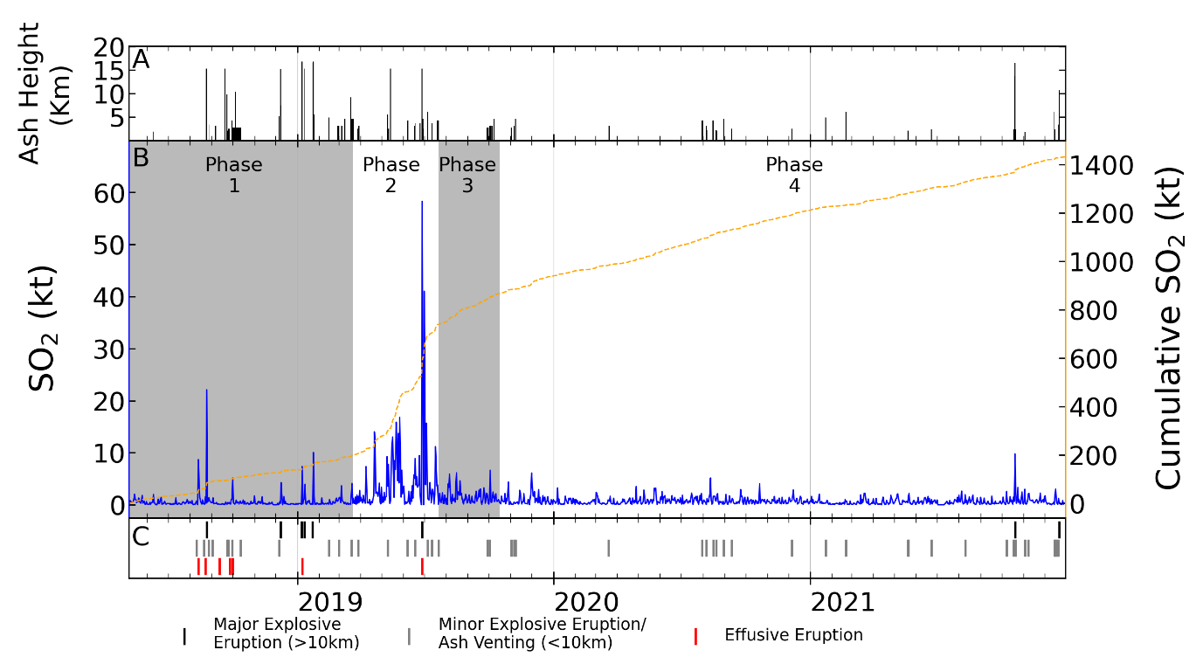
Figure S5 – (A) Eruption column heights reported by Rabaul Volcanological Observatory and Darwin Volcanic Ash Advisory Centre used as the interpolation height for SO₂ mass calculations. (B) TROPOMI derived SO₂ emissions. (C) Activity reported by Rabaul Volcanological Observatory and Global Volcanism Program (Global Volcanism Program | Manam,” 2021)

