Genomic richness enables worldwide invasive success

Carles Galià-Camps ^{1,2,*}, Tilman Schell ^{3,4}, Cinta Pegueroles ^{1,2}, Damian Baranski ^{3,4}, Alex Ben Hamadou ^{3,4}, Xavier Turon ^{5,+}, Marta Pascual ^{1,2,+}, Carola Greve ^{3,4,+}, Carlos Carreras ^{1,2,+}.

1. Departament de Genètica, Microbiologia i Estadística, Universitat de Barcelona, Avinguda Diagonal 643, 08028 Barcelona, Spain.
2. Institut de Recerca de la Biodiversitat (IRBio), Universitat de Barcelona (UB)
3. LOEWE Centre for Translational Biodiversity Genomics (LOEWE-TBG), Senckenberganlage 25, 60325 Frankfurt am Main, Germany.
4. Senckenberg Forschungsinstitut und Naturmuseum, Senckenberganlage 25, 60325 Frankfurt am Main, Germany
5. Centre d'Estudis Avançats de Blanes (CEAB, CSIC), Accés Cala St. Francesc 14, 17300 Blanes, Girona, Spain.

*: Corresponding author. cgaliacamps@gmail.com
+: These authors jointly supervised this work

SUPPLEMENTARY FIGURES

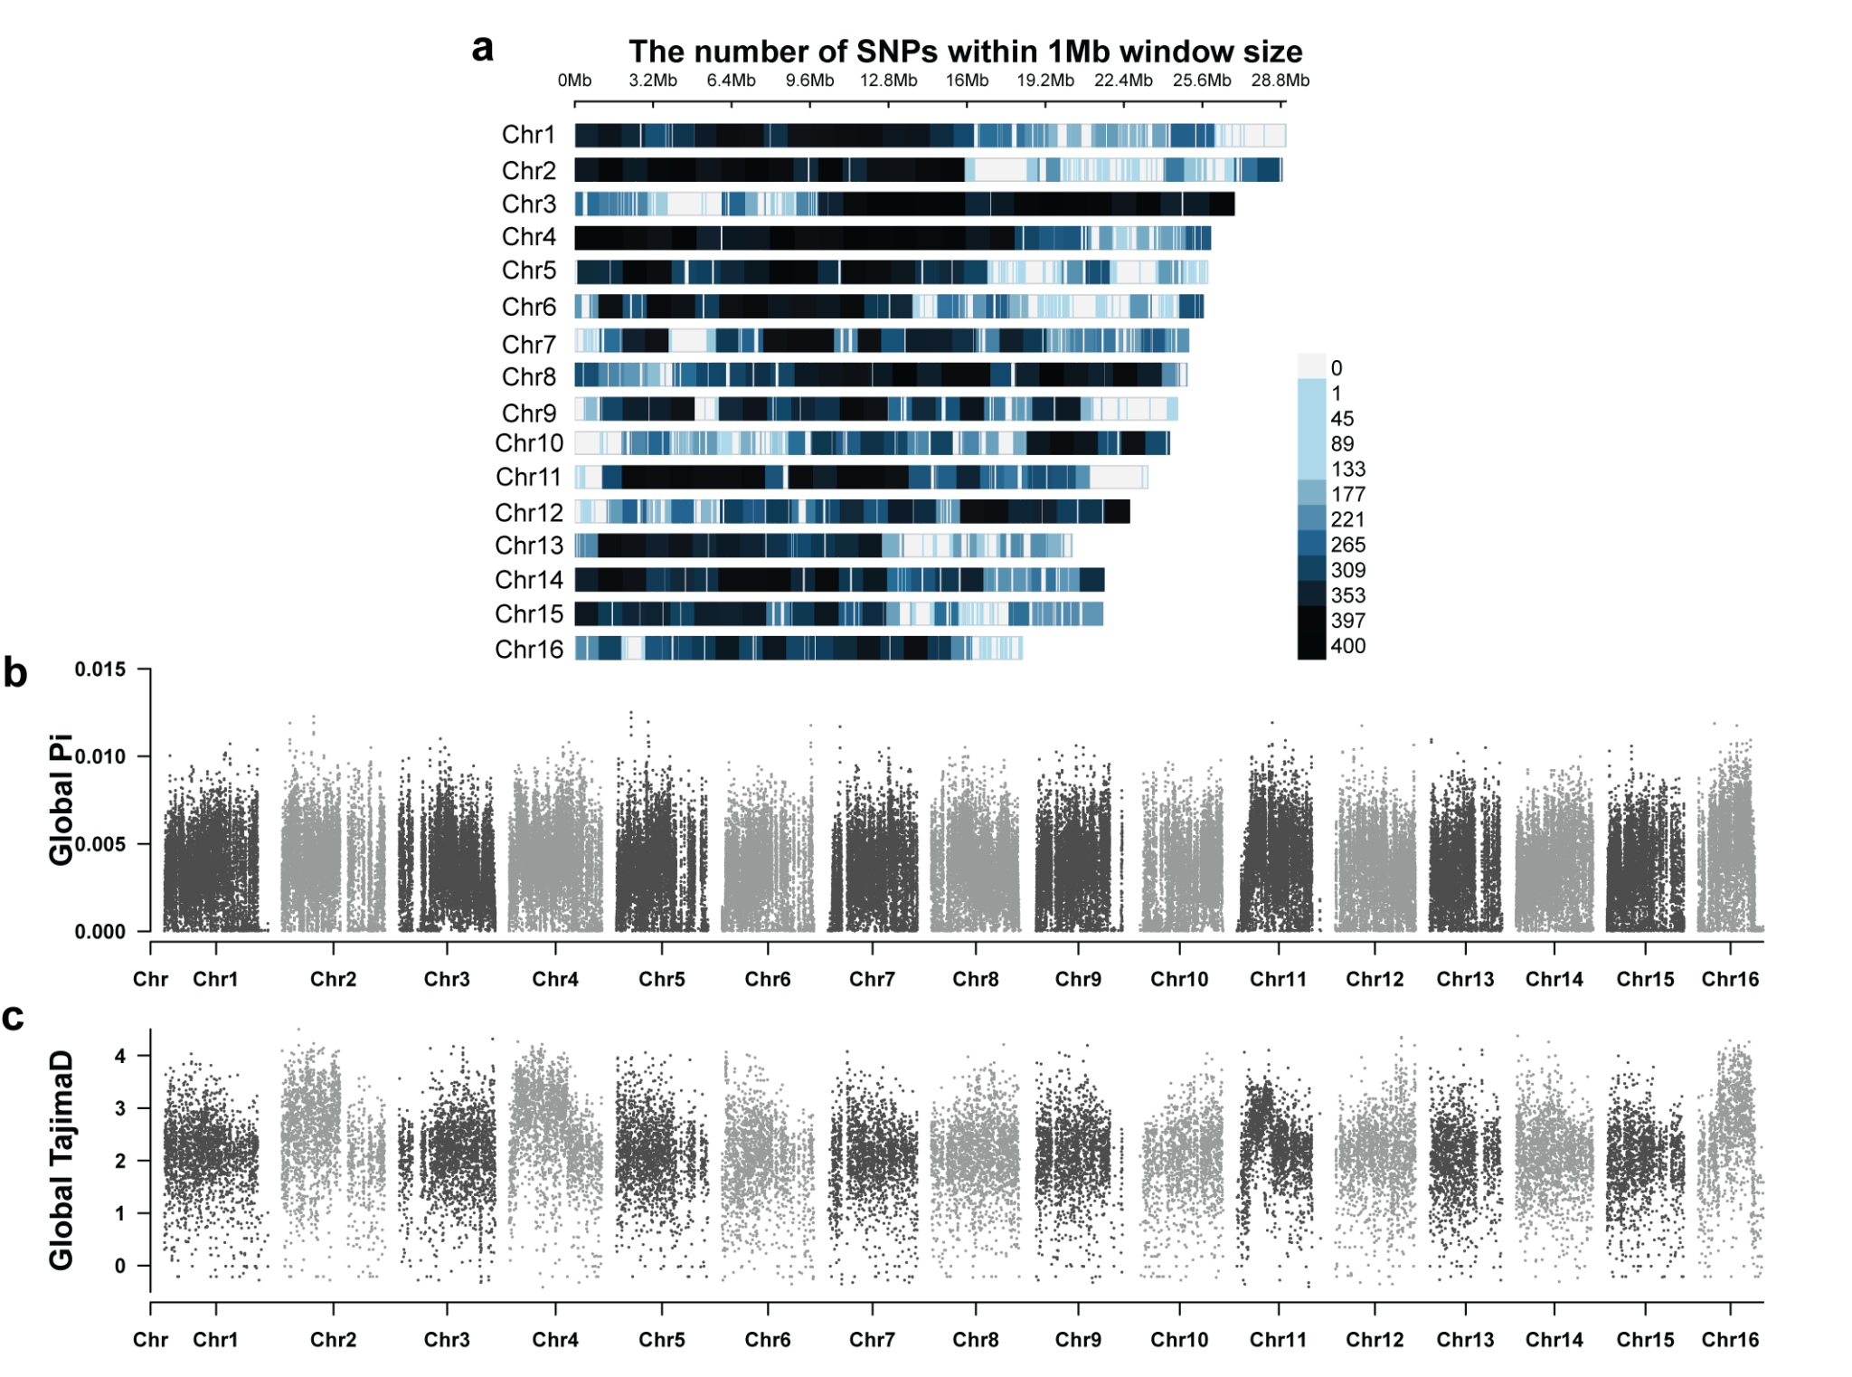Extended Data Figure 1: Global genetic diversity. a: Filtered SNPs density along the chromosomes. b: Global diversity (π) values along the chromosomes in 10,000 bp windows, with 2,500 bp sliding windows. c: Tajima’s D values along the chromosomes in 10,000 bp windows. Note that no outliers were identified for pi and Tajima’s D.
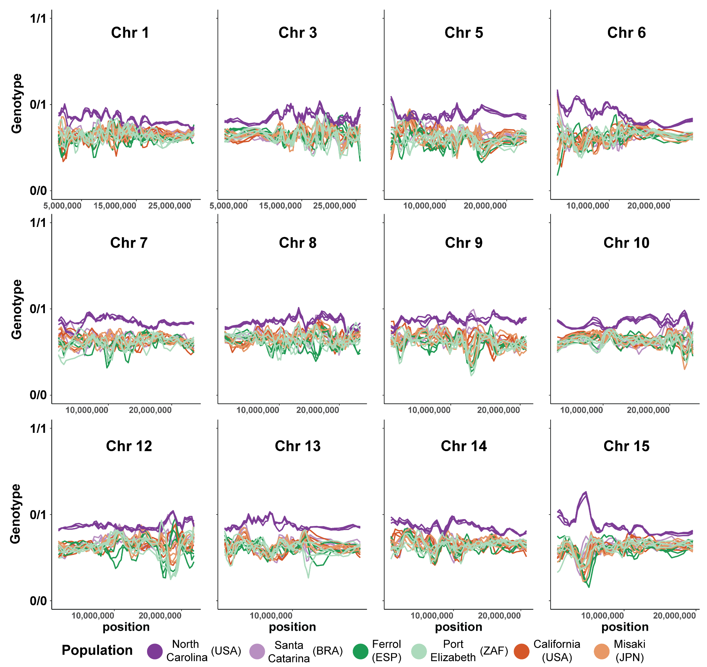Extended Data Figure 2: Average genotype for each individual on 10,000 bp windows, with 2,500 bp sliding windows, for the chromosomes without chromosomal inversions, considering 0/0 as homozygous for the reference allele, 0/1 as heterozygous, and 1/1 as homozygous for the alternative allele.
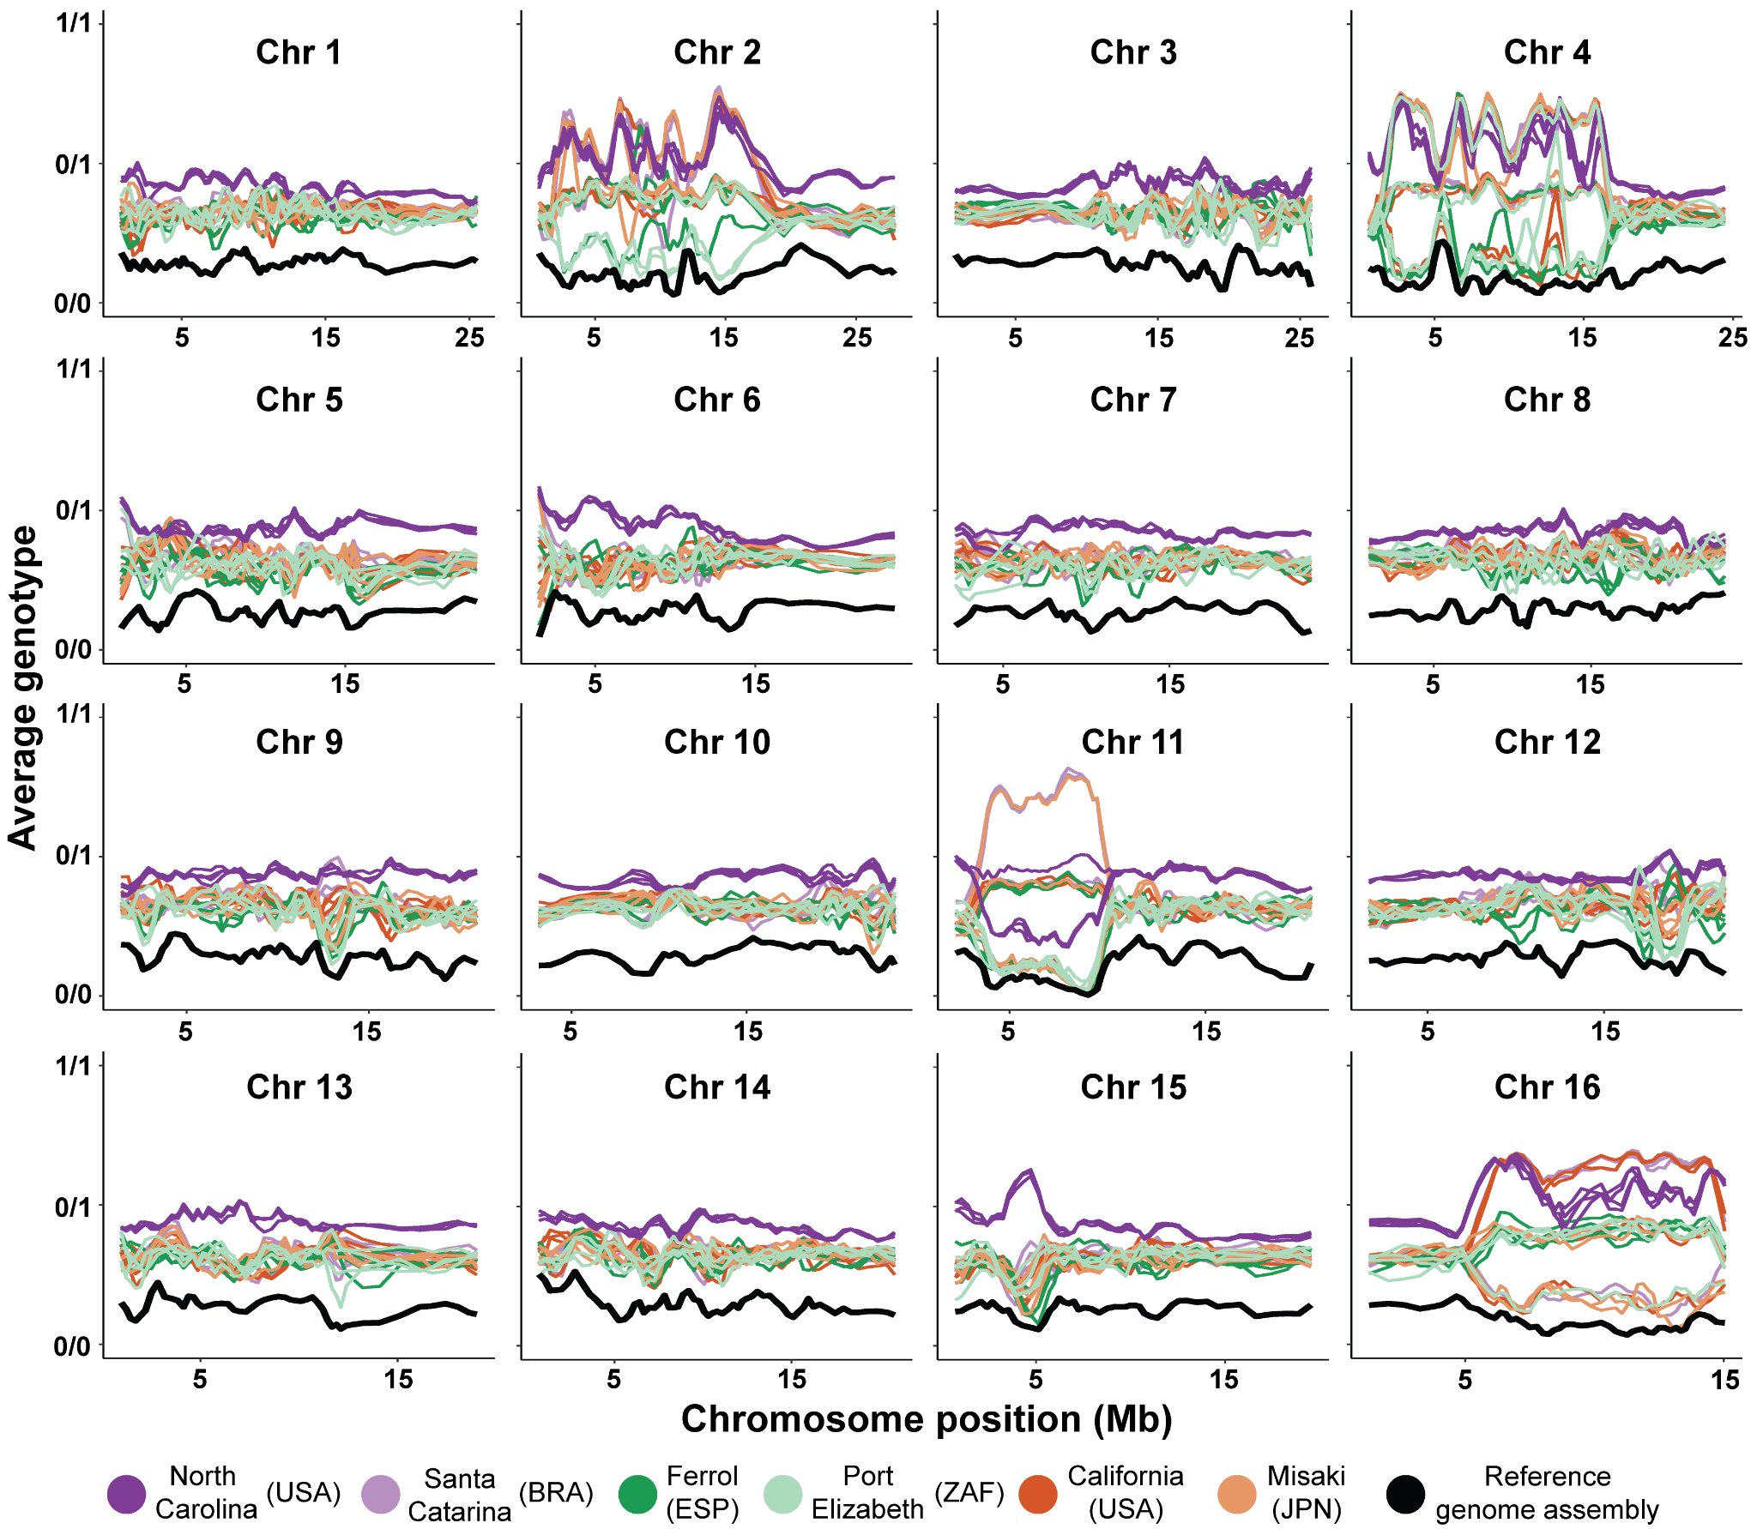Extended Data Figure 3: Comparison of reference genome assembly and all those included for the analysis. Detection of the 10,000 bp window genotype with 2,500 bp sliding window for each individual. 0/0, 0/1, and 1/1 correspond to homozygous for the reference ordination, heterozygous (50% reference and 50% alternative ordinations), and homozygous for the alternative ordination respectively. Note that the overall reference average genotype is close to 0/0 and all inversions are found to be homozygous since there is a drop in the genotype signal towards 0/0.
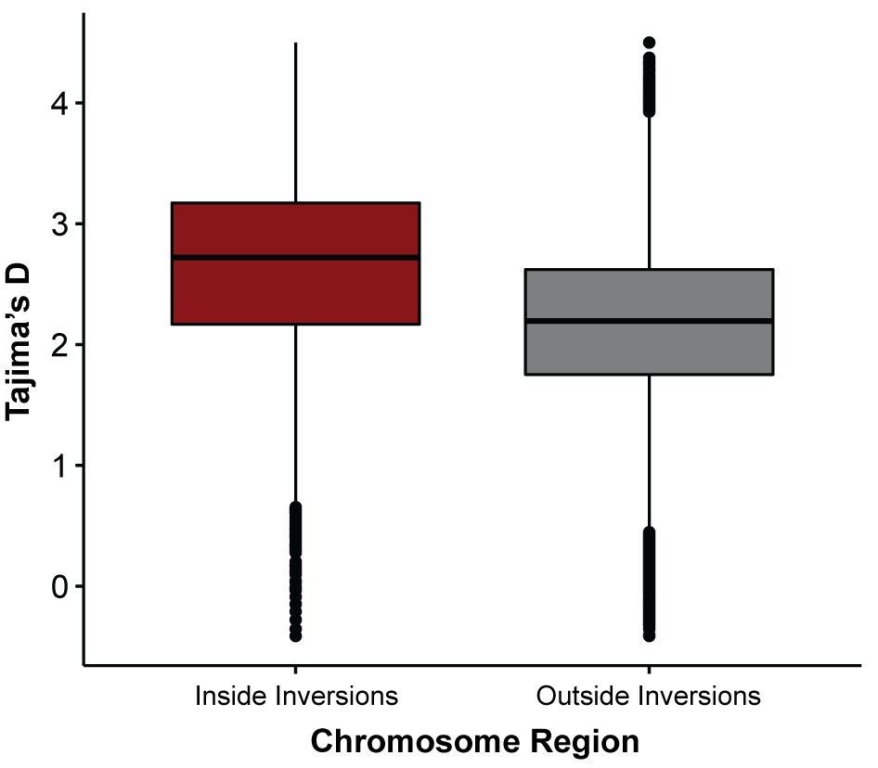
Extended Data Figure 4: Tajima’s D values inside and outside the block regions identified as inversions based on genotypes. Box plots’ center lines identify the mean value, box limits correspond the 1st and 3rd quartiles, whiskers are 1.5 interquartile range, and circles outside the whisker range represent outlier values.

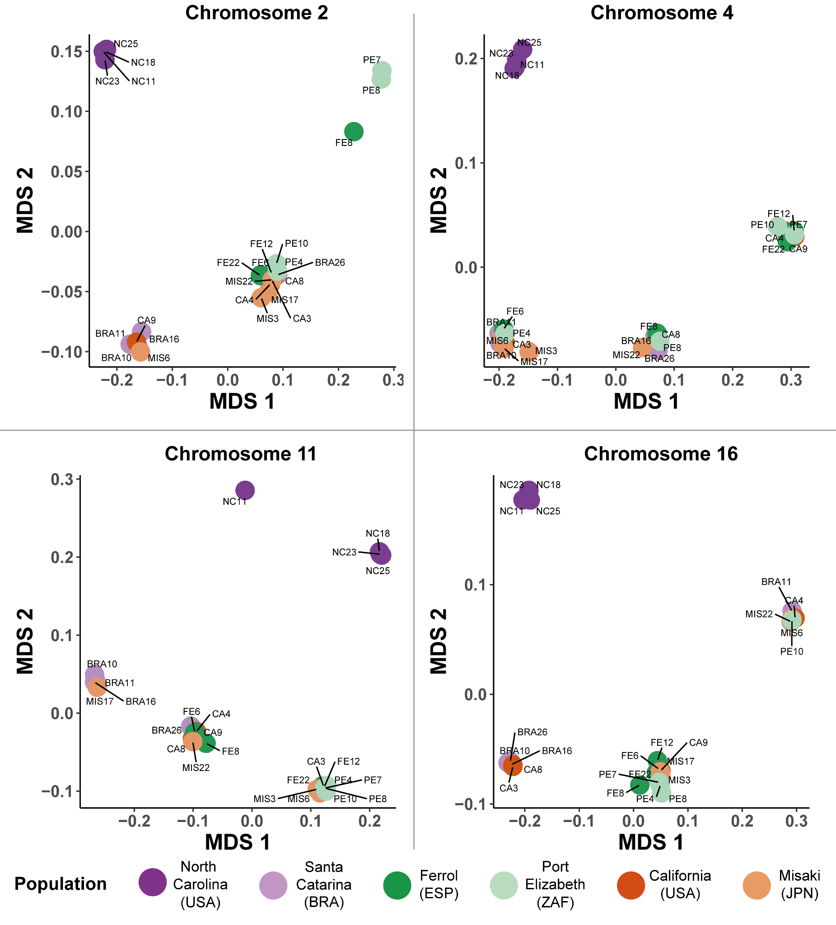
Extended Data Figure 5: Genetic differentiation analysis based on the chromosomes with inversions. MDS analysis plot of all individuals using SNPs in chromosomes with identified inversions. Each chromosomal karyotype is recovered along the first axis, whereas the second axis stands for sequence differentiation.
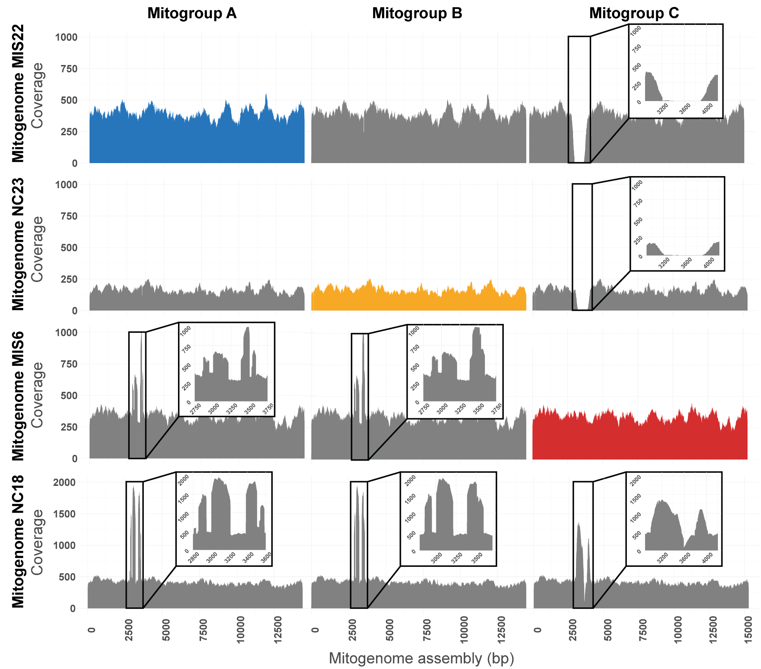Extended Data Figure 6: Mitogenome mapping profiles. Each column corresponds to a main mitogroup sequence, and rows identify the sample’s reads used to generate mapping profiles. Note that the individuals MIS22, NC23, and MIS6 were randomly selected as representatives for the mitogroup A, B, and C respectively. Regions with non-uniform coverage were plotted separately for visualization accuracy.
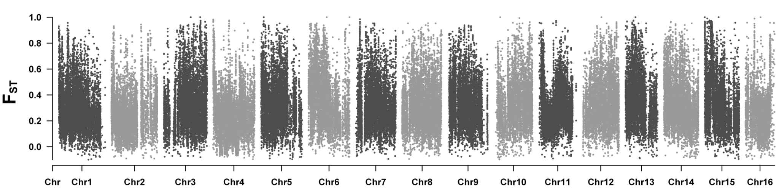Extended Data Figure 7: Manhattan plot depicting F_{ST} values between North Carolina and all remaining populations in 10,000 bp windows, with 2,500 bp sliding windows.
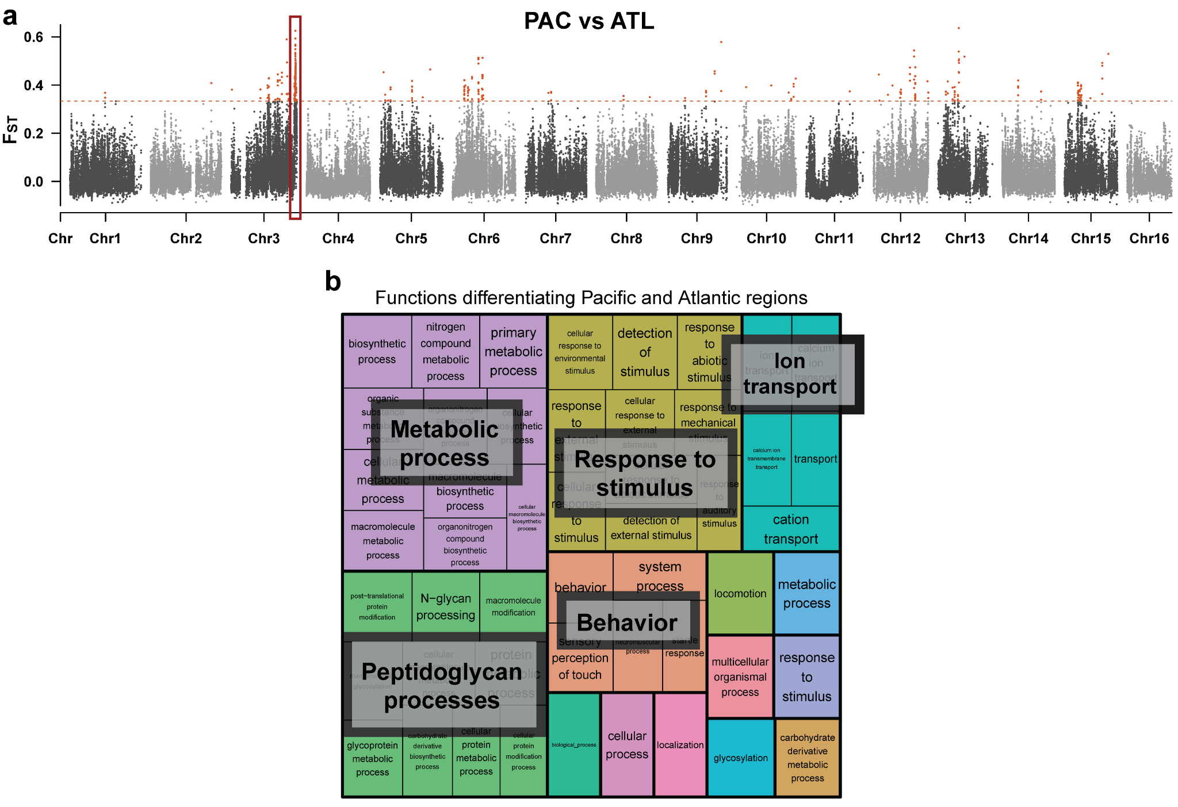Extended Data Figure 8: Signals of biogeographic adaptation. a: F_{ST} values between Atlantic and Pacific individuals. Note that NC individuals were excluded from the analysis since their genetic divergence masks genetic differentiation among the remaining individuals. Orange dots represent the top 1% F_{ST} values. The red rectangle indicates the region used for functional analyses. b: Biological functions inside the region driving Atlanto-Pacific divergence in chromosome 3. 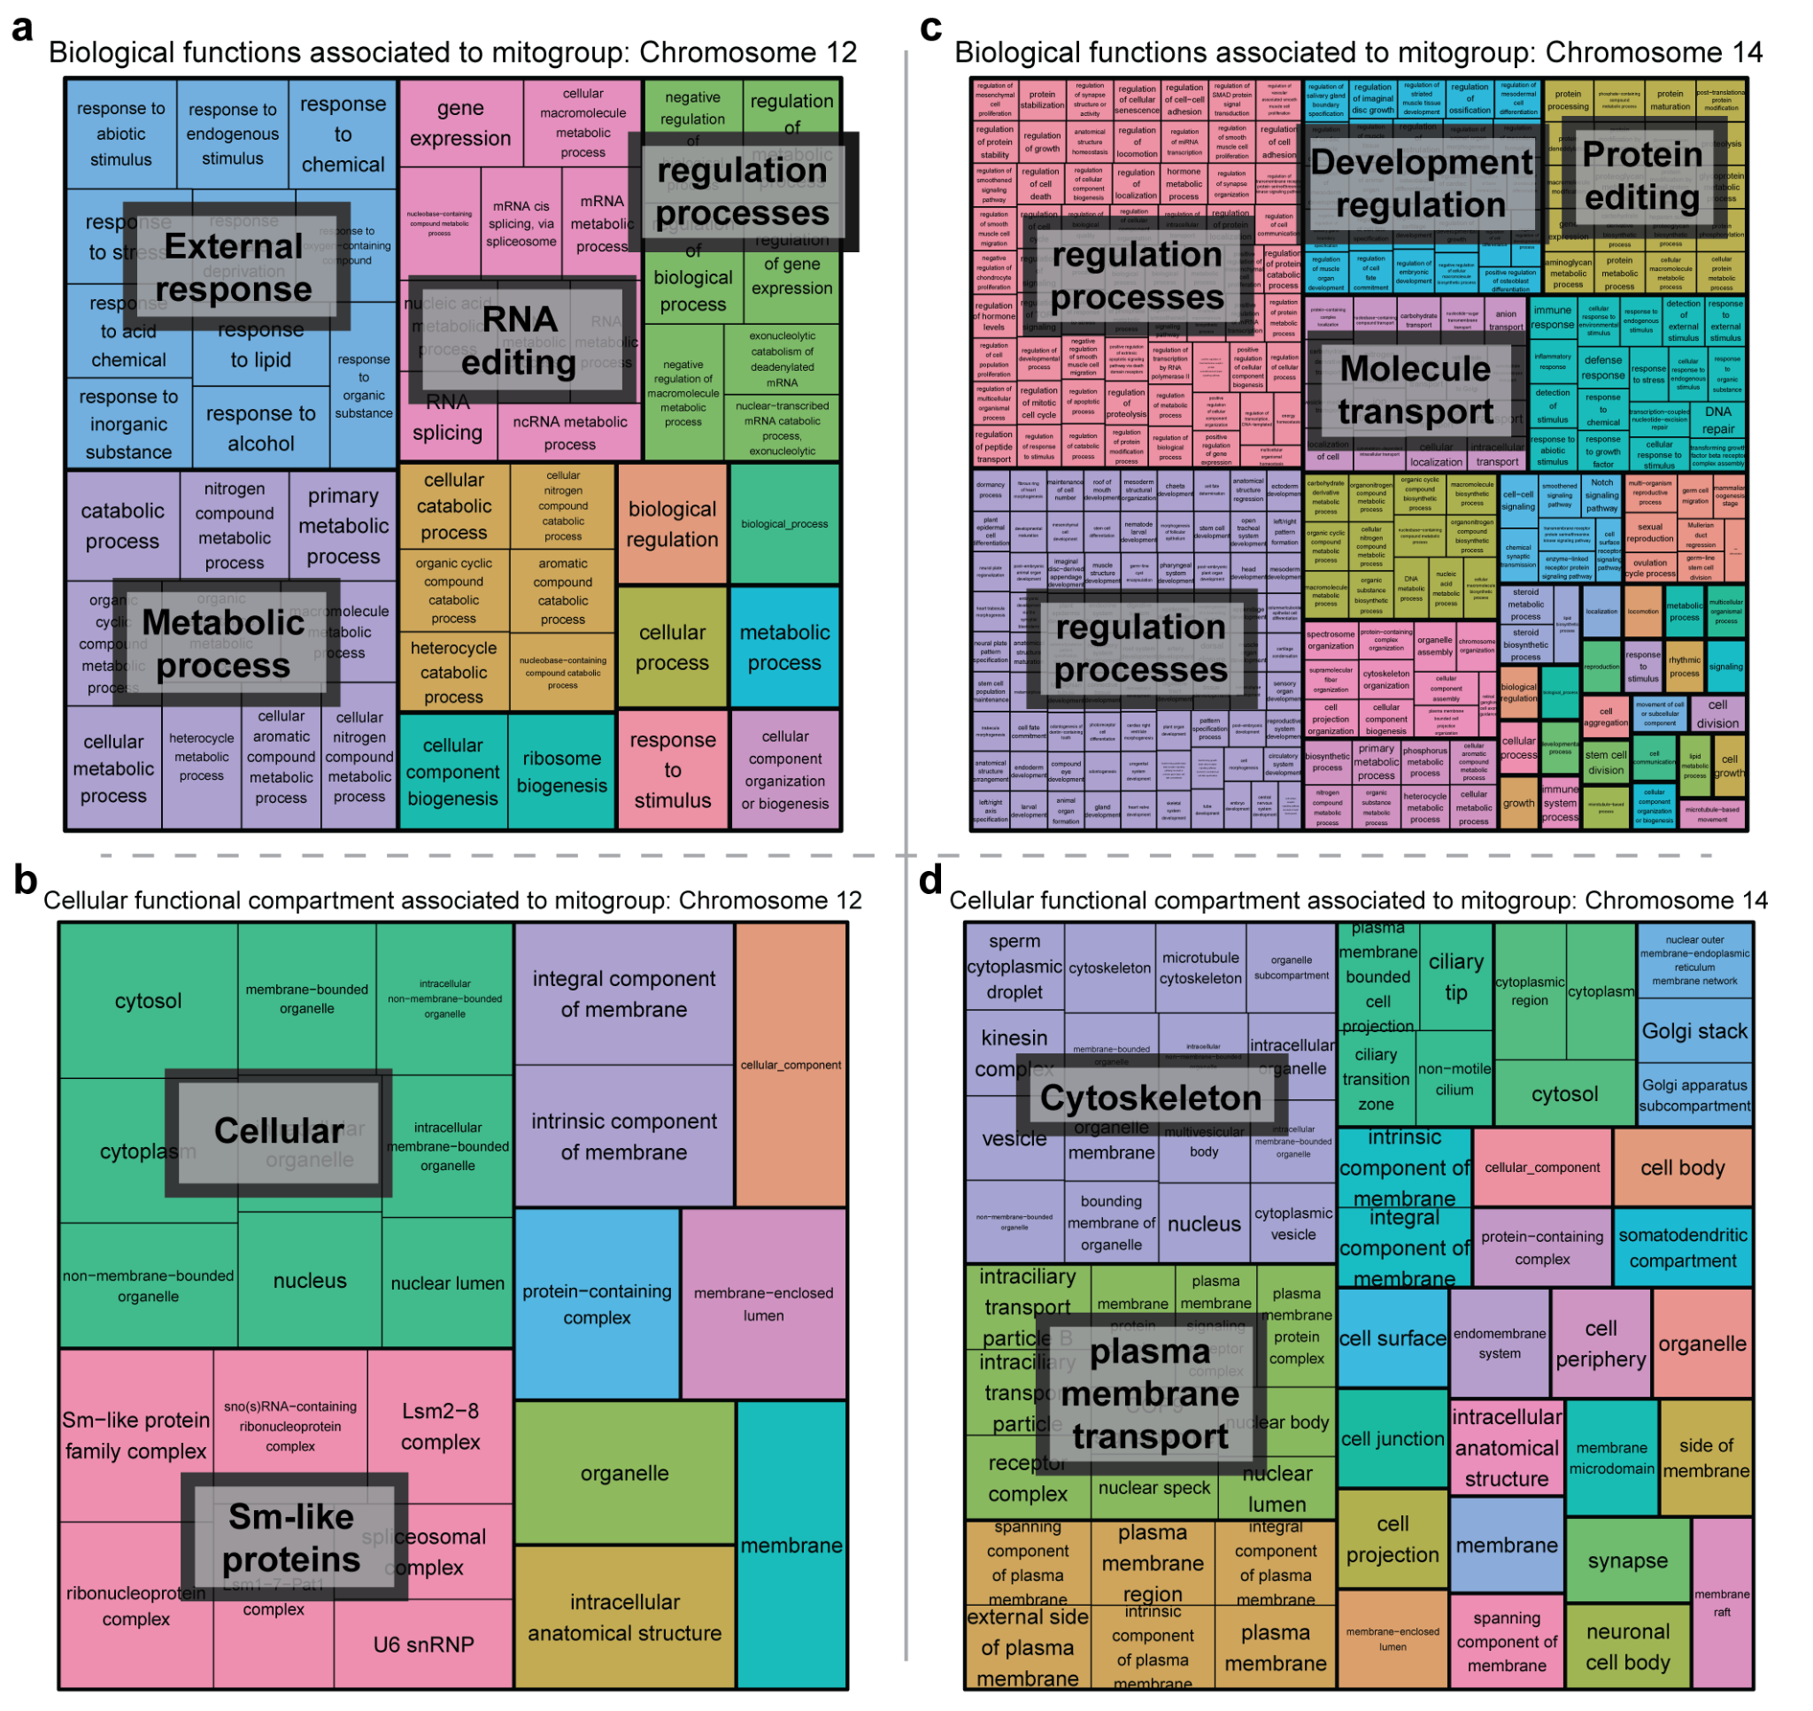Extended Data Figure 9: Biological functions and Cellular compartments found interacting between mitochondrial and nuclear genomes. a: Biological functions found in chromosome 12 F_{ST} peak region. b: Cellular compartments where biological functions found in chromosome 12 F_{ST} peak region take place. c: Biological functions found in chromosome 14 F_{ST} peak region. d: Cellular compartments where biological functions found in chromosome 14 F_{ST} peak region take place. Note that colors do not stand for the same function in all panels.

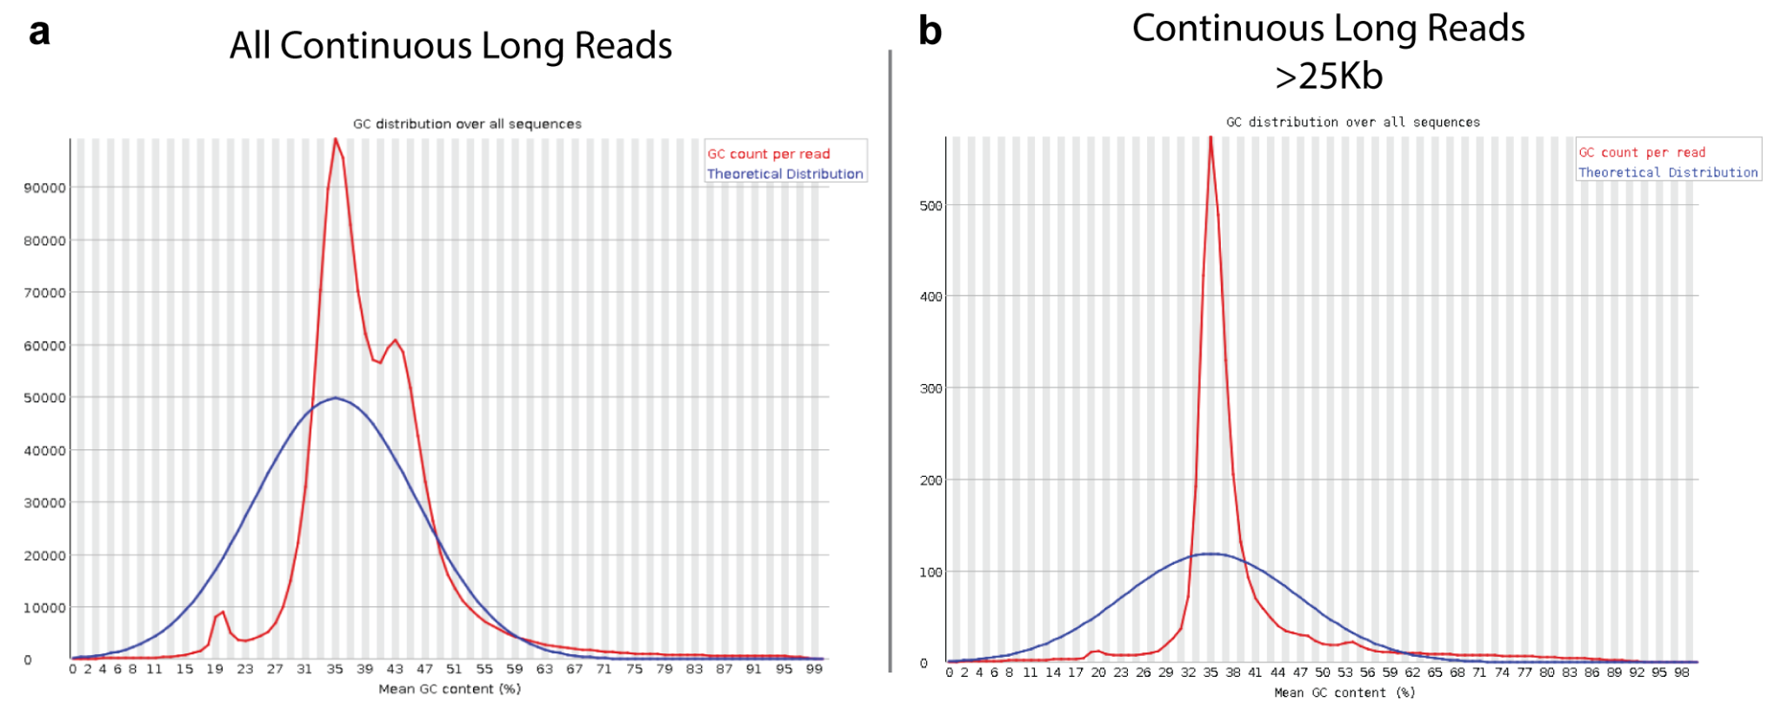Extended Data Figure 10: PacBio Continuous Long Reads (CLR) GC profiles. a: Sequence data after applying standard quality filters. b: Sequence data after applying an additional length filtering (>25Kb). Note that after the length filtering, GC distribution is more uniform, suggesting a lack of possible contamination and/or mitochondrial DNA.
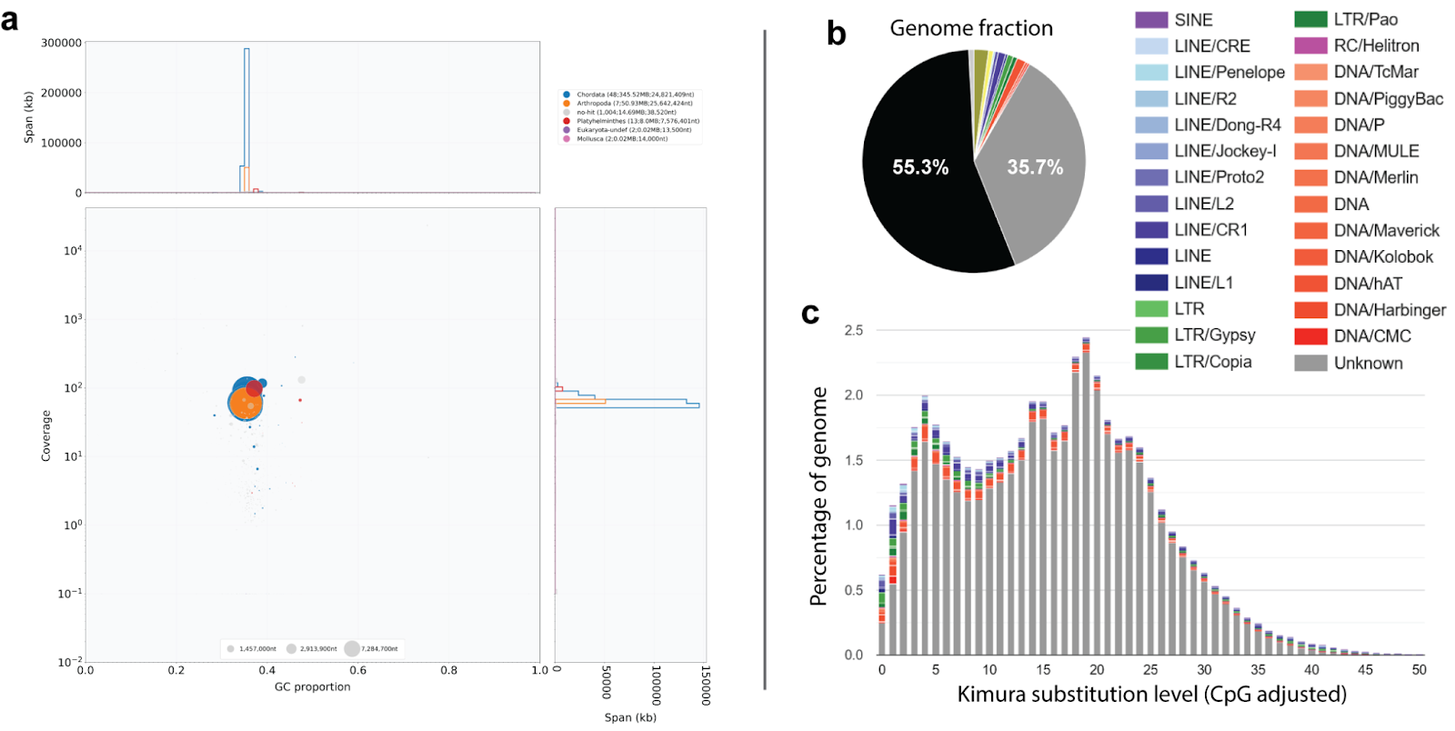Extended Data Figure 11: Genome assembly features. a: Blob plot of genome assembly scaffolds’ size, GC content, coverage, and associated taxonomic group. Circle size and color correspond to sequence length, and taxonomic assignment respectively (Blue=chordata, orange=arthropoda, red=platyhelmintes). Note that all scaffolds (larger circles) are similar in GC content (x axis) and coverage (y axis). b: Fraction of the genome annotated as non-repetitive genomic elements (black), unknown Transposable Elements (TE, gray) or identified as different TE families (colored bars). c: Frequency distribution of the genetic differences between TEs within families.

SUPPLEMENTARY TABLES

Extended Data Table 1: Sample information. For each sample, we provide its Sample code, Locality, Geographic region, coordinates, and mitochondrial COI haplogroup as reported in previous studies ²⁵.

Sample code | Locality | Geographic region | Latitude (UTM) | Longitude (UTM) | Haplogroup
Ref_DNA_Styela | Barcelona, Spain | Mediterranean | 41.38 | 2.18 | 1
Ref_RNA_Styela | Barcelona, Spain | Mediterranean | 41.38 | 2.18 | 1
NC11 | North Carolina, USA | Atlantic | 34.14 | -77.86 | 2
NC18 | North Carolina, USA | Atlantic | 34.14 | -77.86 | 2
NC23 | North Carolina, USA | Atlantic | 34.14 | -77.86 | 2
NC25 | North Carolina, USA | Atlantic | 34.14 | -77.86 | 2
BRA10 | Santa Catarina, Brazil | Atlantic | -26.77 | -48.66 | 2
BRA11 | Santa Catarina, Brazil | Atlantic | -26.77 | -48.66 | 2
BRA16 | Santa Catarina, Brazil | Atlantic | -26.77 | -48.66 | 1
BRA26 | Santa Catarina, Brazil | Atlantic | -26.77 | -48.66 | 1
PE4 | Port Elizabeth, South Africa | Atlantic | -33.96 | 25.64 | 1
PE7 | Port Elizabeth, South Africa | Atlantic | -33.96 | 25.64 | 2
PE8 | Port Elizabeth, South Africa | Atlantic | -33.96 | 25.64 | 1
PE10 | Port Elizabeth, South Africa | Atlantic | -33.96 | 25.64 | 2
FE6 | Ferrol, Spain | Atlantic | 43.48 | -8.24 | 1
FE8 | Ferrol, Spain | Atlantic | 43.48 | -8.24 | 1
FE12 | Ferrol, Spain | Atlantic | 43.48 | -8.24 | 1
FE22 | Ferrol, Spain | Atlantic | 43.48 | -8.24 | 2
MIS3 | Misaki, Japan | Pacific | 35.16 | 139.62 | 2
MIS6 | Misaki, Japan | Pacific | 35.16 | 139.62 | 2
MIS17 | Misaki, Japan | Pacific | 35.16 | 139.62 | 2
MIS22 | Misaki, Japan | Pacific | 35.16 | 139.62 | 1
CA3 | California, USA | Pacific | 32.73 | -117.2 | 2
CA4 | California, USA | Pacific | 32.73 | -117.2 | 1
CA8 | California, USA | Pacific | 32.73 | -117.2 | 2
CA9 | California, USA | Pacific | 32.73 | -117.2 | 1

Extended Data Table 2: Inversion boundaries detected by genotype and F_{ST}.
 | Genotype boundaries |  | F_{ST} boundaries
Chromosome with inversion | Start (in bp) | End (in bp) | Start (in bp) | End (in bp)
Chromosome 2 | 1 | 19,480,816 | 2,119,820 | 16,203,413
Chromosome 4 | 1 | 16,999,389 | 1,895,369 | 16,269,236
Chromosome 11 | 1 | 10,440,662 | 3,555,678 | 9,885,946
Chromosome 16 | 4,371,327 | 18,293,200 | 5,779,766 | 14,958,823

Extended Data Table 3: Sequencing approaches followed per sample. Find library type, tissue used, raw reads in millions (M), raw bases in Gigabases (Gb), filtered reads and filtered bases.
Sample ID | Library Type | Tissue DNA | RAW reads (M) | RAW bases (Gb) | Filtered reads (M) | Filtered bases (Gb)
Ref_DNA_Styela | Pacbio CLR | Mantle | 22.44 | 180.05 | 1.19 | 46.17
Ref_DNA_Styela | Illumina WGS | Mantle | 169.94 | 30.08 | 166.61 | 24.75
Ref_DNA_Styela | Illumina Omni-C | Mantle | 317.21 | 47.58 | 308.39 | 45.72
Ref_RNA_Styela | Illumina RNAseq | Tissue pool | 220.10 | 33.01 | 107.20 | 16.08

Extended Data Table 4: Mapping to reference genome. For each sample, we provide the sequencing platform, tissue for DNA extraction, raw reads, filtered reads, mapped reads in absolute values and %, and mean coverage.
Sample ID | Sequencing platform | Tissue DNA | RAW reads (M) | Filtered reads (M) | Mapped Reads (M) | Mapped Reads | Mean coverage
Reference | PacBio | Gill | 22.44 | 1.19 | 1.18 | 99.4% | 78.5X
Reference | Illumina WGS | Gill | 169.94 | 166.61 | 166.5 | 99.9% | 58.2X
BRA10 | Illumina WGS | Mantle | 39.0 | 39.0 | 38.5 | 98.7% | 13.0X
BRA11 | Illumina WGS | Mantle | 36.3 | 36.2 | 35.8 | 99.0% | 12.1X
BRA16 | Illumina WGS | Mantle | 35.7 | 35.5 | 35.2 | 99.2% | 11.9X
BRA26 | Illumina WGS | Mantle | 33.0 | 32.9 | 32.6 | 98.9% | 11.0X
CA3 | Illumina WGS | Mantle | 37.6 | 37.6 | 37.1 | 98.6% | 12.5X
CA4 | Illumina WGS | Mantle | 31.7 | 31.5 | 31.3 | 99.3% | 10.6X
CA8 | Illumina WGS | Mantle | 38.6 | 38.5 | 38.2 | 99.2% | 12.9X
CA9 | Illumina WGS | Mantle | 37.5 | 37.5 | 37.2 | 99.1% | 12.6X
FE6 | Illumina WGS | Mantle | 37.7 | 32.5 | 31.3 | 96.3% | 10.7X
FE8 | Illumina WGS | Mantle | 38.2 | 34.9 | 33.3 | 95.4% | 11.3X
FE12 | Illumina WGS | Mantle | 32.6 | 37.8 | 37.4 | 99.2% | 12.7X
FE22 | Illumina WGS | Mantle | 34.9 | 38.1 | 29.2 | 76.6% | 9.8X
MIS3 | Illumina WGS | Mantle | 38.0 | 32.6 | 32.3 | 99.2% | 10.9X
MIS6 | Illumina WGS | Mantle | 34.6 | 35.2 | 34.9 | 99.2% | 11.8X
MIS17 | Illumina WGS | Mantle | 32.8 | 38.1 | 37.8 | 99.2% | 12.8X
MIS22 | Illumina WGS | Mantle | 35.3 | 34.5 | 34.2 | 99.2% | 11.6X
NC11 | Illumina WGS | Mantle | 33.2 | 33.3 | 32.8 | 98.6% | 10.9X
NC18 | Illumina WGS | Mantle | 38.4 | 38.7 | 38.2 | 98.6% | 12.8X
NC23 | Illumina WGS | Mantle | 36.1 | 36.2 | 35.7 | 98.8% | 11.8X
NC25 | Illumina WGS | Mantle | 33.7 | 33.8 | 33.4 | 98.8% | 11.1X
PE4 | Illumina WGS | Mantle | 35.2 | 35.1 | 34.8 | 99.3% | 11.8X
PE7 | Illumina WGS | Mantle | 38.7 | 35.0 | 34.7 | 99.2% | 11.8X
PE8 | Illumina WGS | Mantle | 37.7 | 38.6 | 38.3 | 99.2% | 13.0X
PE10 | Illumina WGS | Mantle | 35.2 | 37.4 | 37.1 | 99.1% | 12.6X

Extended Data Table Codes: Figure 3b code legend.
tRNA |  | Coding genes |  | rRNA
Code | Gene | Code | Gene | Code | Gene
T | Threonine | 1 | COX2 | s | 12S small subunit
D | Aspartic Acid | 2 | NAD1 | l | 16S large subunit
G | Glycine | 3 | NAD4L
C | Cysteine | 4 | CYTB
A | Alanine | 5 | COX1
S | Serine | 6 | NAD6
M | Methionine | 7 | NAD2
L | Leucine | 8 | NAD5
R | Arginine | 9 | NAD3
N | Asparagine | 10 | COX3
W | Tryptophan | 11 | ATP6
V | Valine | 12 | ATP8
Y | Tyrosine | 13 | NAD4
I | Isoleucine
F | Phenylalanine
H | Histidine
K | Lysine
Q | Glutamine
E | Glutamic Acid.

