Table 1 Statistical results of aggression assays. All tests were separated by assay (conspecific = ABC, heterospecific = ABX). Within each assay, colonies fought against two opponent types in a paired design (i.e., each colony was assayed twice, one for each opponent to be paired against). Number of attacking worms was the dependent variable. Results for these paired t-tests are shown, as well as effect size estimates, and the statistical power estimated from those effect sizes. Conf. int. = confidence intervals
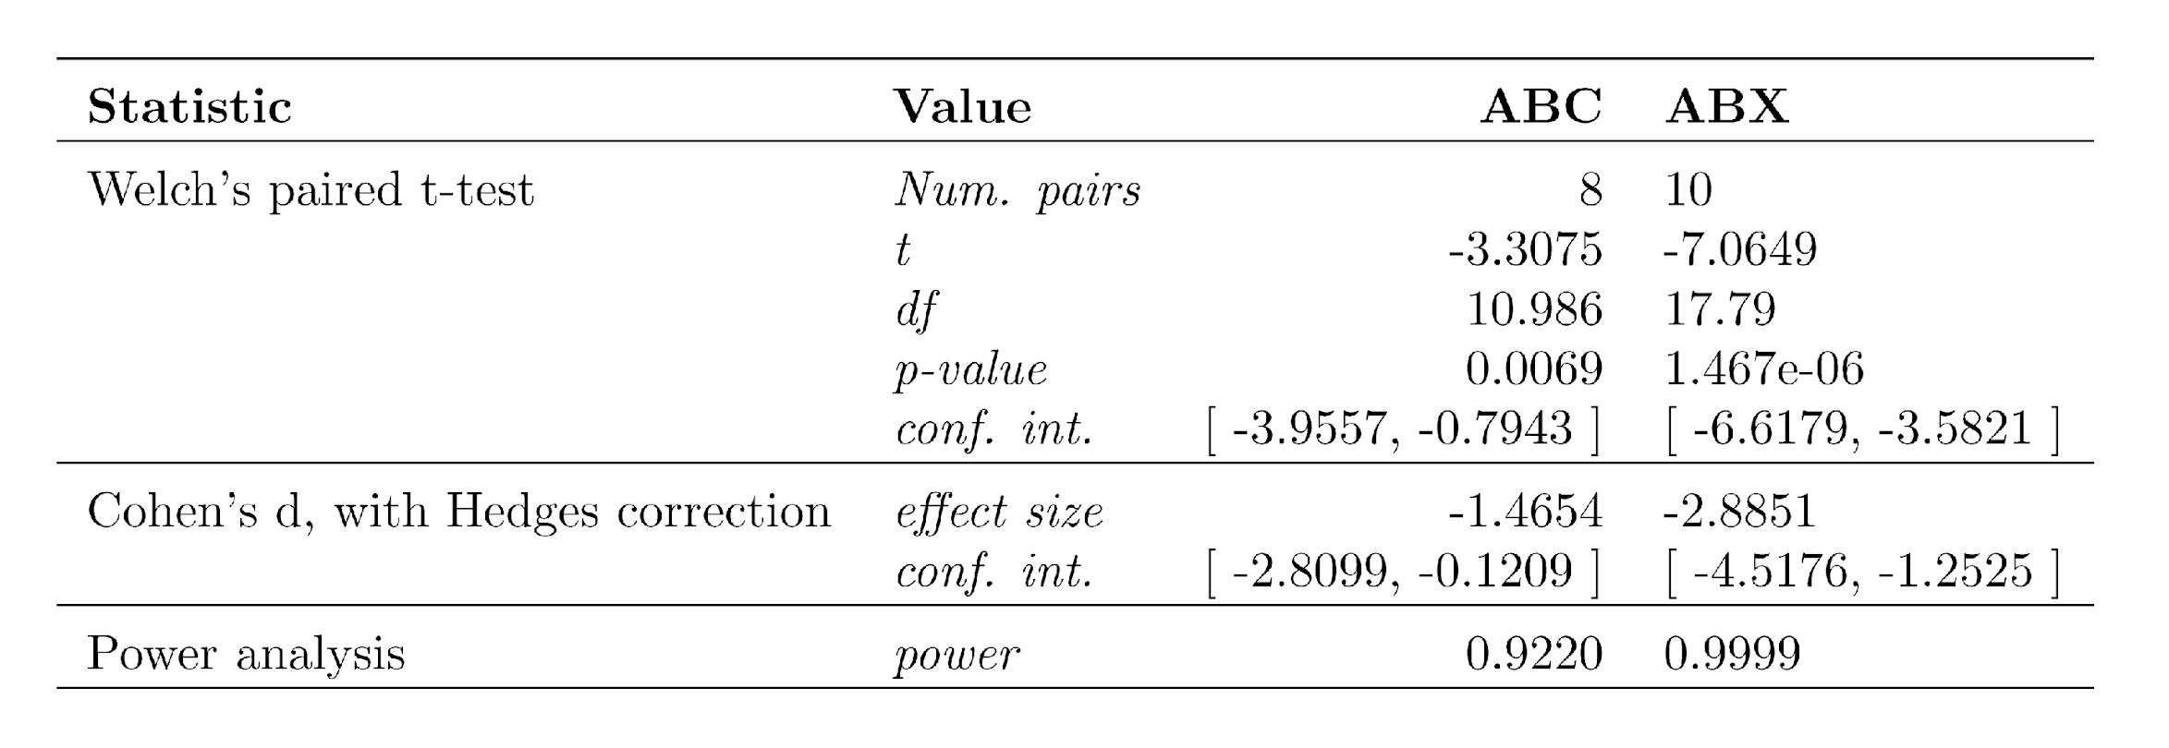

Table 2 Regression model comparisons. (1) Logistic regression using data from the conspecific (ABC) assays to test the effect of opponent type, germinal ball count, and genetic distance on whether soldiers would attack their opponents. (2) Model 1 but including a random effect for colony identity, as multiple individuals would come from the same colony. (3) Logistic regression using data from the heterospecific (ABX) assays to test the effect of opponent type, germinal ball count, and genetic distance on whether soldiers would attack their opponents. (4) Model 3 but including a random effect for colony identity. Opponent type, germinal balls, and genetic distance show coefficient estimates with standard errors in parentheses and asterisks indicating when effects were significant. Genetic distance between a subject and their opponent was calculated with dist.dna in R (Paradis 2010) following the nucleotide substitution estimation method of (Tamura and Nei 1993). Table created using stargazer R package (Hlavac 2015)
