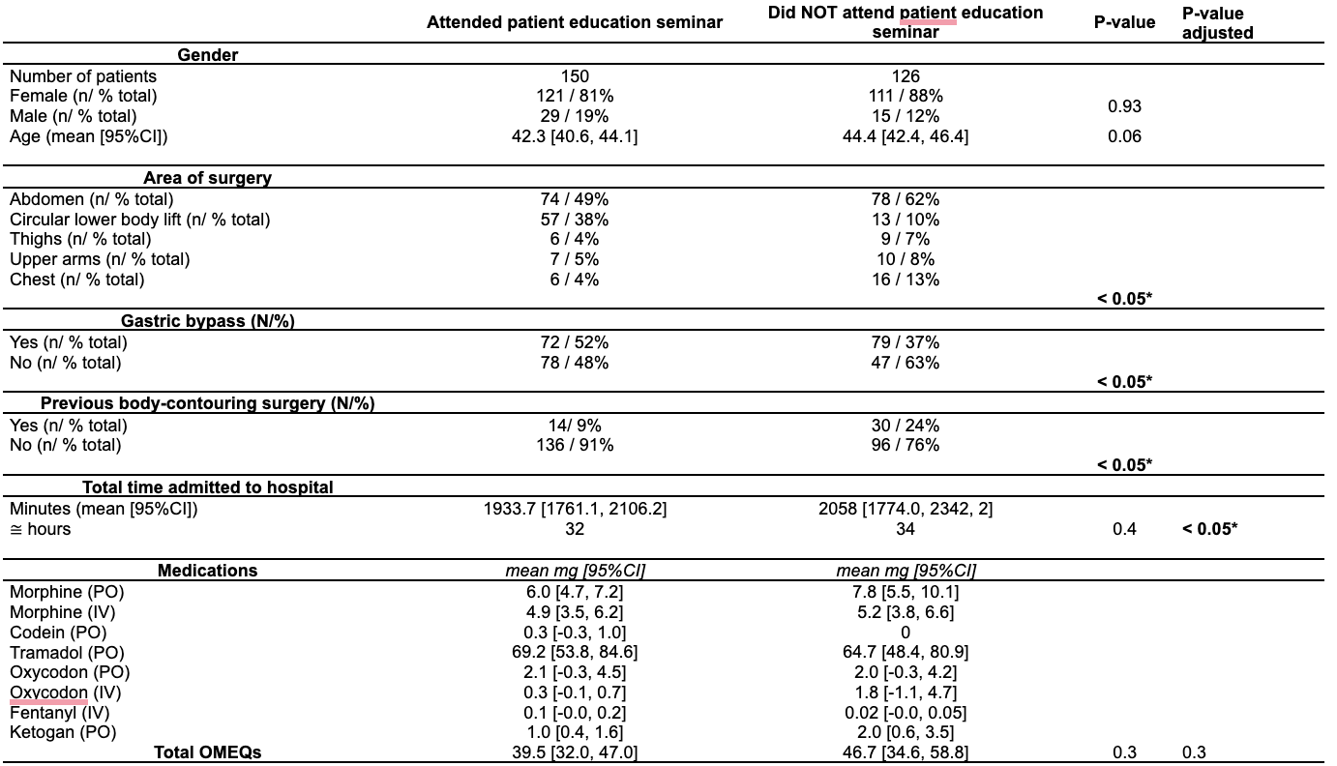

Table 1 - Demographics and results. All variables are reported at percentages or mean [95% CI]. Total time admitted is defined as the number of minutes from the time of the start of surgery to the time of discharge to home. OMEQs = Oral Morphine Equivalents. Differences in means were calculated using the independent t-test for continuous variables and Pearson's Chi-square test for categorical variables. Adj. t-tests report results from linear regression analysis adjusting for gender, previous gastric bypass, area of surgery, age and previous cosmetic surgery. * = p-value 0.05

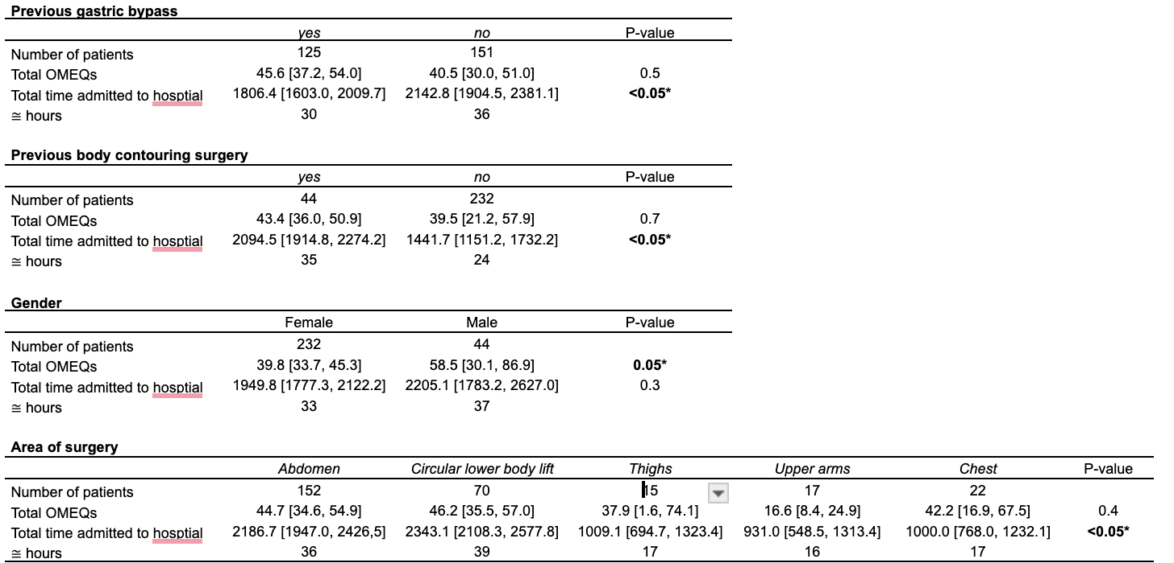

Table 2 - Results of secondary outcomes, where differences in patients characteristics are compared to the total OMEQs and total time admitted to hospital. All variables are reported at percentages or mean [95% CI]. Total time admitted is defined as the number of minutes from the time of the start of surgery to the time of discharge to home. OMEQs = Oral Morphine Equivalents. Differences in means of previous gastric bypass, previous cosmetic surgery due to massive weight loss and gender were calculated using the independent t-test. Differences between the different areas of surgery were calculated using the one-way ANOVA. For the area of surgery, there was a significant difference between the groups regarding the total time admitted to the hospital. When comparing by groups, the areas: thighs, upper arms, and chest were statistically significantly different compared to the abdomen and circular lower body lift.* = p-value 0.05

