Extended Hopanoid | (m/z) | Structure
3-Me Bacteriohopanetetrol | 669 | 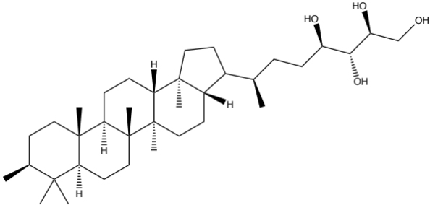
Aminotriol | 714 | 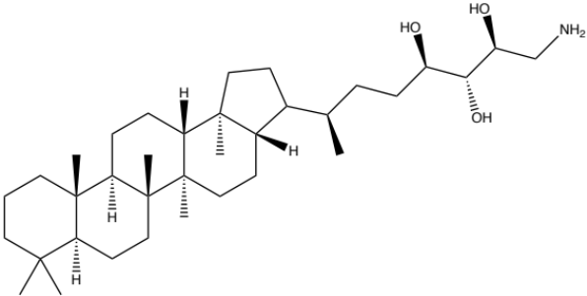
Bacteriohopanetetrol | 655 | 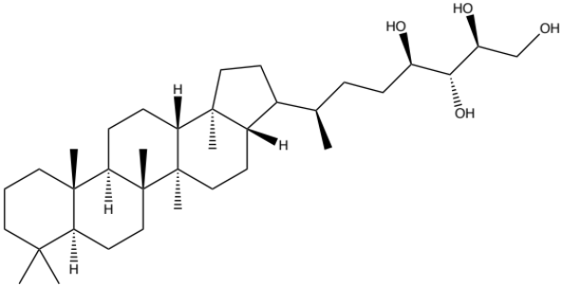
Bacteriohopanetetrol cyclitol ether | 1002 | 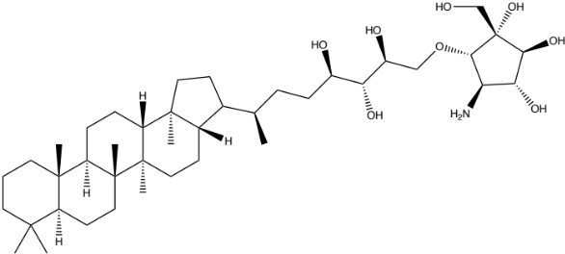
Bacteriohopanepentol cyclitol ether | 1060 | 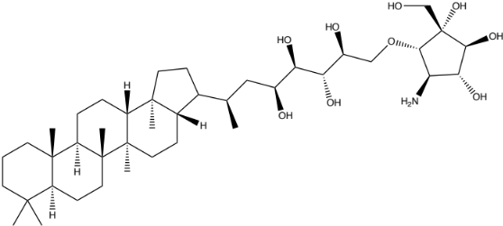
Table 1 LC-MS determination of extended hopanoids produced in Rhodopila sp. LVNP (structures referenced from Zhu et al. 2011)

Table 2 Locus tags of hopanoid biosynthesis gene homologues in our analyzed cultures of purple nonsulfur bacteria. –, indicates gene absent

 | Gene Function | Rhodopseudomonas palustris ATCC 17001 (JGI Genome ID 2516653006) | Rhodoblastus acidophilus DSM 137 (JGI Genome ID 2724679731) | Rhodopila globiformis DSM 161 (JGI genome ID 2831737867) | Rhodopila sp. LVNP (JGI genome ID 2684622831)
Total Genome Size (Mb) | – | 5.2 | 4.7 | 7.2 | 8.1
hpnR | methylates at C-3 position | – | – | Ga0347445_1940 | Ga0132156_116223
shc | cyclizes squalene into diploptene | RPATCC17001_01169 | Ga0170454_103148 | Ga0347445_5024 | Ga0132156_117315
hpnC | synthesizes the C30 squalene substrate from two isoprenoid precursor farnesyl pyrophosphate (C15) molecules | RPATCC17001_01500 | Ga0170454_10337 | Ga0347445_3393 | Ga0132156_112831
hpnD | synthesizes the C30 squalene substrate from two isoprenoid precursor farnesyl pyrophosphate (C15) molecules | RPATCC17001_01501 | Ga0170454_10338 | Ga0347445_3392 | Ga0132156_112832
hpnE | synthesizes the C30 squalene substrate from two isoprenoid precursor farnesyl pyrophosphate (C15) molecules | RPATCC17001_01170 | Ga0170454_10339 | Ga0347445_5025 | Ga0132156_117314
hpnH | first step in side chain development by addition of an adenosyl group to diploptene | RPATCC17001_01164 | Ga0170454_10877 | Ga0347445_577 | Ga0132156_114302
hpnG | cleaves an adenine from the tail end of adenosylhopane for side chain modification | RPATCC17001_01168 | Ga0170454_10876 | Ga0347445_5023 | Ga0132156_117316
hpnI | glycosyltransferase that helps generate the extended hopanoid glucosaminyl BHT | – | Ga0170454_1027 | Ga0347445_582 | Ga0347445_582
hpnJ | catalyzes a ring contraction to produce a BHT cyclitol ether | – | Ga0170454_101616 | Ga0347445_583 | Ga0132156_114296
hpnK | deacetylates the BHT acetylglucosamine formed by HpnI to generate the extended hopanoid glucosaminyl BHT | – | – | Ga0347445_584 | Ga0132156_114295
hpnO | generates amino BHT | RPATCC17001_01161 | Ga0170454_108103 | Ga0347445_6048 | Ga0132156_112646
hpnP | methylates at C-2 position | RPATCC17001_04569 | – | – | –

