Supporting Information
Title: Towards Industry-Ready Additive Manufacturing: AI-Enabled Closed-Loop Control for 3D Melt Electrowriting
Author(s), and Corresponding Author(s)*:
Pawel Mieszczanek, Peter Corke, Courosh Mehanian, Paul D. Dalton, Dietmar. W. Hutmacher*

MEW automated device
The MEW device used in this study was developed in accordance to the open-source assembly instructions provided in our previous study [1] which includes all necessary details needed to build the automated printer. Additionally, MATLAB was used a platform to develop algorithms encompassing data processing, user interface, model fitting, image processing, and real-time process control.

Telecentric vision system
Conventional lenses have an angular field of view which functions in the same way as human vision – as the distance between the lens and object increases, the magnification decreases. While it allows humans to have depth perception, it also introduces perspective error as the observed size of the object changes when the object moves closer or further away. Telecentric lenses, in contrast, have a constant field of view, which means that magnification does not change with respect to depth. In practice, using a telecentric lens is a much more reliable solution in high precision machine vision applications as the output measurements are not affected by magnification errors caused by even slight variations of the measured object position [2].
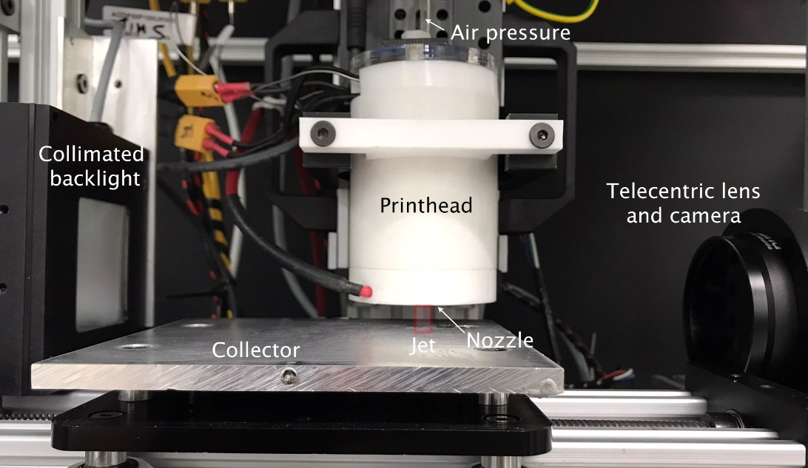
Supporting Fig. 1 | Telecentric vision system used in this study. Close up image of the telecentric vision system consisting of the collimated backlight, telecentric lens, and monochrome camera.
In this study, telecentric optics are used to measure the Taylor cone area, jet angle, and jet diameter. Here, the machine vision system consists of a telecentric lens (1.0X 2/3" GoldTL™, Edmund Optics, USA), monochrome USB 3.0 camera (acA2440-75um ace, Basler, Germany) and collimated backlight (2”x 2” White Collimated LED Backlight, Metaphase Technologies, USA) as shown in Supporting Fig. 1. The output image shows a well-defined silhouette of the observed object (Supporting Fig. 2a) as compared to the previously used camera (Supporting Fig. 2b). However, the main advantage of the telecentric vision system in MEW is the fixed field of view, which implies constant magnification.
In applications where the precise measurement of dynamic systems, such as MEW, is carried out using a vision system, variations of the distance between the lens and object are unavoidable. Using a telecentric lens, the size of the output image is not affected by those variations due to the constant magnification. Furthermore, telecentric lenses blur symmetrically, which means that the features such as edges retain their centre of mass location permitting accurate measurements even when the object is beyond best focus [2].
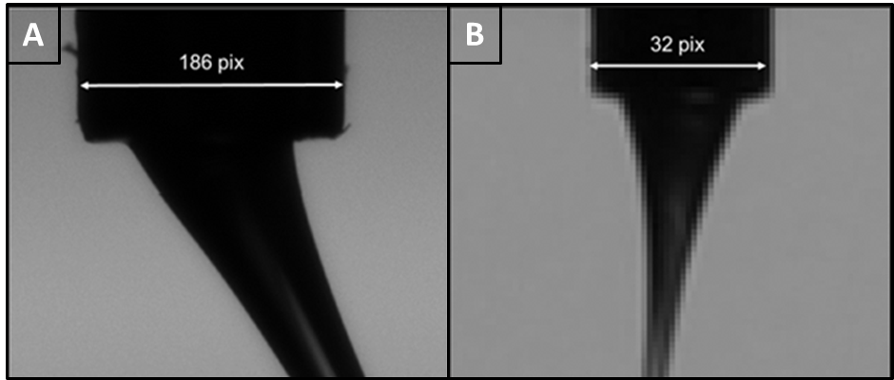
Supporting Fig. 2 | Vision system comparison. The comparison between the output images from (A) the new telecentric vision system and (B) previous DSLR-based imaging. The telecentric vision system combines the appropriate magnification, optical system resolution and sensor pixel size to enhance image resolution, significantly improving the accuracy of the measurement of the output features.

Image analysis algorithm
An image analysis algorithm was developed to analyse the images captured during the MEW material deposition process. The algorithm focused on the measurement of 3 output features: Taylor cone area, jet angle, and fibre diameter. The algorithm processed the data in real-time analysing each captured frame (Supporting Fig. 3).
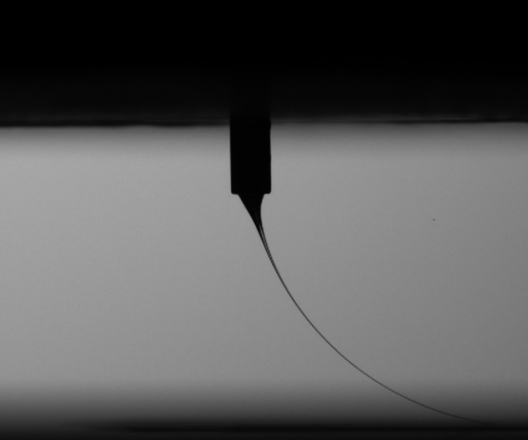
Supporting Fig. 3 | Raw image. Example of a raw image captured during the MEW process.

Threshold
An initial threshold was applied to the raw image in order to obtain a silhouette of the nozzle, Taylor cone, and fibre jet. Specifically, Otsu’s method [3] was used to obtain a binary image of the captured frame followed by cropping to remove a fragment of the printhead visible in the top section of the image. The image was used to locate the nozzle tip and to compute the jet angle.
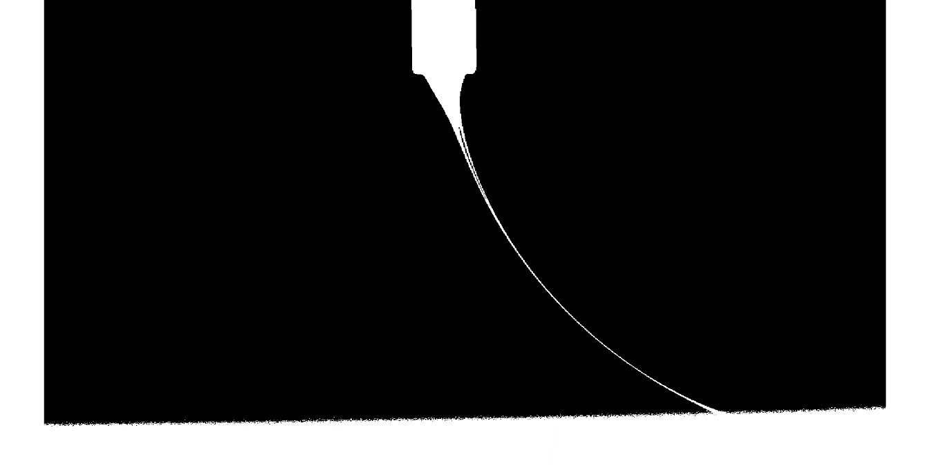
Supporting Fig. 4 | Threshold. Output image after applying Otsu’s threshold. The image was cropped to remove a fragment of the printhead visible in the top section of the image.

Locating the nozzle
Morphological operations were used to separate the nozzle from the rest of the image, thereby locating the nozzle tip. Due to the substantial difference in size between the nozzle and other features, morphological opening was used to isolate the nozzle, thus locating the bottom centre point of the nozzle.
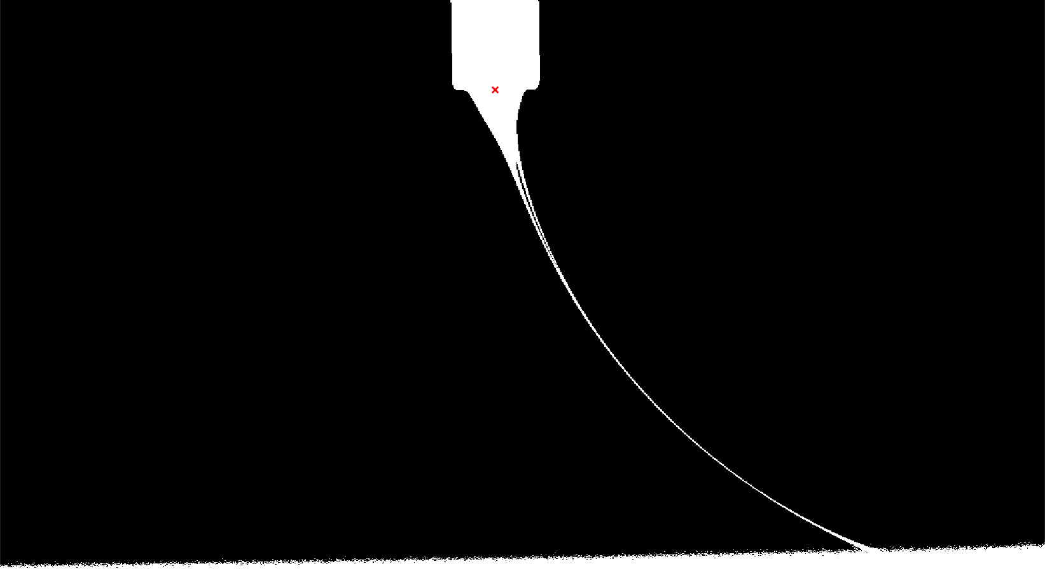
Supporting Fig. 5 | Nozzle tip. Morphological operations were used to find the bottom centre point of the nozzle (red cross).

Computing jet angle
The jet angle was computed by tracing the centre of the polymer jet from the previously found centre of the nozzle tip to the 60% of the working distance defined as the vertical distance between the nozzle tip and collector plate. The distance was chosen based on the previously published study [4] that showed the correlation between jet angle measurements computed at different points along the jet.
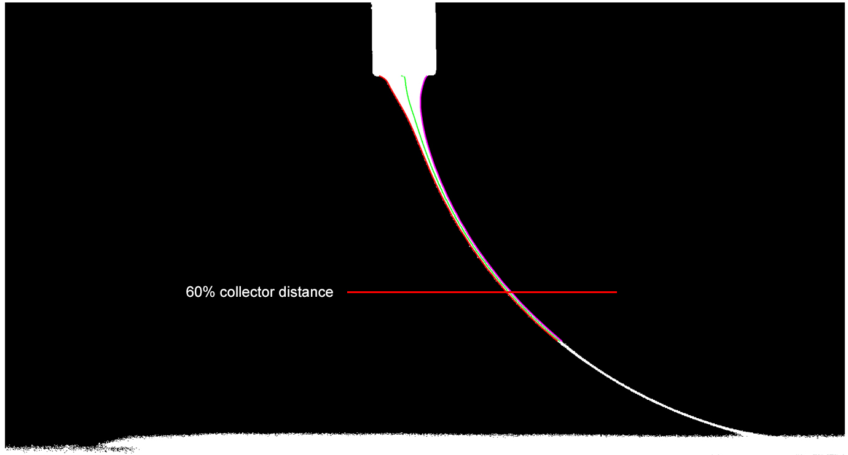
Supporting Fig. 6 | Jet angle. Jet angle computed from the bottom centre of the nozzle to the 60% working distance point. Here, working distance is measured vertically from the nozzle tip to the collector plate.

Computing jet diameter
The high-resolution camera used in this study allowed, for the first time, the measurement of the fibre jet thickness. The position along the fibre jet where the jet diameter is to be measured needed to be defined. We expected that the jet diameter would decrease as it gets closer to the deposition point. To demonstrate this, the diameter was measured at many different points along the fibre jet from the nozzle tip to the deposition point (Supporting Fig. 7). The results not only confirmed that the jet diameter decreases during its flight between the nozzle and the collector plate, but also showed that the rate of decrease slows down as the jet approaches the collector plate (Supporting Fig. 8).
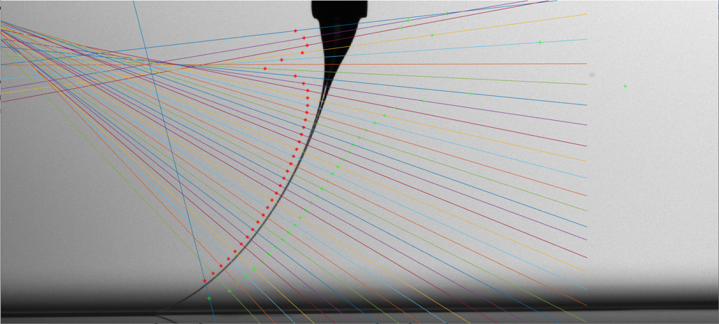
Supporting Fig. 7 | Jet diameter measurement method. Example of the jet diameter measurement at different location along the fibre jet ([0, 0] pixel location is defined at the top left corner).
This allowed us to choose the jet diameter measurement point, similarly to the jet angle measurement, at the point 60% of the working distance below the nozzle. Therefore, the jet diameter measurement avoids measurement error due to the distractors present around the deposition point while providing a very good estimation of the jet diameter at the deposition point.
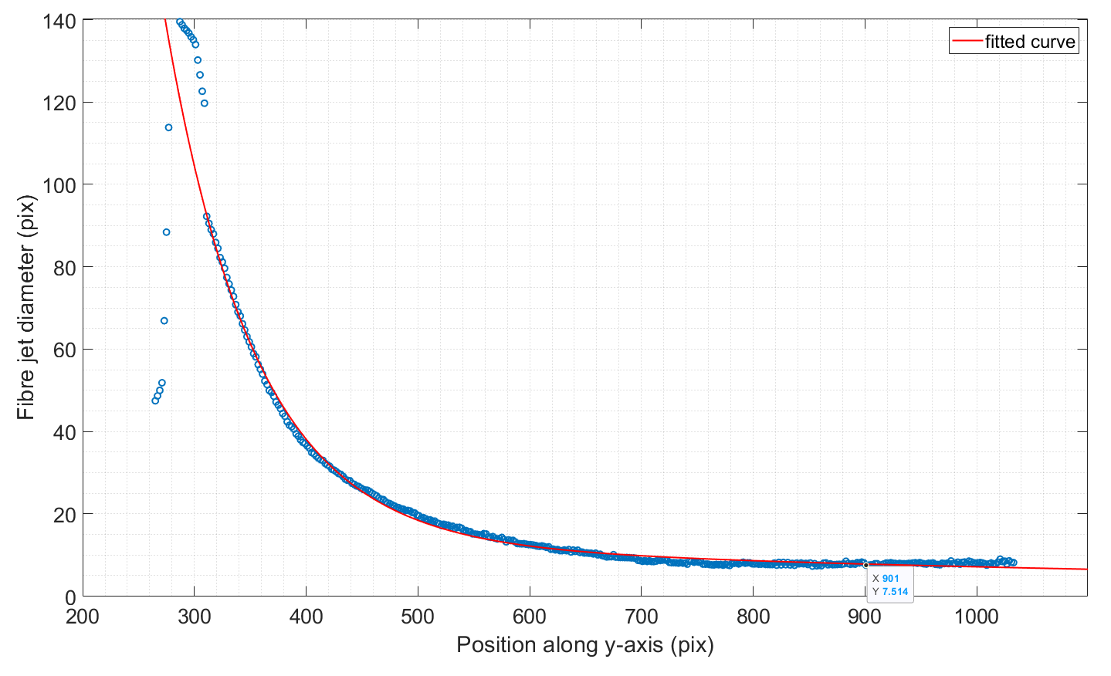
Supporting Fig. 8 | Jet diameter measurement results. Example of the measured jet diameter results along the fibre jet. The results show slower change in diameter close to the collector plate.
An original image was cropped around the defined distance resulting in a 100x100 pixel image that consisted of the section of the fibre jet to be analysed. Here, subpixel interpolation together with several different thresholding methods were compared to determine the most suitable method for fibre jet diameter measurement. Otsu’s method was found to be the most consistent across multiple printing tests.
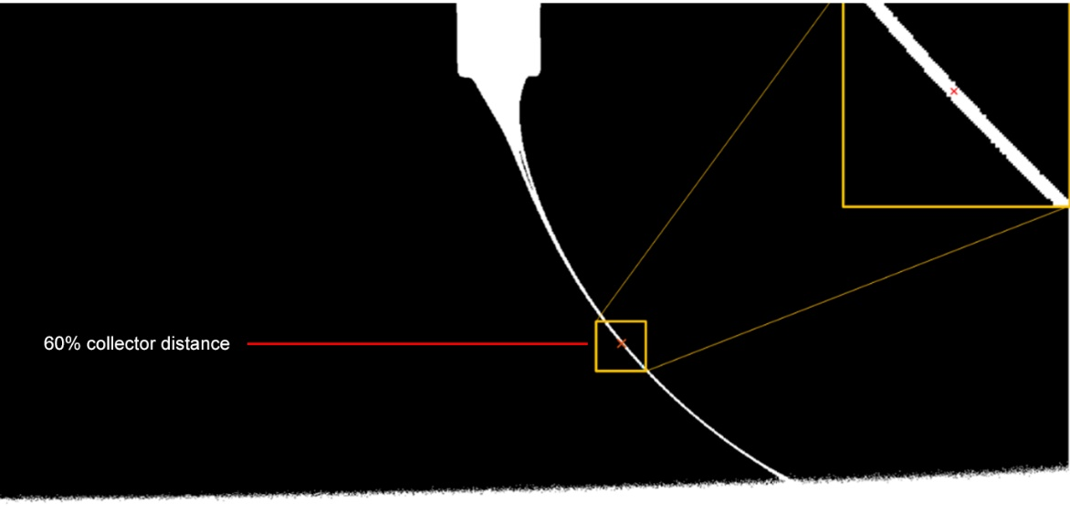
Supporting Fig. 9 | Jet diameter measurement location. Example of jet diameter measurement.

Computing the Taylor cone area
The Taylor cone area was measured by defining the bottom of the Taylor cone in the collected images. The height of the horizontal plane defining the transition between Taylor cone and fibre jet depends on system parameters. The results from the previous investigation [4] showed that while the relative variation of the Taylor cone area is the same regardless of the definition of the Taylor cone end point, the resolution of the Taylor cone area measurement improves with larger Taylor cone end definition. Therefore, in this investigation the Taylor cone end point was defined as the fixed distance of 300 pixels from the tip of the nozzle, which ensures the entire area of the Taylor cone is captured.
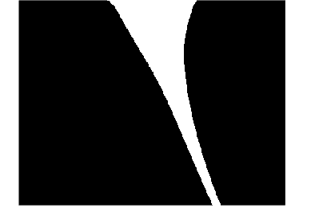
Supporting Fig. 10 | Taylor cone area. An image representing the Taylor cone. The image was obtained using previously defined nozzle tip which indicated the beginning of the Taylor cone. A fixed value of 300 pixels was used to define the Taylor cone end, thus enabling measurement of the Taylor cone area.

Experimental data collection
The next generation MEW device described here facilitated automated input control and output measurement in real-time. This allowed the rapid performance of experiments focusing on the input-output data, faster than possible before. In this study, we used a full-factorial Design-of-Experiments (DoE) in the parameter space described in Supporting Table 1.

Working distance (mm) | Applied temperature (°C) | Collection speed (mm/min) | Applied voltage (kV) | Applied pressure (kPa)
3.8 | 75 | 800 | 4.37 | 40
 | 85 | 1400 | 4.56 | 60
 |  | 2000 | 4.75 | 80
 |  |  | 4.94 | 100
 |  |  | 5.13 | 120
 |  |  | 5.32 | 140
 |  |  |  | 160
 |  |  |  | 180
 |  |  |  | 200
Supporting Table 1 | Experimental parameter space. Explored input parameter experimental space used to create input-output model of the system using a neural network.
The experiments tested 324 different combinations of input parameters using poly(ε-caprolactone) (PCL), with a total duration 15 hours. Each sample was printed using combination collection speed and applied temperature (the total of 6 experimental structures printed). Each input parameter combination was printed for 150s, comprising 75s of stabilization time and 75s of data capture time. Although the order of traversal of parameters space was designed to avoid excessive MEW system excitation, changing input parameters even by a small amount can cause momentary instability. Stabilization time allows for the system to settle so that only steady-state data is captured. Supporting Fig. 12 shows an example of the Taylor cone area data.
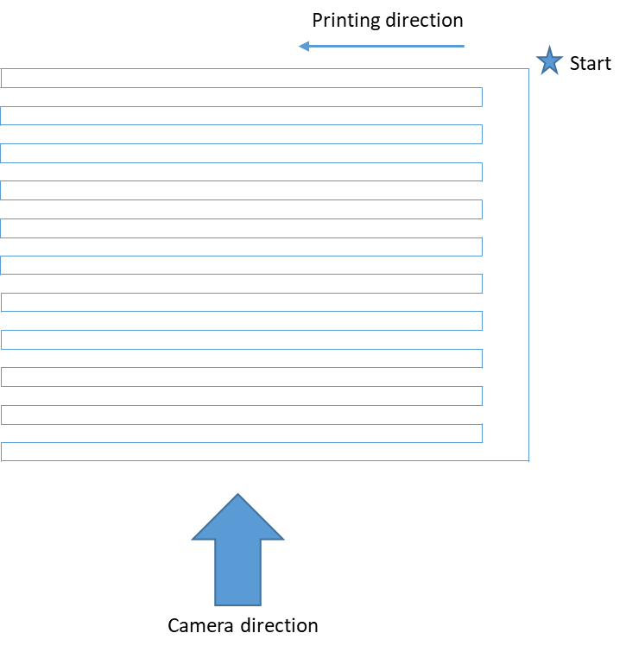
Supporting Fig. 11 | Experimental toolpath. The toolpath designed for experimentation and data collection.
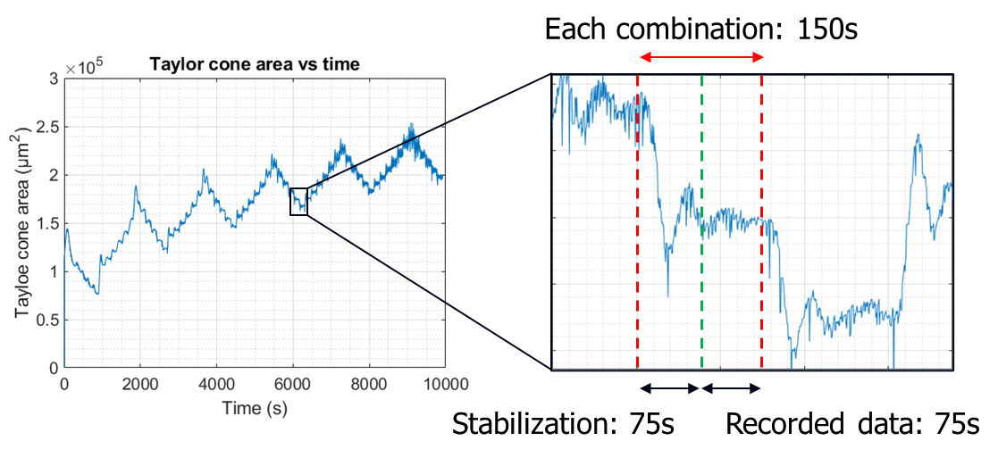
Supporting Fig. 12 | Experimental data. Example of the data captured during experimentation. Here the Taylor cone area was plotted versus time showing detailed transition from one input parameter set to another. Stabilisation allowed the system to settle after parameter adjustment so that only steady-state data is captured.
The captured images were analysed in real-time using the previously described image analysis algorithm. The computed data was subject to statistical analysis to determine 3 output parameters for each input parameter combination: mean Taylor cone area, mean jet angle, standard deviation of the Taylor cone area. The presented experimentation is a rapid methodology for obtaining input-output data that can be used to train an NN model for a given MEW system.

Taylor cone area to fibre diameter mapping
Fibre diameter is arguably the most important output parameter of the MEW process. It describes the size of the fabricated fibre which defines the most important characteristics of the printed structures such as mechanical properties and porosity. In this experiment, the quantitative relationship between the fibre diameter and Taylor cone was established for the first time.
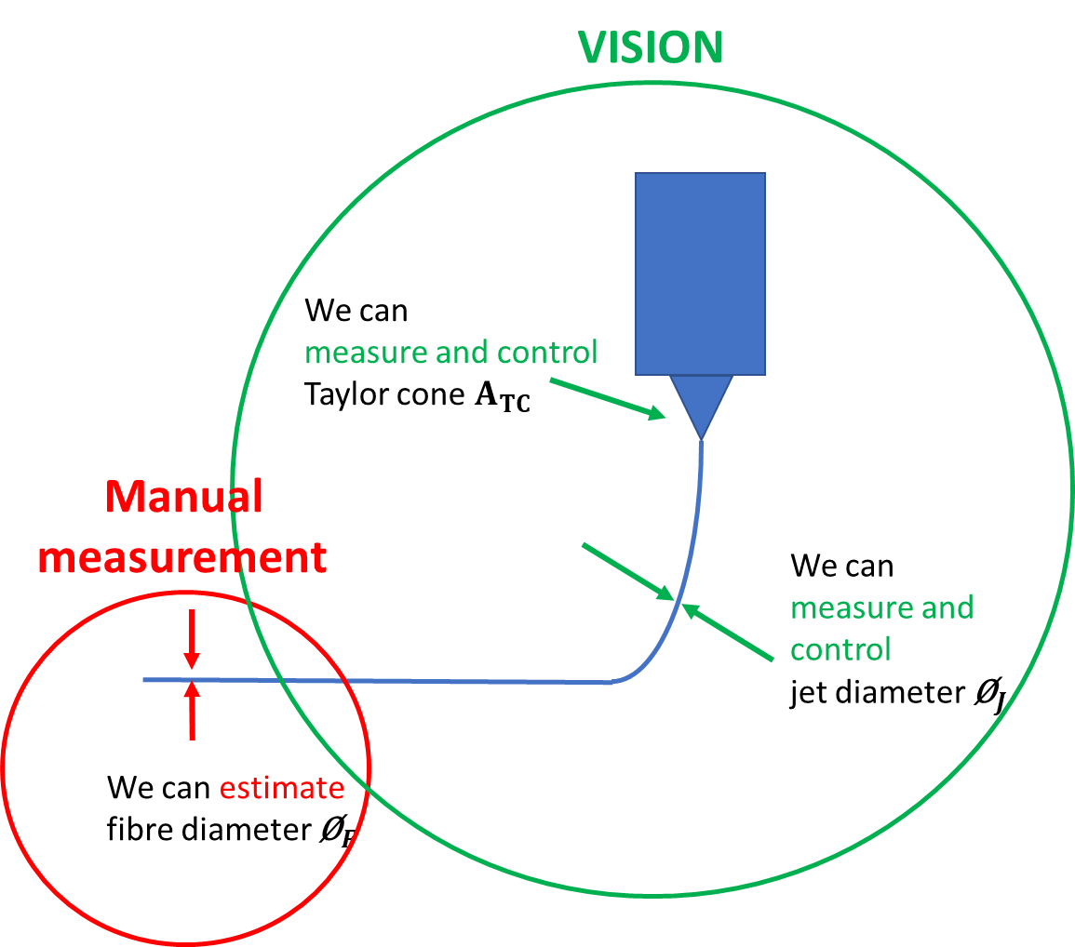
Supporting Fig. 13 | Experiment overview. Experimental Schematic relating the Taylor cone area with the fibre diameter.
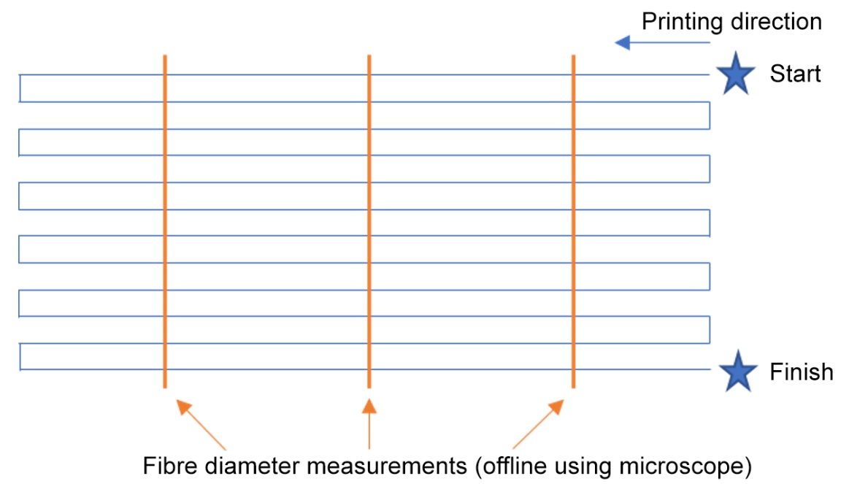
Supporting Fig. 14 | Experimental structure and measurement points. Graphical representation (top view) of the fibre diameter measurement experimental process. The experimental structure was only one layer high to enable correct fibre diameter measurement with a microscope.
The experiment tested the hypothesis that the collection speed is the dominant factor causing the jet to stretch and get thinner. The experiment also established the relationship between jet diameter and fibre diameter, thereby defining the Taylor cone area and fibre diameter correlation. In this experiment, 14 prints were conducted to test the effect of the collection speed on the fibre diameter for a given jet diameter. The Taylor cone area was also recorded. Table 2 shows the experimental results, where:
- CS – collection speed
- ${\text{Ø}}_{J}$ – jet diameter request
- $Ø_{F}$ – fibre diameter
- $A_{TC}$ – Taylor cone area
- ${\text{CF}}_{{\text{Ø}}_{J}-{\text{Ø}}_{F}}=\frac{Ø_{F}}{Ø_{J}}$ – ratio between jet diameter and fibre diameter
- $\overline{{\text{CF}}_{{\text{Ø}}_{J}-{\text{Ø}}_{F}}}$ – mean ratio between jet diameter and fibre diameter
- ${\text{CF}}_{A_{TC}-{\text{Ø}}_{F}}=\frac{Ø_{F}}{A_{TC}}$ – ratio between Taylor cone are and fibre diameter
- $\overline{{\text{CF}}_{A_{TC}-{\text{Ø}}_{F}}}$ – mean ratio between Taylor cone area and fibre diameter
- ${\text{CF}}_{A_{TC}-{\text{Ø}}_{J}}=\frac{Ø_{J}}{A_{TC}}$ – ratio between Taylor cone area and jet diameter

CS (mm/min) | ${\text{Ø}}_{J}$ (µm) | ${\text{Ø}}_{F}$(µm) | $${\text{CF}}_{{\text{Ø}}_{J}-{\text{Ø}}_{F}}$$ | $$\overline{{\text{CF}}_{{\text{Ø}}_{J}-{\text{Ø}}_{F}}}$$ | $${\text{CF}}_{A_{TC}-{\text{Ø}}_{F}}$$ | $$\overline{{\text{CF}}_{A_{TC}-{\text{Ø}}_{F}}}$$ | $${\text{CF}}_{A_{TC}-{\text{Ø}}_{J}}$$
2000 | 15.8 | 5.2 | 0.33 | 0.32 | $$3.6*{10}^{-5}$$ | $$3.55*{10}^{-5}$$ | $$1.10*{10}^{-4}$$
2000 | 22.3 | 7.0 | 0.31 | 0.32 | $$3.5*{10}^{-5}$$ | $$3.55*{10}^{-5}$$ | $$1.12*{10}^{-4}$$
1800 | 15.0 | 5.15 | 0.34 | 0.33 | $$3.7*{10}^{-5}$$ | $$3.6*{10}^{-5}$$ | $$1.08*{10}^{-4}$$
1800 | 21.7 | 7.0 | 0.32 | 0.33 | $$3.5*{10}^{-5}$$ | $$3.6*{10}^{-5}$$ | $$1.08*{10}^{-4}$$
1600 | 15.1 | 5.3 | 0.35 | 0.34 | $$4.0*{10}^{-5}$$ | $$3.9*{10}^{-5}$$ | $$1.14*{10}^{-4}$$
1600 | 23.1 | 7.8 | 0.33 | 0.34 | $$3.8*{10}^{-5}$$ | $$3.9*{10}^{-5}$$ | $$1.14*{10}^{-4}$$
1400 | 10.3 | 4.25 | 0.41 | 0.4 | $$4.4*{10}^{-5}$$ | $$4.4*{10}^{-5}$$ | $$1.06*{10}^{-4}$$
1400 | 19.5 | 7.8 | 0.40 | 0.4 | $$4.4*{10}^{-5}$$ | $$4.4*{10}^{-5}$$ | $$1.09*{10}^{-4}$$
1200 | 15 | 7.3 | 0.49 | 0.45 | $$5.3*{10}^{-5}$$ | $$4.9*{10}^{-5}$$ | $$1.07*{10}^{-4}$$
1200 | 23.1 | 9.5 | 0.40 | 0.45 | $$4.5*{10}^{-5}$$ | $$4.9*{10}^{-5}$$ | $$1.11*{10}^{-4}$$
1000 | 14.8 | 7.6 | 0.51 | 0.48 | $$5.5*{10}^{-5}$$ | $$5.6*{10}^{-5}$$ | $$1.07*{10}^{-4}$$
1000 | 23.3 | 11.0 | 0.47 | 0.48 | $$5.75*{10}^{-5}$$ | $$5.6*{10}^{-5}$$ | $$1.2*{10}^{-4}$$
800 | 15.2 | 9.0 | 0.59 | 0.56 | $$6.4*{10}^{-5}$$ | $$6.4*{10}^{-5}$$ | $$1.08*{10}^{-4}$$
800 | 22.1 | 12.0 | 0.54 | 0.56 | $$6.3*{10}^{-5}$$ | $$6.4*{10}^{-5}$$ | $$1.16*{10}^{-4}$$
Supporting Table 2 | Experimental results. The measured data as well as computed ratio were recorded.
The results clearly show the correlation between the collection speed and ratio for both Taylor cone area and fibre jet diameter (Pearson coefficient r = -0.9707). The higher the collection speed, the lower the correcting factor. This experiment is a two-point check (the Taylor cone area and jet diameter) which implies that the fibre diameter can be estimated in real-time based on the measured Taylor cone area at a given collection speed.
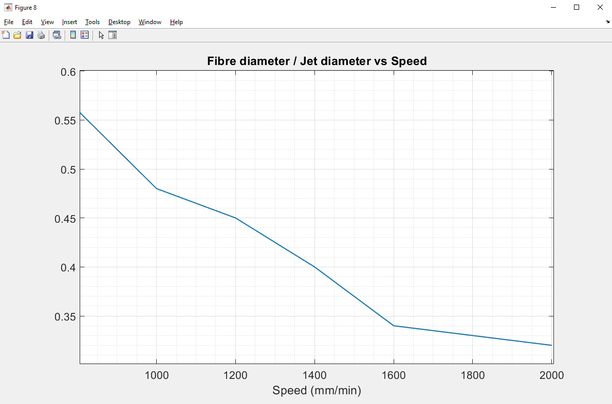
Supporting Fig. 15 | Fibre diameter to jet diameter ratio. Correcting between the fibre diameter and jet diameter for a given collection speed.

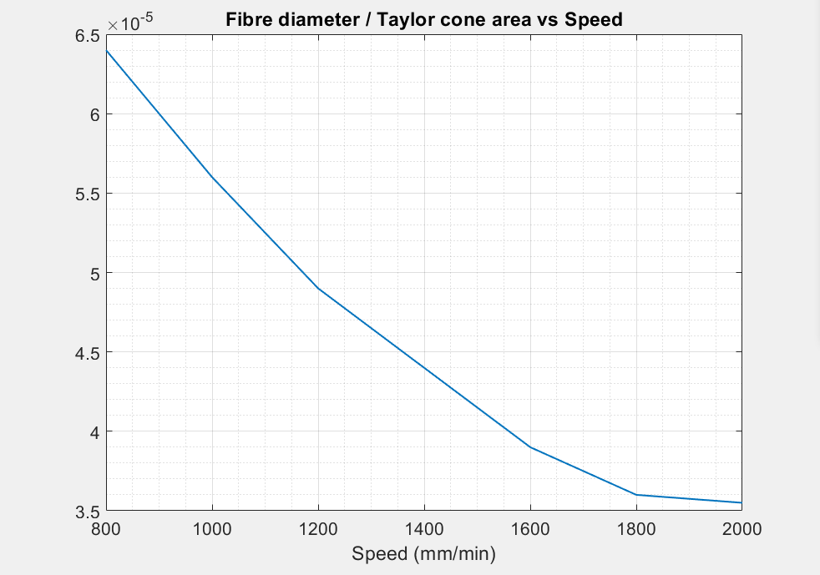
Supporting Fig. 16 | Fibre diameter to Taylor cone area ratio. The ratio between the Taylor cone area and fibre diameter for a given collection speed.

Neural network training and design
Training data
The process of experimental data collection is described in Supporting material Section 3. The data obtained through that process is saved in csv format. Before the data is passed as an input-output training set, it is scaled and normalized.
Neural network training results
Neural network (NN) training was performed using MATLAB 2020b and the Deep Learning Toolbox. The hyperparameters for NN training were as follows: 3 different training algorithms (Bayesian Regularization Backpropagation, Levenberg–Marquardt, and Scaled Conjugate Gradient), and 4 different numbers of neurons in the hidden layer (4, 8, 12, 16) were tested. Each network was trained 5 times. The shallow neural network architecture with 1 input layer, 1 hidden layer consisting of 12 hidden neurons, and 1 output layer was chosen. It was found that Bayesian Regularization Backpropagation was the best performing optimization algorithm.
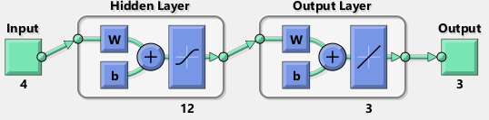
Supporting Fig. 17 | Neural network architecture. Shallow neural network architecture with one input layer, one hidden layer with 12 neurons, and one output layer.

Open-loop control
Open-loop control allows the user to select the required output values and provides the user with the set of inputs that produce the desired outcome. This functionality is based on the data-driven, feedforward NN model of the MEW system plus optimization as we show below.
The feedforward model can be described as a function $y=f(x)$ that takes input $x$:
$x=\left[\begin{aligned}P \\ \begin{aligned}V \\ S \\ T\end{aligned}\end{aligned}\right]$,
and estimates the output $y$:
$$y=\left[\begin{matrix}A_{TC} \\ θ_{J} \\ σ_{A_{TC}}\end{matrix}\right]$$
where $P$ is the applied pressure, $V$ is the applied voltage, $S$ is the collector speed, $T$ is the applied temperature, $A_{TC}$ is the Taylor cone area, $θ_{J}$ is the jet angle, and $σ_{A_{TC}}$ is the standard deviation of the Taylor cone area. While the feedforward model is a valuable tool for simulating the output of the system, generally the inverse of such functionality is required to enable an unexperienced user to achieve a desired outcome. The inverse allows the user to obtain the input parameters for a given required output. In other words, we would like to obtain the inverse function,$x=f^{-1}(y)$. Instead of training a model to approximate the inverse function, optimization can be used as an alternative to minimize a cost function. Such an optimization problem is defined as$x=\min_{x}\left\|\left.y^{*}-y\left(x\right)\right\|\right.$, where $y^{*}$ is the required output.
MATLAB 202b and the Optimization Toolbox were used to compute the optimization. In this case, the objective of the optimization is to find a minimum of a constrained nonlinear multivariable function. Sequential Quadratic Programming (SQP) is the optimization algorithm that was chosen for this application because this optimization methods allows constraints to be defined such as upper and lower function bounds. Here, the upper and lower bounds were defined for all input parameters based on the capabilities of the hardware and physical properties (e.g., maximum speed of the linear stages or maximum applied voltage for a given working distance to prevent electric discharge).
Lastly, the contribution of each output parameter to the cost function can be defined in a weight matrix $W$
$W= \left[\begin{matrix}W_{A_{TC}} \\ W_{θ_{J}} \\ W_{σ_{A_{TC}}}\end{matrix}\right]$
and hence the weighted optimization problem can be defined:
$x=\min_{x}\left\|\left.{W(y}^{*}-y\left(x\right))\right\|\right.$.
The weight matrix permits the prioritization of output parameters in the optimization process. Thus, if input parameters cannot be found to satisfy a given desired output, the user may use the weight matrix to prioritize certain components of the output over others. For example, if the allowable error for the jet angle is less than the allowable error for the Taylor cone area, the user would select the jet angle weight to be much higher than the Taylor cone area weight). The average time for computing the local minimum is 0.15 s.

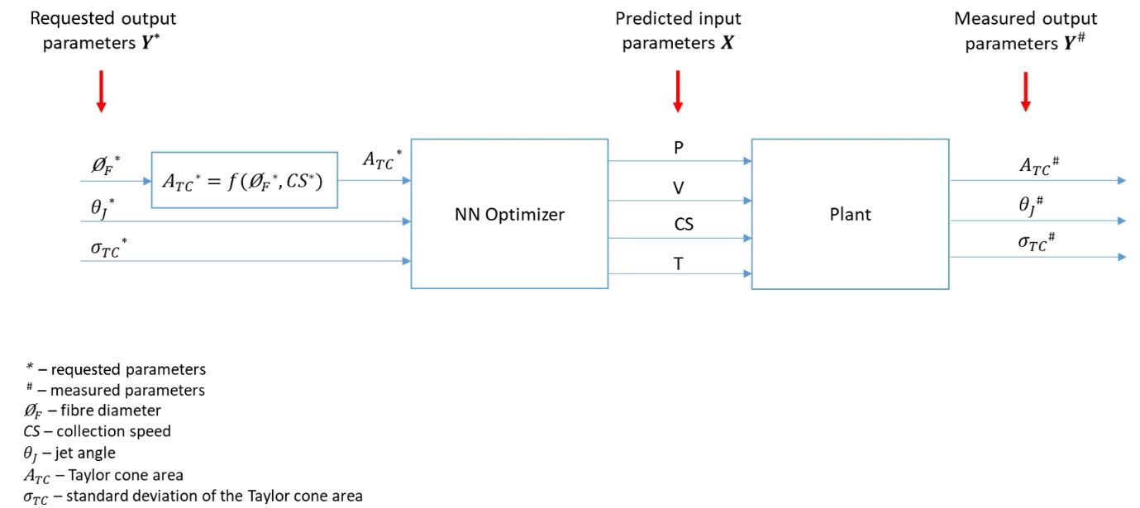
Supporting Fig. 18 | Schematic of the open-loop control functionality. The system is based on the optimization that uses the NN model to minimize the cost function in order to provide a set of input parameters that will result in the desired request.

Closed-loop control
Closed-loop control allows the system to autonomously compensate for detected output errors by applying adjustments to the input parameters during the printing process. Feedback control was achieved by the implementation of a controller to the previously described open-loop control system as shown in Supporting Fig. 19.
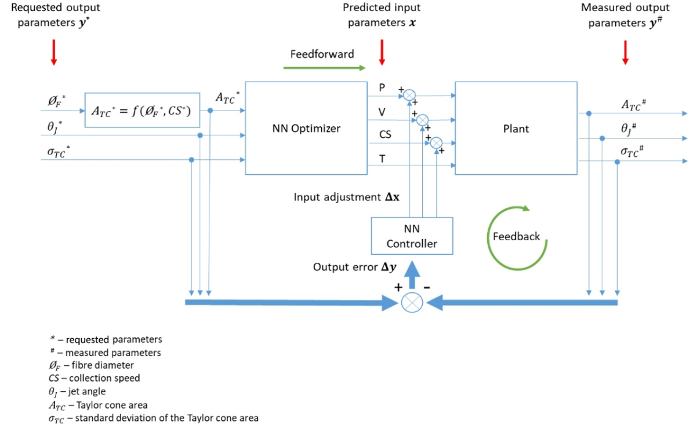
Supporting Fig. 19 | Schematic of the feedback control in the MEW system. The previously feedforward control is complemented by the feedback control that adjusts the input parameters based on the detected output error.
The ability to measure the output of the MEW process in real-time allows the implementation of an MEW closed-loop control system. The measured output error $Δy$ is computed by comparing the required output with the output measured in real-time:
$Δy=y^{*}-y^{\#}$,
where $y^{\#}$ is the measured output. The NN controller was developed based on the optimization described above and NN model of the system. The controller generates the corrective input parameter adjustments $Δx$ that will compensate for the detected output error$Δy$. The controller is based on the Jacobian of the NN model $J_{NN}$ which describes how much the change of each input parameter affects each output parameter:
$$Δy=J_{NN}*Δx$$
Therefore:
$J_{NN}= \left[\begin{matrix}\frac{{∂\text{y}}_{1}}{∂x_{1}} & \frac{{∂\text{y}}_{1}}{∂x_{2}} & \frac{{∂\text{y}}_{1}}{∂x_{3}} \\ \frac{{∂\text{y}}_{2}}{∂x_{1}} & \frac{{∂\text{y}}_{2}}{∂x_{2}} & \frac{{∂\text{y}}_{2}}{∂x_{3}} \\ \frac{{∂\text{y}}_{3}}{∂x_{1}} & \frac{{∂\text{y}}_{3}}{∂x_{2}} & \frac{{∂\text{y}}_{3}}{∂x_{3}}\end{matrix}\right]$,
where:
$$∂x=\left[\begin{matrix}∂P \\ ∂V \\ ∂CS\end{matrix}\right]$$
$∂y=\left[\begin{matrix}{∂\text{A}}_{TC} \\ ∂θ_{J} \\ ∂σ_{TC}\end{matrix}\right]$.

Note that $∂x$ does not include applied temperature. This is because the change in the applied pressure, applied voltage and collection speed affects the output of the system much faster than the change in applied temperature. Therefore, in this study the applied temperature was omitted in the closed-loop control application. The Jacobian $J_{NN}$ was obtained using the previously developed neural network model of the system to compute incremental differences:
$δy=f\left(x+δx\right)-f(x)$,
and:
$J_{NN}=\left[\begin{matrix}\frac{{δ\text{A}}_{TC}}{δP} & \frac{{δ\text{A}}_{TC}}{δV} & \frac{{δ\text{A}}_{TC}}{δCS} \\ \frac{{δθ}_{J}}{δP} & \frac{{δθ}_{J}}{δV} & \frac{{δθ}_{J}}{δCS} \\ \frac{δσ_{TC}}{δP} & \frac{δσ_{TC}}{δV} & \frac{δσ_{TC}}{δCS}\end{matrix}\right]$;
where $δy=\left[\begin{matrix}{δ\text{A}}_{TC} \\ {δθ}_{J} \\ {δσ}_{TC}\end{matrix}\right]$ is the change of output parameters simulated by the neural network model when a small change of input parameters $δx=\left[\begin{matrix}δP \\ δV \\ δCS\end{matrix}\right]=\left[\begin{matrix}1kPa \\ 10V \\ 50mm/min\end{matrix}\right]$ is applied from the current state of the input parameters$x$.
Similarly to the previously described optimization problem in the feedforward control, here $δx$ was obtained by using optimization so that:
$$Δx=\min_{Δx}\left\|\left.{W(Δy}^{*}-Δy)\right\|\right.$$
In this way, the controller minimizes the cost function to find the adjustment of input parameters $δx$ to compensate for the measured output error$Δy$.

Fibre diameter measurement results
The experiment was conducted using the closed-loop control MEW system while the diameter measurement was performed using a benchtop microscope as previously described in the Supporting material Section 4. The images of the measured fibre diameter and the measurement raw data are attached in the “Experimental_results.zip” file.
Fibre diameter measurement for Figure 6a
Fibre diameter request: ${{\text{Ø}}_{F}}^{*}=6.00μm$
Measured Taylor cone area: ${\text{A}}_{TC}=1.69*{10}^{5}μm^{2}$
Measured fibre diameter: $\overline{{{\text{Ø}}_{F}}^{\#}}=5.90μm (SD=0.29μm)$

Fibre diameter measurement for Figure 6b
Fibre diameter request: ${{\text{Ø}}_{F}}^{*}=12μm$
Measured Taylor cone area: ${\text{A}}_{TC}=1.88*{10}^{5}μm^{2}$
Measured fibre diameter: $\overline{{{\text{Ø}}_{F}}^{\#}}=12.09μm (SD=0.09μm)$

Fibre diameter measurement for Figure 6e
Fibre diameter request: ${{\text{Ø}}_{F}}^{*}=4.9μm$
Measured Taylor cone area: ${\text{A}}_{TC}=1.38*{10}^{5}μm^{2}$
Measured fibre diameter: $\overline{{{\text{Ø}}_{F}}^{\#}}=4.66μm (SD=0.10μm)$

Fibre diameter measurement for Figure 6f
Fibre diameter request: ${{\text{Ø}}_{F}}^{*}=9.2μm$
Measured Taylor cone area: ${\text{A}}_{TC}=1.44*{10}^{5}μm^{2}$
Measured fibre diameter: $\overline{{{\text{Ø}}_{F}}^{\#}}=9.19μm (SD=0.04μm)$

Bibliography
[1] P. Mieszczanek, S. Eggert, P. Corke, and D. W. Hutmacher, "Automated melt electrowritting platform with real-time process monitoring," HardwareX, vol. 10, p. e00246, 2021/10/01/ 2021, doi: https://doi.org/10.1016/j.ohx.2021.e00246.
[2] N. J. Gregory Hollows. "The Advantages of Telecentricity." https://www.edmundoptics.eu/knowledge-center/application-notes/imaging/advantages-of-telecentricity/ (accessed 31.07.2022.
[3] N. Otsu, "A threshold selection method from gray-level histograms," IEEE transactions on systems, man, and cybernetics, vol. 9, no. 1, pp. 62-66, 1979.
[4] P. Mieszczanek, T. M. Robinson, P. D. Dalton, and D. W. Hutmacher, "Convergence of Machine Vision and Melt Electrowriting," Advanced Materials, vol. 33, no. 29, p. e2100519, Jul 2021, doi: 10.1002/adma.202100519.

