Supplementary Information for

Generative Design of Crystal Structures by Point Cloud Representations and Diffusion Model
Author Information
Affiliations
School of Physics and Electronic Engineering, Jiangsu University, Zhenjiang, Jiangsu 212013, PR China
Jiangsu Engineering Research Center on Quantum Perception and Intelligent Detection of Agricultural Information, Zhenjiang, 212013, China
Zhelin Li (https://orcid.org/0009-0000-7050-312X), Rami Mrad, Runxian Jiao (https://orcid.org/0009-0006-3852-6739), Guan Huang, Jun Shan, Shibing Chu& Yuanping Chen
Contributions
Z.L.: conceptualization, method, software, investigation, formal analysis, model validation, writing original draft; R.M: editing, model validation and investigation; R.J, G.H and J.S: DFT calculation guide; S.C and Y.C: conceptualization, writing review, funding acquisition, resources and supervision.
Corresponding author
Correspondence to: Shibing Chu (https://orcid.org/0009-0000-8909-1786), Yuanping Chen (https://orcid.org/0000-0001-5349-3484)

Data expression example
Taking MgMnO₃ as an example (Fig. 1), the data were generated by our diffusion model. For the first channel, 128 data points can be classified into five categories: (0, 0.5, 0.5), (0.5, 0, 0.5), (0.5, 0.5, 0), (0, 0, 0) and (0.5, 0.5, 0.5). However, here, one atom is at the position (0, 0, 0), one atom is at the center of the crystal body, and three atoms are at the centers of the crystal faces. However, we have not given more information on the elements and lattice. It can be a carbon system or a Ca-Ti-O system and can also be a triclinic system or a hexagonal system. In the second channel, the element information for the 128 points is given one by one. As shown in Fig. 1, there are three groups of data, and the five categories in the first channel are further categorized into three groups according to one-to-one correspondence. Thus far, the elements and the relative coordinates in the unit cell of every atom can be confirmed. However, the shape of the lattice or crystal system is still unknown, and the system can also be cubic or trigonal. Ignoring the first two channels while processing the third channel, we cluster them directly. Theoretically, materials can be aggregated into two categories: the length $a,b,c$ and the angle $α,β,γ$ of the lattice. Here, the approximate data used are (0.50, 0.50, 0.50) and (0.25, 0.25, 0.25) (all the numbers are less than 1 because, before training, the lattice data have been normalized by dividing by 15Å and the angle used in the radian system and divided by $π$). The three vectors of the lattice can be calculated as follows.
$$\vec{a}=a\left(1,0,0\right)$$
$$\vec{b}= b\left(\left(cosγ, sinγ, 0\right)\right)$$
$$\vec{c}=c(cosβ, cosα-\frac{cosβcosγ}{sinγ} ,\frac{\sqrt{1+2cosαcosβcosγ-\cos^{2}α-\cos^{2}β-\cos^{2}γ}}{sinγ}$$
The results are (3.75, 0, 0), (0, 3.75, 0), and (0, 0, 3.75), and further determine that the system is cubic with a side length of 3.75 Å. Integrating the above, we summarize the following:
- The cubic system has a side length of 3.75 Å.
- The formula for this structure is MgMnO₃.
- For every unit cell, there will be an oxygen atom on each face, a magnesium atom on each corner, and a manganese atom at the center.

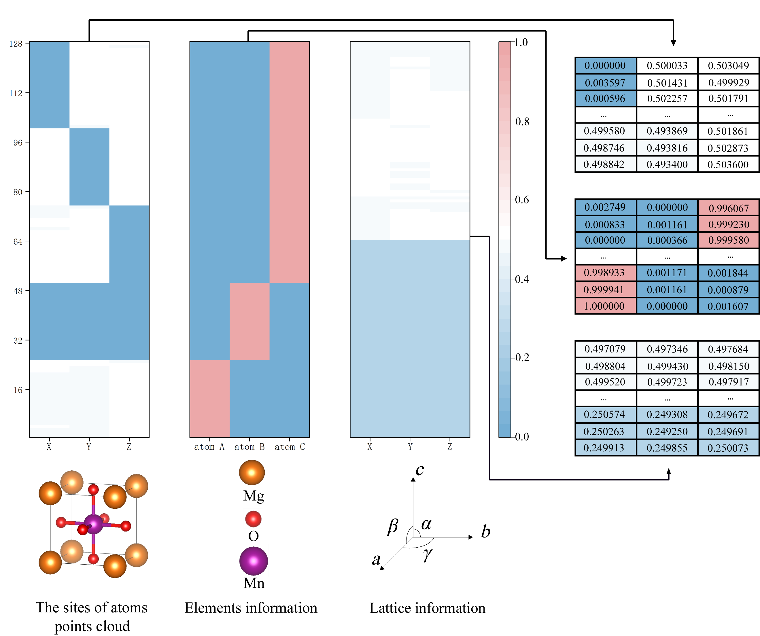
Supplementary Fig. 1. Data expression example.

Generation process example
Additionally, taking MgMnO₃ as an example (Fig. 2), different colors of points indicate different atoms (the second channel of data), and the third channel is ignored for better visualization. The whole inference process requires 1000 steps. The last step is training, and the first step is generation at t=999. The data given here are random numbers that obey a normal distribution. The points in this step are disorganized. with t becoming increasingly closer to 0. Points with the same color gradually come together. At t=200, there is already evidence of clustering. When t=0, it can be clear that there are five groups, which means that this structure has five atoms, including positions and elements.

Supplementary Fig. 2. Generation process example.

DFT configuration
The structures were optimized by density functional theory (DFT) via the Vienna ab initio simulation package (VASP). The Perdew–Burke–Ernzerhof (PBE) functional of the generalized gradient approximation (GGA) was used for the exchange–correlation functional. The kinetic energy cutoff was set to 520 eV for the electronic wavefunction with a plane wave basis set, which was obtained using the projector augmented-wave method. The Monkhorst–pack k-mesh grids were selected by vaspkit.
Model details
Supplementary Fig. 3. The U-Net model used in diffusion.
Training details
The hyperparameters used during training are shown in Table 1.
Hyperparameter | Value
Optimizer | Adam ($β_{1}= 0.9$, $β_{2}= 0.99$)
Learning rate | 0.0001
Batch size | 128
Training steps | 500
Prediction target | $$ϵ$$
Sampling timesteps | 1000
Diffusion noise schedule | cosine
Supplementary Table 1. Hyperparameters for training.
During training, we used the mean absolute error (MAE) to calculate the loss (Figure 4). The loss function is as follows:
$$Loss=E_{t,x_{0},ϵ}(\left\|ϵ-ϵ_{θ}(\sqrt{{\overline{α}}_{t}}x_{0}+\sqrt{{1-\overline{α}}_{t}}ϵ,t)\right\|)$$
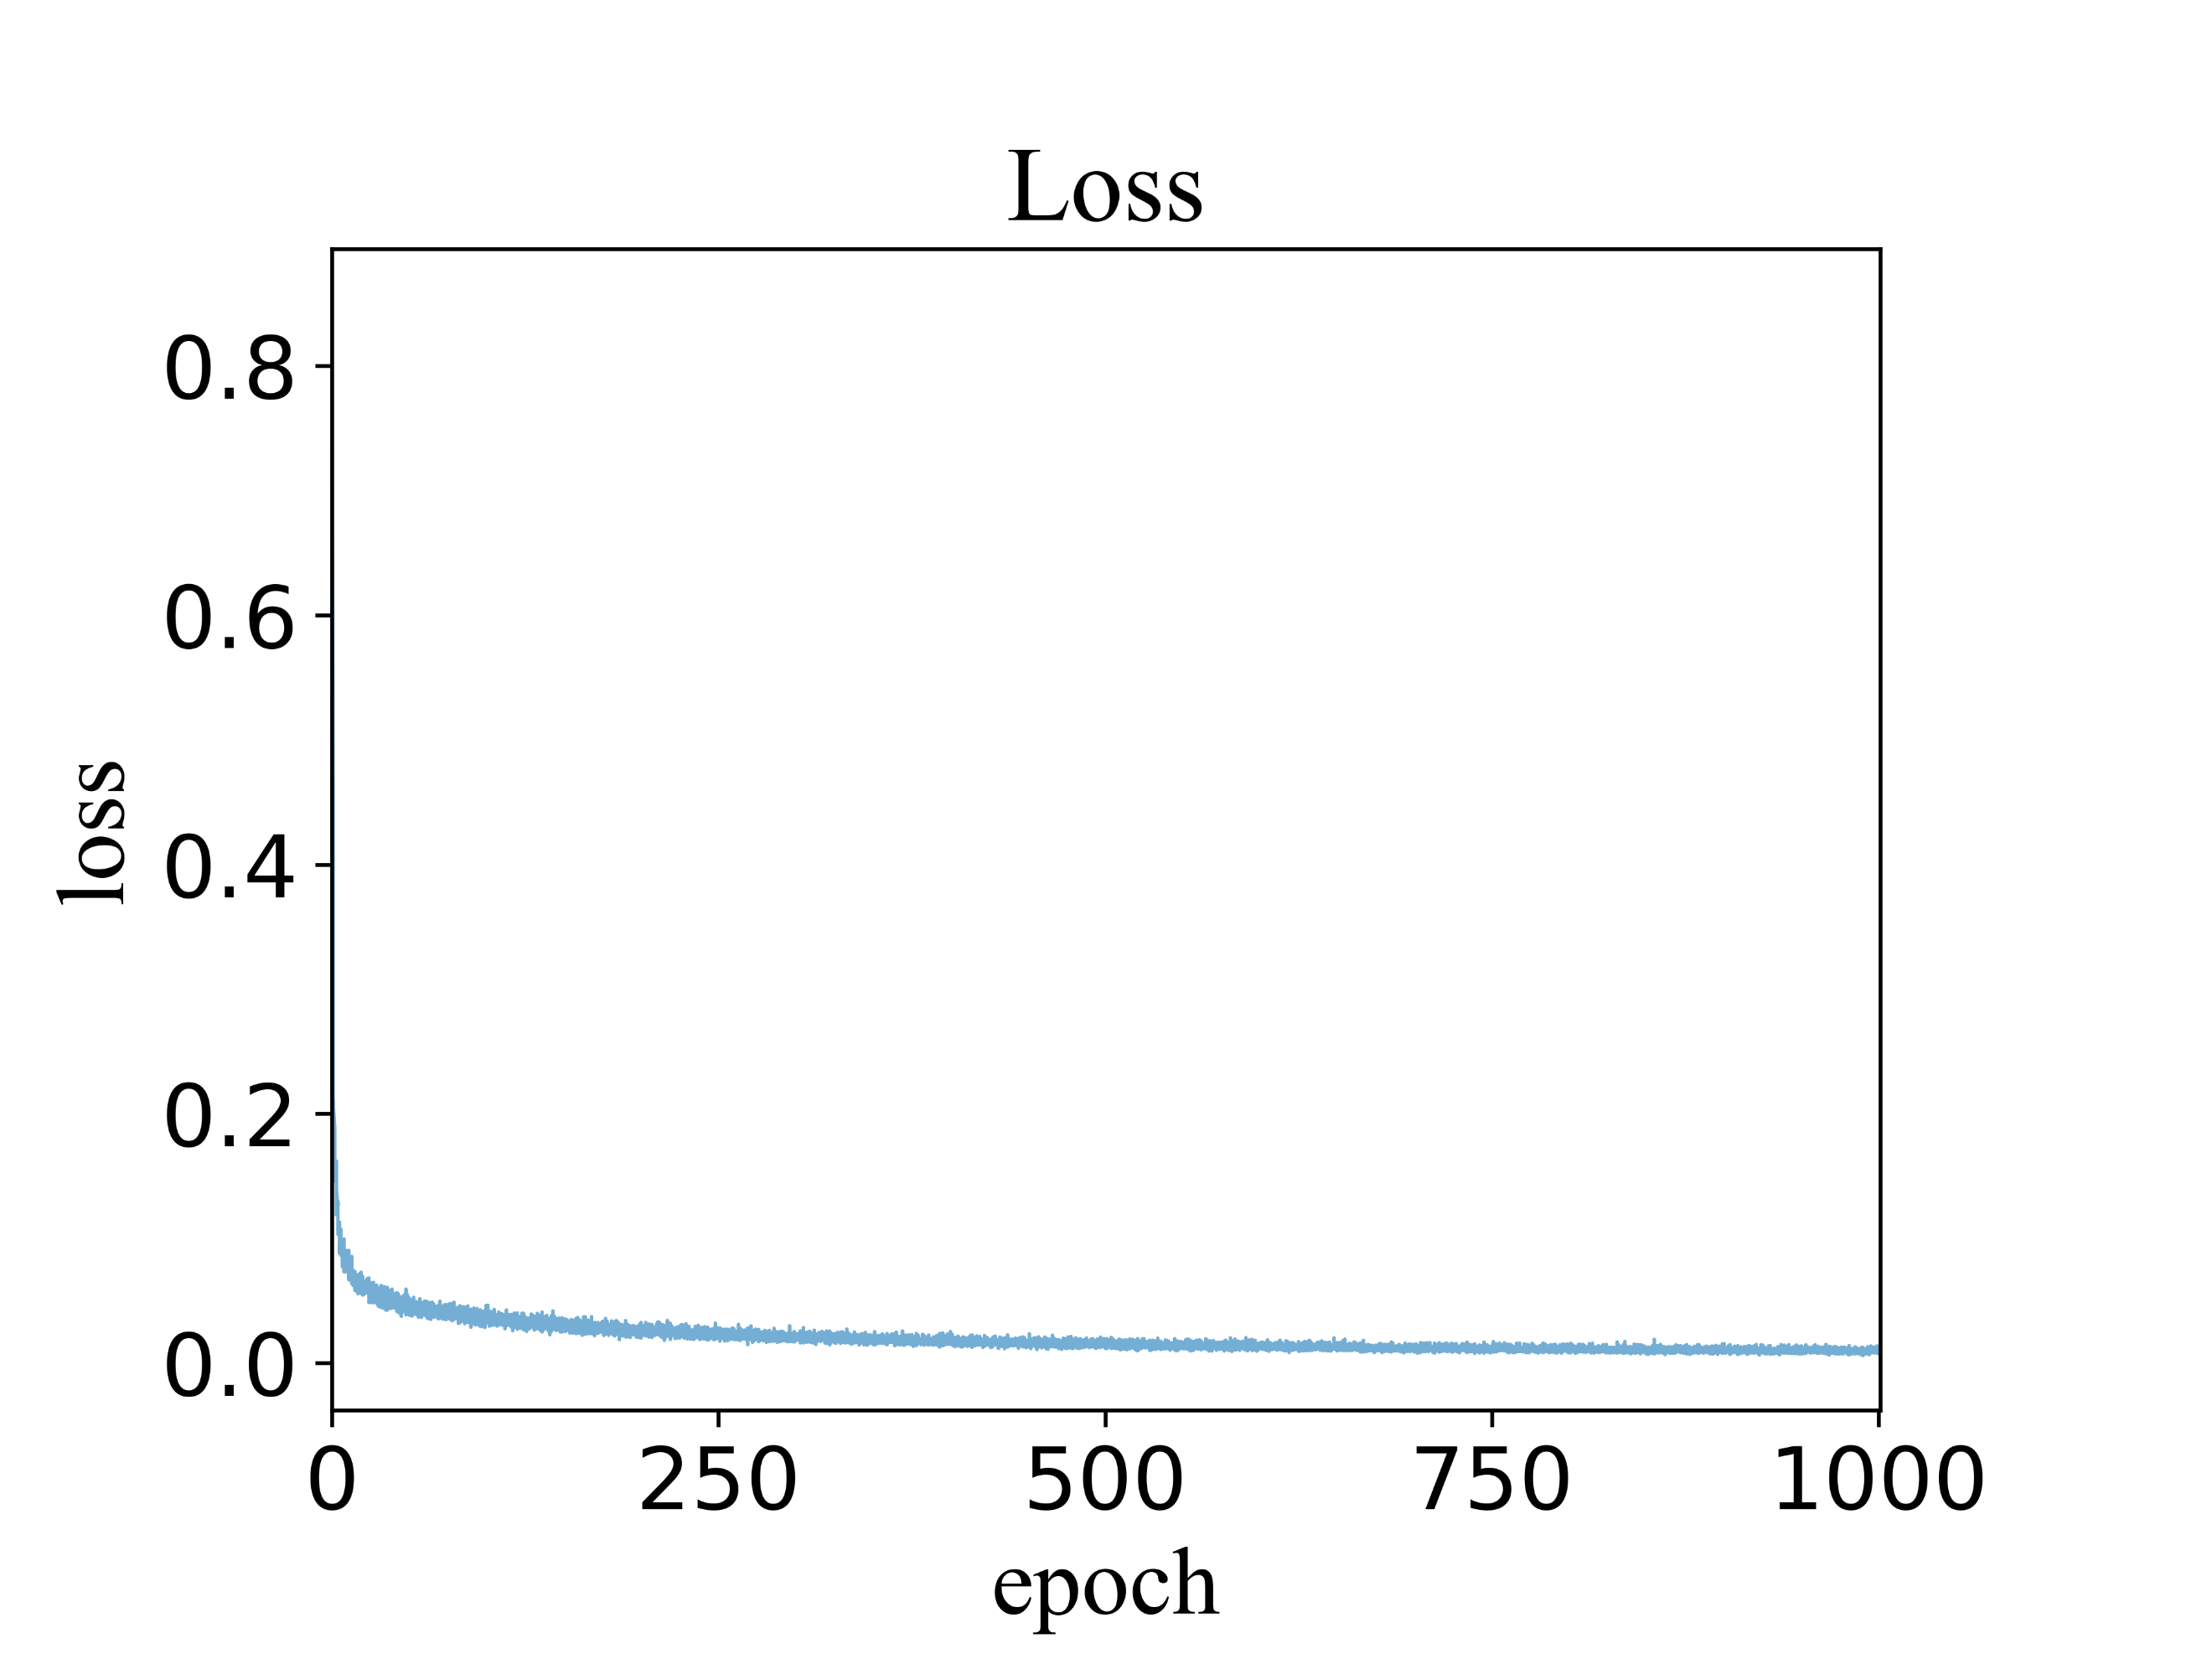
Here, $t$ is the timestep, ${ x}_{0}$ is the original data (training data) without noise, and $ϵ$ is a random matrix with the same shape as ${ x}_{0}$ following a normal distribution.
Supplementary Fig. 4 Loss plot.

Generation Data
All 746 structures generated can be found in structure.csv.

