Supplemental Material

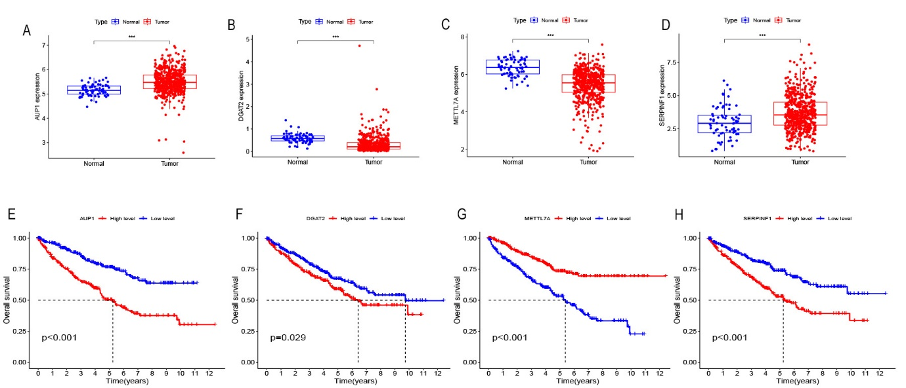
Figure S1: Expression differences and survival analysis of 4 LD-releted genes in KIRC samples. Expression differences of (A)AUP1, (B)DGAT2, (C)METTL7A, (D)SERPINF1 between cancer tissue and normal tissue. survival analysis of (E)AUP1, (F)DGAT2, (G)METTL7A, (H)SERPINF1 between cancer tissue and normal tissue.
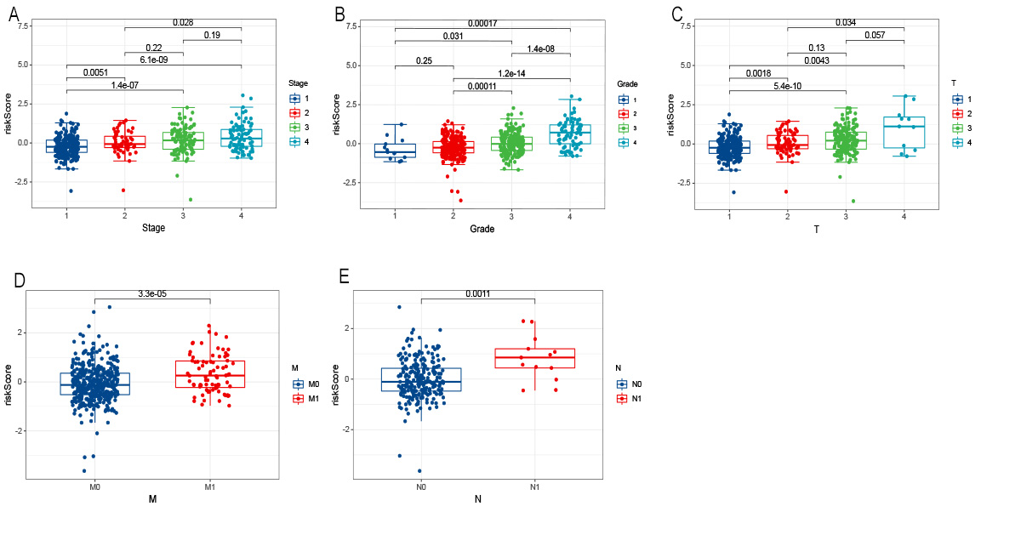
Figure S2 The relationship between diverse clinical features and riskscore. Relationship between (A)Stage, (B)Grade, (C)T, (D)M, (E)N and riskscore.

Table S1 LD-releted genes retrieved from the literature.
ACAT1 | CAVIN1 | HILPDA | METTL7B | PLIN1 | RAB8A
ACSL3 | CES1 | HSD17B11 | MGLL | PLIN2 | SNAP23
ACSL4 | CIDEC | HSD17B13 | MTTP | PLIN3 | SQLE
AGPAT2 | DGAT1 | ICE2 | NAPA | PLIN4 | STX5
ANGPTL8 | DGAT2 | LDAH | NCEH1 | PLIN5 | VAMP4
APOA4 | FAF2 | LIPE | NSF | PNPLA2 | VAPA
APOB | FITM1 | LPCAT1 | OSBPL2 | PNPLA3 | VCP
AUP1 | FITM2 | LPCAT2 | PCYT1A | PNPLA5 | VMP1
CAV1 | G0S2 | LPIN1 | PEMT | RAB5A
CAV2 | GPAT4 | METTL7A | PLD1 | RAB7A

Table S2 ：The differences in gene expression of 162 genes in TCGA dataset
Factors | DEGs | Factors | DEGs | Factors | DEGs
ABHD5 | ***↓ | HILPDA | ***↑ | RAB6A | *↓
ACAT1 | ***↓ | HLA-A | ***↑ | RAB7A | ***↓
ACSL3 | ***↓ | HLA-B | ***↑ | RAB8A | ***↑
ACSL4 | ***↓ | HLA-C | ***↑ | RMRP | ns
ADRB2 | ns | HMGCR | ***↓ | RNF139 | *↑
ALOX15 | ns | HSD17B11 | ***↑ | RPN1 | ns
AMFR | ***↓ | HSD17B13 | ***↑ | RSAD2 | ***↑
APOA1 | ***↓ | ICE2 | ***↓ | RXRA | ns
APOA4 | *↓ | IFNB1 | ***↑ | PEMT | **↓
APOA5 | *↓ | INSIG1 | ***↓ | PPARA | ***↓
APOB | ***↑ | IRF1 | ***↑ | PPARG | ns
ARF1 | ***↑ | ITCH | ***↓ | RAB5A | ***↓
ARSB | ***↑ | JUN | ns | SCD | ***↑
AUP1 | ***↑ | L1CAM | ***↓ | SERPINF1 | ***↑
AGPAT2 | ***↓ | LDAH | ***↓ | SFRP2 | *↑
ANGPTL8 | ***↑ | LINC01672 | ns | SLC27A1 | ***↑
BSCL2 | ***↓ | LIPA | ***↑ | SLC27A4 | ***↓
CAV1 | ***↑ | LIPE | ***↓ | SLX1A-SULT1A3 | ***↑
CAVIN1 | ***↑ | LPA | ***↓ | SMAD2 | ***↓
CCAR2 | ***↓ | LPCAT1 | ***↑ | SMAD3 | ***↓
CCL2 | ns | LPCAT2 | ***↓ | SMAD5-AS1 | **↑
CD274 | ***↑ | LPIN1 | ***↓ | SNAP23 | ns
CDKN3 | ***↓ | LSS | ***↓ | SNORD15A | ns
CERNA3 | ns | M6PR | ns | SQLE | ***↓
CES1 | ***↓ | MAOB | ***↓ | SREBF1 | ***↑
CFTR | ***↓ | MAPK8 | ***↓ | STK24 | ***↓
CIDEA | ns | METTL7A (AAMB) | ***↓ | STX5 | *↓
CIDEB | ns | MGLL | ***↑ | TAOK1 | ***↓
CIDEC | **↑ | MIR148A | ns | TAS2R38 | **↑
COMT | ***↓ | MIR150 | ns | TGFB2 | ***↑
CREB1 | ns | MIR30A | ns | TGFB3 | ***↑
DDHD2 | **↓ | MIR335 | ns | TGFBR1 | ns
DDX3X | ns | MIR7-3HG | ***↑ | TGFBR2 | **↓
DGAT2 | ***↓ | MIRLET7C | ***↓ | TNF | ns
DLEU2 | ***↑ | MTOR | ***↓ | TPD52L2 | ***↑
DGAT1 | ***↓ | MTTP | ***↓ | UBC | ***↑
EMSLR | ***↓ | MYC | ***↑ | UBE2G2 | ns
EPAS1 | ***↑ | METTL7B | ***↑ | VAMP4 | **↓
EPM2A | ***↓ | NAPA | ***↓ | VAPA | ***↓
F8 | ***↑ | NCEH1 | ***↑ | VCP | ***↓
FABP1 | ***↓ | NR1H3 | ***↑ | VIM | ***↑
FAF2 | ***↑ | NSF | ***↓ | VMP1 | ***↑
FBN1 | ***↑ | OCLN | ***↓ | ZFYVE1 | ***↓
FBN2 | ***↓ | OSBPL2 | ***↓ | SPART | ns
FGF21 | ***↑ | PC | ***↓
FITM1 | *↓ | PCYT1A | ns
FITM2 | ***↓ | PLD1 | ***↑
FTO | ***↑ | PLIN1 | ***↑
G0S2 | ***↓ | PLIN2 | ***↑
G6PD | *↑ | PLIN3 | *↑
GAA | ***↑ | PLIN4 | **↓
GBF1 | ***↓ | PLIN5 | ***↓
GHR | ***↓ | PNPLA2 | *↑
GLB1 | ***↓ | PNPLA3 | **↓
GPAT4 | ns | PNPLA5 | ***↑
H19 | ns | PON1 | ***↓
HDAC4 | ***↓ | PTPN22 | ***↑
HEXB | ***↑ | RAB18 | ***↓
HIF1A | ***↓ | RAB5A | ***↓
*** P<0.001
** P=0.01-0.001
* P=0.05-0.01
ns P>0.05
Table S3 The result of univariate Cox regression analysis between DEGs and OS
gene | HR (95% CI) | P value | gene | HR (95% CI) | P value
ACAT1 | 0.589 (0.471 - 0.738) | < 0.001 | MAOB | 0.769 (0.681 - 0.869) | < 0.001
ANGPTL8 | 1.247 (1.119 - 1.391) | < 0.001 | MAPK8 | 0.584 (0.343 - 0.994) | 0.047
APOA4 | 1.430 (1.153 - 1.773) | 0.001 | METTL7A | 0.566 (0.471 - 0.680) | < 0.001
APOA5 | 12.471 (2.446 - 63.594) | 0.002 | NCEH1 | 0.723 (0.583 - 0.896) | 0.003
APOB | 1.176 (1.003 - 1.378) | 0.045 | NR1H3 | 1.493 (1.018 - 2.191) | 0.040
ARSB | 0.693 (0.526 - 0.913) | 0.009 | OCLN | 0.649 (0.477 - 0.883) | 0.006
AUP1 | 3.288 (2.162 - 5.002) | < 0.001 | PLD1 | 0.660 (0.443 - 0.982) | 0.041
BSCL2 | 0.321 (0.112 - 0.916) | 0.034 | PLIN1 | 1.589 (1.189 - 2.124) | 0.002
CDKN3 | 1.900 (1.507 - 2.396) | < 0.001 | PLIN2 | 0.848 (0.749 - 0.960) | 0.009
CHKB-CPT1B | 9475.905 (430.150 - 208747.5155) | < 0.001 | PLIN4 | 1.505 (1.186 - 1.910) | < 0.001
CIDEC | 1.227 (1.017 - 1.481) | 0.032 | PLIN5 | 1.524 (1.111 - 2.090) | 0.009
DGAT2 | 3.094 (1.869 - 5.122) | < 0.001 | PNPLA2 | 1.595 (1.047 - 2.430) | 0.030
DLEU2 | 5.340 (2.670 - 10.679) | < 0.001 | PON1 | 7.387 (2.175 - 25.087) | 0.001
EPAS1 | 0.671 (0.577 - 0.781) | < 0.001 | RAB6A | 0.533 (0.353 - 0.805) | 0.003
EPM2A | 0.110 (0.034 - 0.351) | < 0.001 | RAB7A | 0.569 (0.327 - 0.989) | 0.046
F8 | 0.759 (0.620 - 0.931) | 0.008 | RAB18 | 0.558 (0.365 - 0.853) | 0.007
FAF2 | 0.619 (0.424 - 0.904) | 0.013 | SERPINF1 | 1.408 (1.232 - 1.607) | < 0.001
FGF21 | 2.584 (1.196 - 5.582) | 0.016 | SFRP2 | 1.101 (1.013 - 1.196) | 0.023
FITM1 | 3.146 (1.373 - 7.213) | 0.007 | SLX1A-SULT1A3 | 9587757111984.6348 (70071.8040 -1311869841173144666112.0000) | 0.002
FITM2 | 0.512 (0.363 - 0.722) | < 0.001 | STK24 | 0.580 (0.420 - 0.800) | < 0.001
FTO | 0.651 (0.463 - 0.914) | 0.013 | TGFBR2 | 0.663 (0.554 - 0.794) | < 0.001
G0S2 | 1.269 (1.125 - 1.431) | < 0.001 | TGFB2 | 0.647 (0.450 - 0.932) | 0.019
G6PD | 2.173 (1.653 - 2.857) | < 0.001 | VAPA | 0.530 (0.297 - 0.946) | 0.032
GHR | 0.615 (0.483 - 0.783) | < 0.001 | VIM | 1.564 (1.170 - 2.090) | 0.003
HMGCR | 0.430 (0.283 - 0.655) | < 0.001 | VMP1 | 1.608 (1.318 - 1.962) | < 0.001
IFNB1 | 192.668 (2.680 - 13850.7506) | 0.016 | ZFYVE1 | 0.424 (0.259 - 0.694) | < 0.001
ITCH | 0.580 (0.381 - 0.884) | 0.011 | TPD52L2 | 2.791 (1.740 - 4.478) | < 0.001
L1CAM | 1.301 (1.164 - 1.455) | < 0.001 | PPARA | 0.551 (0.379 - 0.801) | 0.002
LDAH | 0.576 (0.343 - 0.968) | 0.037 | PEMT | 1.521 (1.122 - 2.061) | 0.007
LIPA | 0.655 (0.519 - 0.826) | < 0.001 | ICE2 | 0.510 (0.277 - 0.941) | 0.031
LIPE | 0.585 (0.373 - 0.918) | 0.020 | DGAT1 | 2.750 (1.784 - 4.238) | < 0.001
LPA | 0.001 (0.000 - 0.163) | 0.008 | COMT | 2.382 (1.540 - 3.684) | < 0.001

Table S4: Sample distribution of TCGA dataset
Variable | Total (n = 513)  n (%) | Train set (n = 333)  n (%) | Test set (n = 180)  n(%)
Age
＜65 | 323 (62.96) | 217 (65.17) | 106 (58.89)
≥65 | 190 (37.04) | 116 (34.83) | 74 (41.11)
Gender
Female | 181 (35.28) | 116 (34.83) | 65 (36.11)
Male | 332 (64.72) | 217 (65.17) | 115 (63.89)
Grade
1 | 13 (2.53) | 9 (2.70) | 4 (2.22)
2 | 223 (43.47) | 142 (42.64) | 81 (45.00)
3 | 203 (39.57) | 133 (39.94) | 70 (38.89)
4 | 74 (14.42) | 49 (14.71) | 25 (13.89)
Stage
1 | 257 (50.1) | 167 (50.15) | 90 (50.00)
2 | 53 (10.33) | 30 (9.01) | 23 (12.78)
4 | 83 (16.18) | 56 (16.82) | 27 (15.00)
3 | 120 (23.39) | 80 (24.02) | 40 (22.22)
T
1 | 263 (51.27) | 172 (51.65) | 91 (50.56)
2 | 65 (12.67) | 36 (10.81) | 29 (16.11)
3 | 174 (33.92) | 118 (35.44) | 56 (31.11)
4 | 11 (2.14) | 7 (2.10) | 4 (2.22)
M
M0 | 408 (79.53) | 259 (77.78) | 149 (82.78)
M1 | 78 (15.2) | 53 (15.92) | 25 (13.89)
Unknow | 27 (5.26) | 21 (6.61 | 6 (3.33)
N
N0 | 233 (45.42) | 152 (45.65) | 81 (45.00)
N1 | 13 (2.53) | 8 (2.40) | 5 (2.78)
Unknow | 267 (52.05) | 173 (51.95) | 94 (52.22)

