Supplementary Materials for
Virome characterization of field-collected rodents in suburban Beijing reveals a spectrum of emerging pathogens
Zhen-Yu Hu^{1,2,3ǂ}, Fang Tang^{4ǂ}, Jing-Tao Zhang², Yun-Fa Zhang², Guang-Qian Si^{2,5}, Bo-Kang Fu^{1,2,3}, Gang Wang², Shuang Li², Lei Zhang², Cong Peng², Mei-Qi Zhang², Xiao-Fang Ma⁶, Yan-Tao Liu⁶, Peng-Tao Bao⁵, Xiao-Ai Zhang^{*,1,2}, Wei Liu^{*,1,2,3}

¹School of Public Health, Anhui Medical University, 230032, Hefei, China;
²State Key Laboratory of Pathogen and Biosecurity, Beijing Institute of Microbiology and Epidemiology, 100071, Beijing, China.
³The First Affiliated Hospital of Anhui Medical University, Hefei, China
⁴Institute of Medical Prevention and Control of Public Health Emergencies, Characteristic Medical Center of the Chinese People's Armed Police Force, Beijing 102613, China.
⁵The Eighth Medical Center of Chinese PLA General Hospital, Beijing, 100091, China.
⁶Qingdao Municipal Center for Disease Control and Prevention, Qingdao 266033, P. R. China.

^{ǂ} These authors have contributed equally to this work
*Corresponding:
Xiao-Ai Zhang, babylovehopi@163.com
Wei Liu, lwbime@163.com or liuwei@bmi.ac.cn

Supplemental Figures
Supplementary Figure 1. Phylogeny of the three mammalian orders, with the nine mammal families included in this study being labeled.
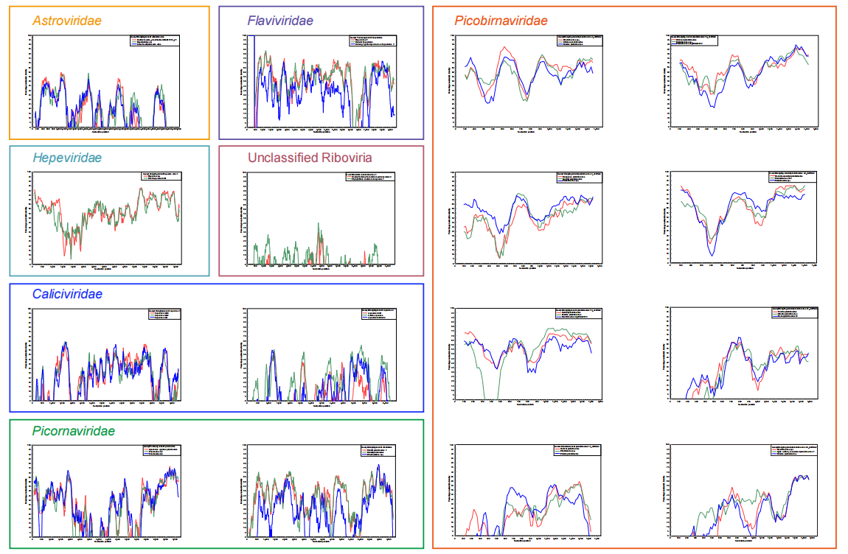Supplementary Figure 2. Similarity plot of currently identified 16 full-length novel viruses and related members in the same families.

Supplementary Figure 3. Host range of high-risk viruses as indicated by the number of host orders infected. Host range was conducted based on host species information retrieved from NCBI and supplemented with the hosts newly identified in the current study.

Supplementary Figure 4. Phylogeny of viral replicase protein sequences in the family Hepadnaviridae. Branch lengths are measured by a scale bar. The RNA virus identified in this study is labeled by red branches. The red circle represents the novel virus identified in this study, and the blue circle represents the previously described virus.
Supplementary Figure 5. Phylogeny of viral replicase protein sequences in the family Parvoviridae. Branch lengths are measured by a scale bar. The RNA virus identified in this study is labeled by red branches. The red circle represents the novel virus identified in this study, and the blue circle represents the previously described virus.
Supplementary Figure 6. Phylogeny of viral replicase protein sequences in the family Circoviridae. Branch lengths are measured by a scale bar. The RNA virus identified in this study is labeled by red branches. The red circle represents the novel virus identified in this study, and the blue circle represents the previously described virus.
Supplementary Figure 7. Phylogeny of viral replicase protein sequences in the family Genomoviridae. Branch lengths are measured by a scale bar. The RNA virus identified in this study is labeled by red branches. The red circle represents the novel virus identified in this study, and the blue circle represents the previously described virus.
Supplementary Figure 8. Phylogeny of viral RdRp protein sequences in the family Sedoreoviridae. Branch lengths are measured by a scale bar. The RNA virus identified in this study is labeled by red branches. The red circle represents the novel virus identified in this study, and the blue circle represents the previously described virus.
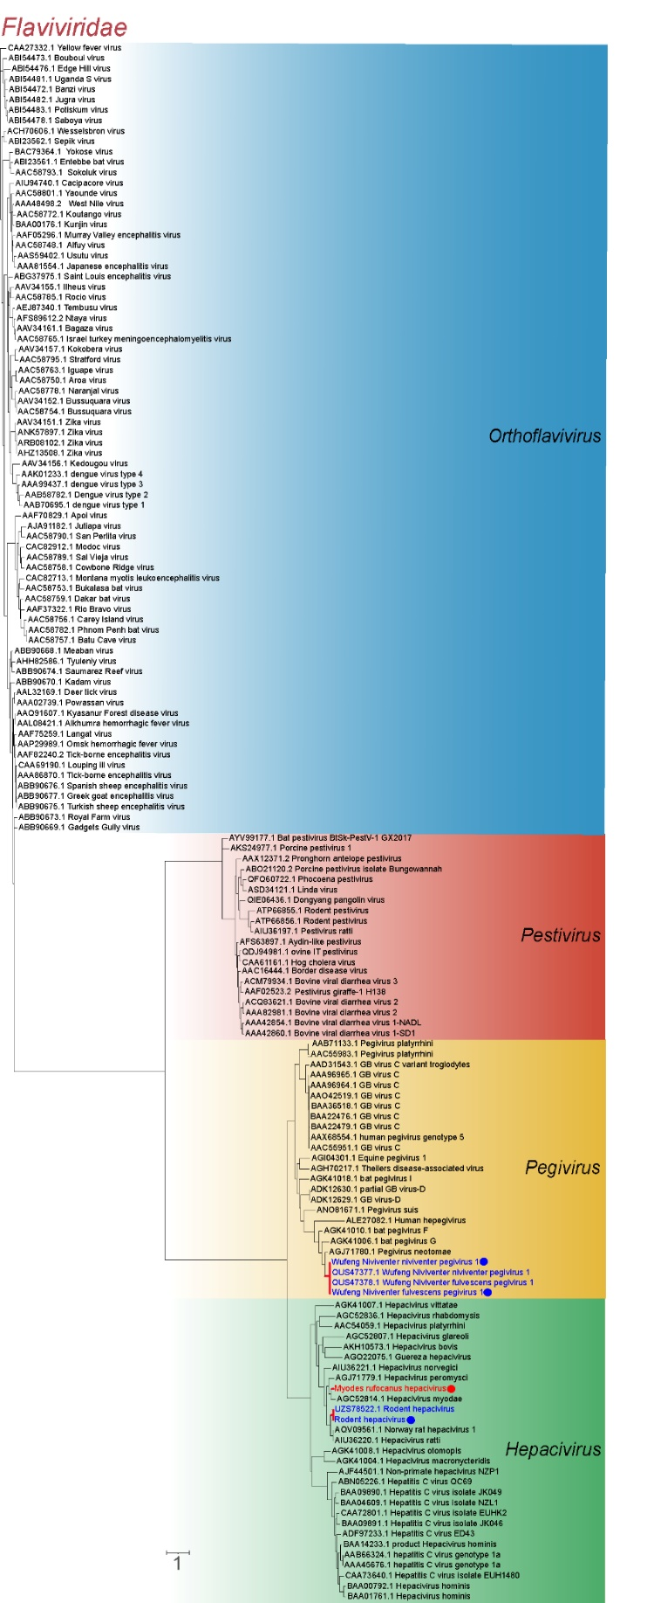
Supplementary Figure 9. Phylogeny of viral RdRp protein sequences in the family Flaviviridae. Branch lengths are measured by a scale bar. The RNA virus identified in this study is labeled by red branches. The red circle represents the novel virus identified in this study, and the blue circle represents the previously described virus.
Supplementary Figure 10. Phylogeny of viral RdRp protein sequences in the family Hepeviridae. Branch lengths are measured by a scale bar. The RNA virus identified in this study is labeled by red branches. The red circle represents the novel virus identified in this study, and the blue circle represents the previously described virus.

Supplementary Figure 11. Phylogeny of viral RdRp protein sequences in the family Nodaviridae. Branch lengths are measured by a scale bar. The RNA virus identified in this study is labeled by red branches. The red circle represents the novel virus identified in this study, and the blue circle represents the previously described virus.
Supplementary Figure 12. Phylogeny of viral RdRp protein sequences in the family Peribunyaviridae. Branch lengths are measured by a scale bar. The RNA virus identified in this study is labeled by red branches. The red circle represents the novel virus identified in this study, and the blue circle represents the previously described virus

Supplementary Figure 13. Phylogeny of viral RdRp protein sequences in the family Qinviridae. Branch lengths are measured by a scale bar. The RNA virus identified in this study is labeled by red branches. The red circle represents the novel virus identified in this study, and the blue circle represents the previously described virus.

Supplementary Figure 14. Phylogeny of viral RdRp protein sequences in the family Orthomyxoviridae. Branch lengths are measured by a scale bar. The RNA virus identified in this study is labeled by red branches. The red circle represents the novel virus identified in this study, and the blue circle represents the previously described virus.
Supplementary Figure 15 Phylogeny of viral RdRp protein sequences in the family Rhabdoviridae. Branch lengths are measured by a scale bar. The RNA virus identified in this study is labeled by red branches. The red circle represents the novel virus identified in this study, and the blue circle represents the previously described virus.
Supplementary Figure 16. Phylogeny of viral RdRp protein sequences in the family Chuviridae. Branch lengths are measured by a scale bar. The RNA virus identified in this study is labeled by red branches. The red circle represents the novel virus identified in this study, and the blue circle represents the previously described virus.
Supplementary Figure 17. Phylogeny of viral RdRp protein sequences in the family Hantaviridae. Branch lengths are measured by a scale bar. The RNA virus identified in this study is labeled by red branches. The red circle represents the novel virus identified in this study, and the blue circle represents the previously described virus.
Supplementary Figure 18. Phylogeny of viral RdRp protein sequences in the family Nairoviridae. Branch lengths are measured by a scale bar. The RNA virus identified in this study is labeled by red branches. The red circle represents the novel virus identified in this study, and the blue circle represents the previously described virus.
Supplementary Figure 19. Phylogeny of viral RdRp protein sequences in the family Phenuiviridae. Branch lengths are measured by a scale bar. The RNA virus identified in this study is labeled by red branches. The red circle represents the novel virus identified in this study, and the blue circle represents the previously described virus.

Supplementary Figure 20. Phylogeny of viral RdRp protein sequences in the family Paramyxoviridae. Branch lengths are measured by a scale bar. The RNA virus identified in this study is labeled by red branches. The red circle represents the novel virus identified in this study, and the blue circle represents the previously described virus.
Supplementary Figure 21. Phylogeny of viral RdRp protein sequences in the family Astroviridae. Branch lengths are measured by a scale bar. The RNA virus identified in this study is labeled by red branches. The red circle represents the novel virus identified in this study, and the blue circle represents the previously described virus.

Supplementary Figure 22. Phylogeny of viral RdRp protein sequences in the family Caliciviridae. Branch lengths are measured by a scale bar. The RNA virus identified in this study is labeled by red branches. The red circle represents the novel virus identified in this study, and the blue circle represents the previously described virus.

Supplementary Figure 23. Phylogeny of viral RdRp protein sequences in the family Picobirnaviridae. Branch lengths are measured by a scale bar. The RNA virus identified in this study is labeled by red branches. The red circle represents the novel virus identified in this study, and the blue circle represents the previously described virus.
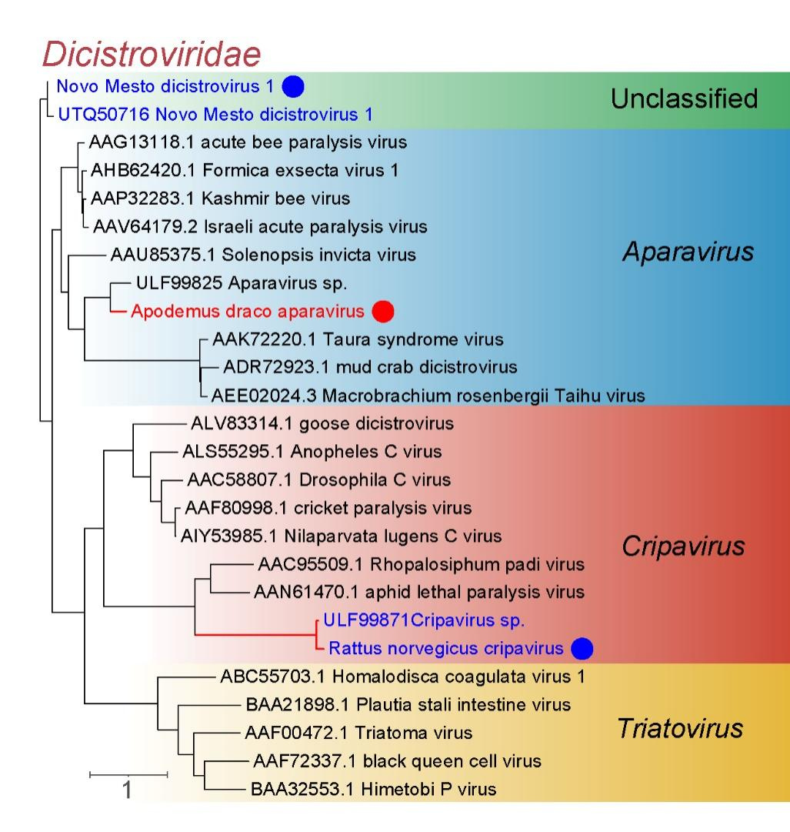
Supplementary Figure 24. Phylogeny of viral RdRp protein sequences in the family Dicistroviridae. Branch lengths are measured by a scale bar. The RNA virus identified in this study is labeled by red branches. The red circle represents the novel virus identified in this study, and the blue circle represents the previously described virus.

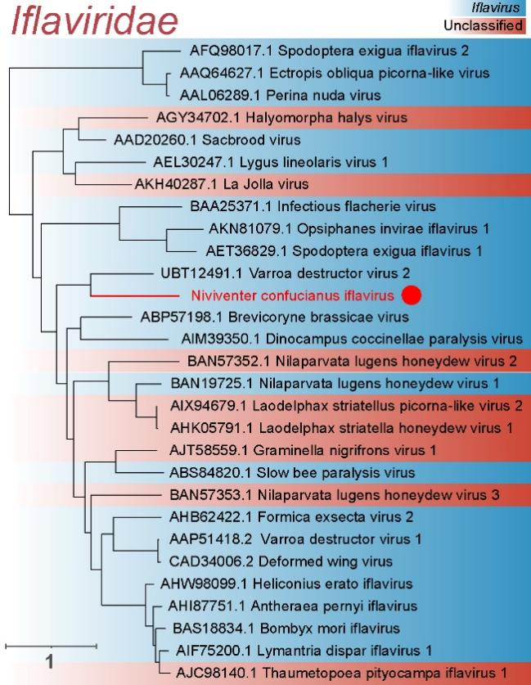
Supplementary Figure 25. Phylogeny of viral RdRp protein sequences in the family Iflaviridae. Branch lengths are measured by a scale bar. The RNA virus identified in this study is labeled by red branches. The red circle represents the novel virus identified in this study, and the blue circle represents the previously described virus.
Supplementary Figure 25. Phylogeny of viral RdRp protein sequences in the family Polycipiviridae. Branch lengths are measured by a scale bar. The RNA virus identified in this study is labeled by red branches. The red circle represents the novel virus identified in this study, and the blue circle represents the previously described virus.

Supplementary Figure 27. Phylogeny of viral RdRp protein sequences in the family Picornaviridae. Branch lengths are measured by a scale bar. The RNA virus identified in this study is labeled by red branches. The red circle represents the novel virus identified in this study, and the blue circle represents the previously described virus.

Supplementary Figure 28. Phylogeny of viral RdRp protein sequences in the family Coronaviride. Branch lengths are measured by a scale bar. The RNA virus identified in this study is labeled by red branches. The red circle represents the novel virus identified in this study, and the blue circle represents the previously described virus.

Supplementary Figure 29. Phylogeny of viral replicase protein sequences in the family Anelloviridae. Branch lengths are measured by a scale bar. The RNA virus identified in this study is labeled by red branches. The red circle represents the novel virus identified in this study, and the blue circle represents the previously described virus.

