Table 1. Chemical structures and binding affinities of previous analogues synthesized in house with guanidine side chain modifications
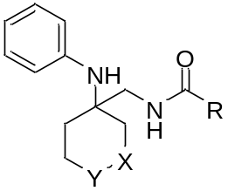
Compound n | X | Y | R | K_{i} NPFF₁-R  (nM)ª | K_{i} NPFF₂-R  (nM)^{b}
 |  |  | 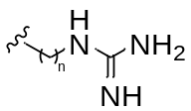
21 | -CH₂- | -N-Bn | n= 1 | 319 ± 19 | 405 ± 56
22 | -CH₂- | -N-Bn | n=2 | 441 ± 14 | 2907 ± 216
23 | -CH₂- | -N-Bn | n=3 | 2692 ± 121 | 2682 ± 570
24 | -CH₂- | -N-Bn | 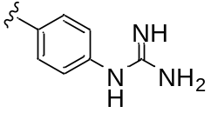 | 1966 ± 324 | 1620 ± 179
25 | -CH₂- | -N-Bn | 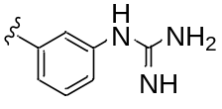 | 1623 ± 630 | 993 ± 87
26 | -CH₂- | -N-Bn | 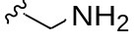 | 3429 ± 377 | 3220 ± 53
27 | -N-Bn | -CH₂- | 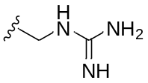 | 904 ± 237 | 1893± 490

ªK_{i} values were determined by using [¹²⁵I]YVP or [³H]NPVF for hNPFF₁-R, and are the mean ± SEM from two to four experiments performed in duplicate. ^{b}K_{i} values were determined by using [¹²⁵I]EYF or [³H]EYF for hNPFF₂-R, and are the mean ± SEM from two to four experiments performed in duplicate.

Table 2. Binding affinities of the synthesized analogues 8-17c
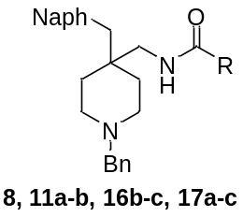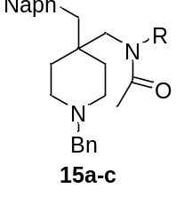
Compound | R | K_{i} hNPFF₁-R (nM)^{[a]} | K_{i} hNPFF₂-R (nM)^{[a]}
MES304 | 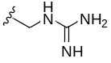 | 112 ± 19 | 30 ± 5
8 | 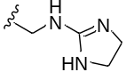 | 282 ± 15 | 165 ± 4
11a | 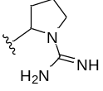 | 554 ± 26 | 1119 ± 21
11b | 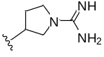 | 351 ± 19 | 359 ± 9
15a |  | 517 ± 141 | 389 ± 97
15b | 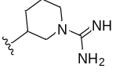 | 204 ± 44 | 416 ± 128
15c | 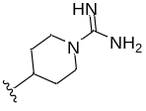 | 1042 ± 3 | 1390 ± 15
16b | 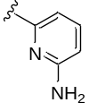 | 1152 ± 183 | 2411 ± 198
16c | 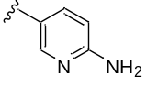 | 955 ± 94 | 1869 ± 106
17a | 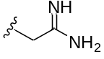 | 320 ± 56 | 692 ± 45
17b | 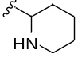 | 292 ± 32 | 298 ± 2
17c | 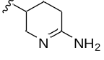 | 209 ± 20 | 154 ± 7
ªK_{i} values were determined by using [¹²⁵I]YVP or [³H]-NPVF and [¹²⁵I]EYF or [³H]-EYF for hNPFF₁-R and hNPFF₂-R, respectively, and are the mean ± SEM from two to four experiments performed in duplicate.

