Supplementary Information for
Projected runoff declines from plant physiological effects on precipitation

Supplementary Table 1: 12 CMIP6 Earth system models participating in C4MIP used in this study
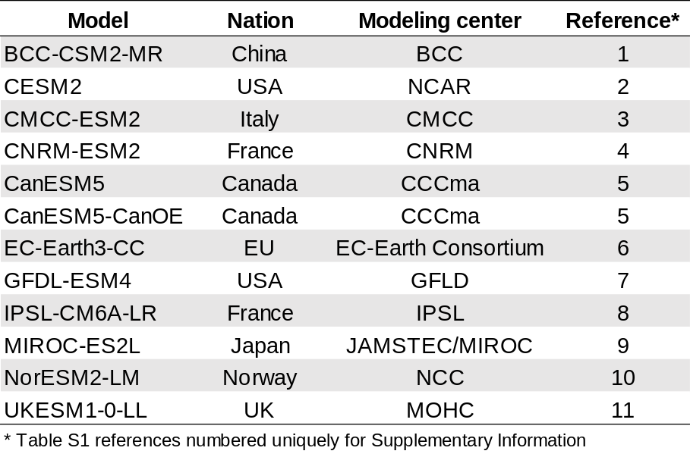

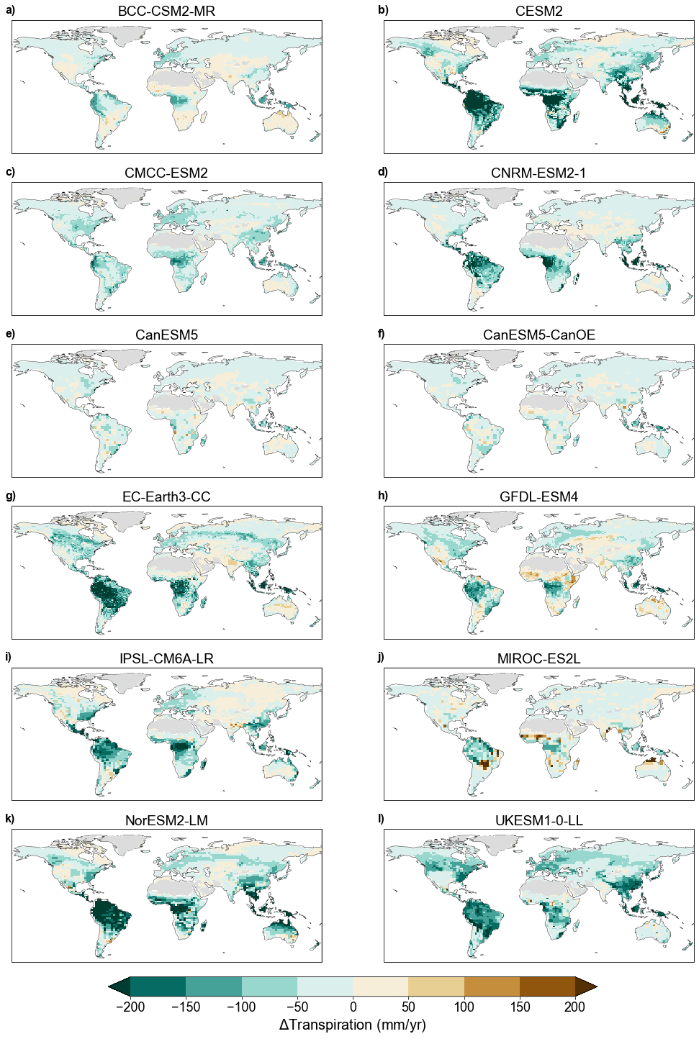
Supplementary Figure 1: Transpiration changes under CO₂ physiological forcing in individual Earth system models. Water-year total transpiration responses to a quadrupling of CO₂ in the BGC experiment across the ensemble of 12 ESMs (mm per water-year). Barren areas (water-year leaf area index < 0.1) are masked in light grey.
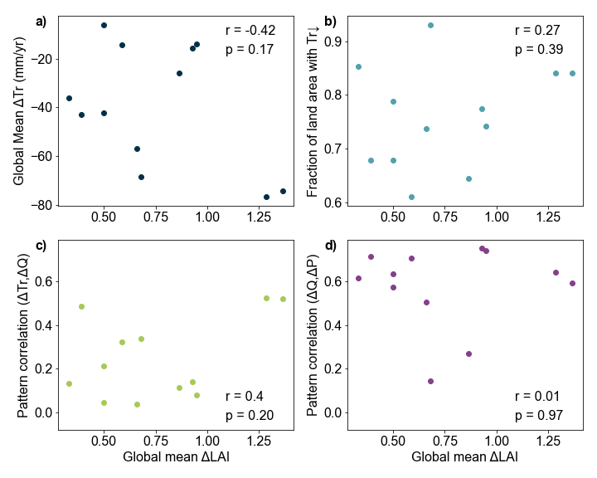
Supplementary Figure 2: Ensemble links between ecohydrologic changes and leaf area index under CO₂ physiological effects. a) Dependence of transpiration (Tr) changes on leaf area index (LAI) changes averaged over non-barren land areas across the ESM ensemble, under a quadrupling of CO₂ in the physiology-only (BGC) experiment. b) Same as a), showing for the fraction of land area with declining Tr versus ΔLAI. c) Dependence of pattern correlations between ΔTr and ΔQ on global mean ΔLAI across the 12 ESMs. d) Same as c), but for pattern correlations between ΔQ and ΔP. Correlation coefficients and two-sided p-values of each relationship is annotated at right.

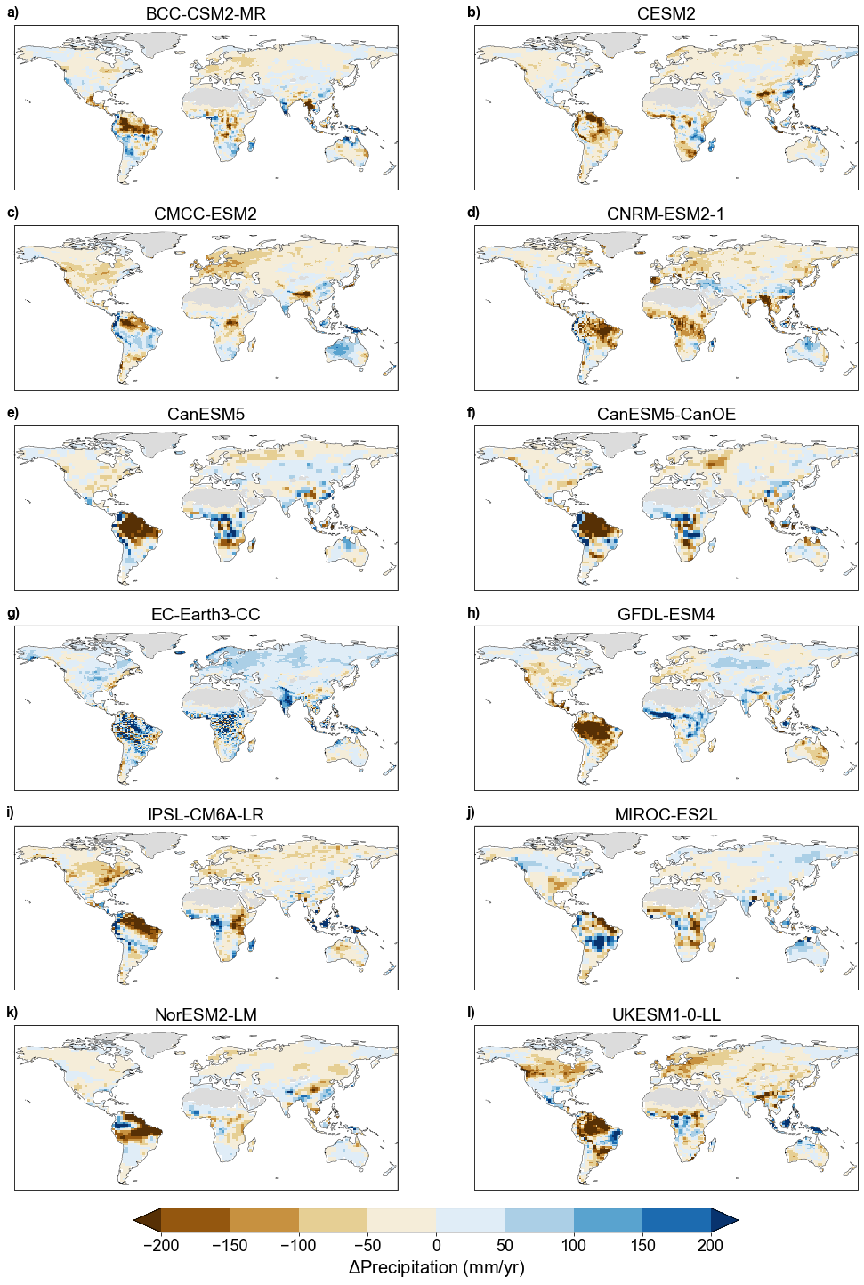
Supplementary Figure 3: Precipitation changes under CO₂ physiological forcing in individual Earth system models. Water-year total precipitation responses to a quadrupling of CO₂ in the BGC experiment across the ensemble of 12 ESMs (mm per water-year). Barren areas (water-year leaf area index < 0.1) are masked in light grey.
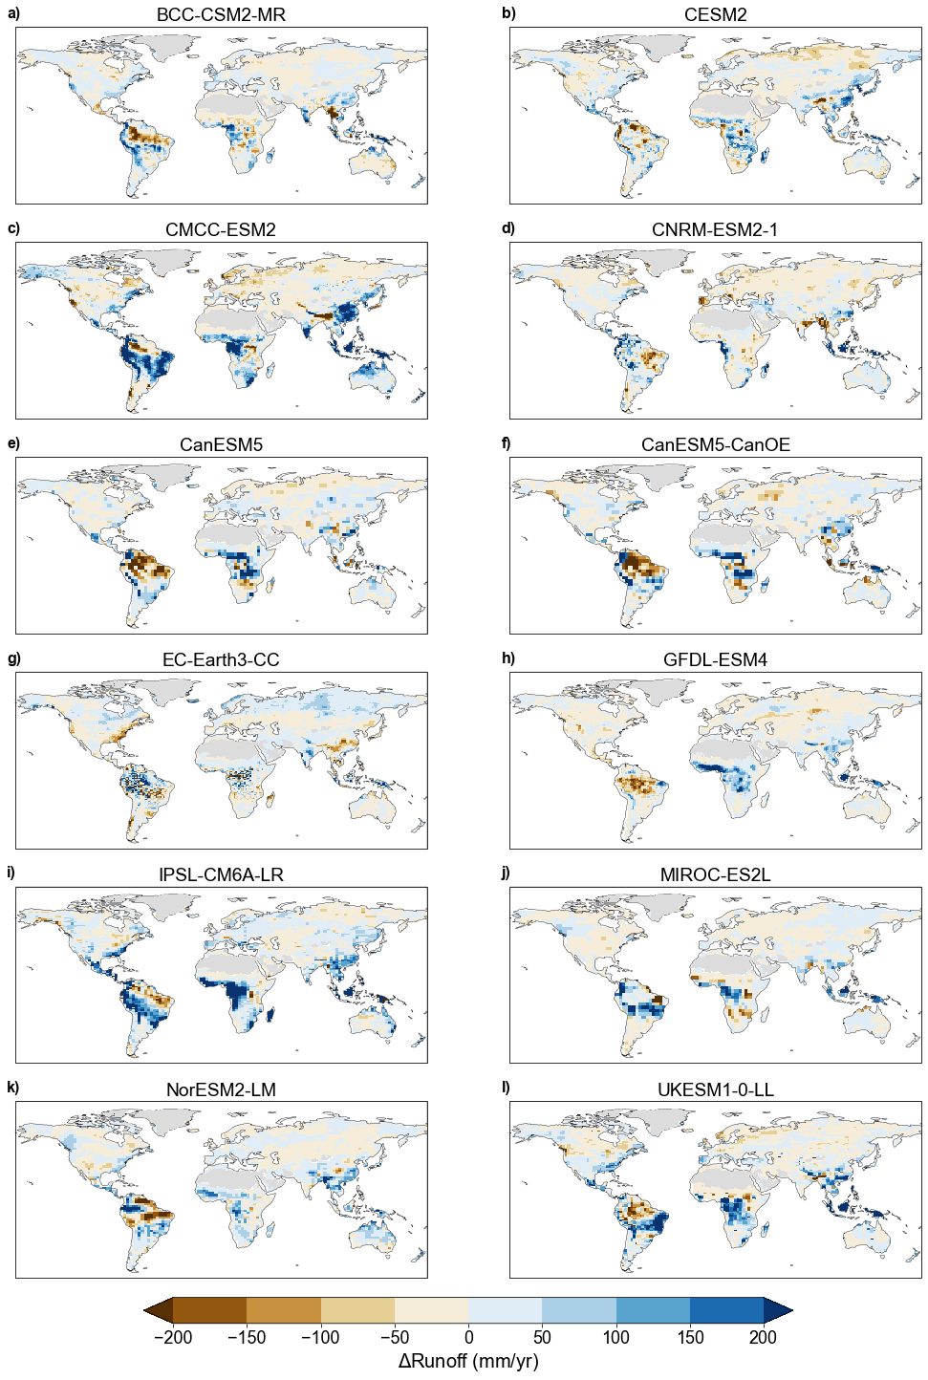
Supplementary Figure 4: Runoff changes under CO₂ physiological forcing in individual Earth system models. Water-year total runoff responses to a quadrupling of CO₂ in the BGC experiment across the ensemble of 12 ESMs (mm per water-year). Barren areas (water-year leaf area index < 0.1) are masked in light grey.
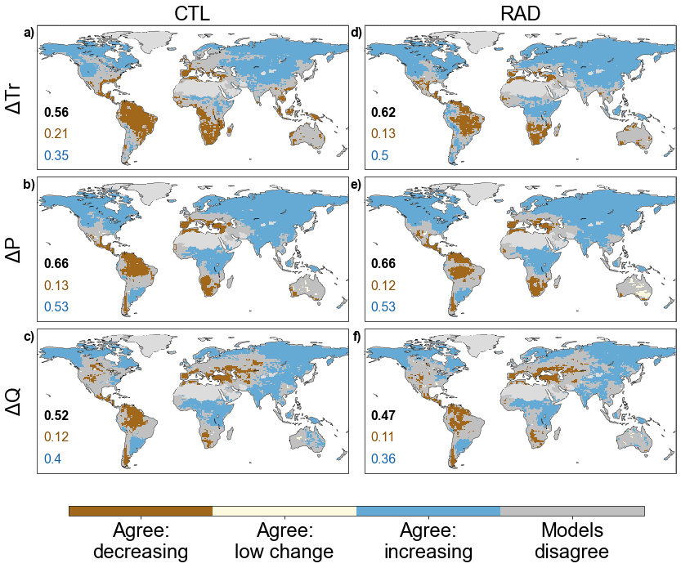
Supplementary Figure 5: Ensemble agreement on changes in key hydrologic variables under rising CO₂ for radiative and control experiments. Agreement on sign of changes in water-year total transpiration (ΔTr), precipitation (ΔP), and runoff (ΔQ) under a quadrupling of atmospheric CO₂ concentration under the control (CTL, a-c) and radiative (RAD, d-f) experiments. In RAD, rising CO₂ is presented only to the atmosphere and not the land surface and, in the fully-coupled control (CTL), CO₂ increases for all model components. Across the ensemble of 12 Earth system models, grid cells are classified on the criterion that at least 2/3 of models agree on the sign change. The threshold for change set at one-quarter of a standard deviation of interannual variability under recent atmospheric CO₂ concentrations (first 30 years of the simulation). Numerical annotations indicate the fraction of land area falling into ensemble agreement classifications (decreasing in brown, increasing in blue, total agreement including low change in black). Barren areas (water-year mean leaf area index < 0.1) are shaded in pale grey.

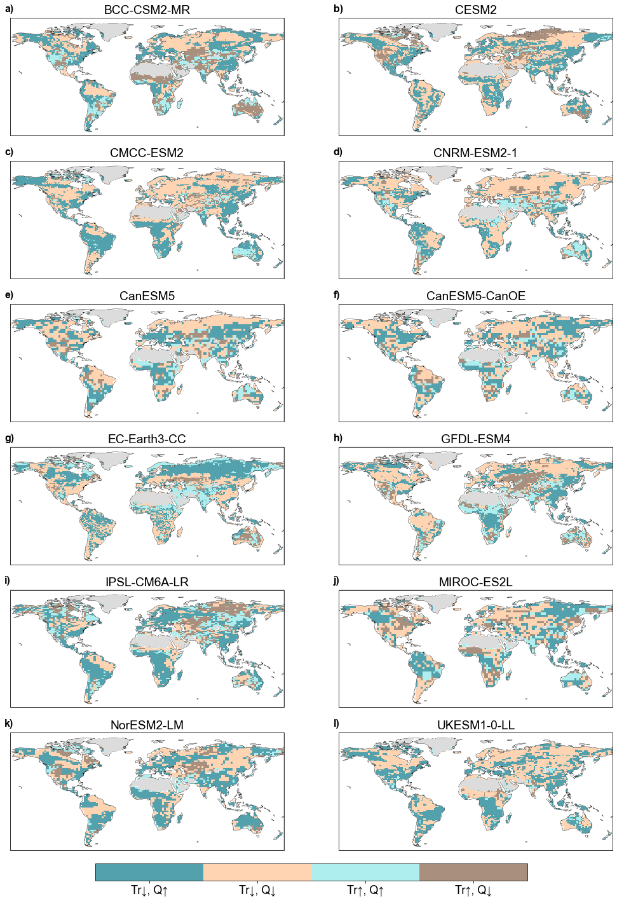
Supplementary Figure 6: Joint changes in transpiration and runoff in response to CO₂ physiological forcing. Classification of concordant or discordant increases versus decreases in water-year runoff (Q) and transpiration (Tr) for individual ESMs under the BGC experiment (quadrupling of CO₂). For clarity in this classification, the threshold of ≥σ/4 departure from recent-CO₂ variability for change is relaxed. Barren areas (water-year leaf area index < 0.1) are masked in light grey.
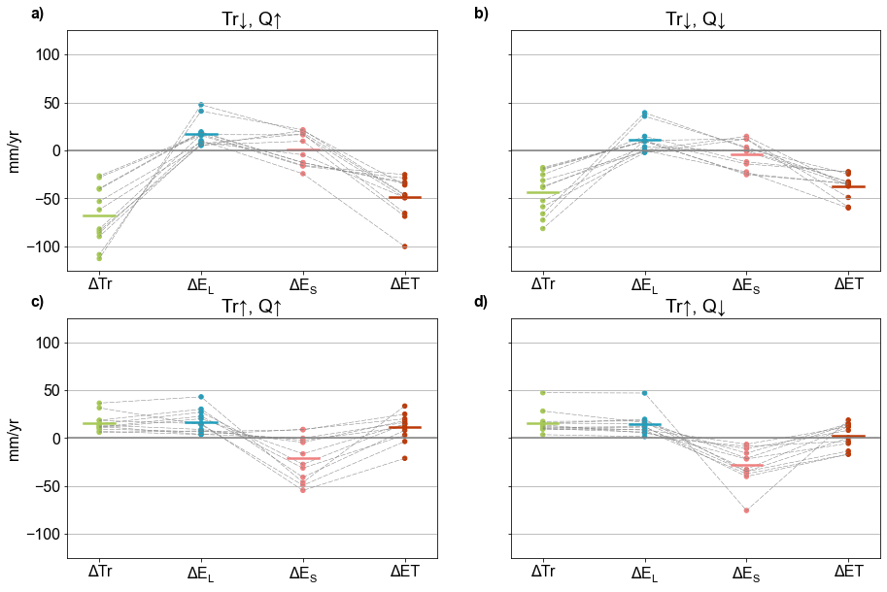
Supplementary Figure 7: Changes in evapotranspiration components under CO₂ physiological forcing. Responses in transpiration (Tr), leaf evaporation (E_{L}), soil evaporation (E_{S}), and total evaporation (ET, here approximated as the sum of Tr, E_{L}, and E_{S}) in responses to a quadrupling of CO₂ in the BGC experiment. ET-component changes for each ESM (points) are averaged across pooled non-barren model grid cells falling within each case of joint change in runoff (Q) and Tr (Fig. 1, Fig. S4). The horizontal dash indicates the ensemble mean. Data for ΔTr and ΔET are identical to those in Fig. 1 and are reproduced to ease comparison.

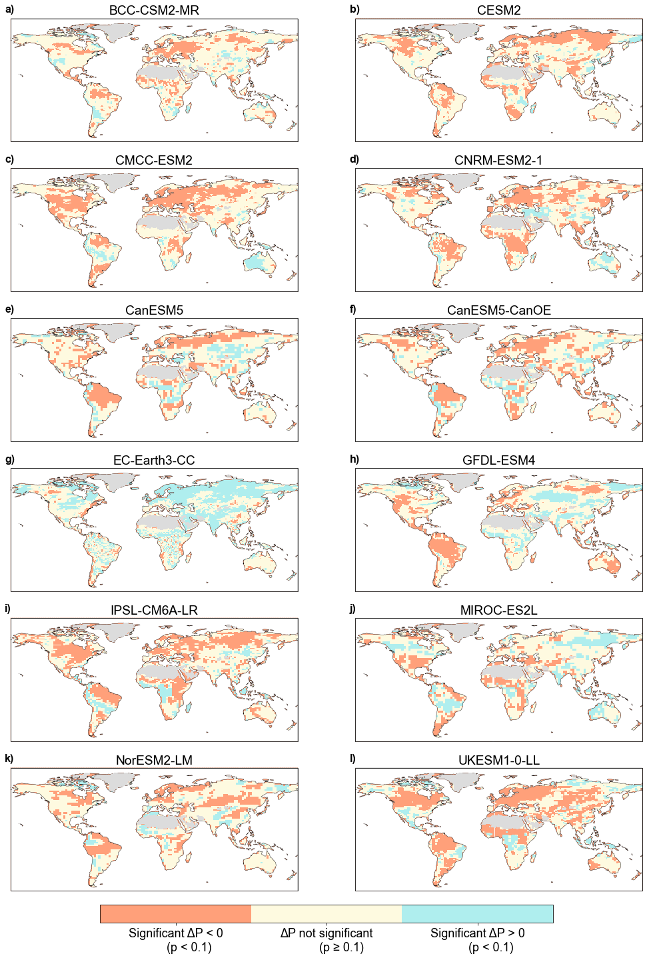
Supplementary Figure 8: Significance of precipitation changes in response to CO₂ physiological forcing. Spatial pattern of significance in precipitation change (ΔP) in 12 individual ESMs. Significance is defined as ΔP exceeding two-tailed α = 0.1 relative to the bootstrapped distribution of 30-year mean P variability in each ESM’s pre-industrial control simulation. Barren areas (water-year leaf area index < 0.1) are masked in light grey.
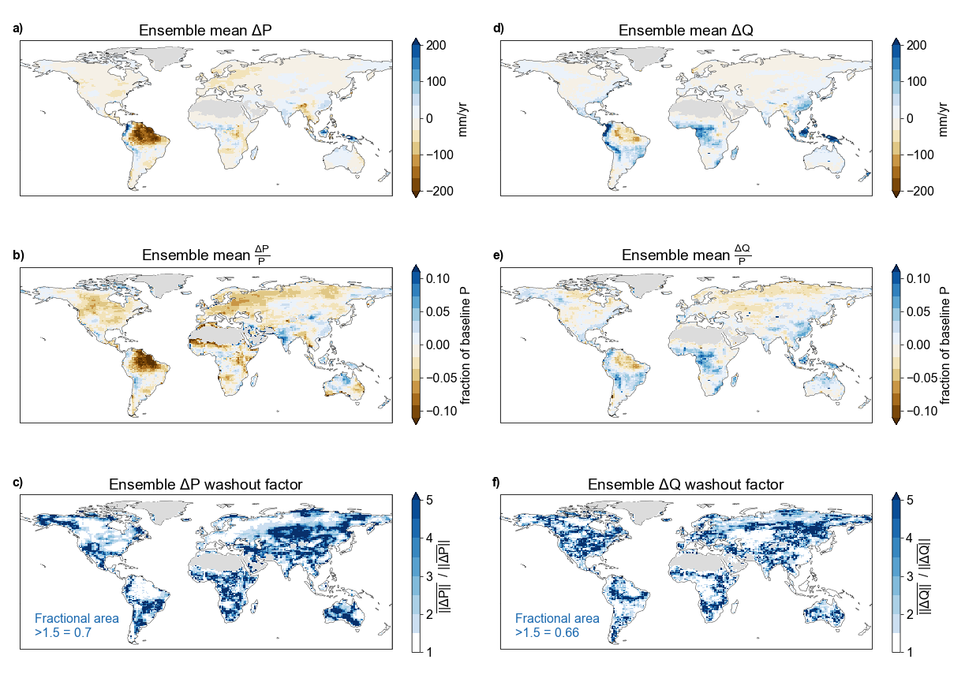
Supplementary Figure 9: Hydrologic signal loss through ensemble averaging. a) Ensemble mean absolute precipitation (P) change due to CO₂ physiological forcing under a quadrupling of CO₂. b) Ensemble mean P change as a fraction of simulated P under late-20th Century CO₂. c) Ensemble washout factor estimated as the ratio between the ensemble mean absolute value of P change and the absolute value of the ensemble mean P change. Where this metric is substantially greater than 1, the ensemble averaging meaningfully cancels individual model responses of opposing sign. Annotations show fractional land area with washout factor >1.5. d-f) Same as a-c) but for runoff (Q).

References
- T. Wu, et al., The Beijing Climate Center Climate System Model (BCC-CSM): the main progress from CMIP5 to CMIP6. Geoscientific Model Development 12, 1573–1600 (2019).

- G. Danabasoglu, et al., The Community Earth System Model Version 2 (CESM2). Journal of Advances in Modeling Earth Systems 12, e2019MS001916 (2020).

- A. Cherchi, et al., Global Mean Climate and Main Patterns of Variability in the CMCC-CM2 Coupled Model. Journal of Advances in Modeling Earth Systems 11, 185–209 (2019).

- R. Séférian, et al., Evaluation of CNRM Earth System Model, CNRM-ESM2-1: Role of Earth System Processes in Present-Day and Future Climate. Journal of Advances in Modeling Earth Systems 11, 4182–4227 (2019).

- N. C. Swart, et al., The Canadian Earth System Model version 5 (CanESM5.0.3). Geoscientific Model Development 12, 4823–4873 (2019).

- R. Döscher, et al., “The EC-Earth3 Earth System Model for the Climate Model Intercomparison Project 6” (Climate and Earth system modeling, 2021)

- J. P. Dunne, et al., The GFDL Earth System Model Version 4.1 (GFDL-ESM 4.1): Overall Coupled Model Description and Simulation Characteristics. Journal of Advances in Modeling Earth Systems 12, e2019MS002015 (2020).

- O. Boucher, et al., Presentation and Evaluation of the IPSL-CM6A-LR Climate Model. Journal of Advances in Modeling Earth Systems 12, e2019MS002010 (2020).

- T. Hajima, et al., Development of the MIROC-ES2L Earth system model and the evaluation of biogeochemical processes and feedbacks. Geoscientific Model Development 13, 2197–2244 (2020).

- Ø. Seland, et al. Overview of the Norwegian Earth System Model (NorESM2) and key climate response of CMIP6 DECK, historical and scenario simulations. Geoscientific Model Development 13, 6165-6200 (2020).

- A. A. Sellar, et al., UKESM1: Description and Evaluation of the U.K. Earth System Model. Journal of Advances in Modeling Earth Systems 11, 4513–4558 (2019).

