Supplementary material
Table S1. List of possible intermediate and reaction products of PQ
Parent compounds | Intermediate/reaction products | Molecular or cationic mass (Da)
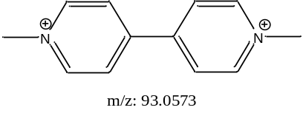 | 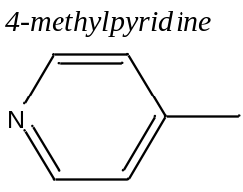 | 93
 | 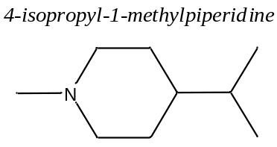 | 141
 | 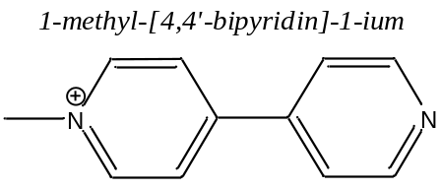 | 171
 | 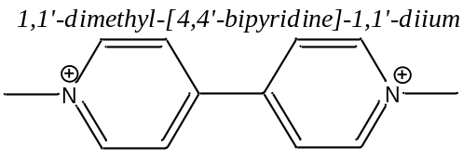 | 185
 | 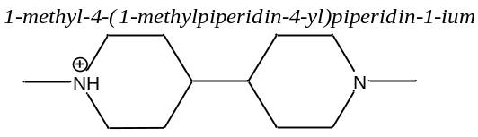 | 197
 | 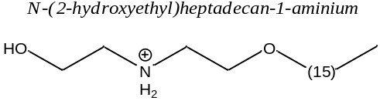 | 300

Table S2. List of possible intermediate and reaction products of PQ after 10 min irradiation, with artificial light.
Parent compounds | Intermediate/reaction products | Molecular or cationic mass (Da)
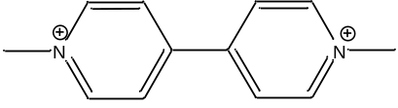 | 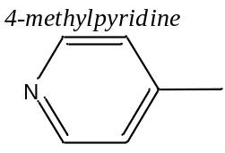 | 93
 | 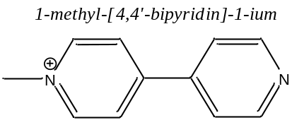 | 171
 | 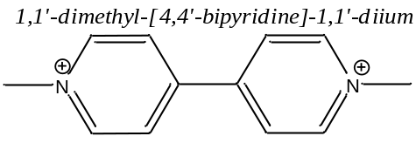 | 185
 | 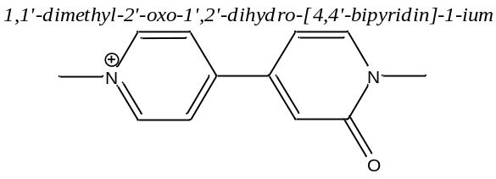 | 201
 | 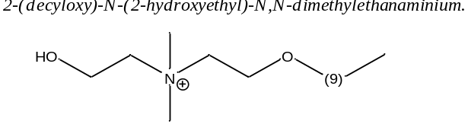 | 274
 | 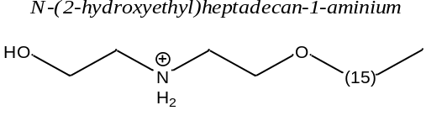 | 300

