Supplemental Data
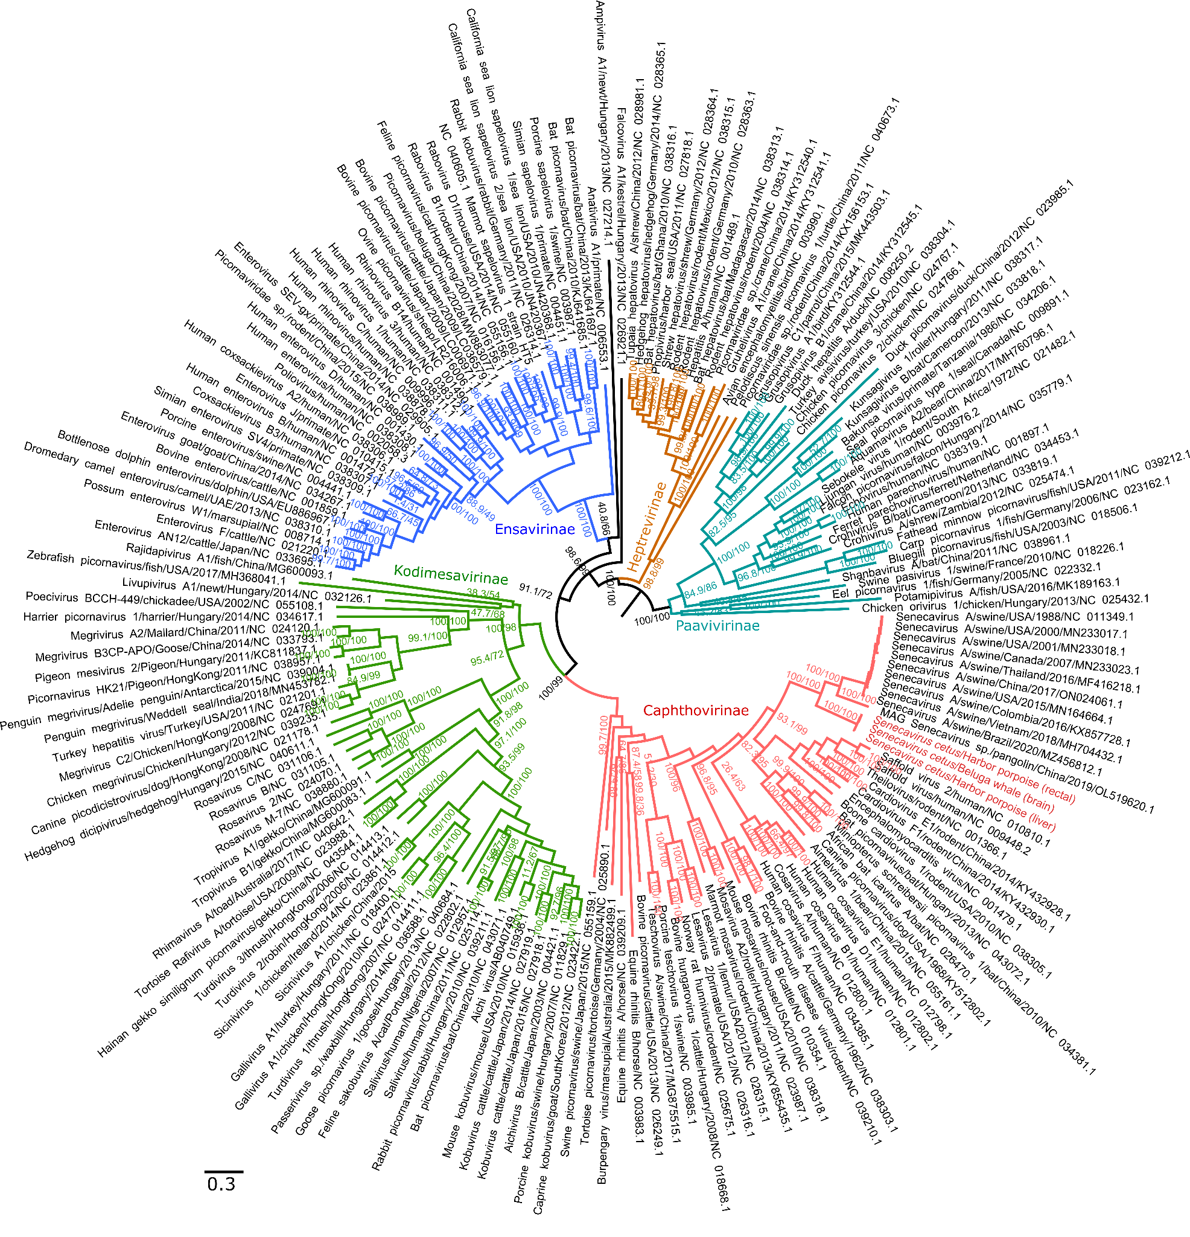
Supplemental Figure 1. Phylogenetic tree of the family Picornaviridae. Maximum likelihood phylogenetic tree was constructed in IQ-TREE v.1.6.12. Numbers at the nodes represent support values, approximate likelihood ratio test (aLRT)/ultrafast bootstrap (UFboot). Branches of the tree are coloured according to the four subfamilies within the Picornaviridae. The three isolates of the novel picornavirus species, Senecavirus cetus, are shown in red.

