Supplementary Information for
Imaging Generalized Wigner Crystal States in a WSe₂/WS₂ Moiré Superlattice
Hongyuan Li^{1, 2, 3, 8}, Shaowei Li^{1, 3, 4, 8}*, Emma Regan^{1, 2, 3}, Danqing Wang^{1, 2}, Wenyu Zhao¹, Salman Kahn^{1, 3}, Kentaro Yumigeta⁵, Mark Blei⁵, Takashi Taniguchi⁶, Kenji Watanabe⁷, Sefaattin Tongay⁵, Alex Zettl^{1, 3, 4}, Michael F. Crommie^{1, 3, 4}* and Feng Wang^{1, 3, 4}*,

¹Department of Physics, University of California at Berkeley, Berkeley, CA, USA.
²Graduate Group in Applied Science and Technology, University of California at Berkeley, Berkeley, CA, USA.
³Materials Sciences Division, Lawrence Berkeley National Laboratory, Berkeley, CA, USA.
⁴Kavli Energy Nano Sciences Institute at the University of California Berkeley and the Lawrence Berkeley National Laboratory, Berkeley, CA, USA.
⁵School for Engineering of Matter, Transport and Energy, Arizona State University, Tempe, AZ, USA.
⁶International Center for Materials Nanoarchitectonics, National Institute for Materials Science, Tsukuba, Japan
⁷Research Center for Functional Materials, National Institute for Materials Science, Tsukuba, Japan
⁸These authors contributed equally: Hongyuan Li and Shaowei Li

- Raw images and FFT filtering of the generalized Wigner crystal states
The dI/dV images of the generalized Wigner crystal states shown in Fig. 2 of the main text are FFT filtered to suppress the periodic feature associated with the moire superlattice. Figure S1 shows the unfiltered raw images of the generalized Wigner crystal states and the process of the FFT filtering.
Fig.S1a displays the raw dI/dV map of the n = 2/3 state, with the corresponding FFT image shown in Fig. S1b. Here the red circles label the positions of reciprocal unit vectors of the moire superlattice. We filter out the signal within the red circles in the FFT filtering process. Fig. S1c shows the FFT filtered image of Fig. S1a (same as Fig. 2e in the main text) and Fig. S1d shows the corresponding filtered FFT image (same as Fig. 2f in the main text).
Similar filtering procedures are performed for the n = 1/3 and n = 1/2 Wigner crystal states. Figure S1e and S1f show the raw real space and FFT images, respectively, of the n=1/3 Wigner crystal state, and the corresponding FFT filtered images are shown in Fig. 1g and 1h. Figure S1i and S1j show the raw real space and FFT images, respectively, of the n=1/2 Wigner crystal state, and the corresponding FFT filtered images are shown in Fig. 1k and 1l.

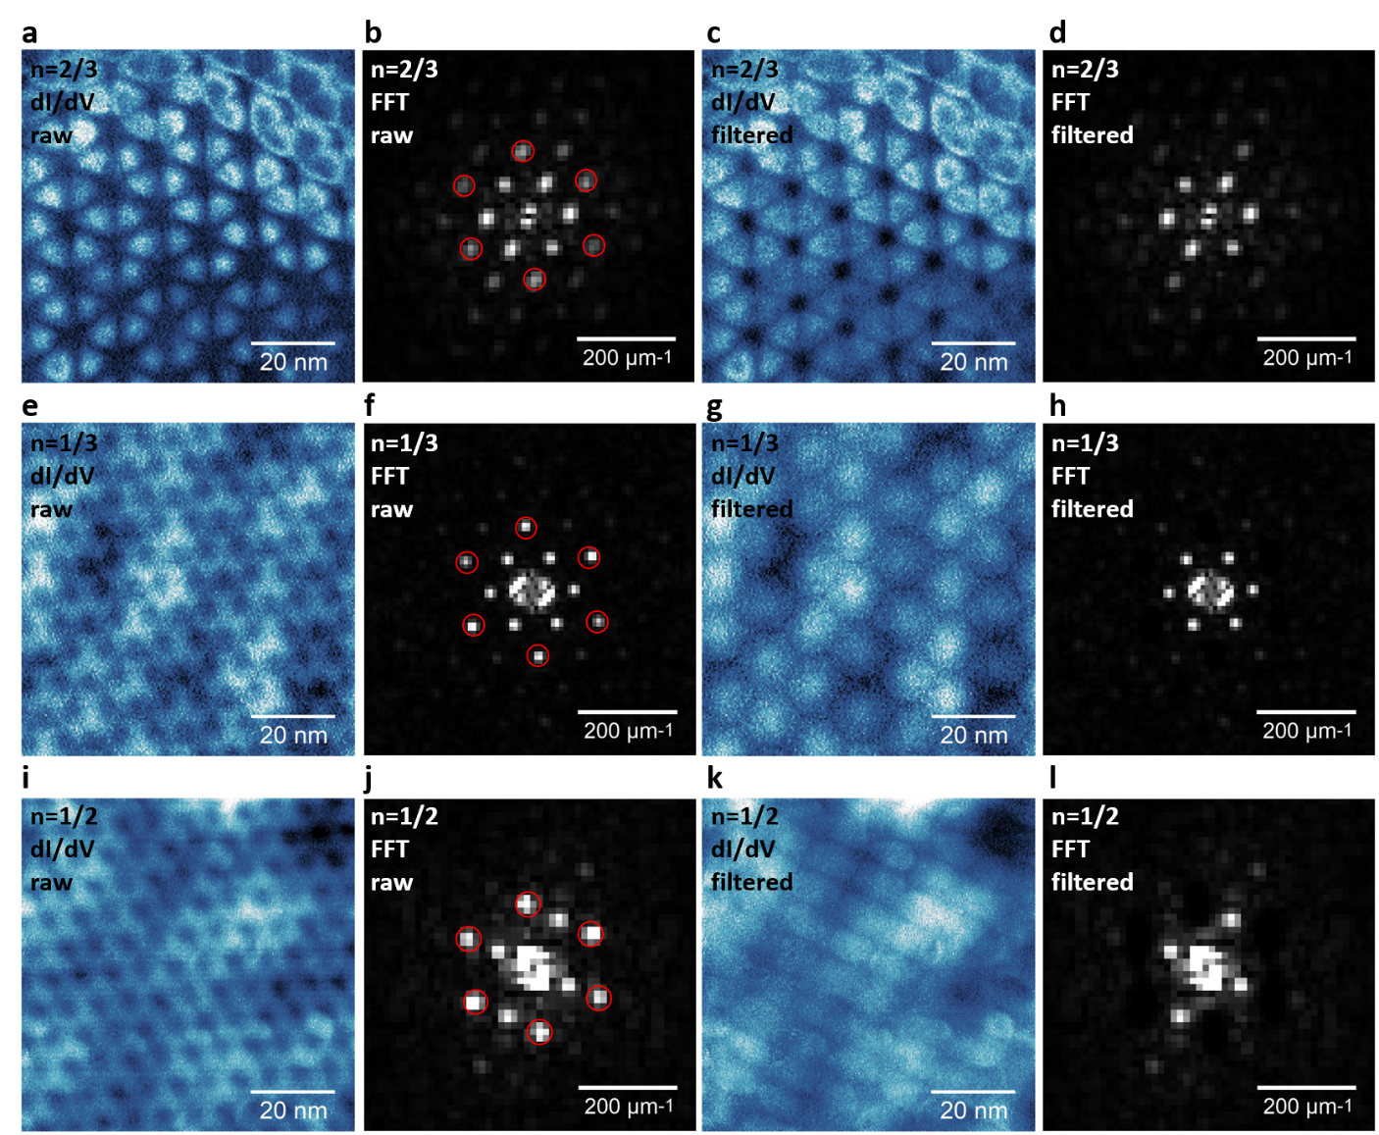
Figure S1. Raw images and FFT filtering of the dI/dV maps for the generalized Wigner crystal states. a. Raw dI/dV map of the n = 2/3 state. b. FFT image of (a). c. Real space dI/dV map after FFT filtering of (a). In the filtering process, we removed the Fourier components within the six red circles indicated in (b). This FFT filtering suppresses the periodic feature associated with the moiré superlattice. d. FFT image of (c). e. Raw dI/dV map of the n = 1/3 state. f. FFT image of (e). g. Real space dI/dV map after FFT filtering of (e). The Fourier components within the red circles shown in (f) have been filtered out. h. FFT image of (g). i. Raw dI/dV map of the n = 1/2 state. j. FFT image of (i). k. Real space dI/dV map after FFT filtering of (i). The Fourier components within the red circles shown in (j) have been filtered out. l. FFT image of (k).

