Research article:
Pinoresinol targets NF-kB alongside STAT3 pathway to attenuate IL-6-induced inflammation

Anupam Dutta, Dorothy Das, Rituraj Chakraborty, Bhargab Jyoti Baruah, Manoj Sharma, Pushpa Sharma, M. V. Satish Kumar and Rupak Mukhopadhyay*
Department of Molecular Biology and Biotechnology, Tezpur University,
Assam 784028, India

* Corresponding Author
Dr. Rupak Mukhopadhyay
Associate Professor,
Department of Molecular Biology and Biotechnology,
Tezpur University,
Assam 784028, India.
Email: mrupak@tezu.ernet.in

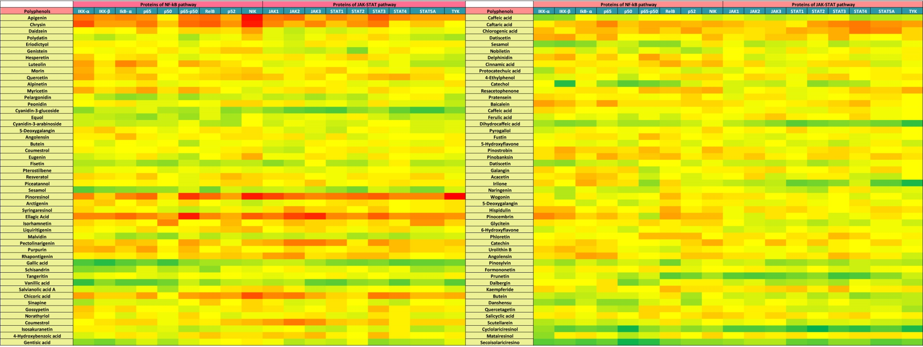
Supplementary Table 1A: Binding affinities of 100 polyphenols against pivotal proteins of NF-kB and JAK-STAT pathway obtained using AutoDock Vina
Supplementary Table 1B: Binding affinities of 100 polyphenols against pivotal proteins of NF-kB and JAK-STAT pathway obtained using HADDOCK web server
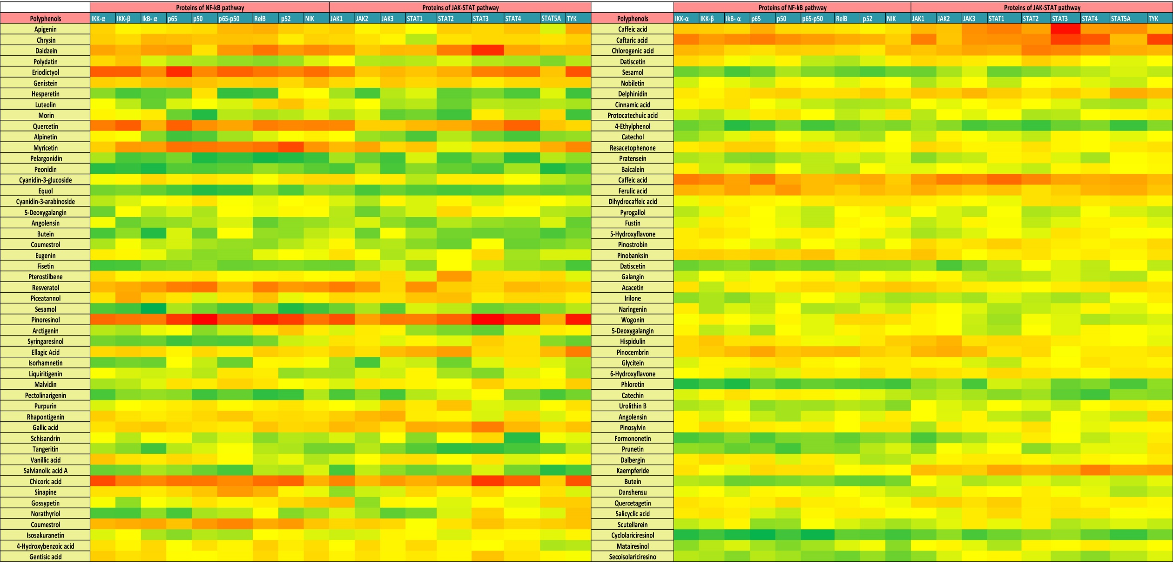

Supplementary Table 2: The binding scores of pinoresinol against key proteins in the NF-kB and JAK-STAT pathways evaluated using AutoDock Vina and the HADDOCK web server

AutoDock Vina |  |  | HADDOCK
Sl. no | Protein | Score (Kcal/mol) | Sl. no | Protein | HADDCOCK Score
1 | IKK-α | -7.0 | 1 | IKK-α | -28.8 ± 1.3
2 | IKK-β | -7.0 | 2 | IKK-β | -27.6 ± 0.7
3 | IkB- α | -6.9 | 3 | IkB- α | -37.8 ± 1.2
4 | p65 | -7.1 | 4 | p65 | -34.3 ± 3.2
5 | p50 | -6.2 | 5 | p50 | -40.5 ± 0.9
6 | p65-p50 heterodimer | -7.5 | 6 | p65-p50 heterodimer | -31.7 ± 3.3
7 | RelB | -7.1 | 7 | RelB | -36.9 ± 3.6
8 | p52 | -6.7 | 8 | p52 | -33.8 ± 2.8
9 | NIK | -7.7 | 9 | NIK | -27.8 ± 4.6
10 | JAK1 | -7.4 | 10 | JAK1 | -31.7 ± 0.9
11 | JAK2 | -7.1 | 11 | JAK2 | -22.6 ± 1.1
12 | JAK3 | -6.9 | 12 | JAK3 | -27.1 ± 3.1
13 | STAT1 | -7.0 | 13 | STAT1 | -26.6 ± 0.8
14 | STAT2 | -7.1 | 14 | STAT2 | -29.7 ± 1.9
15 | STAT3 | -7.2 | 15 | STAT3 | -40.6 ± 4.7
16 | STAT4 | -6.9 | 16 | STAT4 | -36.7 ± 3.2
17 | STAT5A | -6.9 | 17 | STAT5A | -21.2 ± 1.6
18 | TYK | -7.9 | 18 | TYK | -38.0 ± 3.0

Supplementary Table 3: List of primers and their sequences for amplification of indicated genes
Gene Name | Forward Primer Sequence (5'-3') | Reverse Primer Sequence (3'-5')
Β-Actin | CCCTTCATTGACCTCAACTACA | ATGACAAGCTTCCCGTTCTC
COX-2 | GTTCCAGACAAGCAGGCTAATA | CCACTCAAGTGTTGCACATAATC
TNF-α | CCAGGGACCTCTCTCTAATCA | TCAGCTTGAGGGTTTGCTAC
IL-1β | GGTGTTCTCCATGTCCTTTGTA | GCTGTAGAGTGGGCTTATCATC
MCP-1 | GCTCGCTCAGCCAGATGCAAT | TGGGTTGTGGAGTGAGTGTTC
ICAM-1 | CCGGAAGGTGTATGAACTG | TCCATGGTGATCTCTCCTC
VCAM-1 | CATCCACAAAGCTGCAAGAAG | AGGTGCTGTAGATTCCCATTATC

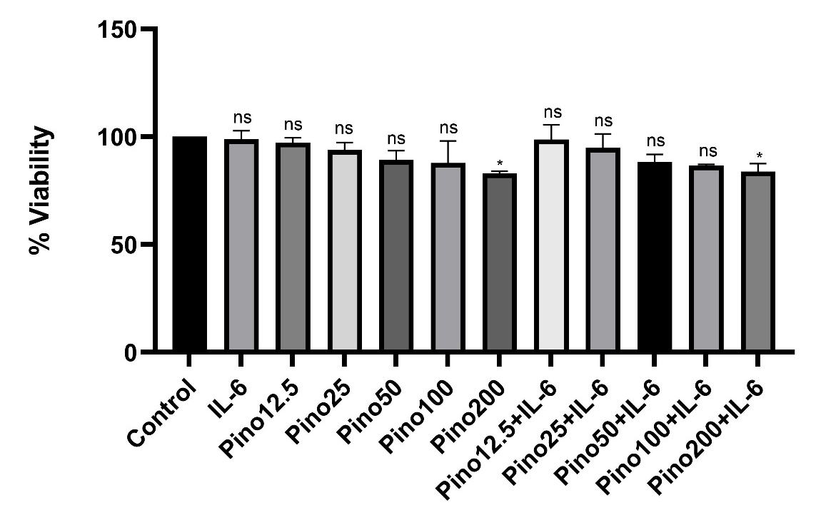

Supplementary fig. 1: : In MTT assay ,THP-1 macrophages were treated with pinoresinol alone at specified concentrations or pre-treated with pinoresinol for 4 hours followed by IL-6 stimulation (50 ng/ml) for 2 hours. Statistical analysis was conducted using unpaired Student's t-test to compare the control group with the different treatments (*), indicating a significant difference. The statistical significance was denoted as * p<0.05.

