Supplementary material
“The highly differentiated Pachnoda marginata gut hosts sequential microbiomes with biotechnological applications”
Àngela Vidal-Verdú, Daniel Torrent, Alba Iglesias, Adriel Latorre-Pérez, Christian Abendroth, Paola Corbín-Agustí, Juli Peretó*, Manuel Porcar*

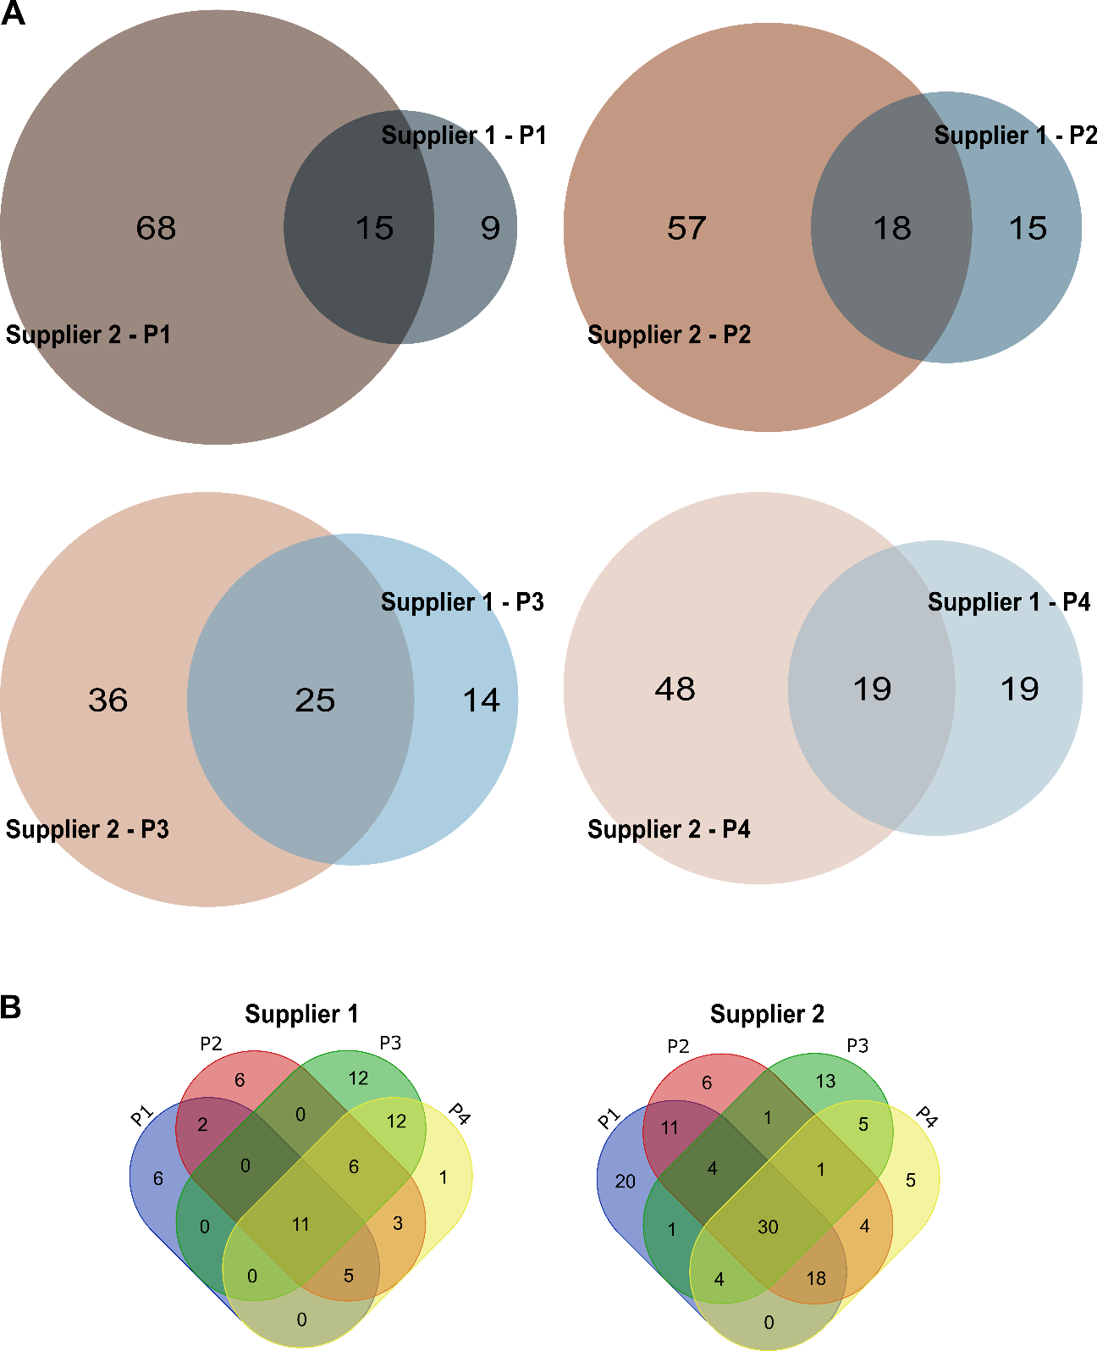
Supplementary figure 1. Venn diagrams showing the defined genera (bacterial, fungal, and archaeal) present exclusively in each supplier and those shared by both for each part of the gut (A); Microbial taxa shared by each part of the gut, divided by supplier (B).

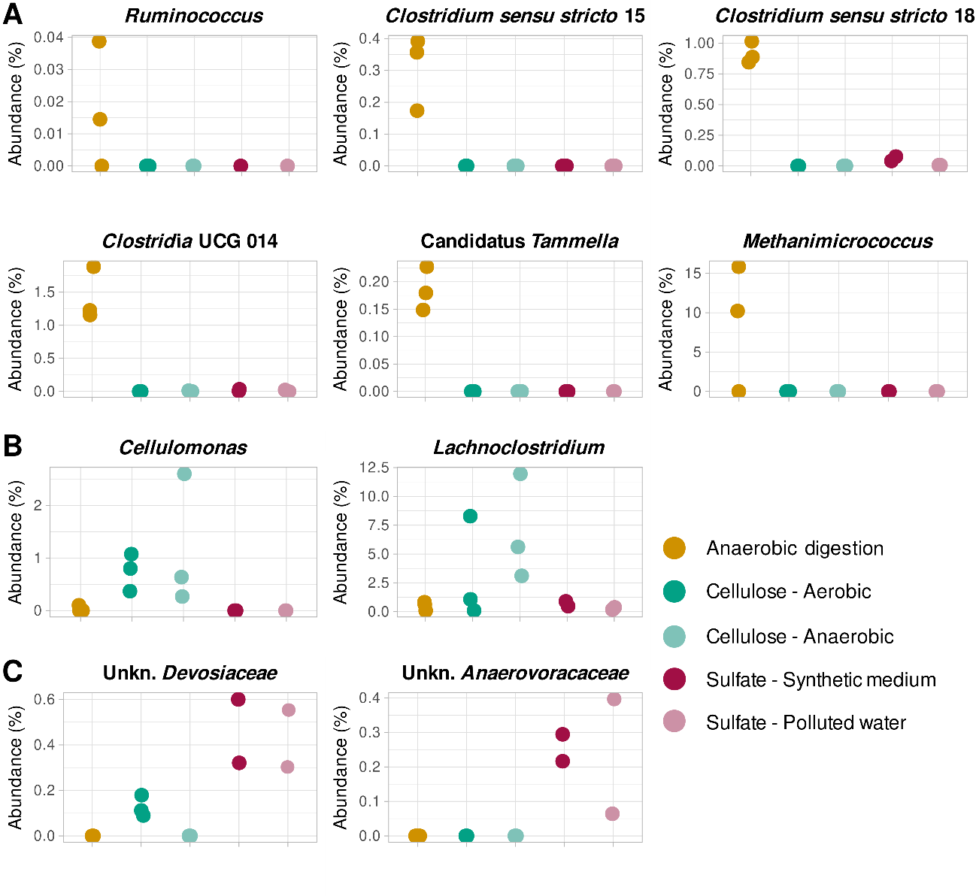

Supplementary figure 2. Relative abundances (%) of some genera that were significantly more abundant in each of the three assays (A: anaerobic digestion; B: cellulose degradation; C: sulfate reduction), at the end of the incubation period.

