Xiashengella succiniciproducens gen. nov., sp. nov.,
a succinate-producing bacterium isolated from an anaerobic digestion tank in the family Marinilabiliaceae of the order Bacteroidales

Hao-Jie Huang^{1,3}, Xi Zhang^{1,2}, Xin-Wei Sun³, Biao Chen⁴, Xiu-Tong Li^{1,3}, Nan Zhou¹, Rashidin Abdugheni^{1,2}, Tie-Jun Zhang⁵, Yao Liu⁵, Yong Jiang⁵, Ye Deng⁶, Shuang-Jiang Liu^{1,2,3,6*}, Cheng-Ying Jiang^{1,2,6*}
¹ State Key Laboratory of Microbial Resources, Institute of Microbiology, Chinese Academy of Sciences, Beijing 100101, China
² College of Life Science, University of Chinese Academy of Sciences, Beijing 100049, China
³ State Key Laboratory of Microbial Technology, Shandong University, Qingdao 266000, China
⁴ Xuzhou Medical University, Xuzhou, 221004, China
⁵ Beijing Drainage Group Co., Ltd, Beijing, 100044, China
⁶ IMCAS-RCEES joint lab at CAS Key Laboratory of Environmental Biotechnology, Research Center for Eco-Environmental Sciences, Chinese Academy of Sciences, Beijing 100085, China

*Corresponding authors: Cheng-Ying Jiang, jiangcy@im.ac.cn; Shuang-Jiang Liu, liusj@im.ac.cn

Subject Category: New taxa (Bacteroidetes)
Running title: Xiashengella succiniciproducens gen. nov. sp. nov.
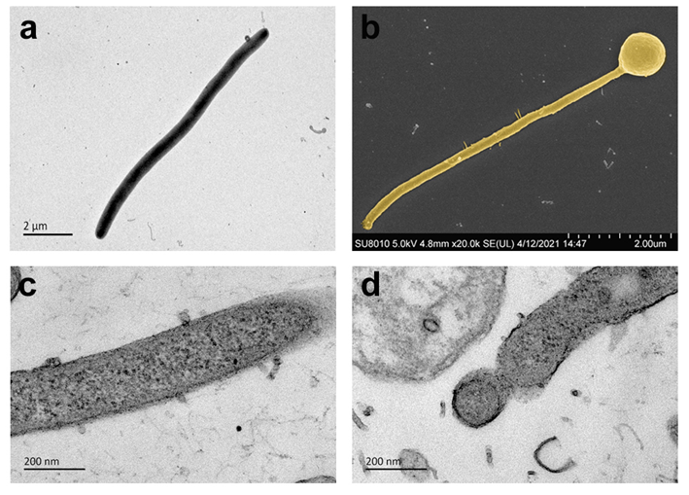
Fig. S1 Electron micrographs of strain Ai-910^{T}. a. Transmission electron micrograph of a negatively stained cell. b. Scanning electron microscope of cells at station phase with cyst-like coccoid structure. Colored the cells according to colony color using Adobe Photoshop CC 2019 software. c and d. Ultrathin sections micrographs revealing wave-like protrusions and cyst-like coccoid structure.

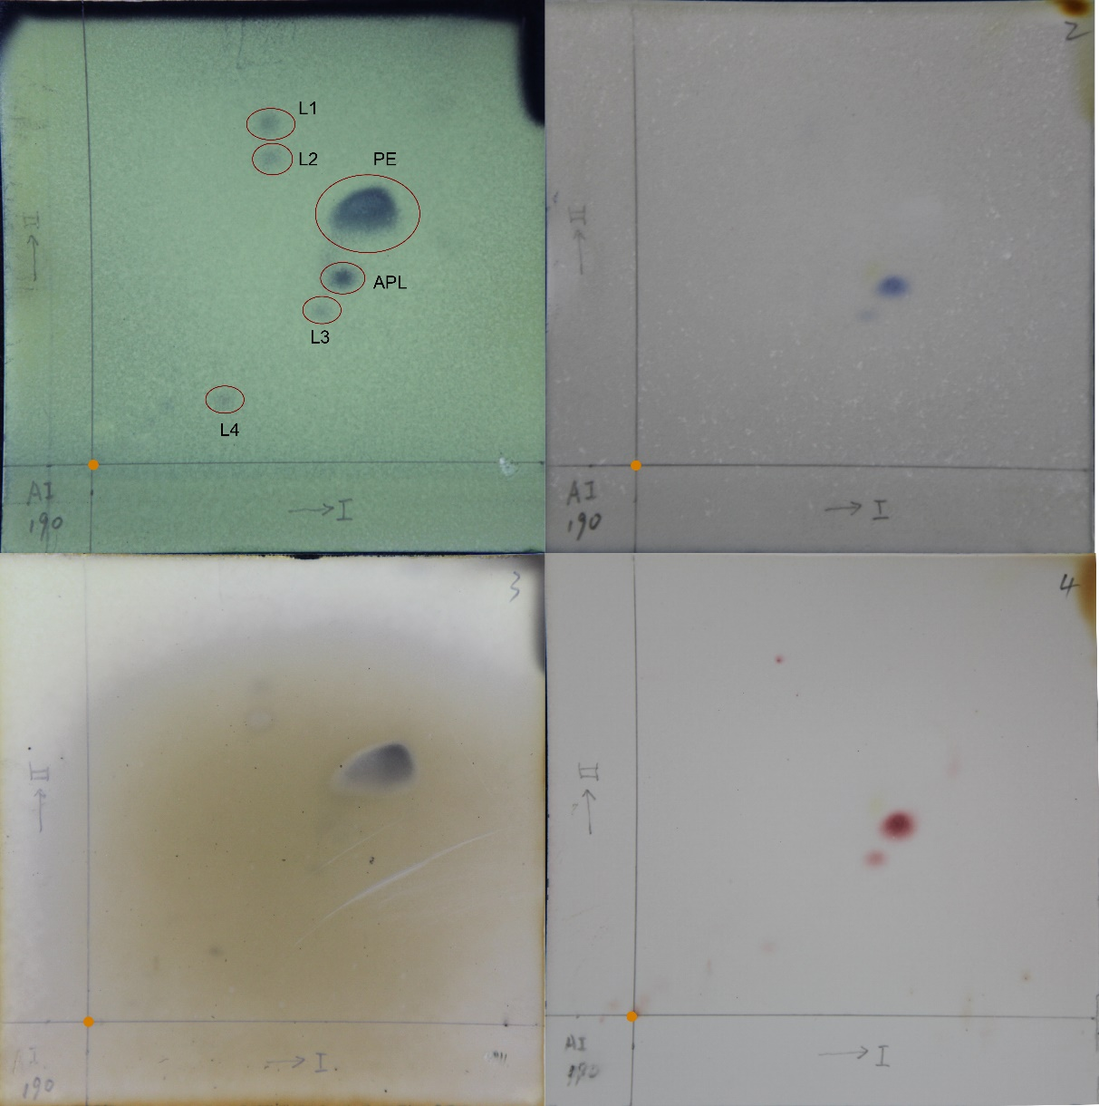
Fig. S2 Polar lipids profile of strain Ai-910^{T} following two-dimensional TLC with chloroform/methanol/water (65:24:4, v/v/v) in the first dimension, followed by chloroform/methanol/acetic acid/water (80:18:12:5, v/v/v/v) in the second dimension (Minnikin et al. 1974). The arrow Ⅰ and arrow Ⅱ respectively represented first dimension and second dimension development direction. The orange dots showed the original position for development. PE, phosphatidylethanolamine; APL, aminophospholipid, L1-4, unidentified polar lipids.

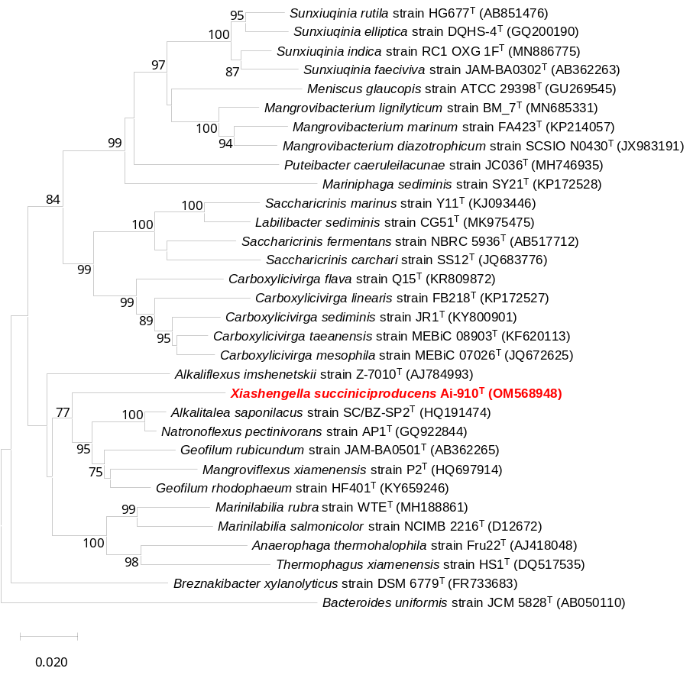
Fig. S3 Phylogenetic tree of 16S rRNA gene sequences indicating the position of Xiashengella succiniciproducens gen. nov. sp. nov. with members of the 30 phylogenetically closest species. The tree was reconstructed using the neighbour-joining method with mega with Bacteroides uniformis as the outgroup. Sequences were downloaded from EzBioCloud. Numbers at branch nodes represent confidence levels (only values ≥ 70% were shown) from 1,000 replicate bootstrap samplings. GenBank accession numbers are given in parentheses.
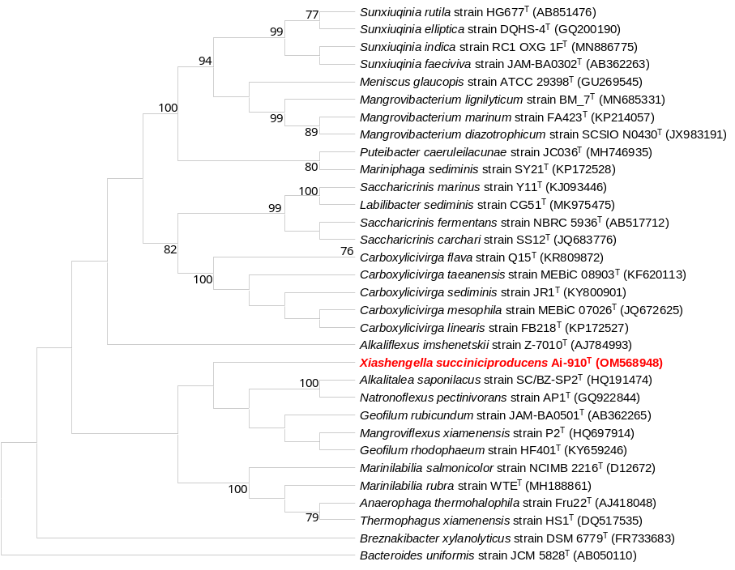
Fig. S4 Phylogenetic tree of 16S rRNA gene sequences indicating the position of Xiashengella succiniciproducens gen. nov. sp. nov. with members of the 30 phylogenetically closest species. The tree was reconstructed using the maximum parsimony algorithm with mega with Bacteroides uniformis as the outgroup. Sequences were downloaded from EzBioCloud. Numbers at branch nodes represent confidence levels (only values ≥ 70% were shown) from 1,00 replicate bootstrap samplings. GenBank accession numbers are given in parentheses.
Table S1. The appearance time and numbers of single colony of strain Ai-910^{T} on three zones of agar plates under different temperature
Temperature for growth | 1d | 2d | 3d | 4d | 5d | 6d | 7d
16℃ | - | - | - | - | - | - | -
25℃ | - | - | - | - | + | + | ++
30℃ | - | + | ++ | ++ | ++ | ++ | ++
35℃ | - | + | ++ | ++ | ++ | ++ | ++
37℃ | - | + | ++ | ++ | ++ | ++ | ++
38℃ | + | ++ | ++ | ++ | ++ | ++ | ++
40℃ | - | + | ++ | ++ | ++ | ++ | ++
42℃ | - | - | - | - | + | + | +
45℃ | - | - | - | - | - | - | -
-Means no colonies appear, + means colonies appear in any area, ++ means colonies appear in all three areas.

Table S2. The appearance time and numbers of single colony of strain Ai-910^{T} on three zones of agar plates under different pH
pH for growth | 1d | 2d | 3d | 4d | 5d | 6d | 7d
5 | - | - | - | - | - | - | -
5.5 | - | + | + | + | + | ++ | ++
6.5 | - | - | + | + | ++ | ++ | ++
7 | - | - | + | + | ++ | ++ | ++
7.5 | - | + | + | ++ | ++ | ++ | ++
8.5 | - | ++ | ++ | ++ | ++ | ++ | ++
9.5 | - | + | ++ | ++ | ++ | ++ | ++
10.5 | - | - | + | + | + | + | +
-Means no colonies appear, + means colonies appear in any area, ++ means colonies appear in all three areas.

Table S3. The appearance time and numbers of single colony of strain Ai-910^{T} on three zones of agar plates under different NaCl concentrations
NaCl % (w/v) | 1d | 2d | 3d | 4d | 5d | 6d | 7d
0 | - | + | ++ | ++ | ++ | ++ | ++
0.06 | - | ++ | ++ | ++ | ++ | ++ | ++
1 | - | - | ++ | ++ | ++ | ++ | ++
2 | - | - | - | - | + | + | ++
3 | - | - | - | - | - | - | -
4 | - | - | - | - | - | - | -
5 | - | - | - | - | - | - | -
-Means no colonies appear, + means colonies appear in any area, ++ means colonies appear in all three areas.

Table S4. The API ZYM kit results of strain Ai-910^{T}
 | Experiments | Results
1 | Control | -
2 | Alkaline phosphatase | +
3 | Esterase (C4) | +
4 | Esterase Lipase (C8) | +
5 | Lipase (C14) | -
6 | Leucine aryminase | -
7 | Valine arylamidase | -
8 | Cystine arylamidase | -
9 | Trypsin | -
10 | Chymotrypsin | -
11 | Acid phosphatase | +
12 | Naphthol-AS-BI-phosphohydrolase | +
13 | α-Galactosidase | -
14 | β-Galactosidase | -
15 | β-Glucuronidase | -
16 | α-Glucosidase | +
17 | β-Glucosidase | +
18 | N-acetyl-β-glucosaminidase | -
19 | α-Mannosidase | -
20 | β-Fucosidase | -
+ represent positive results, - represent negative results.

Table S5. The API 20A kit results of strain Ai-910^{T}
 | Experiments | Results
1 | IND | -
2 | URE | -
3 | GLU | +
4 | MAN | +
5 | LAC | +
6 | SAC | +
7 | MAL | +
8 | SAL | -
9 | XYL | +
10 | ARA | -
11 | GEL | -
12 | ESC | +
13 | GLY | -
14 | CEL | -
15 | MNE | +
16 | MLZ | -
17 | RAF | -
18 | SOR | +
19 | RHA | +
20 | TRE | +
21 | CAT | +
+ represent positive results, - represent negative results.

Table S6. Biolog AN MicroPlate results of strain Ai-910^{T}
Water | N-Acetyl-D-Galactosamine | N-Acetyl-D-Glucosamine | N-Acetyl-β-D-Mannosamine | Adonitol | Amygdalin* | D-Arabitol | Arbutin | D-Cellobiose | α-Cyclodextrin | β-Cyclodextrin | Dextrin
Dulcitol | i-Erythritol | D-Fructose | L-Fucose | D-Galactose | D-Galacturonic Acid | Gentiobiose | D-Gluconic Acid | D-Glucosaminic Acid | α-D-Glucose | Glucose-1-Phosphate | Glucose-6-Phosphate
Glycerol | D, L-α-Glycerol Phosphate | m-Inositol | α-D-Lactose | Lactulose | Maltose | Maltotriose | D-Mannitol | D-Mannose | D-Melezitose | D-Melibiose | 3-Melthyl-D-Glucose
α-Methyl-D-Galactoside | β-Methyl-D-Galactoside | α-Methyl-D Glucoside | β-Methyl-D-Glucoside | Palatinose | D-Raffinose | L-Rhamnose | Salicin | D-Sorbitol | Stachyose | Sucrose | D-Trehalose
Turanose | Acetic Acid | Formic Acid | Fumaric Acid | Glyoxylic Acid | α-Hydroxybutyric Acid | β-Hydroxybutyric Acid | Itaconic | α-Ketobutyric Acid | α-Ketovaleric Acid | D, L-Lactic Acid | L-Lactic Acid
D-Lactic Acid Methyl Este | D-Malic Acid | L-Malic Acid | Propionic Acid | Pyruvic Acid | Pyruvic Acid Methyl Ester | D-Saccharic Acid | Succinamic Acid | Succinic Acid | Succinic Acid Mono-Methyl Ester | m-Tartaric Acid | Urocanic Acid
L-Alaninamide | L-Alanine | L-Alanyl-L-Glutamine | L-Alanyl-L-histidine | L-Alanyl-L-Threonine | L-Asparagine | L-Glutamic Acid | L-Glutamine | Glycyl-L-Aspartic Acid | Glycyl-L-Glutamine | Glycyl-L-methionine | Glycyl-L-Proline
L-Methionine | L-Phenylalanine | L-Serine | L-Threonine | L-Valine | L-Valine plus  L-Aspartic Acid | 2’-Deoxy Adenosine | Inosine | Thymidine | Uridine | Thymidine-5’-Monophosphate | Uridine-5’-Monophosphate
*Purple filled cells represent positive results

Table S7. Cellular fatty acid contents (%) of strain Ai-910^{T} and its closely related type species in the family Marinilabiliaceae.
Strains: 1. Ai-910^{T} (data from this study), 2. Alkaliflexus imshenetskii Z-7010^{T} (Zhilina et al. 2004), 3. Alkalitalea saponilacus SC/BZ-SP2^{T} (Zhao and Chen 2012)[2](2), 4. Anaerophaga thermohalophila Fru22^{T} (Denger et al. 2002), 5. Breznakibacter xylanolyticus XM3^{T} (Haack and Breznak 1993), 6. Carboxylicivirga mesophila MEBiC 07026^{T} (Yang et al. 2014), 7. Geofilum rubicundum JAM-BA0501^{T} (Miyazaki et al. 2012), 8. Mangroviflexus xiamenensis P2^{T} (Zhao et al. 2012), 9. Marinilabilia salmonicolor ATCC 19041^{T} (Suzuki M. 1999 ), 10. Natronoflexus pectinivorans AP1^{T} (Sorokin et al. 2011), 11. Saccharicrinis fermentans DSM 9555^{T} (Liu et al. 2014; Yang et al. 2014), 12. Thermophagus xiamenensis HS1^{T} (Gao et al. 2013). - , Not detected. Data of related type species were come from the references noted in parentheses after the strains.
Characteristic | 1 | 2 | 3 | 4 | 5 | 6 | 7 | 8 | 9 | 10 | 11 | 12
Straight chain
C13:0 | 1.3 | 2.1 | 0.3 | - | - | - | - | - | - | - | - | -
C14:0 | 2.2 | - | 0.5 | 1.8 | - | - | 1.3 | 2.2 | - | - | - | 1.4
C15:0 | - | 35.1 | - | 4.7 | 19.9 | 3.5 | - | - | 19.5 | 16.2 | - | -
C16:0 | 2.8 | 0.3 | 2.6 | 9.5 | 4.1 | - | 2.8 | 5.4 | 12.2 | 0.6 | 2.1 | 8.2
C17:0 | - | - | 2.6 | - | - | - | - | - | 3.4 | - | - | -
C18:0 | 1.0 | - | 1.3 | 3.3 | - | - | - | 1.1 | 4.6 | - | - | 1.5
Branched chain
iso-C 13:0 | 1.2 | 3.9 | 0.5 | - | - | 1.6 | - | 1.2 | - | - | - | -
iso-C 14:0 | 5.2 | - | - | 1.9 | - | 2.6 | 5.6 | 0.5 | - | 1.2 | 3 | -
iso-C 15:0 | 23.7 | 32.7 | 31.5 | 30.2 | 3.7 | 21.7 | 23.7 | 33.5 | 11.3 | 19.4 | 29.5 | 36.5
iso-C 16:0 | 1.7 | 0.6 | 1.2 | 2.9 | - | 4.7 | 2.1 | 0.5 | 2.1 | 2.8 | 1 | -
iso-C 17:0 | 0.3 | - | 0.7 | - | - | 1.5 | - | 1.7 | - | 0.6 | 1.4 | 1.8
anteiso-C 15:0 | 30.2 | 9.2 | 18.0 | 21.2 | 57.2 | 10.8 | 33.4 | 18.9 | 31.7 | 16.9 | 25.9 | 21.1
anteiso-C 17:0 | 0.8 | - | 0.4 | - | 1.8 | - | - | 0.7 | 2.0 | - | - | -
Hydroxy
C15:0 2-OH | 1.0 | - | 0.5 | - | - | 1.3 | - | - | - | - | 3.3 | -
C17:0 2-OH | 2.0 | - | 2.1 | - | - | 1 | - | - | - | - | 1.5 | -
C15:0 3-OH | 6.7 | 3.4 | 5.8 | 5.1 | 5.5 | - | - | 0.6 | - | - | - | 1.2
C16:0 3-OH | 4.2 | - | 2.3 | 3.4 | - | - | 2.9 | 7.7 | - | - | - | 3.8
C17:0 3-OH | 1.3 | - | 6.0 | - | 3.3 | - | - | - | - | 3.3 | - | -
iso-C 15:0 3-OH | 3.1 | - | 2.3 | - | - | 7.9 | 4.8 | - | - | 1.7 | 7.5 | 5.1
iso-C 16:0 3-OH | 2.0 | - | 1.3 | - | - | 5.1 | 7.0 | 0.9 | - | - | 2.7 | -
iso-C 17:0 3-OH | 5.1 | - | 9.4 | 7.8 | - | 5.9 | 3.5 | 13.3 | 3.3 | 11.0 | 4.9 | 8.3

Table S8. General genomic characteristics of strain Ai-910^{T}
Characteristics | Ai-910^{T}
INSDC number | CP098400
Circular | T
Genome size | 3101014 bp
G+C content | 42.8%
Total genes | 2576
tRNA genes | 46
5S rRNA genes | 4
16S rRNA genes | 4
23S rRNA genes | 4
Other RNA genes | 3

Table S9. Functional genes related to metabolism of strain Ai-910^{T} and other members of the family Marinilabiliaceae
Genome no. | Organism name | Carbohydrate metabolism | Amino acid metabolism | Metabolism of cofactors and vitamins | Nucleotide metabolism
1 | Ai-910^{T} | 145 | 88 | 85 | 62
2 | Alkaliflexus imshenetskii  Z-7010^{T} | 199 | 92 | 89 | 64
3 | Alkalitalea saponilacus JAM-BA0501^{T} | 209 | 99 | 97 | 63
4 | Anaerophaga thermohalophila  DSM 12881^{T} | 190 | 99 | 82 | 56
5 | Breznakibacter xylanolyticus DSM 6779^{T} | 192 | 86 | 102 | 60
6 | Carboxylicivirga mesophila MEBiC 07026^{T} | 241 | 123 | 113 | 67
7 | Carboxylicivirga sediminis  J1R^{T} | 251 | 122 | 118 | 66
8 | Geofilum rhodophaeum HF401^{T} | 188 | 93 | 100 | 61
9 | Geofilum rubicundum  JAM-BA0501^{T} | 219 | 102 | 103 | 67
10 | Labilibacter marinus  Y11^{T} | 256 | 107 | 116 | 67
11 | Labilibacter sediminis  CG51^{T} | 253 | 106 | 113 | 66
12 | Marinilabilia rubra  WTE16^{T} | 237 | 105 | 107 | 61
13 | Marinilabilia salmonicolor NCIMB 2216^{T} | 238 | 108 | 101 | 63
14 | Natronoflexus pectinivorans AP1^{T} | 206 | 98 | 94 | 65
15 | Saccharicrinis aurantiacus HQYD1^{T} | 226 | 99 | 119 | 70
16 | Saccharicrinis carchari  DSM 27040^{T} | 194 | 100 | 89 | 68
17 | Saccharicrinis fermentans  DSM 9555^{T} | 253 | 104 | 108 | 66
18 | Thermophagus xiamenensis DSM 19012^{T} | 195 | 93 | 91 | 60

Table S7. Pan-genomic characterization of strain Ai-910^{T} and other members of the family Marinilabiliaceae
Genome no. | Organism name | No. of core genes | No. of accessory genes | No. of unique genes | No. of exclusively absent genes
1 | Alkaliflexus imshenetskii  Z-7010^{T} | 620 | 1741 | 694 | 24
2 | Alkalitalea saponilacus JAM-BA0501^{T} | 620 | 2396 | 333 | 1
3 | Anaerophaga thermohalophila  DSM 12881^{T} | 620 | 1759 | 549 | 5
4 | Breznakibacter xylanolyticus  DSM 6779^{T} | 620 | 1092 | 1539 | 31
5 | Carboxylicivirga mesophila MEBiC 07026^{T} | 620 | 3194 | 366 | 0
6 | Carboxylicivirga sediminis J1R^{T} | 620 | 3265 | 465 | 0
7 | Geofilum rhodophaeum HF401^{T} | 620 | 1921 | 721 | 1
8 | Geofilum rubicundum  JAM-BA0501^{T} | 620 | 2211 | 972 | 48
9 | Labilibacter marinus  Y11^{T} | 620 | 2542 | 1251 | 1
10 | Labilibacter sediminis CG51^{T} | 620 | 2220 | 1606 | 1
11 | Marinilabilia rubra  WTE16^{T} | 620 | 2383 | 794 | 0
12 | Marinilabilia salmonicolor NCIMB 2216^{T} | 620 | 2293 | 752 | 0
13 | Natronoflexus pectinivorans AP1^{T} | 620 | 2379 | 251 | 0
14 | Saccharicrinis aurantiacus HQYD1^{T} | 620 | 2038 | 1579 | 7
15 | Saccharicrinis carchari  DSM 27040^{T} | 620 | 1946 | 848 | 5
16 | Saccharicrinis fermentans DSM 9555^{T} | 620 | 2388 | 1063 | 1
17 | Thermophagus xiamenensis DSM 19012^{T} | 620 | 1797 | 408 | 2
18 | Ai-910^{T} | 620 | 1206 | 688 | 34

References
Denger K, Warthmann R, Ludwig W, Schink B (2002) Anaerophaga thermohalophila gen. nov., sp. nov., a moderately thermohalophilic, strictly anaerobic fermentative bacterium. Int J Syst Evol Microbiol 52:173-178 doi: 10.1099/00207713-52-1-173
Gao ZM, Liu X, Zhang XY, Ruan LW (2013) Thermophagus xiamenensis gen. nov., sp. nov., a moderately thermophilic and strictly anaerobic bacterium isolated from hot spring sediment. Int J Syst Evol Microbiol 63:109-113 doi: 10.1099/ijs.0.038547-0
Haack SK, Breznak JA (1993) Cytophaga xylanolytica sp. nov., a xylan-degrading, anaerobic gliding bacterium. Archives of Microbiology 159:6-15 doi: 10.1007/BF00244257
Liu QQ, Wang Y, Li J, Du ZJ, Chen GJ (2014) Saccharicrinis carchari sp. nov., isolated from a shark, and emended descriptions of the genus Saccharicrinis and Saccharicrinis fermentans. Int J Syst Evol Microbiol 64:2204-2209 doi: 10.1099/ijs.0.061986-0
Miyazaki M, Koide O, Kobayashi T, Mori K, Shimamura S, Nunoura T, et al. (2012) Geofilum rubicundum gen. nov., sp. nov., isolated from deep subseafloor sediment. Int J Syst Evol Microbiol 62:1075-1080 doi: 10.1099/ijs.0.032326-0
Sorokin DY, Panteleeva AN, Tourova TP, Kaparullina EN, Muyzer G (2011) Natronoflexus pectinivorans gen. nov. sp. nov., an obligately anaerobic and alkaliphilic fermentative member of Bacteroidetes from soda lakes. Extremophiles 15:691-696 doi: 10.1007/s00792-011-0399-7
Suzuki M. NY, Harayama S., Yamamoto S. (1999 ) Phylogenetic analysis of genus Marinilabilia and related bacteria based on the amino acid sequences of GyrB and emended description of Marinilabilia salmonicolor with Marinilabilia agarovorans as its subjective synonym. Int J Syst Bacteriol 49:1551–1557
Yang SH, Seo HS, Woo JH, Oh HM, Jang H, Lee JH, et al. (2014) Carboxylicivirga gen. nov. in the family Marinilabiliaceae with two novel species, Carboxylicivirga mesophila sp. nov. and Carboxylicivirga taeanensis sp. nov., and reclassification of Cytophaga fermentans as Saccharicrinis fermentans gen. nov., comb. nov. Int J Syst Evol Microbiol 64:1351-1358 doi: 10.1099/ijs.0.053462-0
Zhao B, Chen S (2012) Alkalitalea saponilacus gen. nov., sp. nov., an obligately anaerobic, alkaliphilic, xylanolytic bacterium from a meromictic soda lake. Int J Syst Evol Microbiol 62:2618-2623 doi: 10.1099/ijs.0.038315-0
Zhao C, Gao Z, Qin Q, Ruan L (2012) Mangroviflexus xiamenensis gen. nov., sp. nov., a member of the family Marinilabiliaceae isolated from mangrove sediment. Int J Syst Evol Microbiol 62:1819-1824 doi: 10.1099/ijs.0.036137-0
Zhilina TN, Appel R, Probian C, Brossa EL, Harder J, Widdel F, et al. (2004) Alkaliflexus imshenetskii gen. nov. sp. nov., a new alkaliphilic gliding carbohydrate-fermenting bacterium with propionate formation from a soda lake. Arch Microbiol 182:244-253 doi: 10.1007/s00203-004-0722-0

