Supplementary information
Table S1: Pathogenicity prediction of MSGN1 c.374G>T, p.(Arg125Leu) variant.
Table S2: PCR Primers and DNA plasmids used in this study.
Table S3: ClinVar missense MSGN1 VUS variants.
Table S4: ClinVar structural MSGN1 variants.

Figure S1: MSGN1 protein structure computer predictions and amino acid alignment.
Figure S2: Next generation sequencing reads of new MSGN1 missense variant of the affected patient.
Figure S3: Additional in vitro HEK 293T cell transfection data.
Figure S4: Examples of different tail phenotypes of msgn1 mosaic zebrafish embryos.
Figure S5: Phenotypes of CMV:MSGN1-FLAG-tag plasmid injected zebrafish embryos.
Figure S6: In vivo phenotypes of zebrafish msgn1 p.(Arg71Leu) and human MSGN1 p.(Arg125Leu) expressing mosaic zebrafish tp1:VenusPEST embryos.

Excel file S1: Raw Data Fig. 3, ISH signal quantification values and injection statistics.
sIN SILICO TOOLS | PREDICTION
MetaRNN Score | 0.8713
REVEL Score | 0.77
CADD Score | 31
Alpha Missense | 0.9309
Table S1: Pathogenicity prediction of MSGN1 c.374G>T, p.(Arg125Leu) variant.

Table S2: PCR Primers and DNA plasmids used in this study.
Primer name | Primer sequence (5´-3´) | Amplicon size [bp] | Purpose
Zf_tbx6_ribo_fwd | CCAAACTCACCAACAACACG | 1045 | In situ probe cloning  http://zfin.org/ZDB-GENE-020416-5
Zf_tbx6_ribo_rev | GCTGAGCTCAAACCTCCATC
Zf_tbx16_ribo_fwd | TGCAAAATCAGCTTGTCTGG | 870 | In situ probe cloning  http://zfin.org/ZDB-GENE-990615-5
Zf_tbx16_ribo_rev | CAAGACTCGGGACTCAAAGC
zf_bmp2a_gDNA_fwd1 | TTCGCTAAACAACGCAAGTG | 436 | In situ probe cloning  https://zfin.org/ZDB-GENE-980526-388
zf_bmp2a_gDNA_rev1 | GTCGCTGAAGTCCACGTACA
Hum_MSGN1_forward | GGTGGACTACAATATGTTAGCTTTCC | 189 | MSGN1 exon1 amplification and sequencing  ENSEMBL Transcript: ENST00000281047.4
Hum_MSGN1_reverse | TAGACAGGTGGCAGGTAATTCC
Hum_MSGN1_Muta_fwd | TCTGTCCAGCtGAGGCGGAAA | plasmid | MSGN1 variant mutagenesis
Hum_MSGN1_Muta_rev | CATCCTGACTTTGGTGCC
zf_msgn1__mut2Asu _fwd | GAGTATGAGGctGAGGATGAAGG | plasmid | msgn1 variant mutagenesis
zf_msgn1__mut2Asu _rev | ATCTTCACTTTCGGCTTC
Plasmid name | Source and adaptations |  | Purpose
CMV:MSGN1 (WT) | Origene, catalogue #: RC225212  MSGN1 (NM_001105569) Human Tagged ORF Clone, pCMV6-Entry vector |  | In vitro transfection,  zebrafish injection
CMV:MSGN1 p.(Arg125.Leu) | This study,  site directed mutagenesis of CMV:MSGN1 (WT) plasmid |  | In vitro transfection,  zebrafish injection
pCS2+-msgn1 (WT) | This study,  zebrafish msgn1 (WT) CDS in pCS2+ plasmid |  | mRNA synthesis
pCS2+-msgn1 p.(Arg71Arg) | This study,  zebrafish msgn1 p.(Arg71Arg) CDS in pCS2+ plasmid |  | mRNA synthesis
sk-tol2-msgn1:mCherry-p2A-msgn1 (WT) | Yabe and Takada, 2012  partial zebrafish msgn1 promoter sequence driving expression of mCherry and zebrafish msgn1 (WT) CDS |  | zebrafish injection,  in vivo investigation
sk-tol2-msgn1:mCherry-p2A-msgn1 p.(Arg71Leu) | This study,  replacement of zebrafish msgn1 coding sequence with zebrafish msgn1 variant in msgn1:mCherry-p2A-msgn1 plasmid |  | zebrafish injection,  in vivo investigation
sk-tol2-msgn1:mCherry-p2A-MSGN1 p.(Arg125Leu) | This study,  replacement of zebrafish msgn1 coding sequence with human MSGN1 variant CDS in msgn1:mCherry-p2A-msgn1 plasmid |  | zebrafish injection,  in vivo investigation

Table S3: Published missense MSGN1 VUS variants.
(ClinVar database; https://www.ncbi.nlm.nih.gov/clinvar/; accessed 29.08.2023)
cDNA Position in NM_001105569.3(MSGN1) | Protein change | Clinical relevance | Accession ID
c.11T>G p.(Leu4Arg) | L4R | Uncertain | VCV002522663
c.18G>C p.(Glu6Asp) | E6D | Uncertain | VCV002302947
c.82G>T p.(Asp28Tyr) | D28Y | Uncertain | VCV002516087
c.120G>C p.(Gln40His) | Q40H | Uncertain | VCV002354610
c.137G>A p.(Ser46Asn) | S46N | Uncertain | VCV002495774
c.167A>C p.(Tyr56Ser) | Y56S | Uncertain | VCV002263740
c.253G>A p.(Gly85Ser) | G85S | Uncertain | VCV002227906
c.320G>A p.(Gly107Asp) | G107D | Uncertain | VCV002542365
c.352A>G p.(Lys118Glu) | K118E | Uncertain | VCV002204779
c.475G>A p.(Gly159Ser) | G159S | Uncertain | VCV002363247
c.551G>A p.(Arg184His) | R184H | Uncertain | VCV002238447

Table S4: Published structural interstitial variants encompassing MSGN1.
(ClinVar database; https://www.ncbi.nlm.nih.gov/clinvar/; accessed 29.08.2023)
*: variant size <5 Mb; **: variant size >5 Mp (marked in grey); del: deletion; dup: duplication
Genomic Position, GRCh38/hg38,  variant size and type | Clinical relevance;  number of genes affected | Accession ID
2p25.3-23.3  (chr2:12770-25039694)x3 ** ^{dup} | Pathogenic; 655 genes  (Last reviewed: Jul 1, 2013); | VCV000153520
2p25.3-22.3  (chr2:12770-33711509)x3 ** ^{dup} | Pathogenic; 1049 genes  (Last reviewed: Jun 18, 2013) | VCV000153441
2p25.3-24.1  (chr2:17019-20001056)x3 ** ^{dup} | Pathogenic; 500 genes  (Last reviewed: Sep 26, 2012) | VCV000152693
2p25.3-23.3  (chr2:17019-26318846)x3 ** ^{dup} | Pathogenic; 738 genes  (Last reviewed: Apr 8, 2011) | VCV000148269
2p25.3-23.2  (chr2:30341-28419664)x3** ^{dup} | Pathogenic; 895 genes  (Last reviewed: Jul 30, 2009) | VCV000146072
2p25.3-16.1  (chr2:66097-55570637)x3** ^{dup} | Pathogenic; 1633 genes  (Last reviewed: Aug 12, 2011) | VCV000059133
2p25.3-21  (chr2:236816-45983232)x3** ^{dup} | Pathogenic; 1402 genes  (Last reviewed: Nov 19, 2013) | VCV000155615
2p25.3-24.1  (chr2:1664615-23664142)x3** ^{dup} | Pathogenic; 548 genes  (Last reviewed: Nov 4, 2011) | VCV000148848
2p25.1-11.2  (chr2:7495123-87705899)x3** ^{dup} | Benign; 2459 genes  (Last reviewed: Feb 4, 2013) | VCV000152995
2p24.2-24.1  (chr2:16723596-1600734)x1*^{del} | Pathogenic; 132 genes  (Last reviewed: Jun 18, 2012) | VCV000150627
2p25.3-22.3  (chr2:706460-35523639)x3**^{dup} | Pathogenic; 179 genes  (Last reviewed: Apr 15, 2022) | VCV001808629
2p25.1-q13  (chr2:11504318-111365996)x1**^{del} | Pathogenic; 531 genes | VCV001708190
2p25.3-q37.3  (chr2:1-243199373)**^{dup} | Pathogenic; complete trisomy chr.2 | VCV001703543
2p24.3-24.1  (chr2:15640273-19609496)x1*^{del} | Pathogenic; 15 genes  (Last reviewed: Feb 6, 2020) | VCV001180531
2p24.2  (chr2:17846161-18720906)x3*^{dup} | Uncertain significance; 4 genes  (Last reviewed: Jan 27, 2020) | VCV000979980
2p24.3-24.1  (chr2:15631145-21729493)x1**^{del} | Pathogenic; 27 genes  (Last reviewed: Jun 29, 2017) | VCV000687179
2p24.3-24.2  (chr2:12269293-18259781)x3*^{dup} | Pathogenic; 13 genes  (Last reviewed: Jan 26, 2018) | VCV000686578
2p25.3-q37.3  (chr2:15672-243101834)x3**^{dup} | Pathogenic; 1218 genes  (Last reviewed: Jan 1, 2013) | VCV000616168
2p25.3-q37.3  (chr2:14238-243048760)x3**^{dup} | Pathogenic; 1218 genes  (Last reviewed: Jan 5, 2017) | VCV000616166
2p24.2  (chr2:17911847-18217217)x3*^{dup} | Benign; 4 genes  (Last reviewed: Jul 14, 2016) | VCV000603701
2p24.2  (chr2:16926193-18225507)x3*^{dup} | Likely benign; 6 genes  (Last reviewed: Jan 21, 2020) | VCV000562638
2p24.2  (chr2:17814030-18851257)x3*^{dup} | Uncertain significance; 8 genes  (Last reviewed: Jun 23, 2017) | VCV000446356
2p25.3-24.1  (chr2:12770-20081474)x3**^{dup} | Pathogenic; 67 genes  (Last reviewed: Aug 15, 2014) | VCV000443675
2p25.3-q37.3  (chr2:12771-242783384)** ^{dup} | Pathogenic; 1216 genes  (Last reviewed: Jul 14, 2015) | VCV000442998
2p25.3-q37.3  (chr2:12771-242783384)x3**^{dup} | Pathogenic; 1216 gens  (Last reviewed: Dec 2, 2014) | VCV000442997

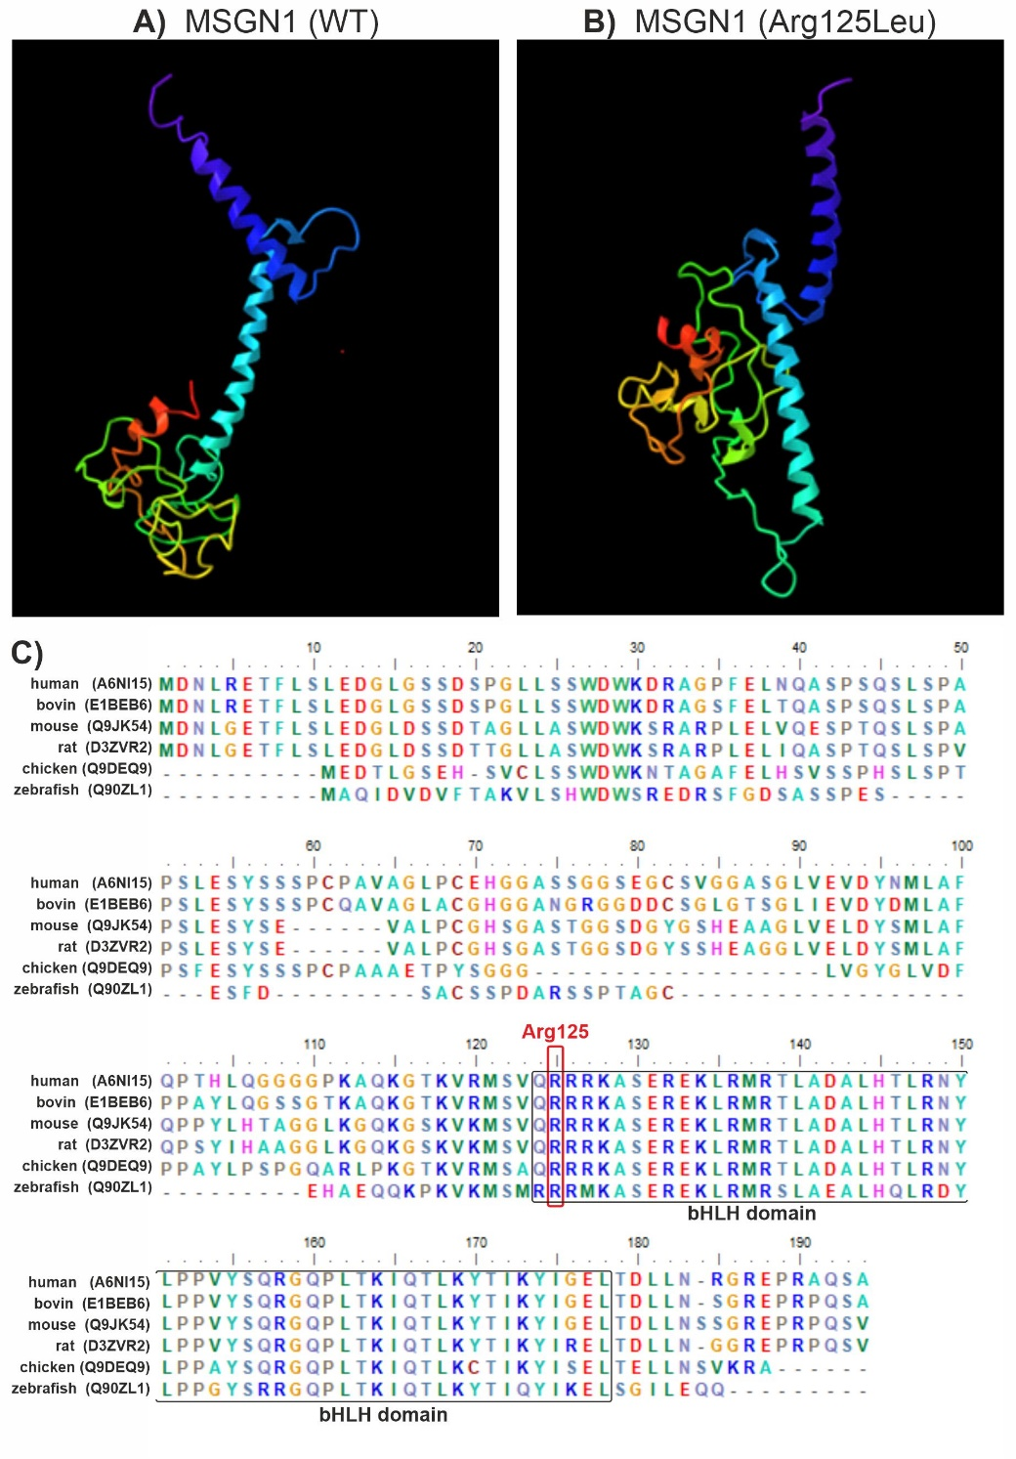
Figure S1: MSGN1 protein structure computer predictions indicate a conformational change, which can be distinguished between the normal protein structure (A) and the p.(Arg125Leu) variant (B). Amino acid alignment of six vertebrate species indicates evolutionary conservation of Arg125 within the basic helix-loop-helix (bHLH) protein domain (C). Numbers indicate position within the human amino acid sequence. Uniport amino acid sequence IDs are given for different species.
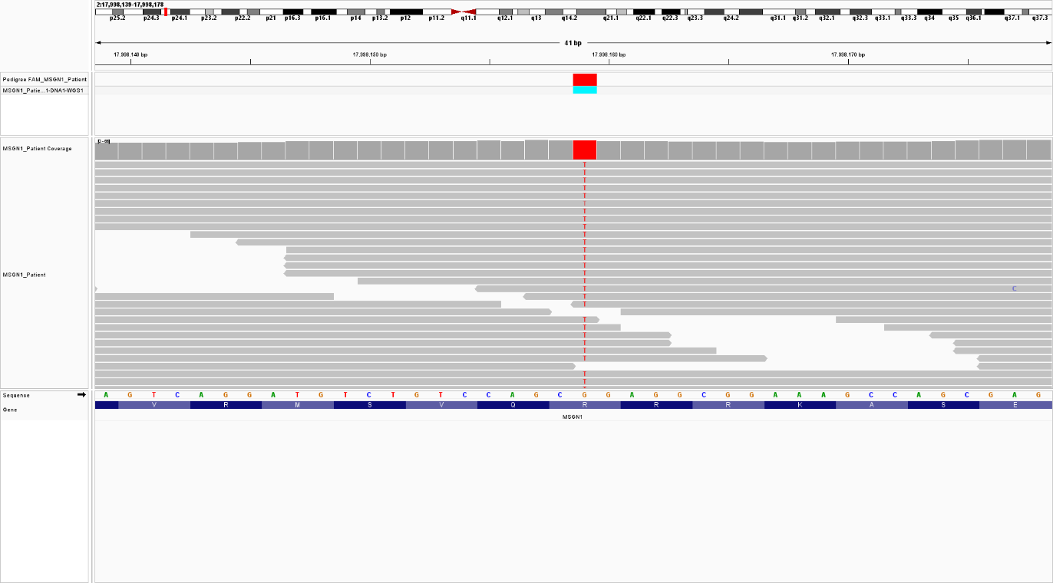
Figure S2: Next generation sequencing reads of new MSGN1 missense variant of the affected patient.
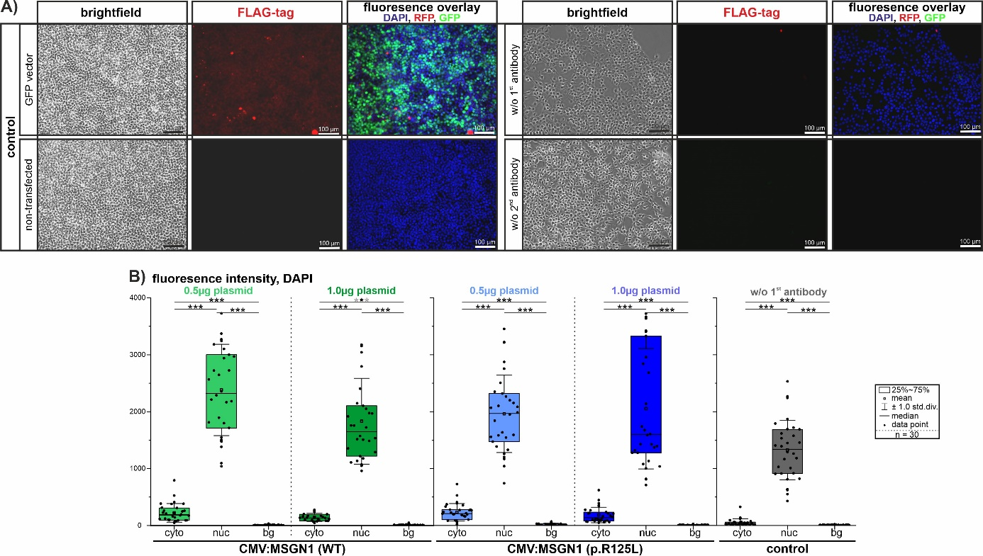
Figure S3: Additional data to in vitro transfection of HEK 293T cells with CMV:MSGN1-Tag and CMV:MSGN1-Arg125Leu plasmids at different concentrations presented in Fig. 3. (A) Corresponding immunofluorescence controls after 48h of transfection are shown. (B) Additional data to quantification of MSGN1 localization in transfected cells. Fluorescence signals in a single z-plane were visualized by confocal laser-scanning microscopy and subsequently signal intensity was measured in single cells (cyto: cytoplasm; nuc: nucleus) and outside of cells (bg: background). Graphs show signal intensity measurements of the DAPI channel (nucleus) of 30 cells per experimental group and 30 background positions. Values are given in Excel file S1.
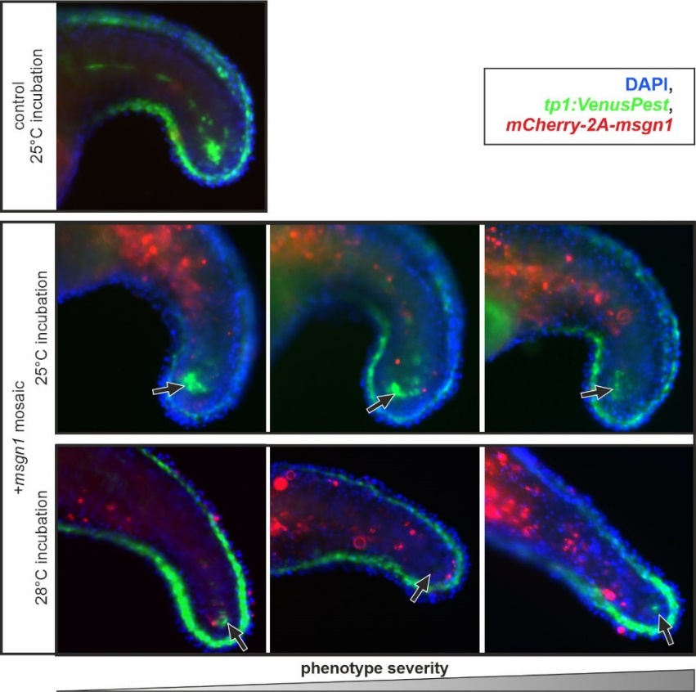
Figure S4: Examples of different phenotypes of msgn1 mosaic zebrafish embryos. Injection with the msgn1:mCherry-2A-msgn1 plasmid results in different amounts of mCherry positive/msgn1 expressing cells within the trunk and tailbud region of tp1:VenusPEST transgenic embryos. Phenotype severity in the PSM (marked by arrows) 24 h after injection is correlated with msgn1 overexpressing cell amount and position.
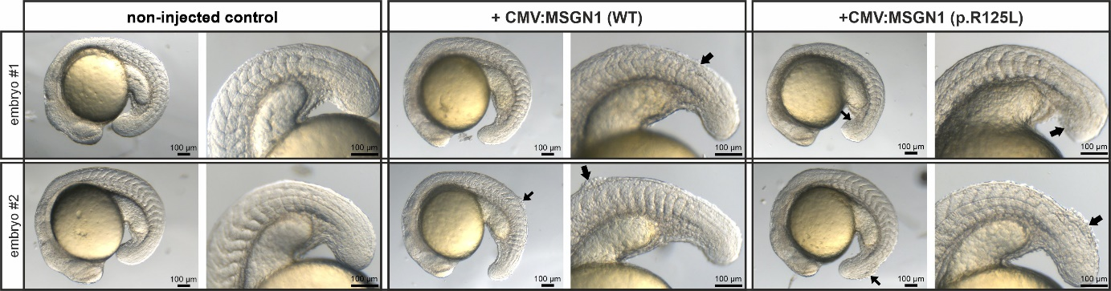
Figure S5: Different phenotypes of CMV:MSGN1 plasmid injected zebrafish embryos. Injection with the CMV:MSGN1-FLAG-tag (WT) or with the CMV:MSGN1-FLAG-tag p.(Arg125Leu) plasmids, which have been used for in vitro cell transfections, results in alteration of tail development also within the trunk and tailbud region of embryos at 18 hpf. Injected embryos display axis bending or cell aggregations in the trunk and PSM regions (marked by black arrows). Number of injected embryos are given in Excel file S1.
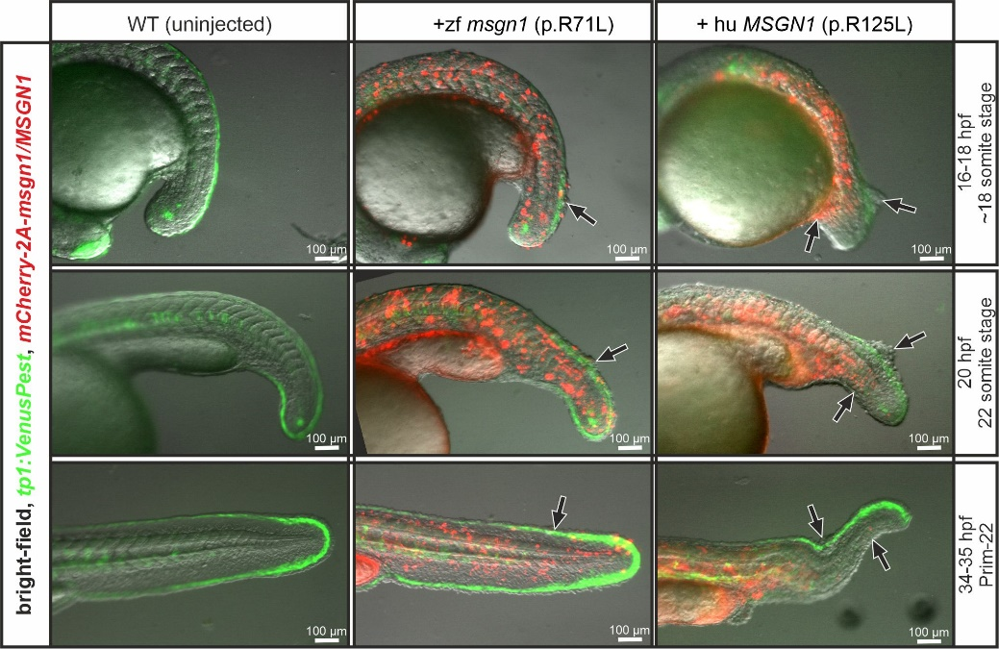
Figure S6: Examples of different phenotypes of msgn1 p.(Arg71Leu) and MSGN1 p.(Arg125Leu) mosaic tp1:VenusPEST zebrafish embryos in vivo. Injection with the sk-tol2-msgn1:mCherry-2A-msgn1 p.(Arg71Leu) or with the sk-tol2-msgn1:mCherry-2A-MSGN1 p.(Arg125Leu) plasmid results in mCherry positive/msgn1 variant expressing cells within the trunk and tailbud region of tp1:VenusPEST transgenic embryos. Phenotype severity in the PSM (marked by arrows) in a time frame between 16 and 35 hpf after injection is shown. The observed phenotypes correlate with msgn1 overexpressing cell amount, position and partly differ in severity between zebrafish and human CDS versions. Number of injected embryos are given in Excel file S1.

