Supplementary material
Table S1. Growth rates (d⁻¹) Chroococcidiopsis sp. UAM571 and Gloeocapsa sp. UAM572 on BG11 supplemented with different NaCl concentrations. Values are expressed as mean ± standard deviation (SD) (n=3). * Indicates significant differences between NaCl concentrations on each cyanobacterial strain (p<0.05; ANOVA, Bonferroni).
Growth rate (d⁻¹)
NaCl (g L⁻¹) Chroococcidiopsis sp. UAM571 Gloeocapsa sp. UAM572
0 0.24 ± 0.01 0.22 ± 0.01
5 0.24 ± 0.01 0.19 ± 0.01
10 0.22 ± 0.01 0.19 ± 0.01
20 0.14 ± 0.01 0.12 ± 0.01
30 -0.06 ± 0.01* -0.03 ± 0.01*

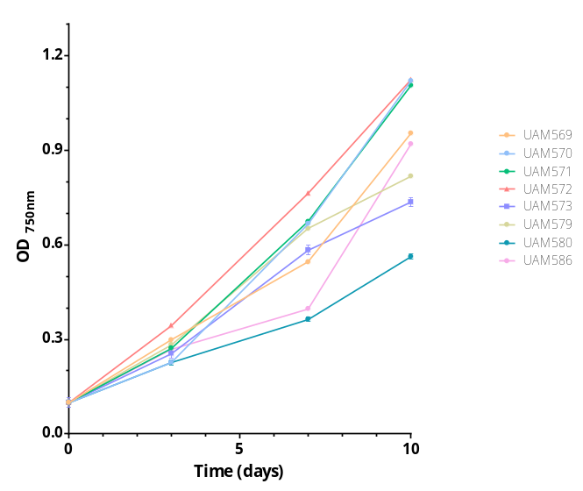
Figure S1. Growth curves of the 8 endolithic cyanobacterial strains in BG11 culture medium expressed by OD_{750nm}. Error bars represent SD (n=3).

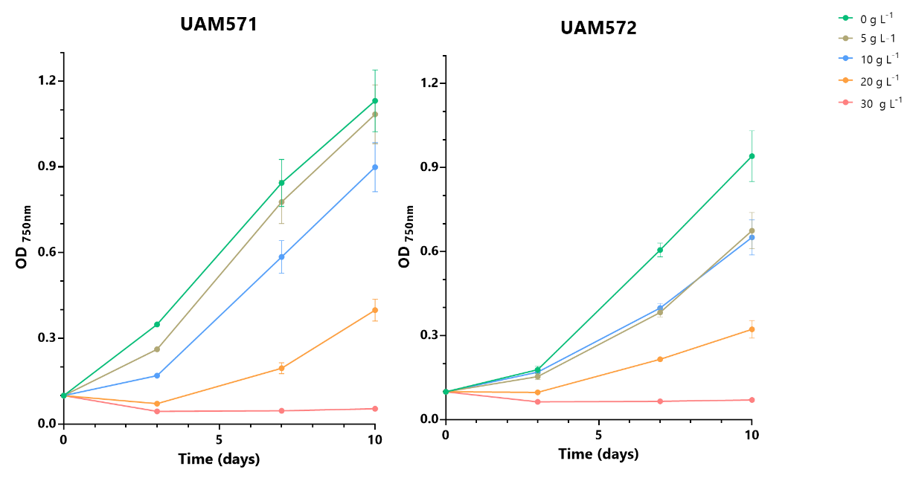
Figure S2. Growth curves of Chroococcidiopsis sp. UAM571 (a) and Gloeococapsa sp. UAM572 (b) on BG11 with different NaCl concentrations. Error bars represent SD (n=3).
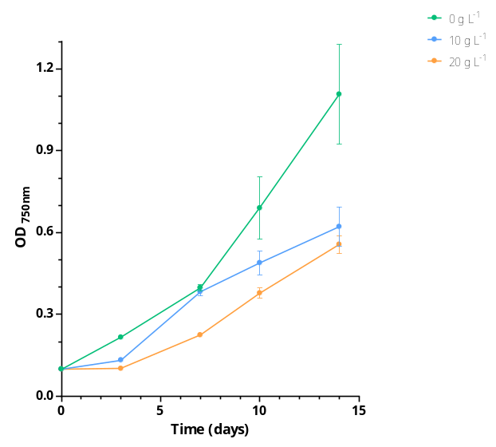
Figure S3. Growth curves of Chroococcidiopsis sp. UAM571 on BG11 with different NaCl concentrations. Error bars represent SD (n=3).

Table S2. Simulated biomass and scytonemin productivity in single and multi-system arrangements mass production for Chroococcidiopsis sp. UAM571.Values are expressed as mean ± standard deviation (SD) (n=3). Simulated multi-system productivities calculated considering east–west-oriented rows with inter-system spacing avoiding shadowing between systems according to two arrangements of bubble tank farms proposed in the literature: ^{A}Wall-to-wall and inter-row separations from Chini Zittelli et al. (2006), ^{B}Wall-to-wall and inter-row separations proposed by Mirón et al. (1999).
Biomass (g DW m⁻² d⁻¹) Scytonemin (mg m⁻² d⁻¹)
NaCl (g·L⁻¹) Single Arrangement A Arrangement B Single Arrangement A Arrangement B
0 22.8 ± 0.6 5.7 ± 0.2 3.8 ± 0.1 1.6 ± 0.4 0.4 ± 0.1 0.3 ± 0.1
10 22.0 ± 6.0 5.5 ± 1.5 3.7 ± 1.0 25.1 ± 2.9 6.3 ± 0.7 4.2 ± 0.5
20 21.9 ± 5.1 5.5 ± 1.3 3.7 ± 0.9 76.5 ± 9.1 19.1 ± 2.3 12.7 ± 1.5

