Supplementary information
Biofilm-disrupting effects of phage endolysins LysAm24, LysAp22, LysECD7, and LysSi3: breakdown the matrix
World Journal of Microbiology and Biotechnology
Anastasiya M. Lendel^{a*}, Nataliia P. Antonovaª, Igor V. Grigoriev^{b}, Evgeny V. Usachev^{b}, Vladimir A. Gushchinª, and Daria V. Vasinaª
ª Laboratory of Pathogen Population Variability Mechanisms, N. F. Gamaleya National Research Center for Epidemiology and Microbiology, Ministry of Health of the Russian Federation, Moscow 123098, Russia
^{b} Translational Biomedicine Laboratory, N. F. Gamaleya National Research Center for Epidemiology and Microbiology, Ministry of Health of the Russian Federation, Moscow 123098, Russia
*Correspondence to: N. F. Gamaleya National Research Center for Epidemiology and Microbiology, Ministry of Health of the Russian Federation, Moscow 123098, Russia.
E-mail address of corresponding author: kazejosei@gmail.com (A.M. Lendel)
Table 1 EPSs of A. baumannii (Ab) и K. pneumoniae (Kp) biofilms ª
Component | Polysaccharides |  |  |  | Proteins |  | eDNA
Method | TSB-CR | Alс blue | CV-Cu BF | TSB-CRCB |  | PK | DNAse
Ab | +^{b} | + | ++ | BDAR, - or +/- | + | +/- | +
Kp | +/- | ++ | + | RDAR, + | + | ++ | +
ª TSB-CR, TSB agar supplemented with Congo red dye; Alc blue, stain with Alcian blue dye, CV-Cu BF, bright field microscopy using differential stain with Crystal violet and CuSO₄; TSB-CRCB, TSB agar supplemented with Congo red and Coomassie blue dyes; PK, treatment of BFs with Proteinase K, DNAse, treatment with DNAse I;
^{b} (+/-), low content in the composition of biofilm; (+), moderate content; (++), pronounced content, according to the matched assessment.

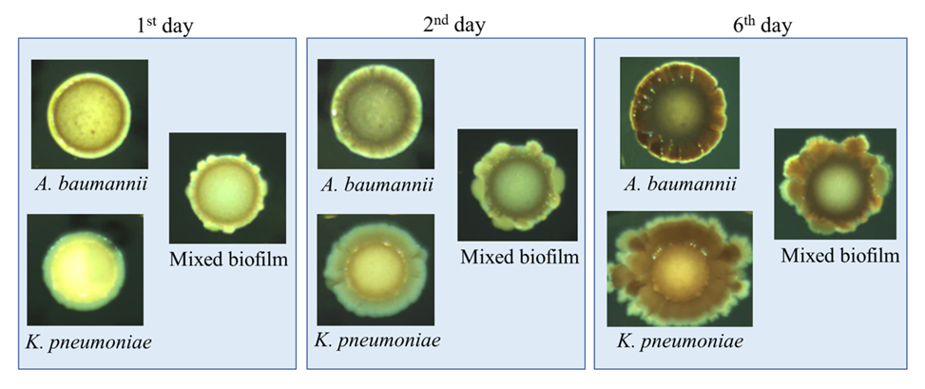
Fig. 1 Morphotyping assay of the investigated biofilm formers grown on TSB agar supplemented with Congo red and Coomassie blue, grown for 24, 48, and 144 hours.

Fig. 2 Possible interaction between eDNA and biofilm-associated proteins within 48-h biofilms, which infer a similar susceptibility to each DNAse I (+, 20 µg/mL) or Proteinase K, PK (+, 800 µg/mL) or both of them. Each data set is demonstrated as normalized mean value (±)SD. Only differences between groups reflected the treatment of biofilms with one type of enzyme and both enzymes are marked as follows: ns, p>0.05; *, p<0.05 (Kruskal-Wallis test with Dunn’s correction).

Fig. 3 Binding of endolysins with A. baumannii DNA in the presence of NaCl. 0, 150 and 300 represent final concentrations (mM) of NaCl in samples with a 10:1 mass ratio of protein:DNA, Cont means only DNA containing solutions; Mr, molecular length in base pairs of standard DNA.

