Supplemental Material

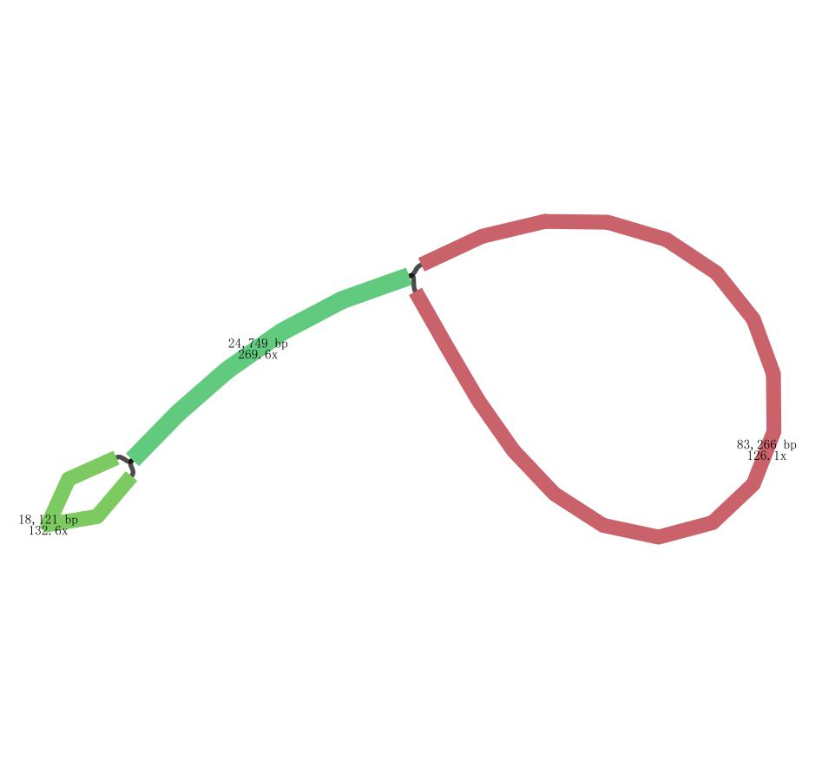
Figure S1. The schematic representation of the coverage depth for the entire chloroplast genome of Calendula officinalis using Bandage. The numbers indicate the depths and length of different regions.

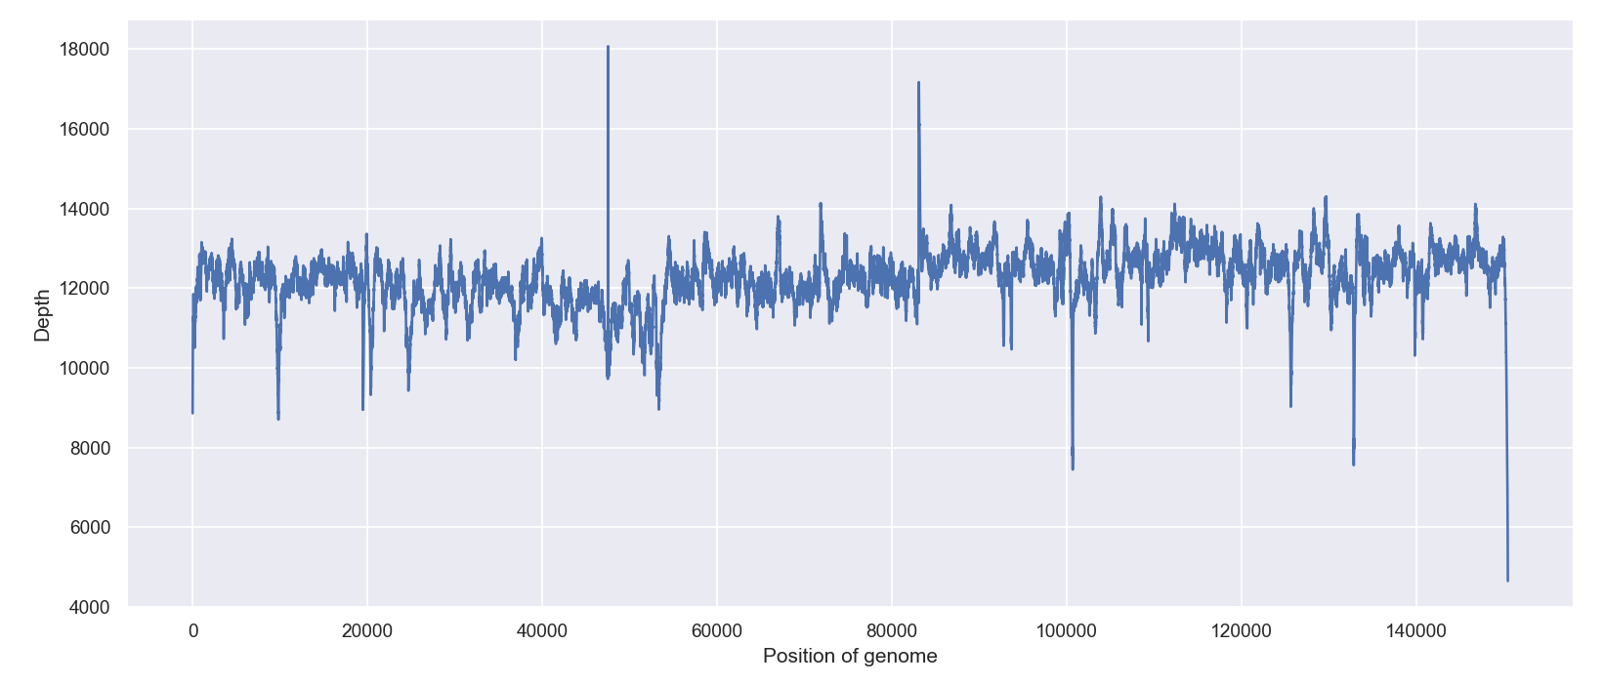
Figure S2. Chloroplast genome sequencing depth distribution for Calendula officinalis. The graph illustrates the chloroplast genome sequencing depth distribution for species Calendula officinalis, with the horizontal axis representing genomic position and the vertical axis indicating sequencing depth.

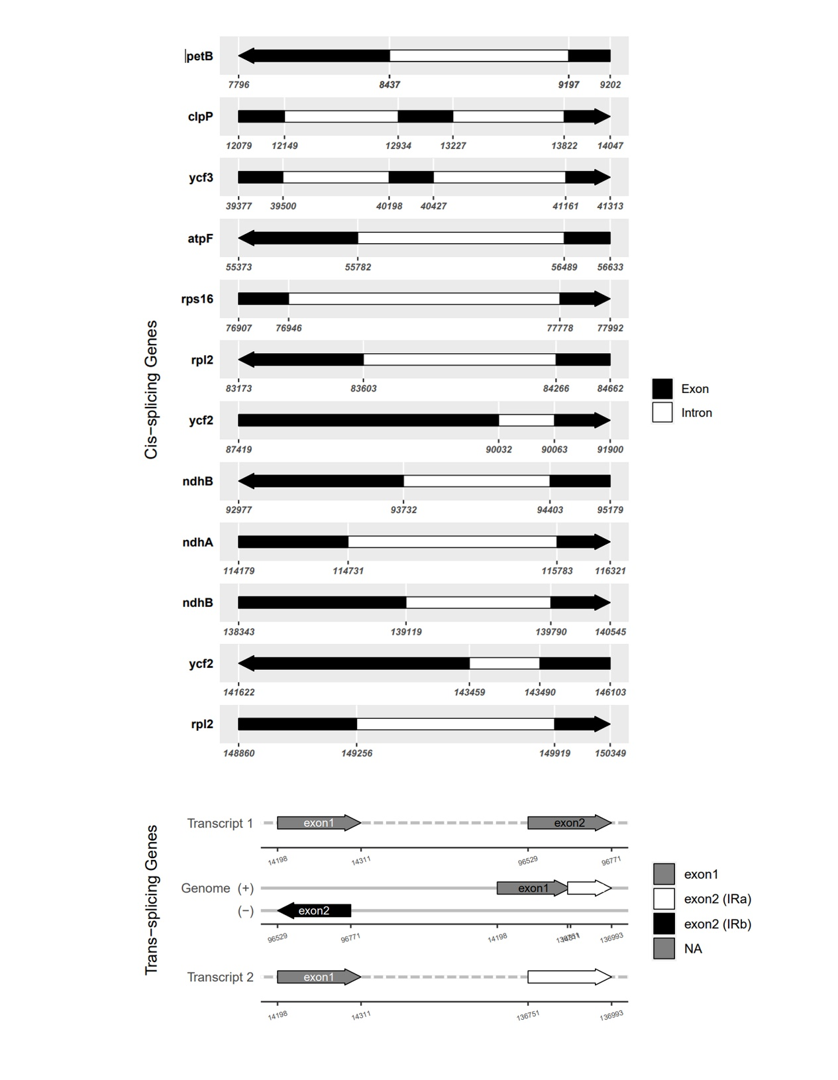
Figure S3. Schematic map of the cis-splicing genes and trans-splicing gene rps12 in the chloroplast genome of Calendula officinalis using CPGView. The exons of the cis-splicing genes are shown in black; the introns are shown in white. The arrow indicates the sense direction of the gene. Please note that lengths of exons and introns are not drawn to scale.

