Table 1 Food consumption questions
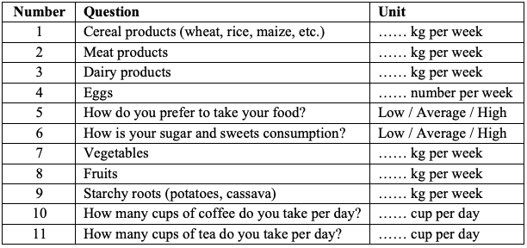

Table 2 Domestic water use - indoors consumption questions
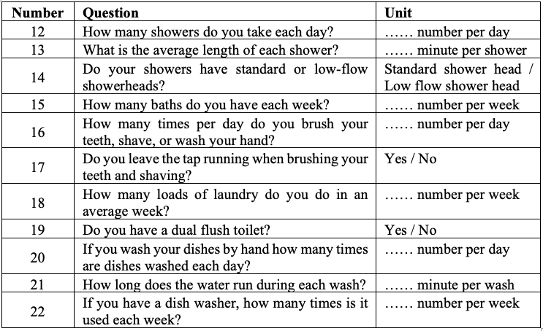

Table 3 Domestic water use - outdoors consumption questions
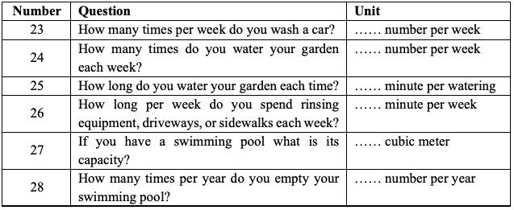

Table 4 Industrial goods consumption questions

