Supporting information
Activation of STING by the Novel Liposomal TLC388 Enhances the Therapeutic Response to Anti-PD-1 Antibodies in Combination with Radiotherapy
Table S1. Clinicopathological parameters of colon carcinoma patients (n=115)
Clinicopathological parameters | Total no. | Tumor STING |  | p value
Clinicopathological parameters | Total no. | High | Low | p value
 | 115 | 42 | 73
Gender |  |  |  | 0.71
Female | 44 | 17 (40.5%) | 27 (37%)
Male | 71 | 25 (59.5%) | 46 (63%)
Age |  |  |  | 0.21
<65 | 46 | 20 (47.6%) | 26 (35.6%)
≥65 | 69 | 22 (52.4%) | 47 (64.4%)
pT stage |  |  |  | 0.61
pT1-2 | 104 | 39 (37.5%) | 65 (62.5%)
pT3-4 | 4 | 2 (50%) | 2 (50%)
Undefined | 7 | 5(71.4%) | 2 (28.6%)
Tumor differentiation |  |  |  | 0.30
Well to moderate | 105 | 39 (90.7%) | 66(91.7%)
Poor | 3 | 2 (4.6%) | 1 (1.4%)
Unknown | 7 | 2(4.7%) | 5(6.9%)
Lymphovascular invasion |  |  |  | 0.996
Absent | 86 | 31 (73.8%) | 55 (75.3%)
Present | 25 | 9 (21.4%) | 16 (21.9%)
Unknown | 4 | 2 (4.8%) | 2 (2.7%)
Perineural invasion |  |  |  | 0.97
Absent | 85 | 31 (73.8%) | 54 (74%)
Present | 26 | 9 (21.4%) | 17 (23.3%)
unknown | 4 | 2 (4.8%) | 2 (2.7%)
MMR status |  |  |  | 0.5
MMR-proficient | 35 | 24 (43.6%) | 11 (18.3%)
MMR-deficient | 1 | 1 (1.8%) | 0 (0%)
Unknown | 79 | 30 (54.5%) | 49 (81.7%)

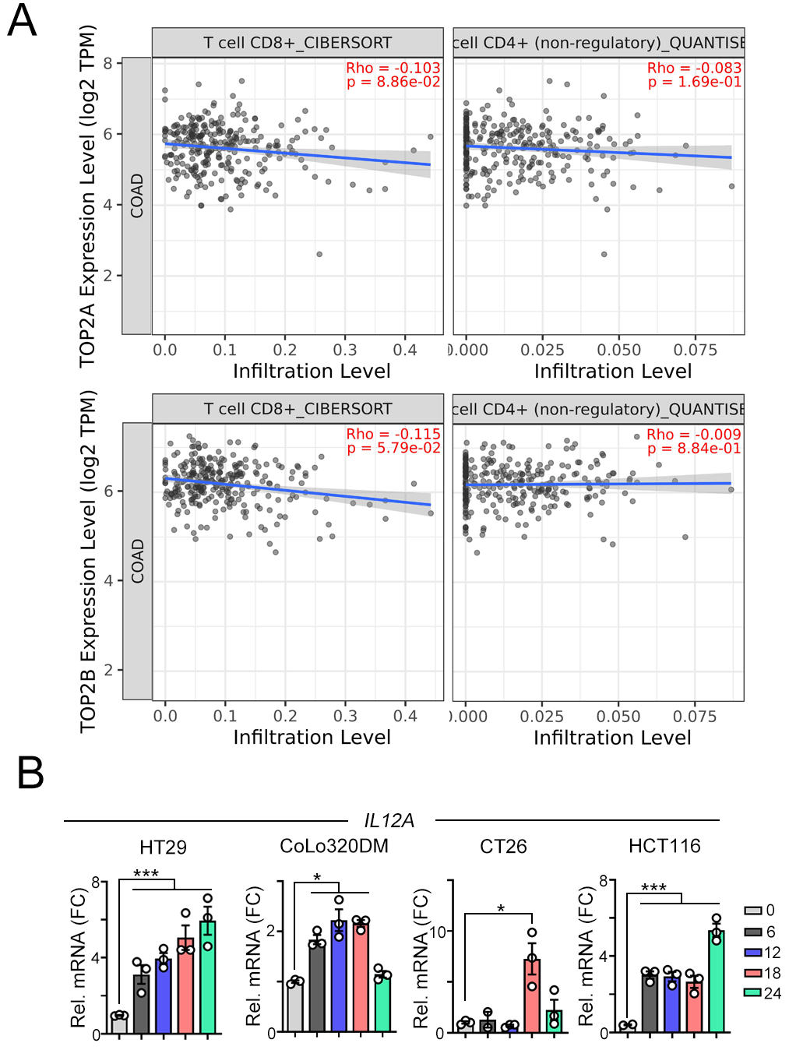
Figure S1. There is no significant correlation between TOP2A/TOP2B mRNA and T cell signatures.
- The relationship between TOP2A/TOP2B mRNA and T cell signatures.
- HT29, CoLo320DM, CT26 and HCT116 cells were treated with TLC388 (0.5μM) at various time point. The mRNA level of IL12A was analyzed by qRT-PCR (n=3). *p<0.05 and **p<0.01.

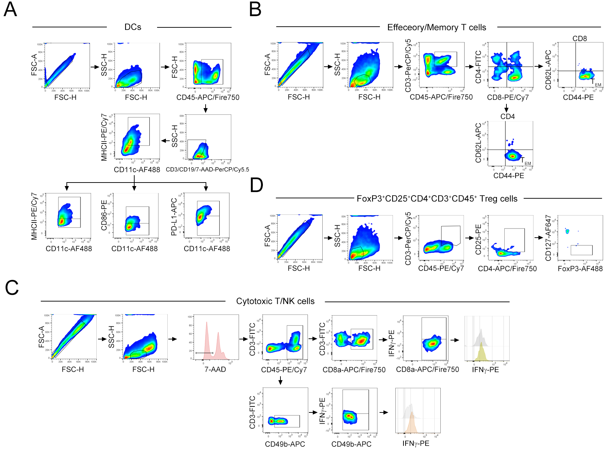
Figure S2. The gating strategies of immune cell profiles within resected tumors.
The gating strategy for dendritic cells (A), CD4 and CD8 T cells (B), IFNγ⁺CD8⁺CD3⁺ T cells (C), and FoxP3⁺CD25⁺CD4⁺CD3⁺CD45⁺ Treg cells (D).

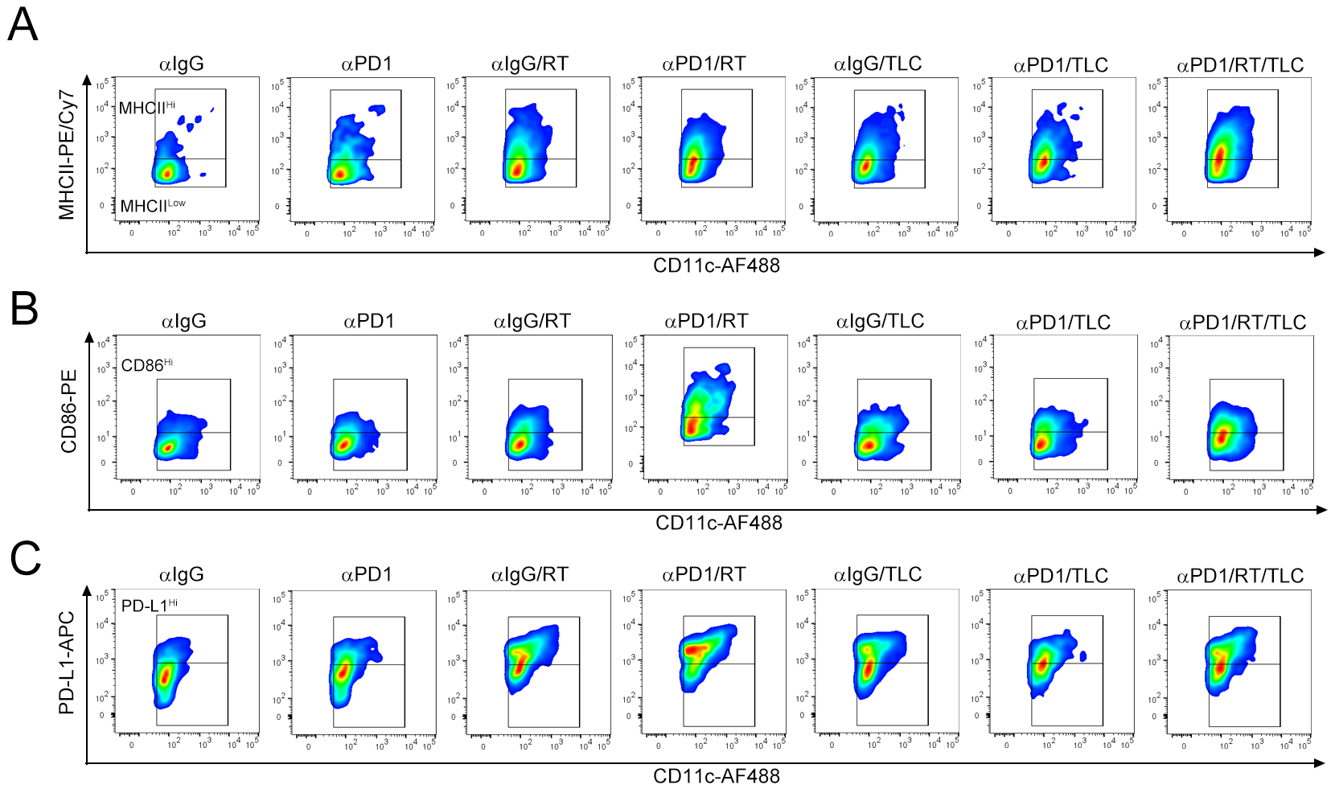
Figure S3. Combinational therapies significantly altered the tumor microenvironment, leading to the recruitment of immune cells.
The tumor-infiltrating MHC-II^{Hi} CD11c⁺ DCs (A), CD86^{Hi} CD11c⁺ DCs (B), and PD-L1^{Hi} CD11c⁺ DCs (C) in resected tumors were analyzed by flow cytometry (n=5).

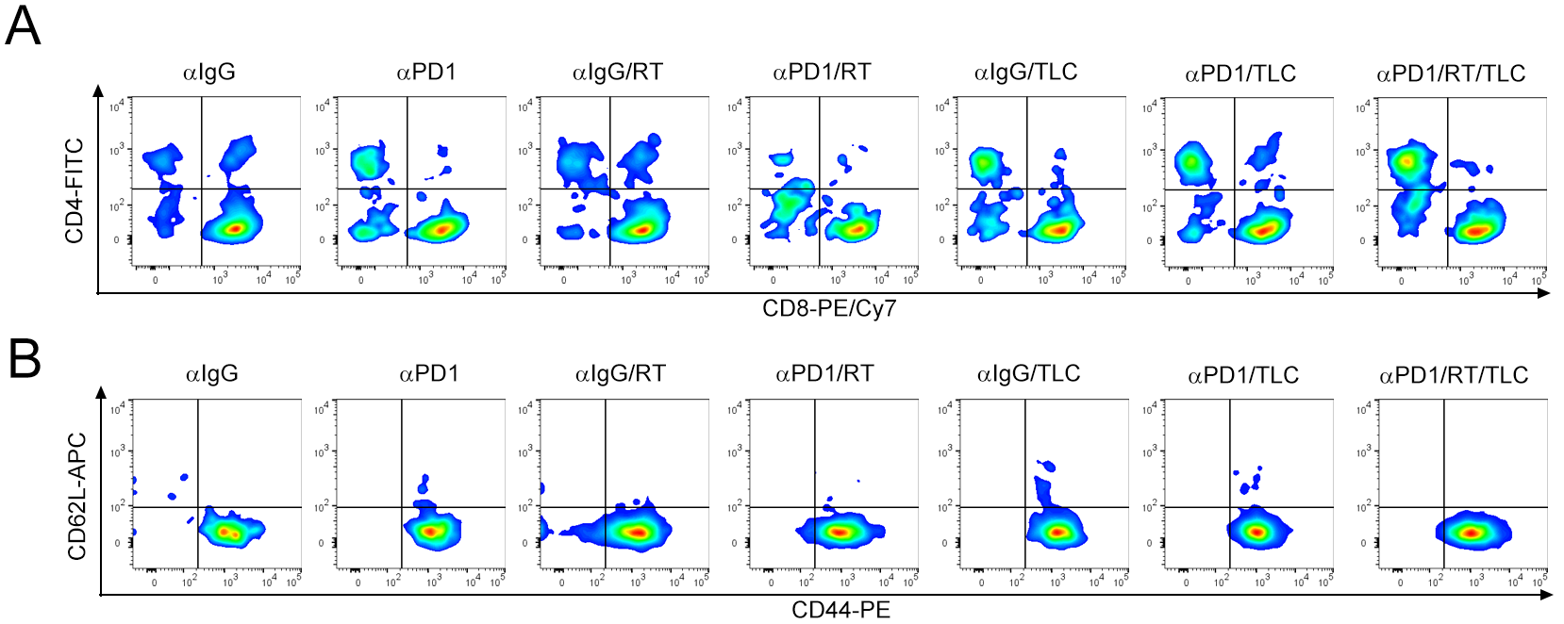
Fig. S4. Combinational therapies significantly altered the tumor microenvironment, leading to the recruitment of immune cells.
The tumor-infiltrating CD4⁺ T cell and CD8⁺ T cell (A) and effector/memory CD44⁺CD62L⁻CD8⁺ T_{EM} cells (B) in resected tumors were analyzed by flow cytometry (n=5).

