Assessing the ecological resilience of Ebola virus in Africa and potential influencing factors based on a synthesized model

Appendix A
Multiple data sources and establishment of a geodatabase
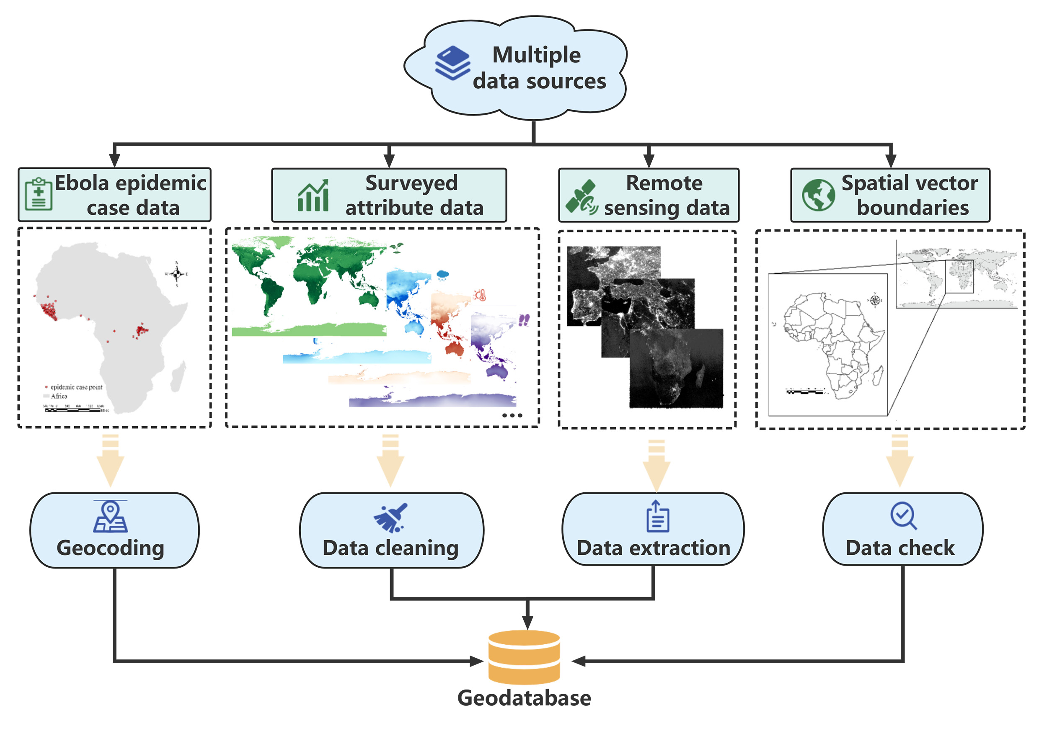

Appendix B
Heat map of Spearman coefficients for each variable
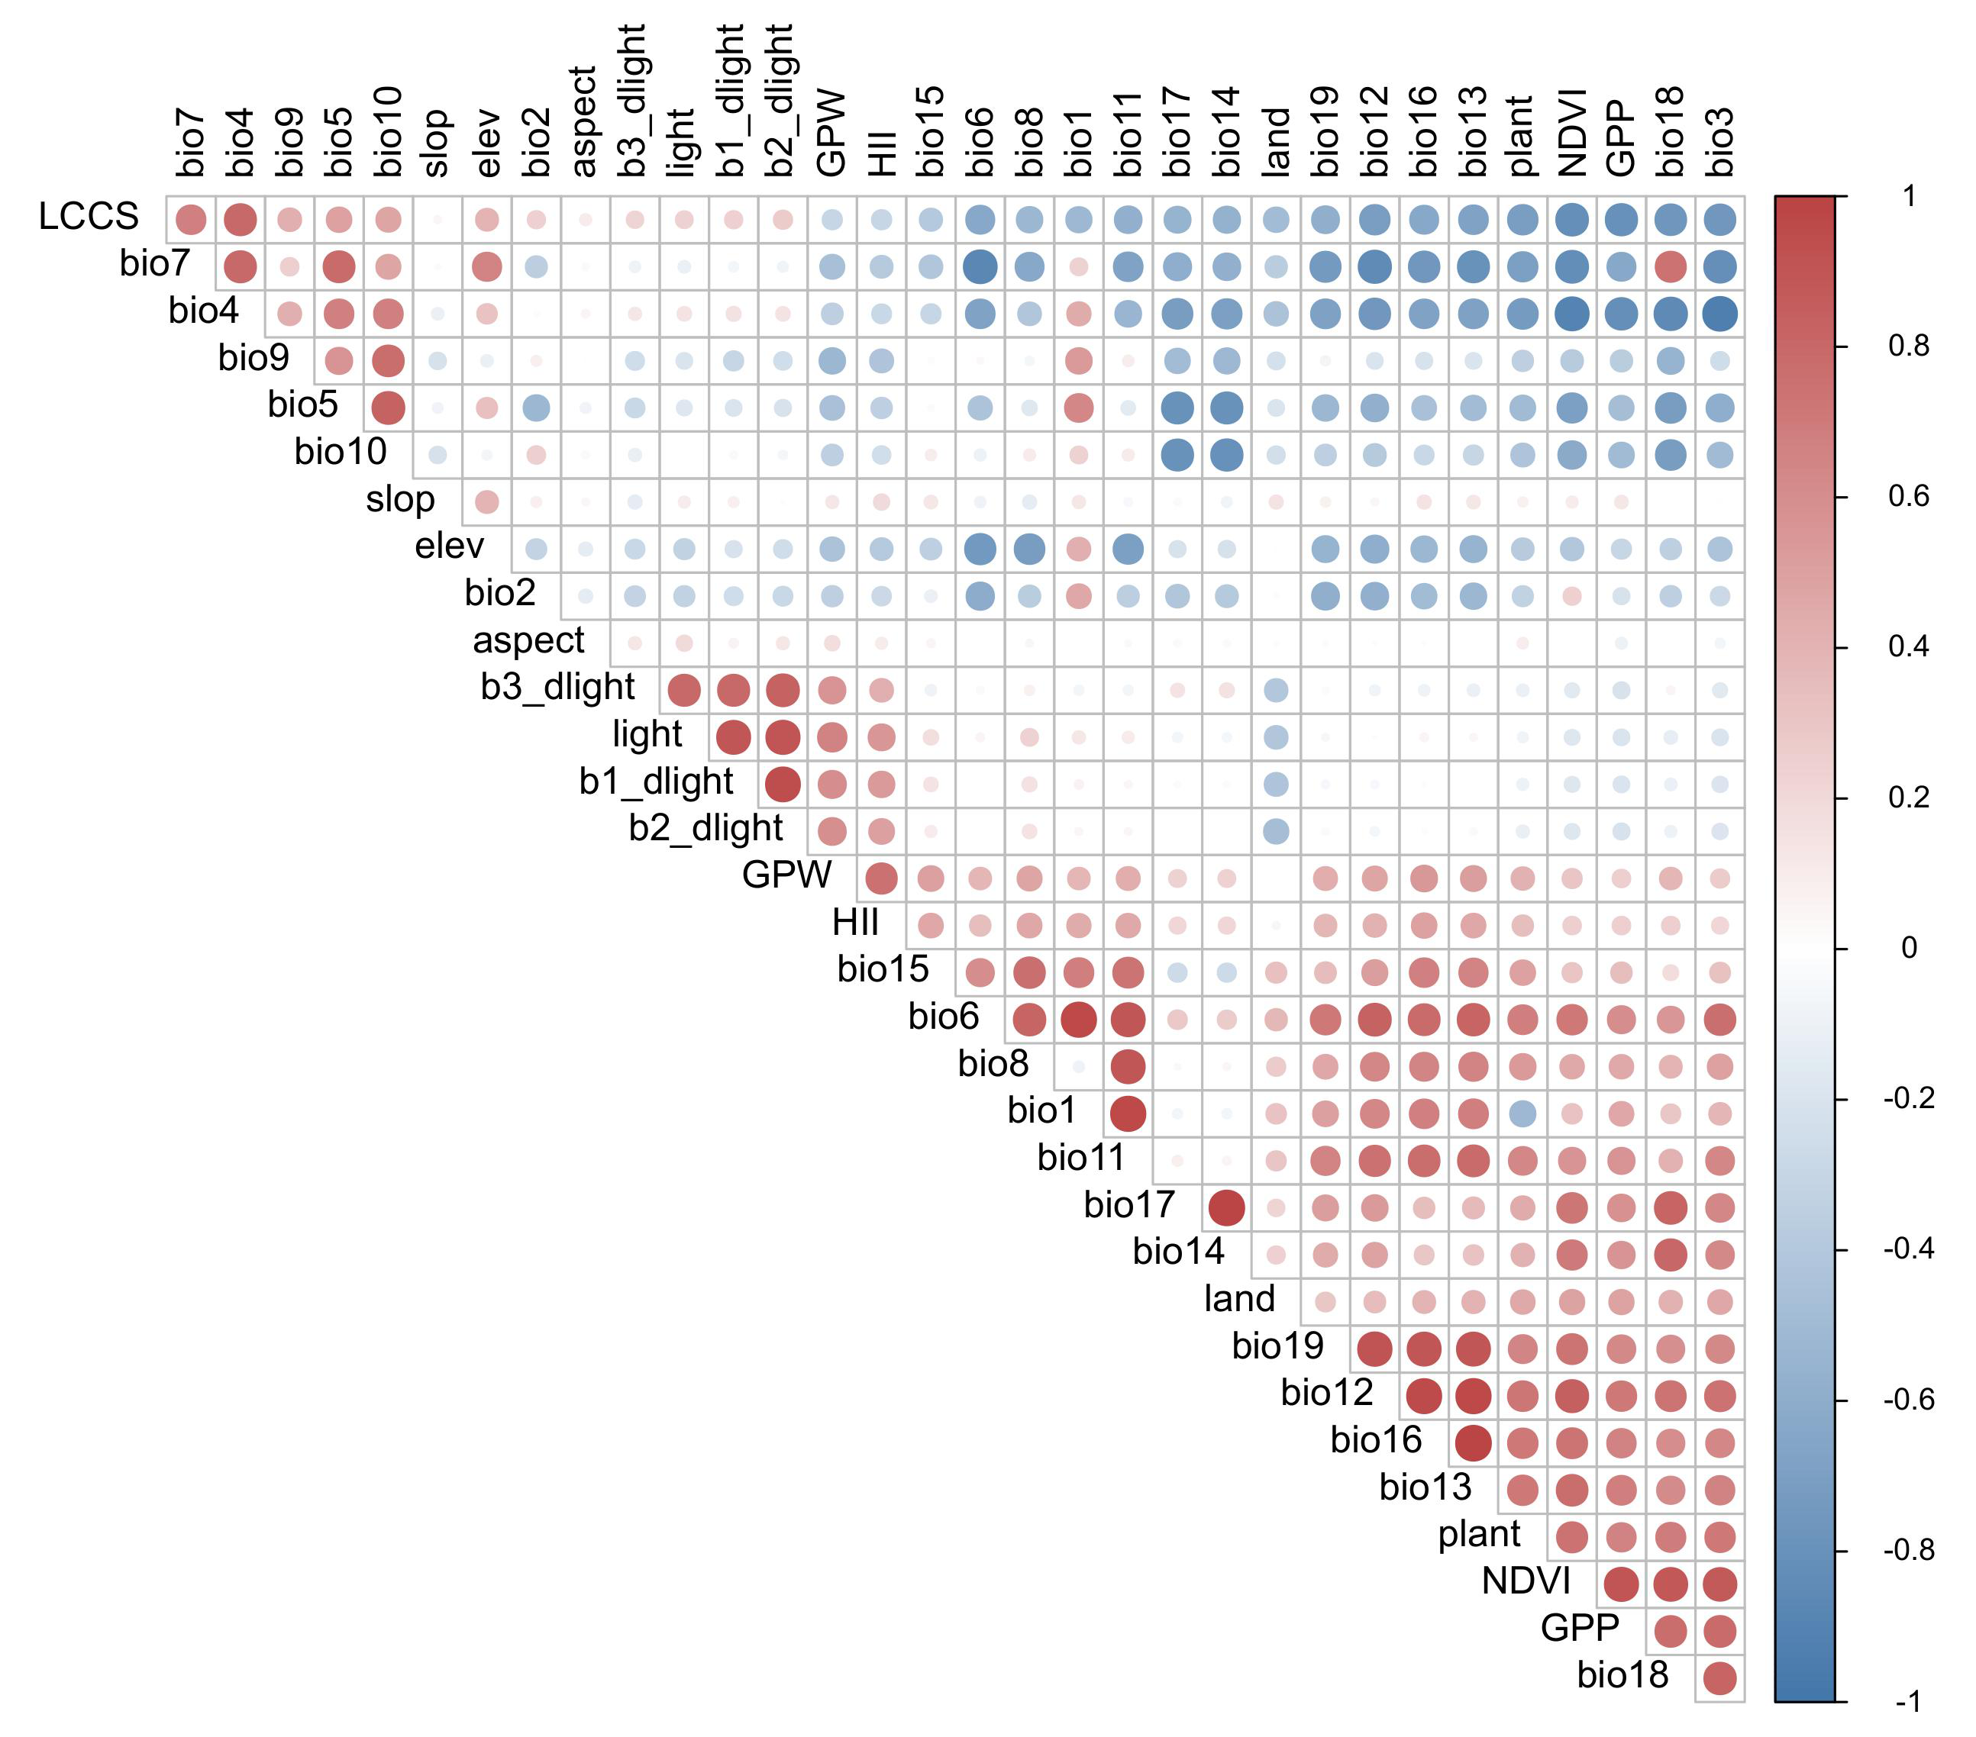

Appendix C
Information related to selected variables
Variables | Mininum | Maxinum | Mean | STD
Isothermality (bio3) | 9.1 | 100.0 | 34.4 | 18.8
Temperature Seasonality (×100; bio4) | 0 | 2377.6 | 888.5 | 467.8
Min Temperature of Coldest Month (℃; bio6) | -72.5 | 26.5 | -20.2 | 26.0
Temperature Annual Range (℃; bio7) | 1 | 72.7 | 34.1 | 12.0
Mean Temperature of Coldest Quarter (℃; bio11) | -66.4 | 29.3 | -14.3 | 26.7
Annual Precipitation (mm; bio12) | 0 | 11246.0 | 537.2 | 636.5
Precipitation of Driest Month(mm; bio14) | 0 | 507.0 | 14.7 | 27.6
Gross Primary Productivity(GPP) | 0 | 715.2 | 44.2 | 85.7
Gridded Population of the World(GPW) | 0 | 357341.3 | 46.2 | 423.7
Human Influence Index(HII) | 0 | 64 | - | -
Land Cover Classification System(LCCS) | 10 | 220 | - | -
Night Lights(light) | 0 | 255.0 | 4.1 | 20.0
Normalized Difference Vegetation Index(NDVI) | -32768.0 | 9938.0 | 188.9 | 6370.3
Abbreviation: STD, standard deviation

Appendix D
Characteristics and introduction of the models used in this study
Maxent model
The Maxent model is grounded in the principle of maximum entropy, leveraging species occurrence data in combination with known influential factors to create sample points. Maxent's versatility enables the fitting of intricate functions, facilitating non-linear modeling with high-dimensional data. Moreover, the model has advantages in capturing interaction effects and effectively addresses overfitting concerns through impressive regularization prowess.
In mathematical terms, the Maxent model optimizes the conditional entropy, denoted by $H\left(y|x\right)$, where $y$ represents the species occurrence and $x$ denotes the influential factors within the training dataset $x$ . The optimization is achieved by minimizing the negative sum of joint probabilities $p\left(y,x\right)$ multiplied by the logarithm of the conditional probabilities $p\left(y|x\right)$, which is modeled as:
$$\begin{aligned}H\left(y ∣ x\right)=-\sum_{\left(x,y\right)∈x}{p\left(y,x\right)\log{p\left(y ∣ x\right)}}\#\left(1\right)\end{aligned}$$
The model seeks the optimal probability distribution $p^{*}\left(y|x\right)$ by maximizing $H\left(y|x\right)$ under the constraint that the distribution belongs to the set $P$. This constraint is expressed as:
$$\begin{aligned}p^{*}\left(y|x\right)=arg\max_{p\left(y|x\right)∈P}H\left(y|x\right)\#（2）\end{aligned}$$

Bioclim model
The Bioclim model primarily compares characteristic of the study area with that of the bioclimatic envelope to explore the potential non-random relationships. It utilizes the Percentile Distribution algorithm to perform multivariate one-sided analysis on each independent variable of every grid. If all variables of a particular area fall within the bioclimatic envelope of the species, then that location can be considered suitable for species survival. The Bioclim model provides a rigorous and logically consistent approach to assess the ecological suitability for species within a given area.

Domain model
The Domain model predicts the distribution area of a species by comparing the independent variables of the focal point with those of the surrounding areas using the Gower matrix. It measures the similarity between the influential variables to estimate the resemblance to the known distribution areas. The maximum similarity value is 100, with higher values indicating greater similarity to the known distribution areas.
In specific terms, the Domain procedure employs a point-to-point similarity metric to attribute a classification value to a candidate site based on its proximity in environmental space to the most similar record site. The Euclidean distance $d$ between two points A and B in a p-dimensional space is defined as:
$$\begin{aligned}d_{AB}=\frac{1}{p}\sum_{k=1}^{p}{ }\left(\frac{\left|A_{k}-B_{k}\right|}{rangek}\right)\#\left(3\right)\end{aligned}$$
The complementary similarity measure $R_{AB}$ is expressed as:
$$\begin{aligned}R_{AB}=1-d_{AB}\#\left(4\right)\end{aligned}$$
The maximum similarity $S_{A}$ between candidate point A and the collection of known record sites $T_{m}$ is articulated as:
$$\begin{aligned}S_{A}=\overset{m}{\max_{j=1}} R_{AT_{j}}\#（5）\end{aligned}$$
Assessing $S$ for every grid point within a designated region results in a matrix of continuously changing similarity values, which can be used for subsequent niche prediction.

GARP model
The Genetic Algorithm Rule-set Production (GARP) model is characterized by a rule-based approach. Its fundamental operating principle involves an iterative process where four rule-sets are selected as genes and passed down through generations using genetic algorithms. In each generation, an attempt is made to incorporate a new rule-set, which is then tested to determine if the change can bring positive gains. Rule-sets that contribute to gains are retained, resulting in a complete model composed of multiple rule-sets. The four rule-sets are as follows: atomic rule-set, bioclimatic envelope, logistic regression, and inverse bioclimatic envelope.

GAMs
The principle of the generalized additive model involves non-parametric regression by summing the predictor variables to compute a non-parametric function of the relationship between predictor variables and response variables. Unlike typical additive models that assume the response variable follows a normal distribution, the variables employed in this study, theoretically speaking, do not adhere to a normal distribution. Hence, a generalized additive model is utilized. The specific formula is presented below:
$$\begin{aligned}Y=β_{0}+f_{1}\left(X_{1}\right)+f_{2}\left(X_{2}\right)+⋯+f_{n}\left(X_{n}\right)\#（6）\end{aligned}$$
Here, each $f_{i}(⋅)$ denotes a non-linear smooth function capturing the relationship with the corresponding predictor variable. The error term $β_{0}$ accounts for unobserved factors contributing to random variability in the model.
Specifically, in the experimental procedure, random points were generated globally. Environmental data corresponding to these points, along with Maxent model outcomes, were extracted. The model results were then employed as the response variable, fitting them against variations in environmental data. The aim was to observe the response of the model outcomes to changes in environmental variables.

