STIMULATION OF PYRAMIDAL NEURONS IN DEEP LAYERS OF RAT VISUAL CORTEX ENHANCES VISUAL INFORMATION PROCESSING
Gytis Baranauskas¹, Kristina Rysevaite-Kyguoliene², Ignas Sabeckis², Tatiana Tkatch*¹, Dainius H Pauza²
¹Neurophysiology laboratory, Neuroscience Institute, Lithuanian University of Health Sciences, Kaunas, Lithuania
²Anatomy Institute, Lithuanian University of Health Sciences, Kaunas, Lithuania
*Present address: Department of Physiology, Northwestern University, Chicago, IL, USA.
Supplementary information
Typically, several methods of optical tagging are used to determine neurons directly activated by blue light (Kvitsiani et al, 2013, Munoz et al, 2014). These methods are based on changes in action potential firing patterns during or/and following a blue light pulse. However, a more detailed analysis revealed that at least in the case of pyramidal neurons these methods may yield false positives, i.e., they will identify neurons that are in fact activated indirectly by blue light pulses via synaptic connections. We analyzed responses of our neurons to blue light stimulation and determined that most if not all neuron responses were evoked synaptically. This conclusion is based on response patterns and the delay between multiunit and single unit signals. This supplementary material provides details of this analysis.
To gain insights into what type of neuronal network activity was induced by LED stimulation, first we divided the recorded single units into putative pyramidal neurons (PPNs) and interneurons (PINs) according to the action potential (AP) width and the time interval between the trough and the peak as shown in figure 3 (Barthó et al., 2004). In the recordings from the CaMKII virus injected rats 78 PPNs and 18 PINs were identified. Although in these rats 465 nm LED pulses are expected to activate pyramidal neurons, in most recorded PPNs trains of LED light pulses suppressed spontaneous AP generation (44/78, 56.4%, 44 ± 13% of control RMS, median 45%, supplementary figure S1A). Meanwhile, APs were generated in ~35% of PPNs during LED stimulation (27/78, 34.6%, supplementary figure S1B), i.e., these neurons were optically tagged ((Kvitsiani et al., 2013), see methods for details) and the probability of firing an AP increased significantly during LED stimulation, on average 3665 ± 8875 fold (n = 27, median 440, range 6.9 – 31,464, supplementary figure S1B). In the remaining 8 PPNs (7/78, 9.0%) no significant changes in firing patterns were detected. It has been shown that the appearance of APs time-locked to the LED pulse in cortical pyramidal neurons does not necessarily mean that these neurons were directly activated by light (Muñoz et al., 2014). In these neurons neither latency nor jitter of generated APs allows discrimination between LED and synaptically activated neurons. Only relatively long (≥40 ms) LED pulses, at least ~40 ms long, permit such discrimination: in the neurons directly activated by the LED light at least several APs are generated (≥3) during 40 ms light pulses, while in the synaptically activated neurons typically only a single action potential is generated (figure 3 in Muñoz et al, 2014). We tested this approach in 4 out of 10 the CamKII virus injected rats. In these rats 12 PPNs were opto-tagged and responded to LED stimulation with an increased firing rate. However, on average they fired only 1.32 ± 0.42 action potentials (median 1.1, range 1 – 2.29, supplementary figure S1C), only a single neuron fired more than 2 APs on average (2.29). Therefore, we conclude that most if not all these PPNs were synaptically activated. Meanwhile, in 8 out of 18 PINs there was a suppression of spontaneous AP generation while in other 8 PINs no change in firing pattern was observed. In the remaining 2 PINs there was a large increase in firing rates during LED stimulation, however, they were clearly synaptically activated (see below).
There are at least two potential reasons why we had difficulty observing neurons directly activated by LED light in the CaMKII virus injected rats. First, as shown in figure 2E, there was approximately 400 µm distance between the optical fiber end and the tip of the recording electrode. It has been shown that the LED light intensity drops off very quickly in the brain tissue effectively limiting the area of high intensity light to ~100 µm from the fiber end (Stark et al., 2012). Meanwhile, large extracellular APs can be recorded only within <100 µm from the tip of the electrode (Harris et al., 2000). Therefore, it is likely that only neurons close to the optical fiber end (<100 µm) were directly activated by the LED light and they were too far from the recording electrode (≥300 µm) to produce APs of sufficient amplitude for single unit identification. Since low amplitude APs could arrive from as far as ~300 µm (Henze et al., 2000), we analyzed low amplitude multiunit (MU) signal during LED stimulation. Indeed, this MU signal in most cases preceded single unit activation while 4 out of 27 PPNs were activated simultaneously (Supplementary figure S1D). In the left panel of supplementary figure S1D, we also included one of two PINs that responded to LED light with an increase in AP rate (middle peristimulus histogram, PSTH). This PIN was activated after the distant neurons (MU signal) were activated; thus, probably this neuron was activated synaptically but not directly by the LED light (supplementary figure S1D).
Meanwhile, in the PV virus injected rats there was a suppression of background (spontaneous) AP generation in all PPNs (n = 20, 45 ± 14% of control RMS, median 40%, supplementary figure S1E). In these rats only 6 PINs were identified, the spontaneous AP rates were increased in 4 PINs (by 98% to ~1,400%) and non-significantly reduced in 2 PINs (supplementary figure S1F). In contrast to PPN activation during LED stimulation in the CaMKII virus injected rats, PINs in the PV virus injected rats generated very sparse APs with large jitter (supplementary figure S1G). This type of response seems to be typical for optogenetically activated parvalbumin interneurons (Muñoz et al., 2014). Weak responses may indicate that these neurons were relatively far away from the light source. This is supported also by the MU signal: in 1 out of 3 rats the MU signal was suppressed by the LED pulse (by ~60%), indicating that even distant neurons were mainly suppressed but not activated by the LED pulse. In the remaining 2 rats there was a modest increase in MU signal during LED pulses (by ~50% and ~100%).
In summary, in PPNs the main observed effect was the suppression of the spontaneous AP firing rate in both the CaMKII and the PV virus injected rats. Moreover, in LED stimulated PPNs from the CaMKII virus injected rats the LED induced APs were followed by similar suppression of the spontaneous APs (indicated by arrows in figure 4B). Therefore, we conclude that in PPNs of both types of rats the main effect was inhibitory in nature.
Despite similarity in the prevalence of inhibitory response in neurons from both the CamKII and the PV virus injected rats, there was one important difference in the time-course of this inhibitory effect. As shown in supplementary figure S1H, the recovery from the suppression of AP firing rate was much slower in the CaMKII virus injected rats: in the PPNs the average recovery time constant was 27 ± 2.2 ms in the PV virus injected rats and 85 ± 7 ms in the CaMKII virus injected rats (n = 20 and 47 correspondingly, p <0.001; in the data sample from the CaMKII virus injected rats 27 optically tagged neurons of supplementary figure S1B were excluded). Much slower recovery from suppression in the CaMKII virus injected rats suggests a recurrent circuit activation. This is supported by the observation that in these rats in 3 out of 26 PPNs that responded to the LED light with increased firing rates, the AP firing rate decayed very slowly following the peak (supplementary figure S1I).

REFERENCES:
Barthó P, Hirase H, Monconduit L, Zugaro M, Harris KD, Buzsáki G (2004). Characterization of neocortical principal cells and interneurons by network interactions and extracellular features. J Neurophysiol 92:600-608.
Harris KD, Henze DA, Csicsvari J, Hirase H, Buzsaki G (2000). Accuracy of tetrode spike separation as determined by simultaneous intracellular and extracellular measurements. J Neurophysiol 84:401-414.
Henze DA, Borhegyi Z, Csicsvari J, Mamiya A, Harris KD, Buzsáki G (2000). Intracellular features predicted by extracellular recordings in the hippocampus in vivo. J Neurophysiol 84:390-400.
Kvitsiani D, Ranade S, Hangya B, Taniguchi H, Huang JZ, Kepecs A (2013). Distinct behavioural and network correlates of two interneuron types in prefrontal cortex. Nature 498:363-366.
Muñoz W, Tremblay R, Rudy B (2014). Channelrhodopsin-assisted patching: in vivo recording of genetically and morphologically identified neurons throughout the brain. Cell Rep 9:2304-2316.
Stark E, Koos T, Buzsáki G (2012). Diode probes for spatiotemporal optical control of multiple neurons in freely moving animals. J Neurophysiol 108:349-363.

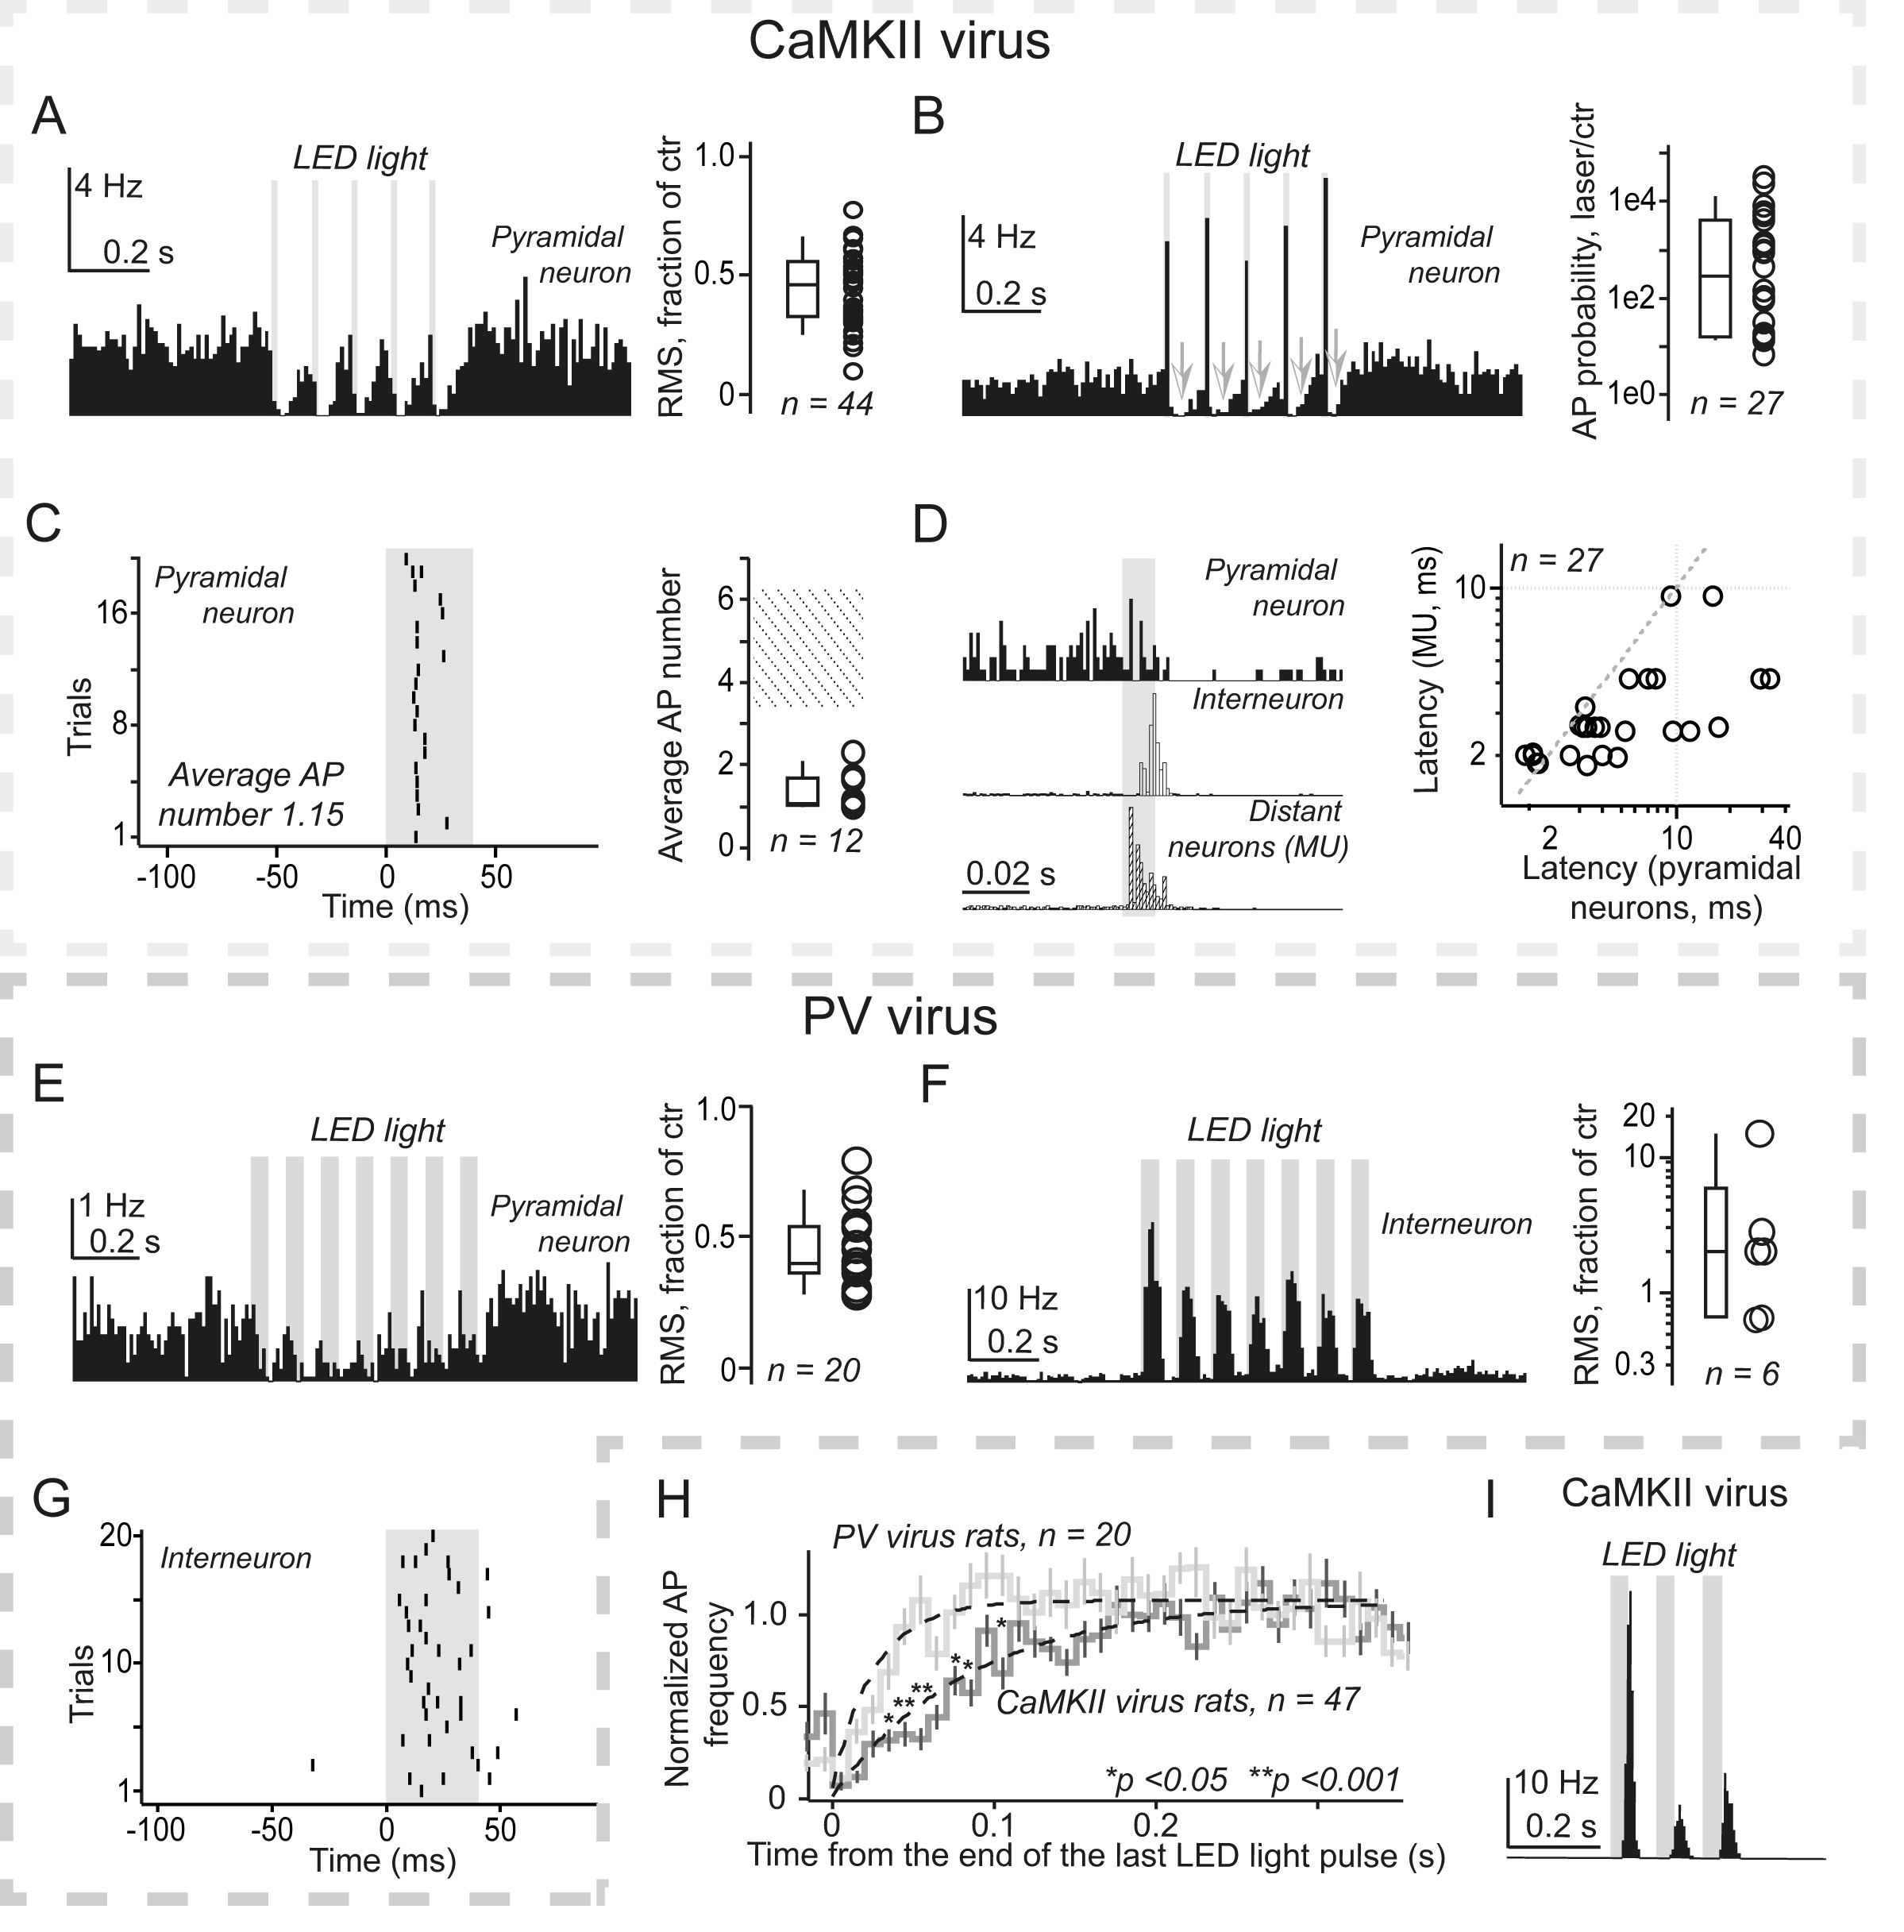
Supplementary figure S1. The neuron activation patterns were clearly distinct in the CaMKII virus (A – D and I) and the PV virus (E – G) injected rats. A. Typical PSTH of a putative pyramidal neuron in the CaMKII virus injected rat. Right, the statistics of average AP rates during train of LED pulses compared to the control before the train. Each circle on the right corresponds to a single unit. B. An optically tagged putative pyramidal neuron that responded to LED stimulation with increased AP firing rate. Arrows indicate a suppression of spontaneous activity between LED pulses. Right, an average peak AP rate normalized to the spontaneous AP rate. C. Left, raster of light evoked activity in putative pyramidal neuron during a 40 ms LED light pulse. Right, average number of evoked APs, on the right each open circle corresponds to a single unit. The dashed area above data points is the expected number of APs in neurons directly activated by light. D. PSTH of low amplitude, multiunit data (MU, bottom trace), a putative interneuron (middle trace) and a putative pyramidal neuron (top trace) obtained during the same recording session. Note, that first MU signal appears, followed by the interneuron and then there is a suppression of spontaneous activity in the putative pyramidal neuron. On the left a plot of MU signal latencies against latencies of optotagged pyramidal neurons from the same recording sessions. A dotted line corresponds to equal latencies of MU and single units. E. A typical PSTH of a putative pyramidal unit in the PV virus injected rat. Right, statistics of average rates normalized to the spontaneous rate. F. Example of putative interneuron response in the PV virus injected rat. Right, average rates during 50 ms pulse in putative interneurons. G. Raster plot of a putative interneuron shown in F. H. Average time-course of recovery from the suppression putative pyramidal neurons of the CaMKII and the PV virus injected rats. I. Example of slowly activated putative pyramidal neuron in the CaMKII virus injected rat, in total 3 such neurons were found.

