6.0 Supplementary section
Marine cyanobacterial sample collection
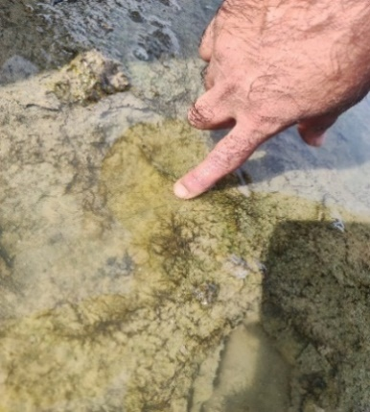
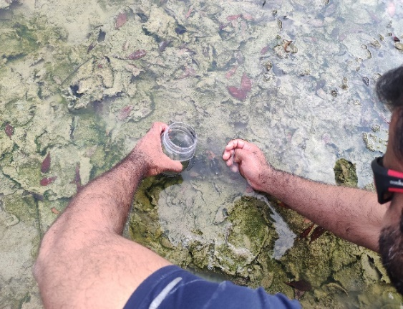
A
B

Supplementary figure 1: Cyanobacterial samples were collected from the location near Pulmude road, Trincomalee (8º 37/ 39.4// N, 81º 12/ 21.3// E) appeared to have a visible formation of thick cyanobacterial mats.

Laboratory Operation of microbial fuel cells
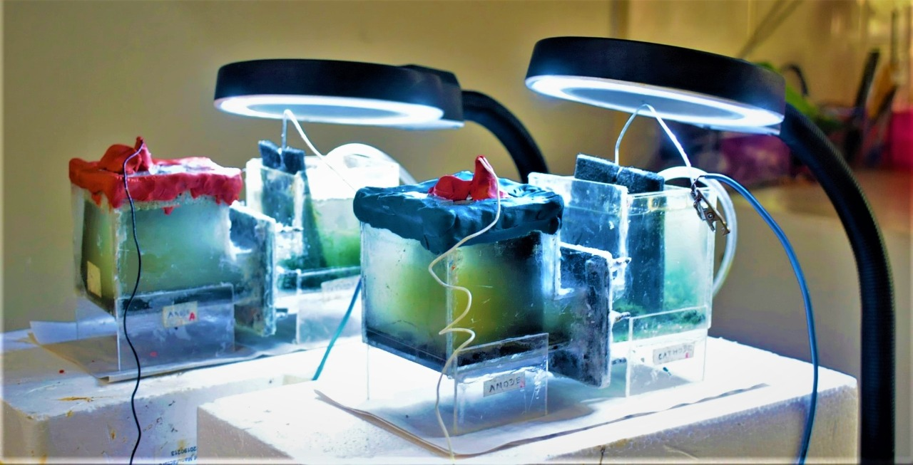
Supplementary figure 2: Cathode compartments housing marine cyanobacterial cultures illuminated for 24 hours using a table lamp with a light intensity of 0.003 lux. The mpMFC operates under artificial light conditions and is fueled with glucose.

Preparation of the exogenous feeding substrate
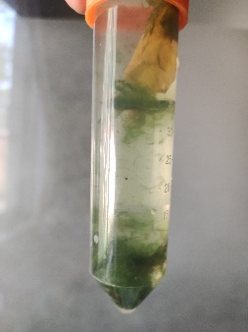
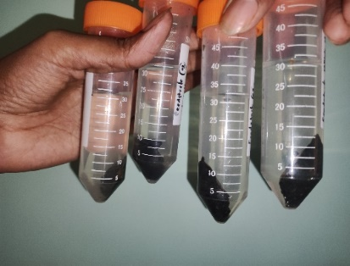
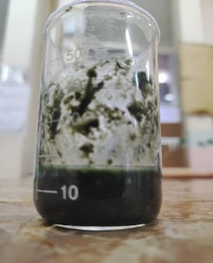
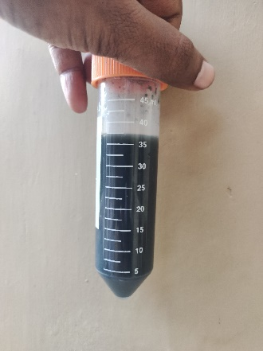
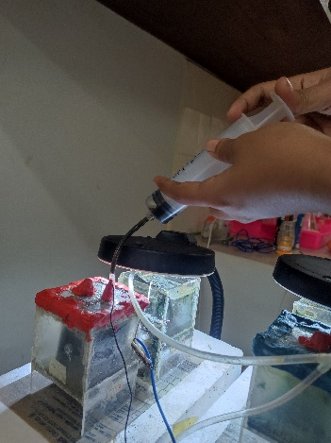
A
B
C
D
E

Supplementary figure 3: (A) Collected biomass from the biocathode, (B) After centrifugation, biomass was deposited in the bottom of the tube, (C) Grounded biomass, (D) Ready to use feeding substrate after neutralizing, (E) Feeding the biomass into the anode in mpMFC using a syringe

Supplementary figure 4: Marine cyanobacterial biomass, collected and consolidated in 50 ml Falcon tubes, underwent centrifugation at 5000 rpm for 5 minutes. Following centrifugation, biomass settled at the tube bottom, separating from the media. The biomass was then milled into a pulp using a mortar and pestle to enhance surface area for efficient hydrolysis. For acid hydrolysis, 10 ml of 0.1M HCl was added to the milled biomass, followed by 10 minutes of sonication at a high wavelength. Post-sonication, the solution's pH was measured, and 1M NaOH was introduced to neutralize it to pH 7, serving as the raw material for the anode's exoelectrogens.

Identification of photosynthetic microorganisms in the biocathode
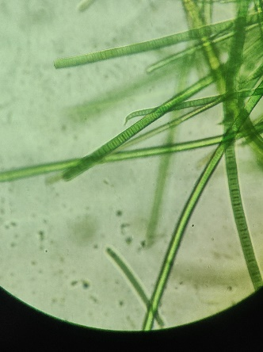
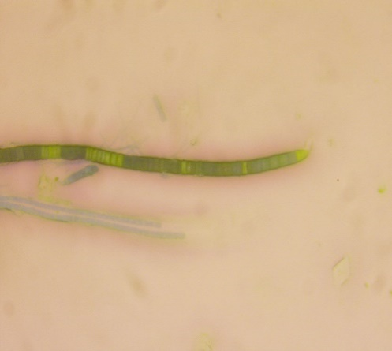
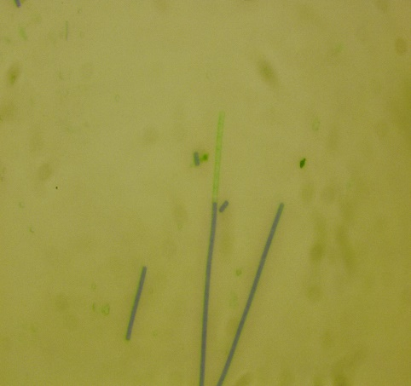
A
B
C

Supplementary figure 5: (A) Marine photosynthetic microbes under the light microscope (10x10x1), (B) Filamentous photosynthetic cells with hooks at the end (10x40x1), (C) Filamentous photosynthetic cells with elongated outer membrane

