Supplementary Materials
Supplementary Table 1. Best responses for the first-line atezolizumab plus bevacizumab treatment
 | Total  (N = 246) | Short-term treatment groupª  (N = 177) | Long-term treatment group^{b}  (N = 69) | p-value^{c}
Best Response, N (%) |  |  |  | <0.001
CR | 11 (4.5) | 2 (1.1) | 9 (13.0)
PR | 68 (27.6) | 25 (14.1) | 43 (62.3)
SD | 114 (46.3) | 97 (54.8) | 17 (24.6)
PD | 53 (21.5) | 53 (29.9) | 0 (0.0)
Objective response rate | 32.1% | 15.3% | 75.4% | <0.001

ª Patients treated with atezolizumab plus bevacizumab for less than 1 year.
^{b} Patients treated with atezolizumab plus bevacizumab for 1 year or more.
^{c} Fisher’s exact test or Pearson’s Chi-square test, as appropriate.
CR, complete response; N, number; PD, progressive disease; PR, partial response; SD, stable disease.

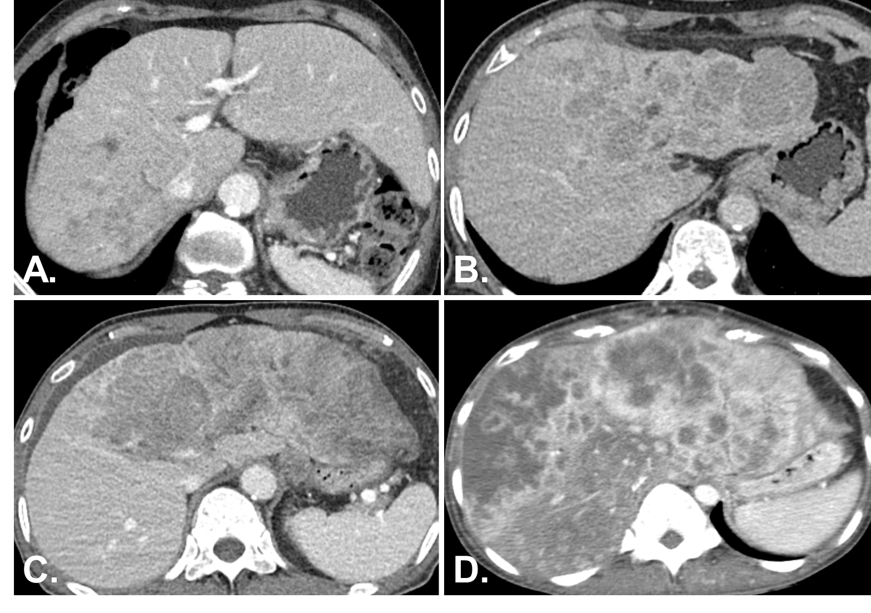
Supplementary figure 1. Representative cases illustrating the four stages of intrahepatic tumor burden assessed on CT scans: Tumors involving <25% (A), 20-50% (B), 50-75% (C), and >75% (D) of the remaining liver volume.

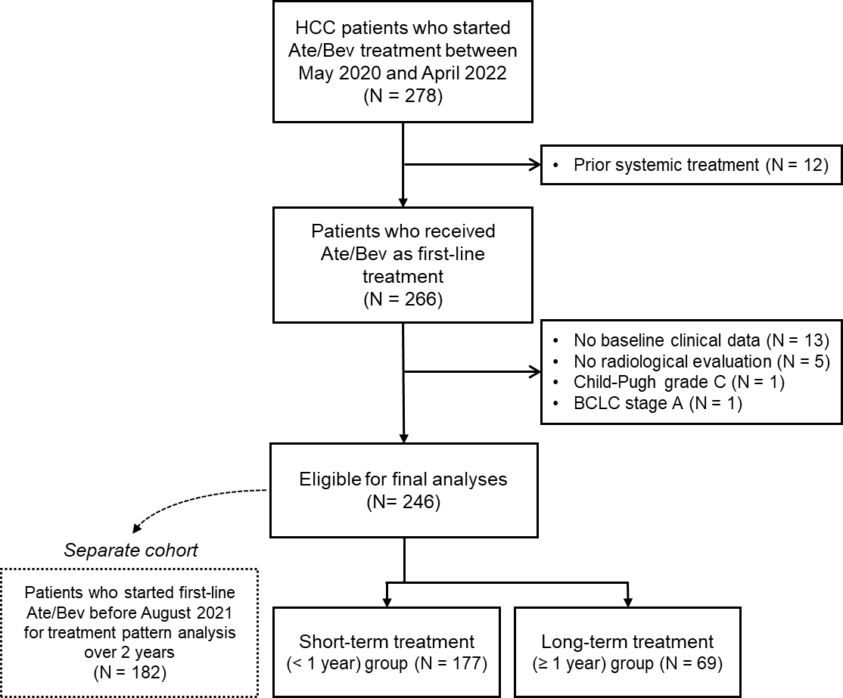
Supplementary Figure 2. Consort diagram. Abbreviations: Ate/Bev, atezolizumab plus bevacizumab; BCLC, Barcelona Clinic Liver Cancer

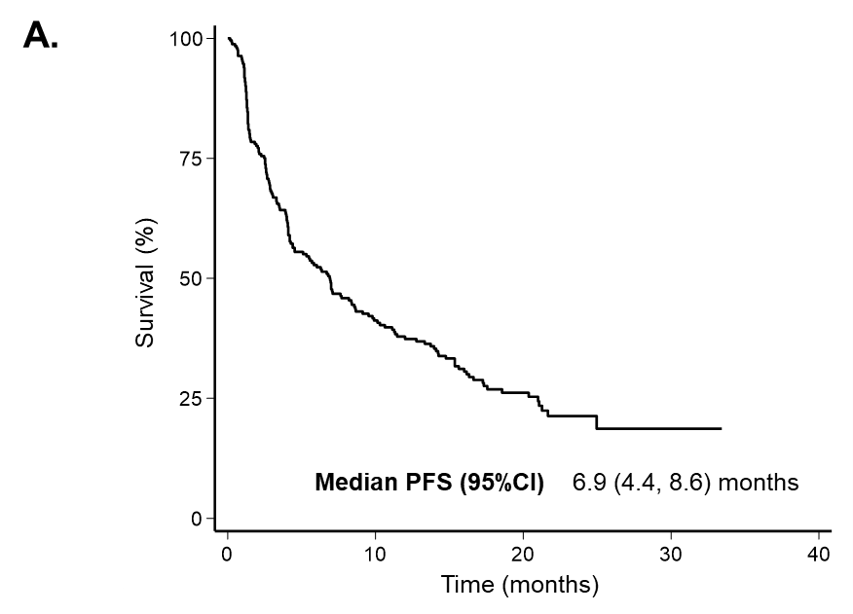
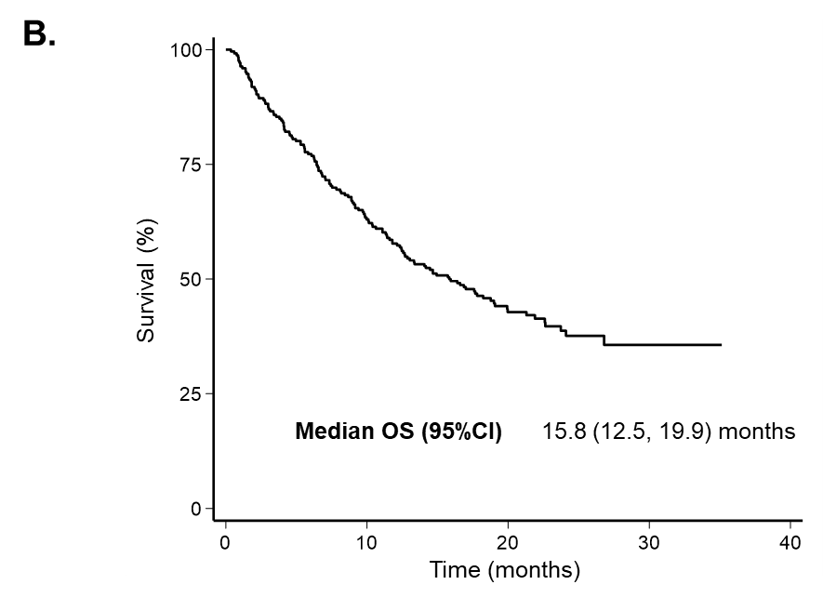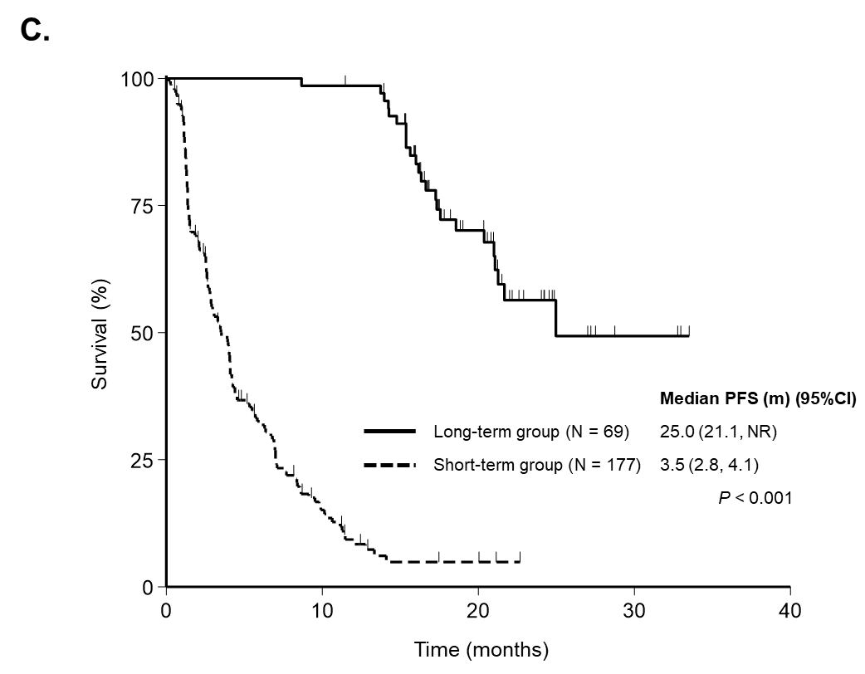
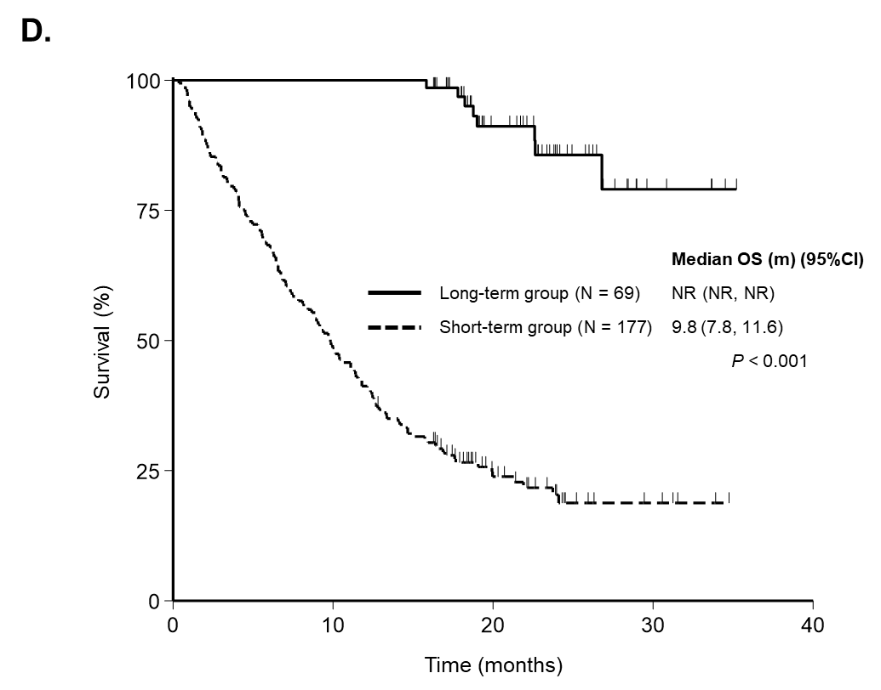
Supplementary Figure 3. Survival outcomes. A. Progression-free survival. B. Overall survival of the overall population. C. Progression-free survival, D. Overall survival based on the atezolizumab plus bevacizumab treatment duration (short-term group [< 1 year] vs. long-term group [≥ 1 year])
Abbreviations: CI = confidence interval; N = number; NR = not reached; OS = overall survival; PFS = progression-free survival

